Q1:
Consider following Version1 of Code Snippet:
main () function
begin
let x has type integer
let y has type integer
x assign 10
y assign 20 plus 30 minus x
y k print kori
end
a. Design Lexical Analysis and Syntax Analysis part of compiler based on the version1 of code snippet.
Parser.y
%{
#include <stdio.h>
#include <stdlib.h>
#include <string.h>
#include "symtab.c"
#include "codeGen.c"
void yyerror();
extern int lineno;
extern int yylex();
%}

%union
{
char str_val[100];
int int_val;
}

%token PRINT SCAN SUB MAIN AS LET HAS TYPE K KORI BEG
%token ADDOP SUBOP MULOP DIVOP EQUOP LT GT THEN END
%token LPAREN RPAREN LBRACE RBRACE SEMI ASSIGN ELSE TO FUNCTION
%token<str_val> ID
%token<int_val> ICONST
%token<int_val> INT INTEGER SINGLE DIM
%token<int_val> IF
%token<int_val> WHILE FOR

%left LT GT /*LT GT has lowest precedence*/
%left ADDOP
%left MULOP /*MULOP has lowest precedence*/

%type<int_val> exp assignment_print_scan

%start program

%%
program: {gen_code(START, -1);} code {gen_code(HALT, -1);}
code: statements;

statements: statements statement | ;

statement: declaration
|BEG
|MAIN LPAREN RPAREN FUNCTION
|assignment_print_scan
|if_statement
|while_statement
|for_loop
|END
;

declaration: DIM ID AS INTEGER
{

}
| LET ID HAS TYPE INTEGER
{

}

;

assignment_print_scan: ID ASSIGN exp
{

}
|ID ASSIGN ICONST
| PRINT LPAREN ID RPAREN SEMI
{

}
|ID K PRINT KORI
{

}
| SCAN LPAREN ID RPAREN SEMI
{
int address = idcheck($3);

if(address != -1)
{
gen_code(SCAN_INT_VALUE, address);
}
else
yyerror();
}
;

exp: ICONST
{
gen_code(LD_INT, $1);
}
| ID
{

}
| exp ADDOP exp { }
|exp SUBOP exp
| exp MULOP exp
| exp GT exp { gen_code(GT_OP, gen_label()); }
| exp LT exp { gen_code(LT_OP, gen_label()); }
;

if_statement:
IF {$1 = gen_label();} exp THEN
{ gen_code(IF_START, $1); }
iftail { gen_code(ELSE_END, $1); }
;
iftail:statements

tail: LBRACE statements RBRACE
;

while_statement: WHILE { $1 = gen_label();
gen_code(WHILE_LABEL, $1); }
LPAREN exp RPAREN { gen_code(WHILE_START, $1); }
tail { gen_code(WHILE_END, $1); }
;

for_loop: FOR{$1 = gen_label() ;
gen_code(FOR_LABEL,$1);}

ID ASSIGN ICONST TO ICONST { gen_code(FOR_START,$1);}
ID ASSIGN exp
{gen_code(FOR_END,$1)}
;

%%

void yyerror ()
{
printf("Syntax error at line %d\n", lineno);
exit(1);
}

int main (int argc, char *argv[])
{
yyparse();
printf("Parsing finished!\n");

return 0;
}

lexer.l:
%option noyywrap

%{
#define INT_TYPE 1
#include <stdio.h>
#include <stdlib.h>
#include <string.h>
#include "parser.tab.h"

int lineno = 1; // initialize to 1
void yyerror();
%}

alpha [a-zA-Z]
digit [0-9]
alnum {alpha}|{digit}
print [ -~]

ID {alpha}{alnum}*
ICONST [0-9]{digit}*
%%

"//".* { }

"integer" {yylval.int_val=INT_TYPE; return INTEGER; }

"if" {return IF;}
"Then" {return THEN;}
"else" {return ELSE;}
"while" { return WHILE; }
"For" {return FOR;}
"To" {return TO;}
"let" {return LET;}
"has" {return HAS;}
"type" {return TYPE;}
"k" {return K;}
"kori" {return KORI;}
"function" {return FUNCTION;}
"end" { return END; }
"plus" { return ADDOP; }
"minus" { return SUBOP; }
"*" { return MULOP; }
"/" { return DIVOP; }
"==" { return EQUOP; }

">" { return GT; }
"<" { return LT; }

"(" { return LPAREN; }
")" { return RPAREN; }
"{" { return LBRACE; }
"}" { return RBRACE; }
";" { return SEMI; }
"assign" { return ASSIGN; }
"print" { return PRINT; }
"scan" { return SCAN; }
"Sub" {return SUB;}
"main" {return MAIN;}
"Dim" {return DIM;}
"As" {return AS;}
"begin" {return BEG;}
"Single" {yylval.int_val=INT_TYPE;return SINGLE;}

{ID} {strcpy(yylval.str_val, yytext); return ID;}
{ICONST} {yylval.int_val=atoi(yytext); return ICONST;}

"\n" { lineno += 1; }
[ \t\r\f]+

. { yyerror("Unrecognized character"); }

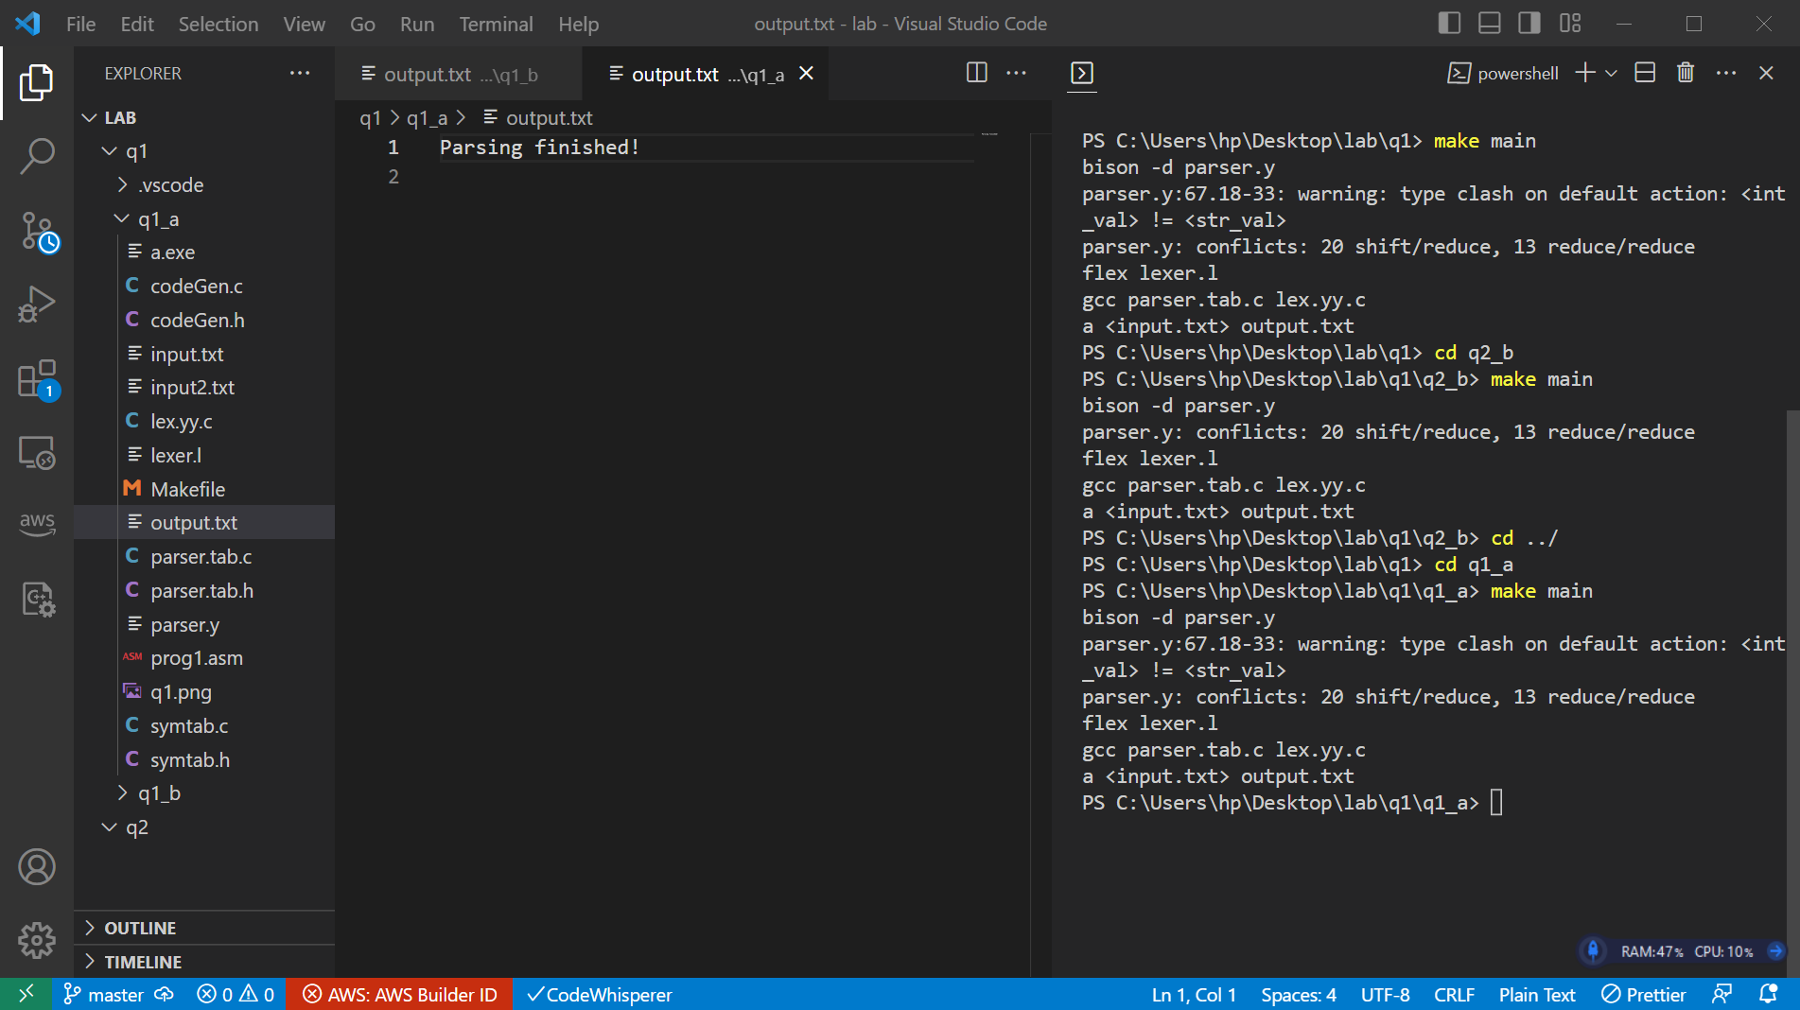

b. Design Intermediate Code Generation and Code Generation part of compiler based on the version1 of code snippet.

Parser.y:
%{
#include <stdio.h>
#include <stdlib.h>
#include <string.h>
#include "symtab.c"
#include "codeGen.c"
void yyerror();
extern int lineno;
extern int yylex();
%}

%union
{
char str_val[100];
int int_val;
}

%token PRINT SCAN SUB MAIN AS LET HAS TYPE K KORI BEG
%token ADDOP SUBOP MULOP DIVOP EQUOP LT GT THEN END
%token LPAREN RPAREN LBRACE RBRACE SEMI ASSIGN ELSE TO FUNCTION
%token<str_val> ID
%token<int_val> ICONST
%token<int_val> INT INTEGER SINGLE DIM
%token<int_val> IF
%token<int_val> WHILE FOR

%left LT GT /*LT GT has lowest precedence*/
%left ADDOP
%left MULOP /*MULOP has lowest precedence*/

%type<int_val> exp assignment_print_scan

%start program

%%
program: {gen_code(START, -1);} code {gen_code(HALT, -1);}
code: statements;

statements: statements statement | ;

statement: declaration
|BEG
|MAIN LPAREN RPAREN FUNCTION
|assignment_print_scan
|if_statement
|while_statement
|for_loop
|END
;

declaration: DIM ID AS INTEGER
{

}
| LET ID HAS TYPE INTEGER
{

}

;

assignment_print_scan: ID ASSIGN exp
{

}
|ID ASSIGN ICONST
{
int address = idcheck($1);
gen_code(STORE, address);

}
| PRINT LPAREN ID RPAREN SEMI
{

}
|ID K PRINT KORI
{
int address = idcheck($1);

gen_code(PRINT_INT_VALUE, address);

}
| SCAN LPAREN ID RPAREN SEMI
{
int address = idcheck($3);

if(address != -1)
{
gen_code(SCAN_INT_VALUE, address);
}
else
yyerror();
}
;

exp: ICONST
{
gen_code(LD_INT, $1);
}
| ID
{

}
| exp ADDOP exp { }
|exp SUBOP exp
| exp MULOP exp
| exp GT exp { gen_code(GT_OP, gen_label()); }
| exp LT exp { gen_code(LT_OP, gen_label()); }
;

if_statement:
IF {$1 = gen_label();} exp THEN
{ gen_code(IF_START, $1); }
iftail { gen_code(ELSE_END, $1); }
;
iftail:statements

tail: LBRACE statements RBRACE
;

while_statement: WHILE { $1 = gen_label();
gen_code(WHILE_LABEL, $1); }
LPAREN exp RPAREN { gen_code(WHILE_START, $1); }
tail { gen_code(WHILE_END, $1); }
;

for_loop: FOR{$1 = gen_label() ;
gen_code(FOR_LABEL,$1);}

ID ASSIGN ICONST TO ICONST { gen_code(FOR_START,$1);}
ID ASSIGN exp
{gen_code(FOR_END,$1)}
;

%%

void yyerror ()
{
printf("Syntax error at line %d\n", lineno);
exit(1);
}

int main (int argc, char *argv[])
{
yyparse();
printf("Parsing finished!\n");

printf("============= INTERMEDIATE CODE===============\n");
print_code();

printf("============= ASM CODE===============\n");
print_assembly();

return 0;
}

lexer.l
%option noyywrap

%{
#define INT_TYPE 1
#include <stdio.h>
#include <stdlib.h>
#include <string.h>
#include "parser.tab.h"

int lineno = 1; // initialize to 1
void yyerror();
%}

alpha [a-zA-Z]
digit [0-9]
alnum {alpha}|{digit}
print [ -~]

ID {alpha}{alnum}*
ICONST [0-9]{digit}*
%%

"//".* { }

"integer" {yylval.int_val=INT_TYPE; return INTEGER; }

"if" {return IF;}
"Then" {return THEN;}
"else" {return ELSE;}
"while" { return WHILE; }
"For" {return FOR;}
"To" {return TO;}
"let" {return LET;}
"has" {return HAS;}
"type" {return TYPE;}
"k" {return K;}
"kori" {return KORI;}
"function" {return FUNCTION;}
"end" { return END; }
"plus" { return ADDOP; }
"minus" { return SUBOP; }
"*" { return MULOP; }
"/" { return DIVOP; }
"==" { return EQUOP; }

">" { return GT; }
"<" { return LT; }

"(" { return LPAREN; }
")" { return RPAREN; }
"{" { return LBRACE; }
"}" { return RBRACE; }
";" { return SEMI; }
"assign" { return ASSIGN; }
"print" { return PRINT; }
"scan" { return SCAN; }
"Sub" {return SUB;}
"main" {return MAIN;}
"Dim" {return DIM;}
"As" {return AS;}
"begin" {return BEG;}
"Single" {yylval.int_val=INT_TYPE;return SINGLE;}

{ID} {strcpy(yylval.str_val, yytext); return ID;}
{ICONST} {yylval.int_val=atoi(yytext); return ICONST;}

"\n" { lineno += 1; }
[ \t\r\f]+

. { yyerror("Unrecognized character"); }

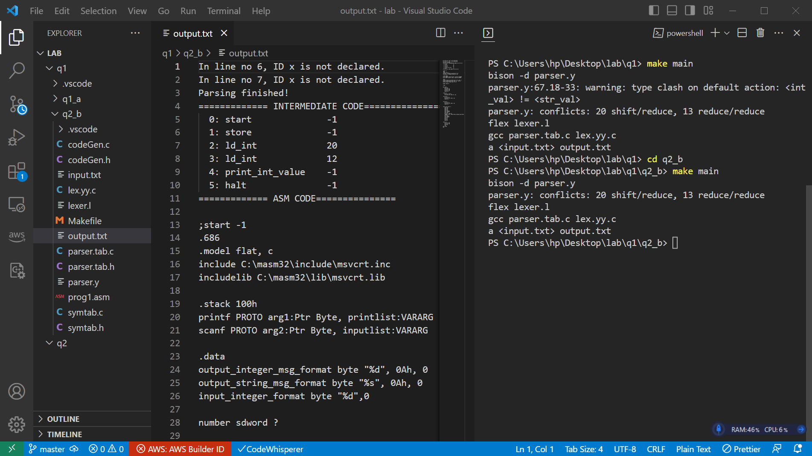

INTERMEDIATE CODE
0: start -1
1: store -1
2: ld_int 20
3: ld_int 12
4: print_int_value -1
5: halt -1

assembly:

;start -1
.686
.model flat, c
include C:\masm32\include\msvcrt.inc
includelib C:\masm32\lib\msvcrt.lib

.stack 100h
printf PROTO arg1:Ptr Byte, printlist:VARARG
scanf PROTO arg2:Ptr Byte, inputlist:VARARG

.data
output_integer_msg_format byte "%d", 0Ah, 0
output_string_msg_format byte "%s", 0Ah, 0
input_integer_format byte "%d",0

number sdword ?

.code

main proc
push ebp
mov ebp, esp
sub ebp, 100
mov ebx, ebp
add ebx, 4

;store -1
mov eax, [ebx-4]
mov dword ptr [ebp--4], eax

;ld_int 20
mov eax, 20
mov dword ptr [ebx], eax
add ebx, 4

;ld_int 12
mov eax, 12
mov dword ptr [ebx], eax
add ebx, 4

;print_int_value -1
push eax
push ebx
push ecx
push edx
push [ebp+4]
push [ebp+8]
push ebp
mov eax, [ebp--4]
INVOKE printf, ADDR output_integer_msg_format, eax
pop ebp
pop [ebp+8]
pop [ebp+4]
pop edx
pop ecx
pop ebx
pop eax

;halt -1
add ebp, 100
mov esp, ebp
pop ebp
ret
main endp
end

