**Jenkins Task**

1). Install Jenkins and run Jenkins on port number 8081.

-Installed Jenkins

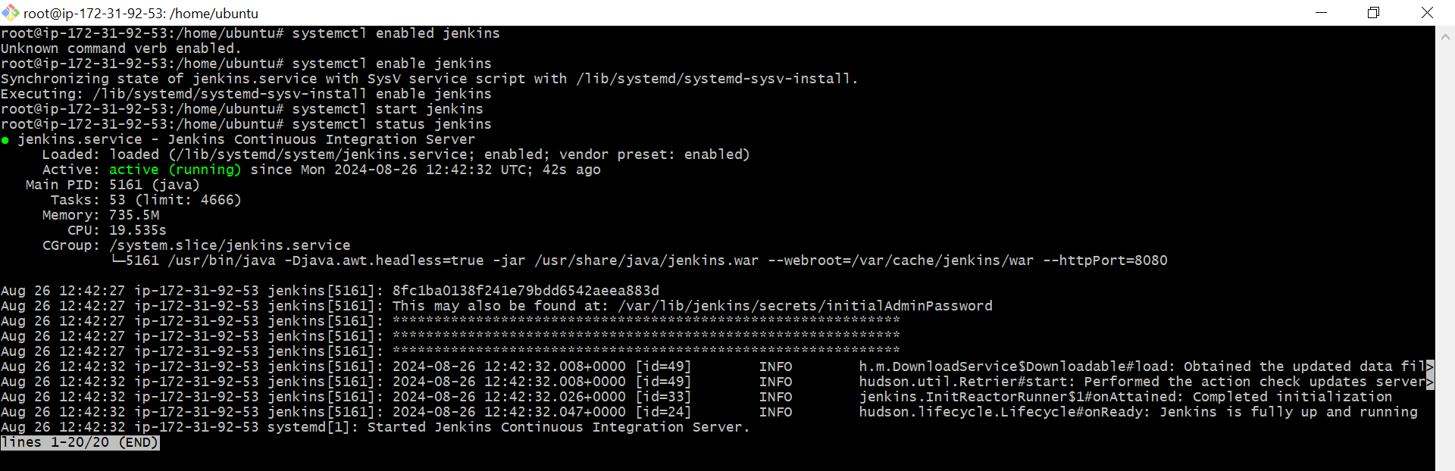

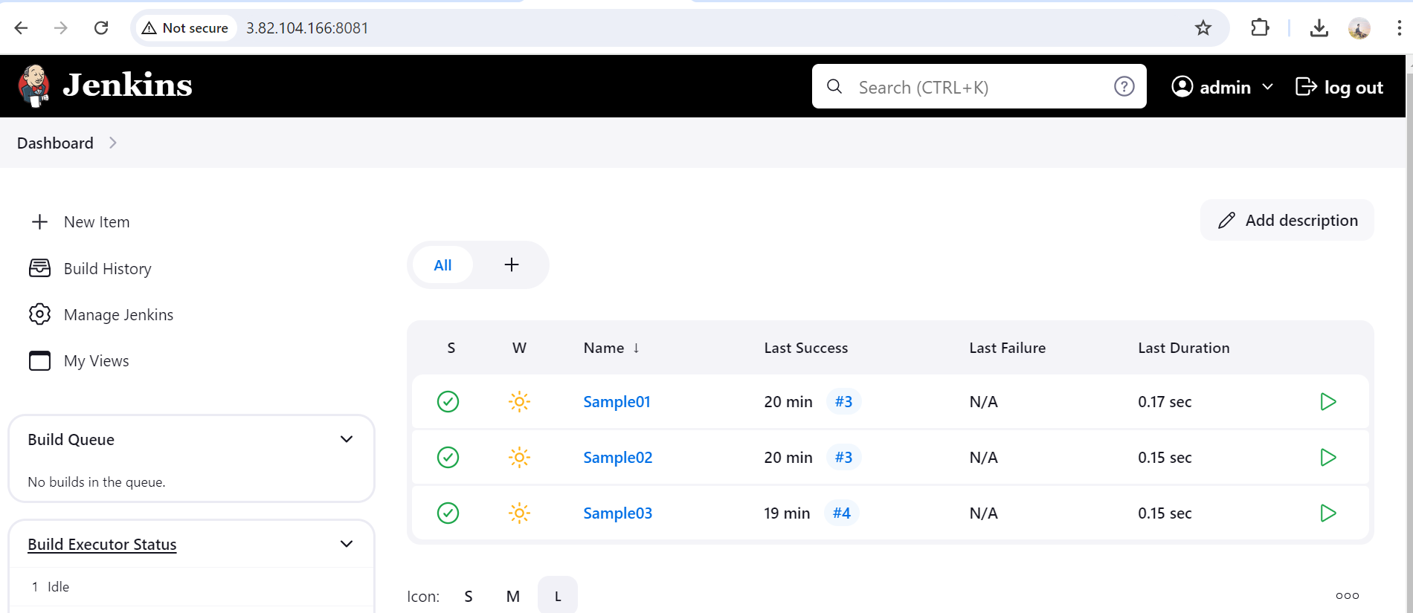

2) Secure Jenkins server

Changed password of admin

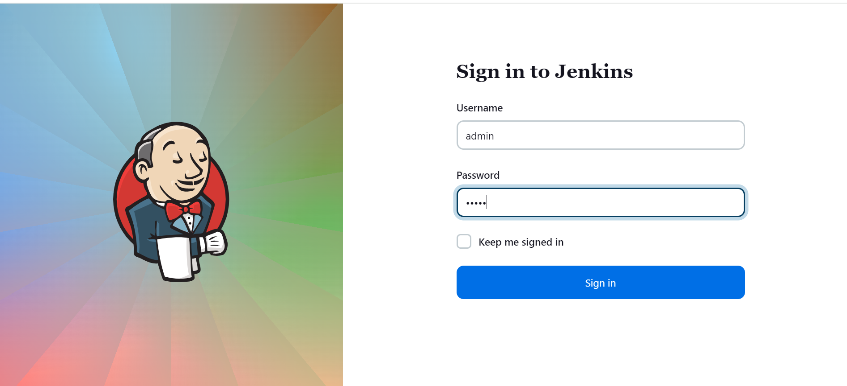

-Deleted initialadminPassword.

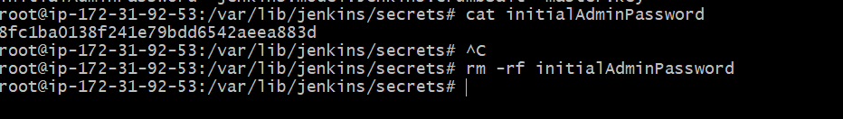

3) Create users called Devops, Testing in Jenkins with Limited access.

-Created two users with Devops and Testing names.

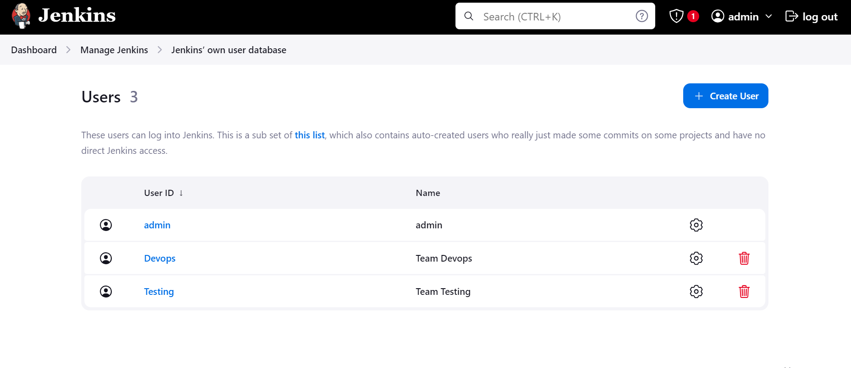

-Installed Role-based Authorization plugin and given different authorization to both user.

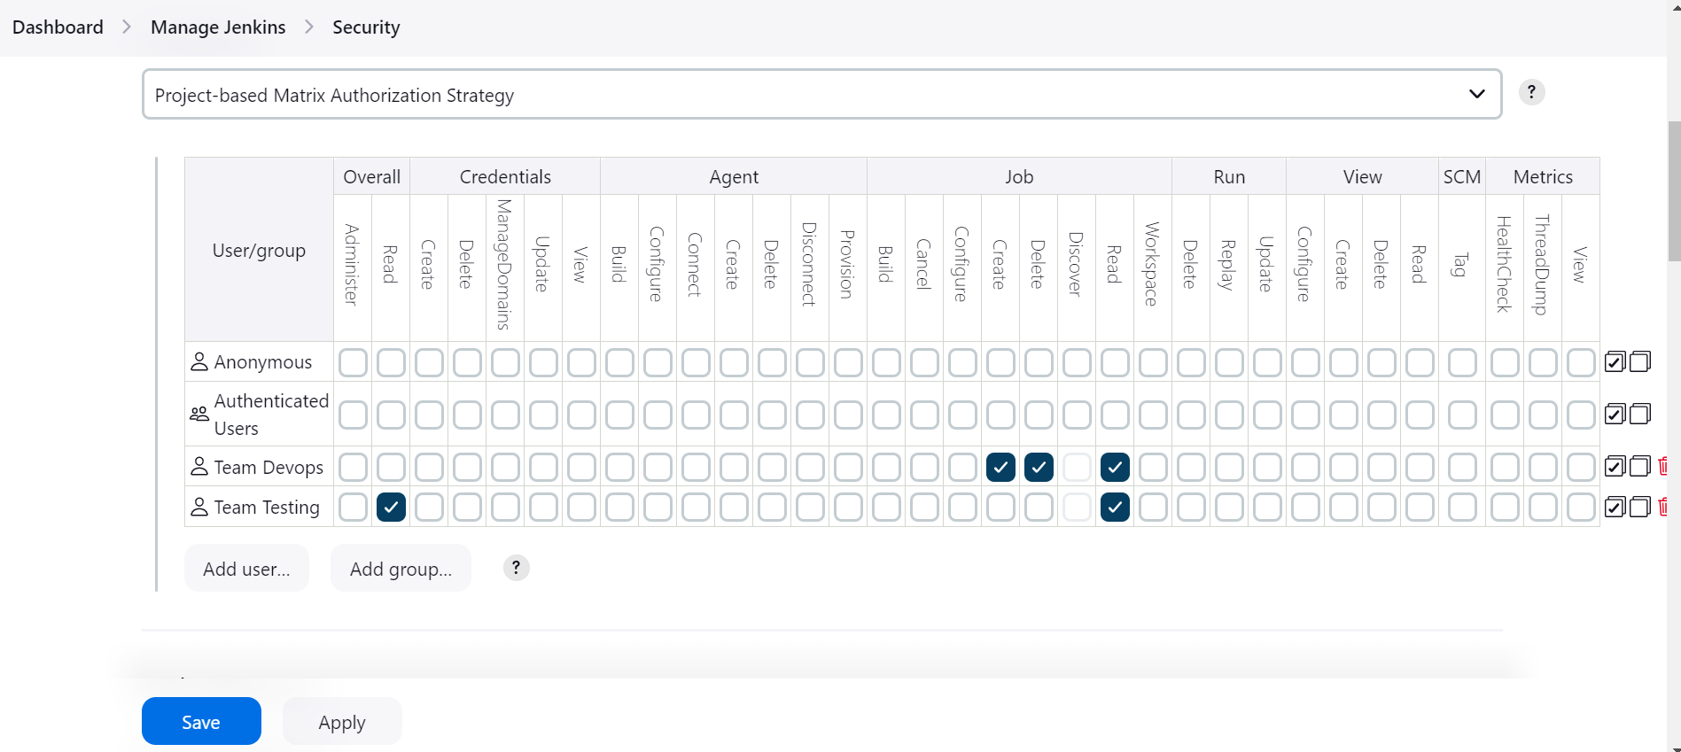

4) Configure labels and restrict the jobs to execute based on label only.

>Created one label called SayyedMohammad and restricted the jobs to execute.

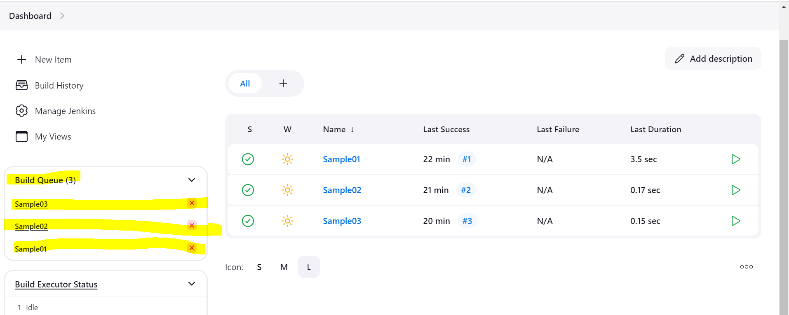

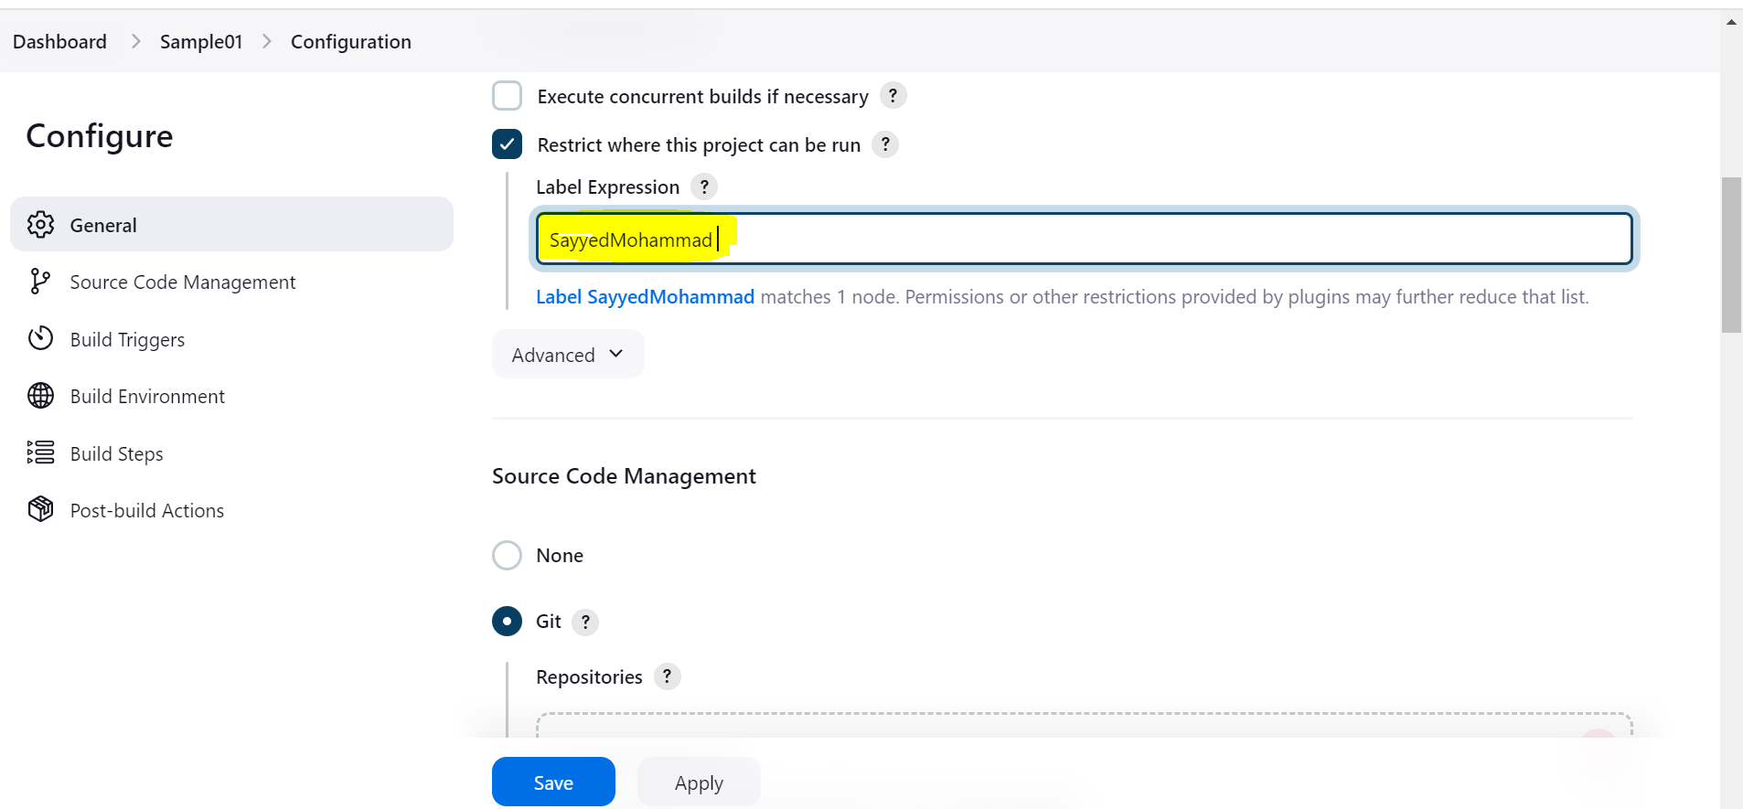

5) Create Three sample jobs using the below URL. <https://github.com/betawins/Techie_horizon_Login_app.git>

Created 3 samples.

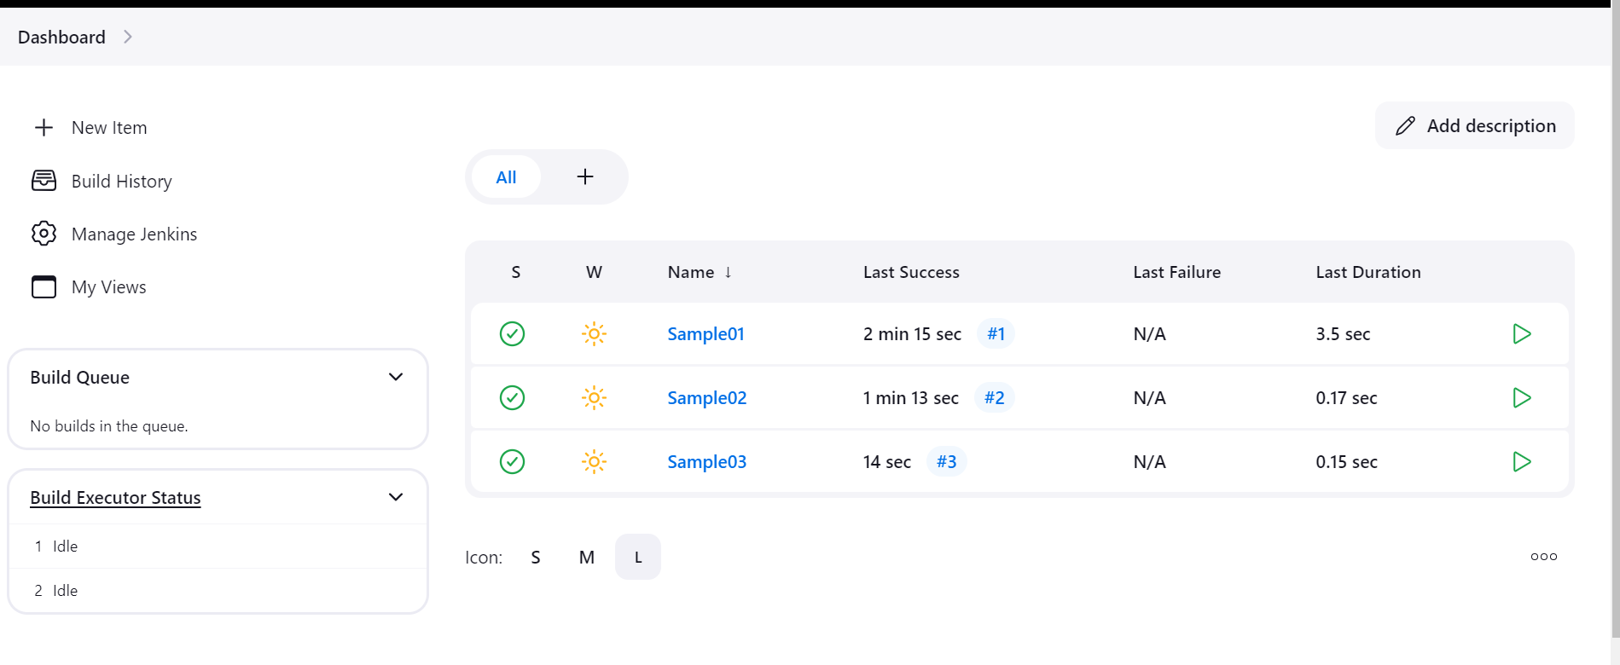

6) Create one Jenkins job using git hub Private repository.

>Created private repository.

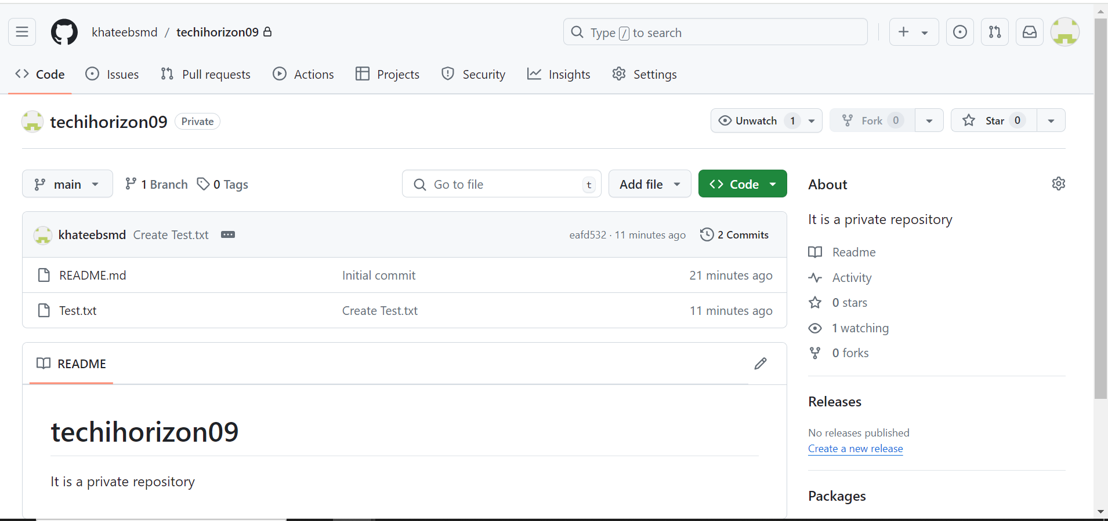

>Created an access token in github

Goto >account >Settings> Developer Settings> Personal Access Token> Tokens(Classic) – Enter general information and create one token and copy the token id.

>Goto Jenkins and create credentials add username as github user name and paste access token in the password and enter any random id and save.

Now you can save it and build.

and added credentials in jenkins.

