1. Configure 2 slave machines in Jenkins master.

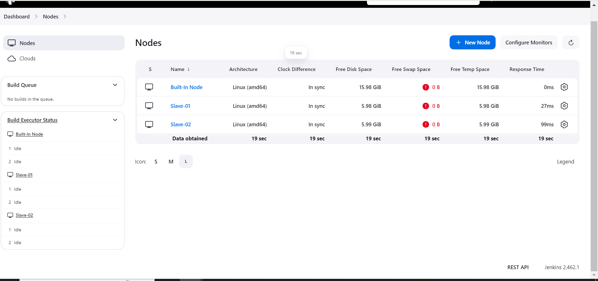

1. Configure webhooks to Jenkins job.

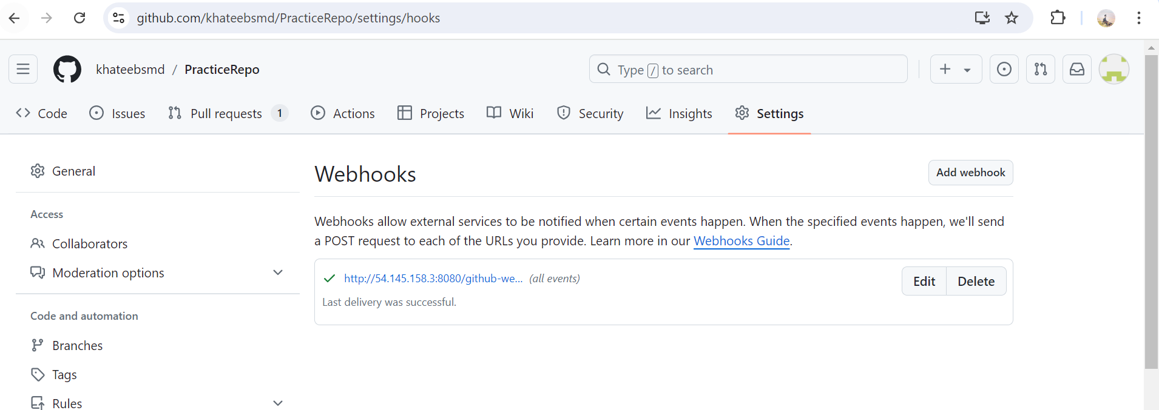

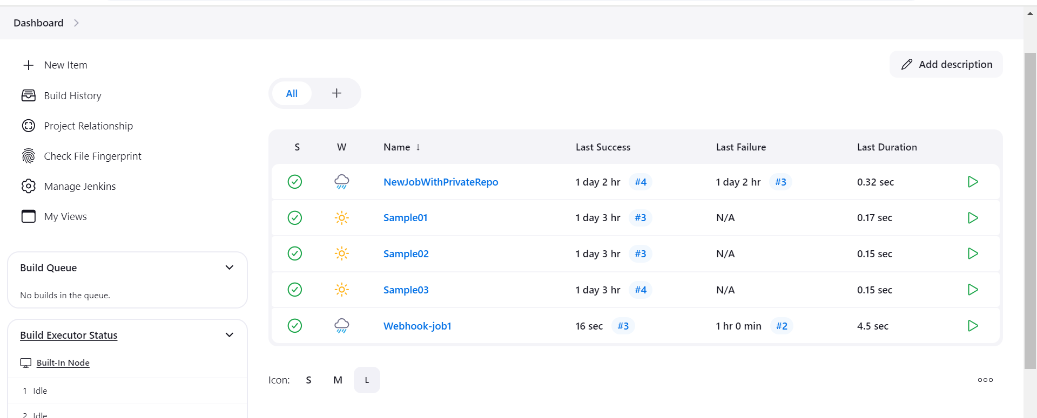

1. Configure poll scm and build periodical options in Jenkins job.

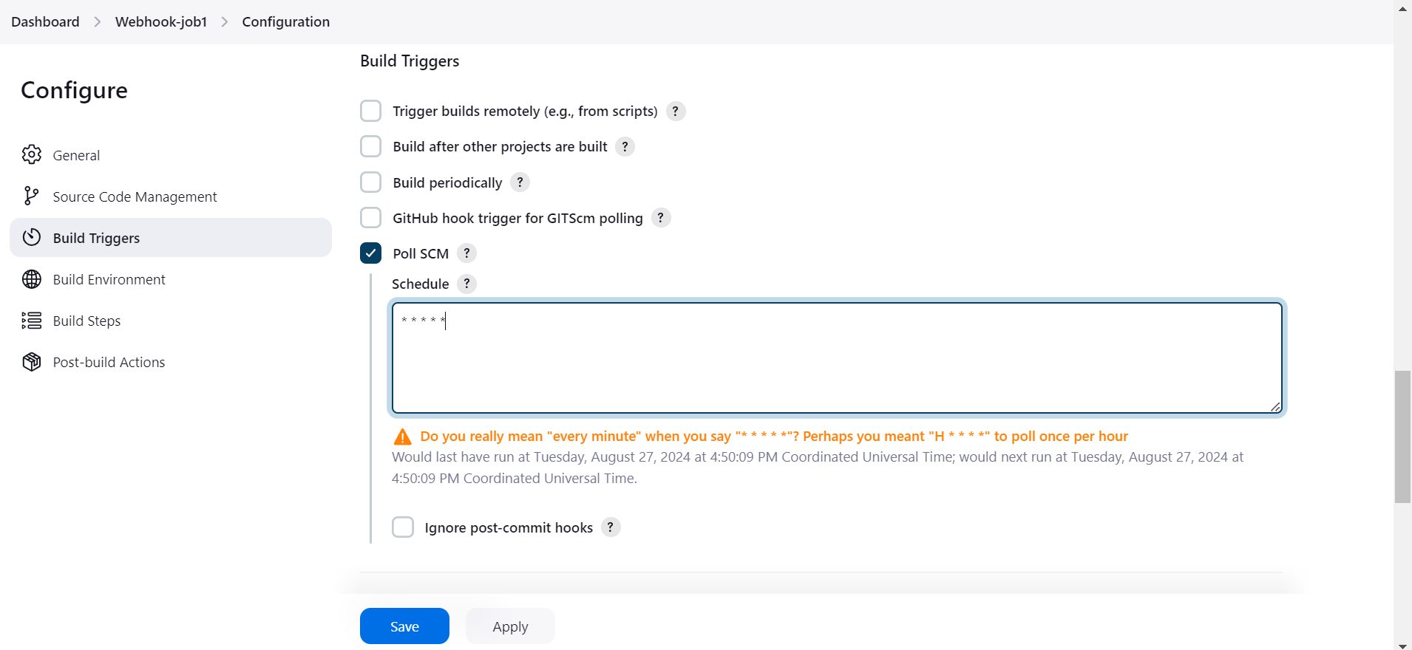

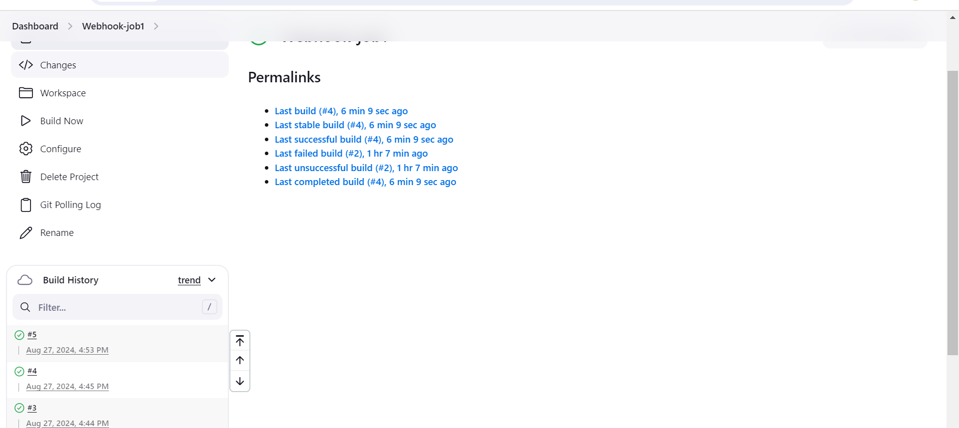

Two commits made in every minutes so two jobs are triggered 4th and 5th one.

1. Take backup of Jenkins server by using bash script.

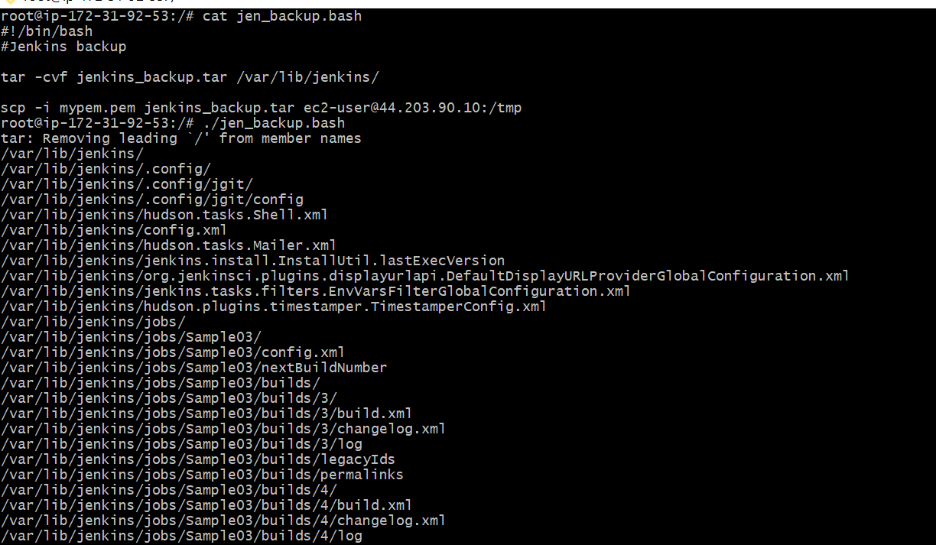

The backup files has been created.

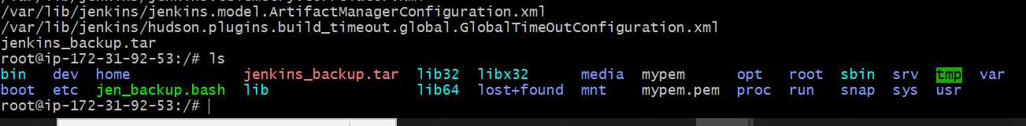

5) Take backup of Jenkins using Thin backup plugin.

6).Setup a new Jenkins server and dump the backup taken in task4.

>Extracted files in /var/lib

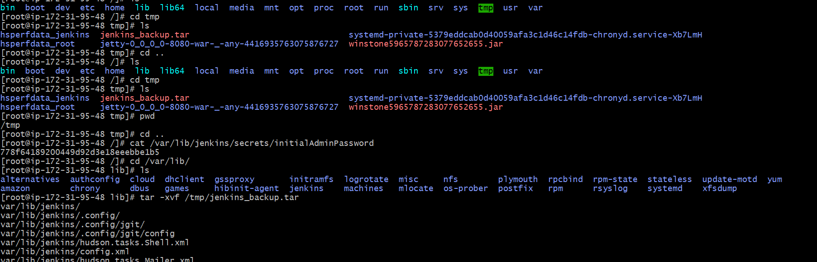

Backup got dumped

