1. Create one jenkins job using the below code and create three stages.

Stage1: Git clone to download the source code.

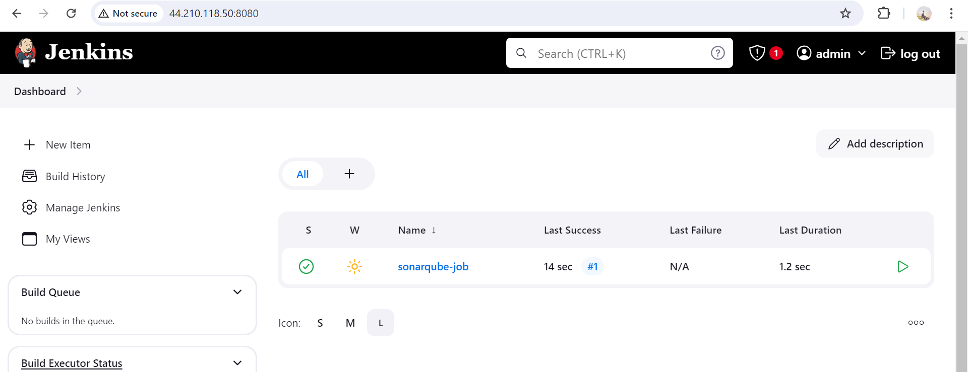

Stage2: Sonarqube Integration to check the quality of code

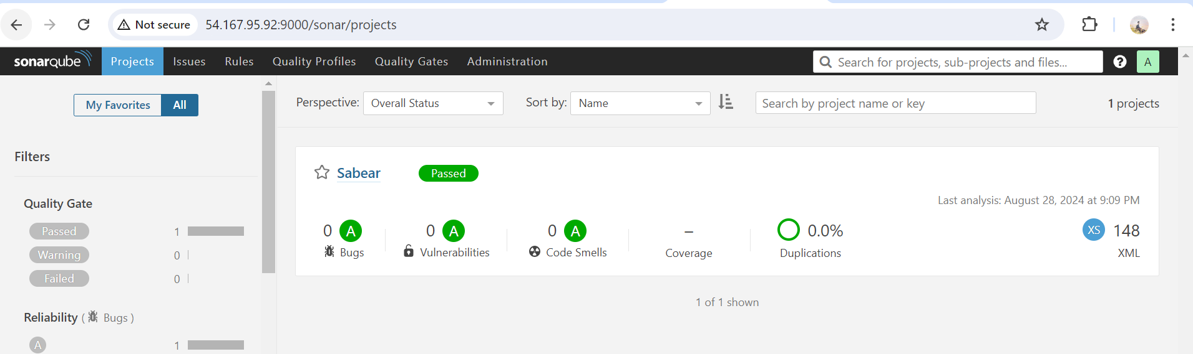

Stage3:

Slack Integration to send the alerts to slack. URL: <https://github.com/betawins/VProfile-1.git>

-Configured Slack Channel

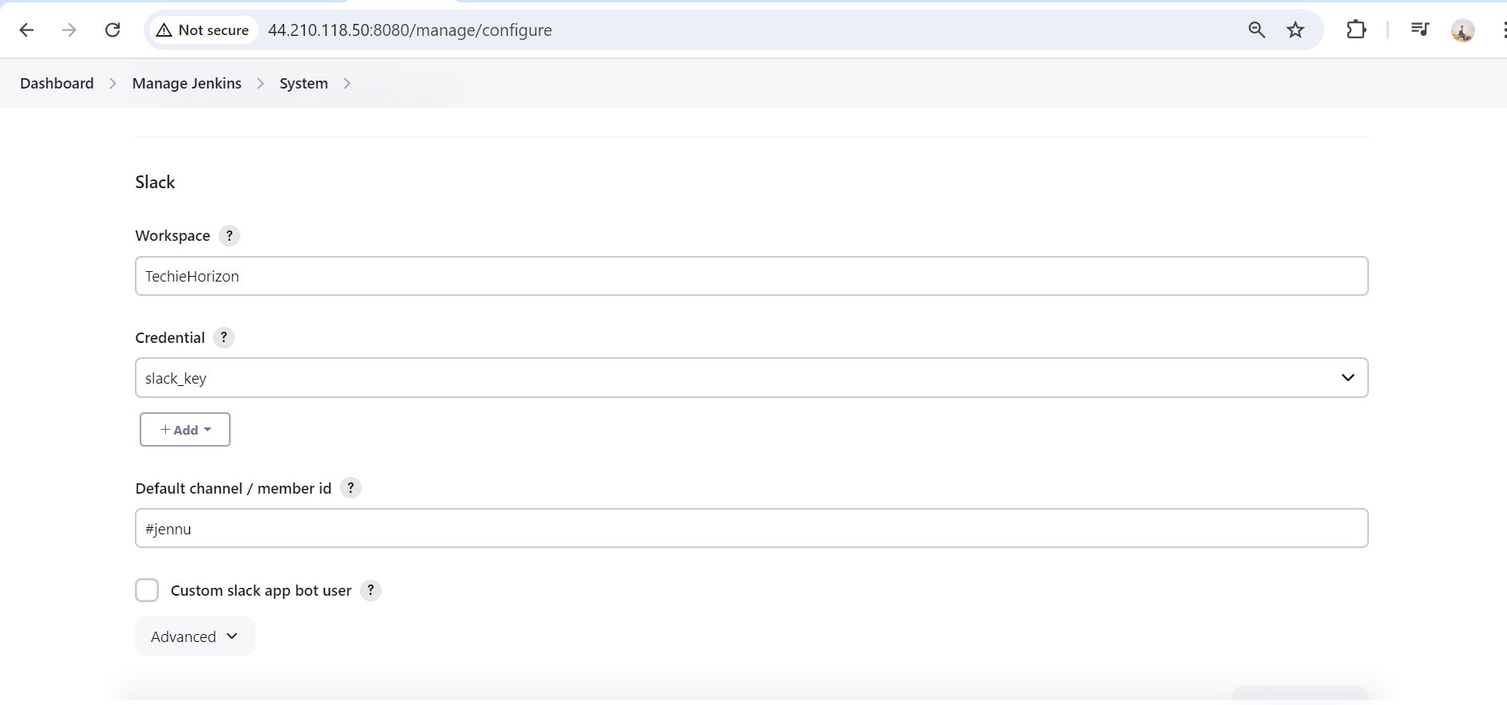

Added post build actions

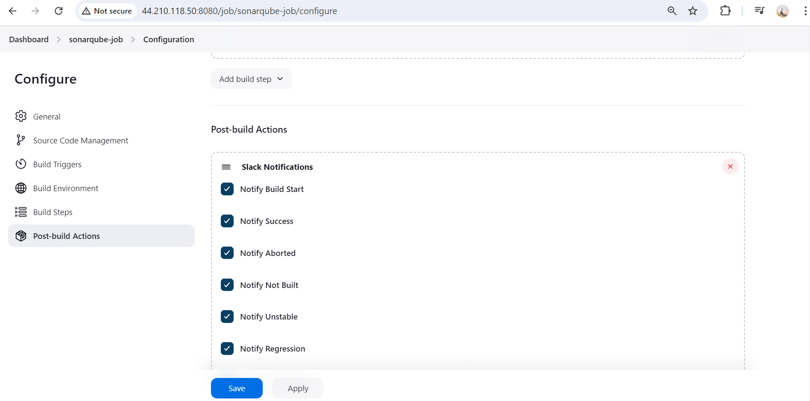

Executed build

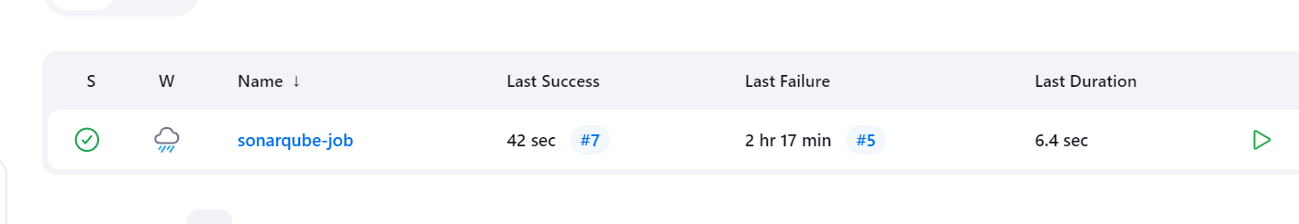

Got notified

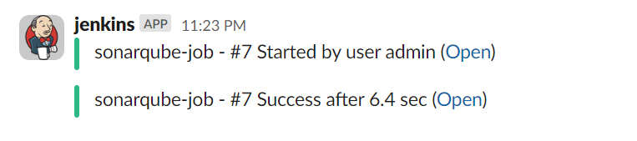

2). 1) Create one jenkins job using the below code and create three stages

Created new job with below link.

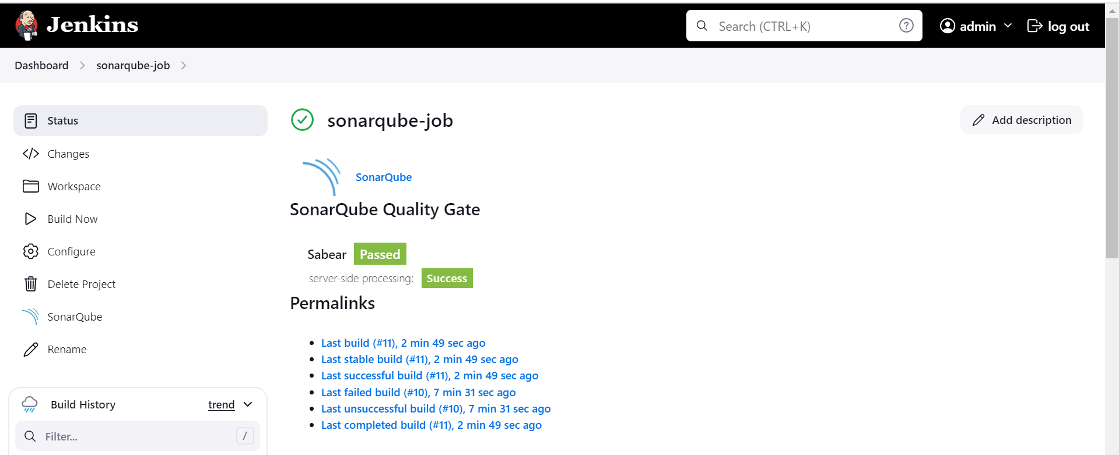

Stage1: Git clone to download the source code.

Downloaded code using below url

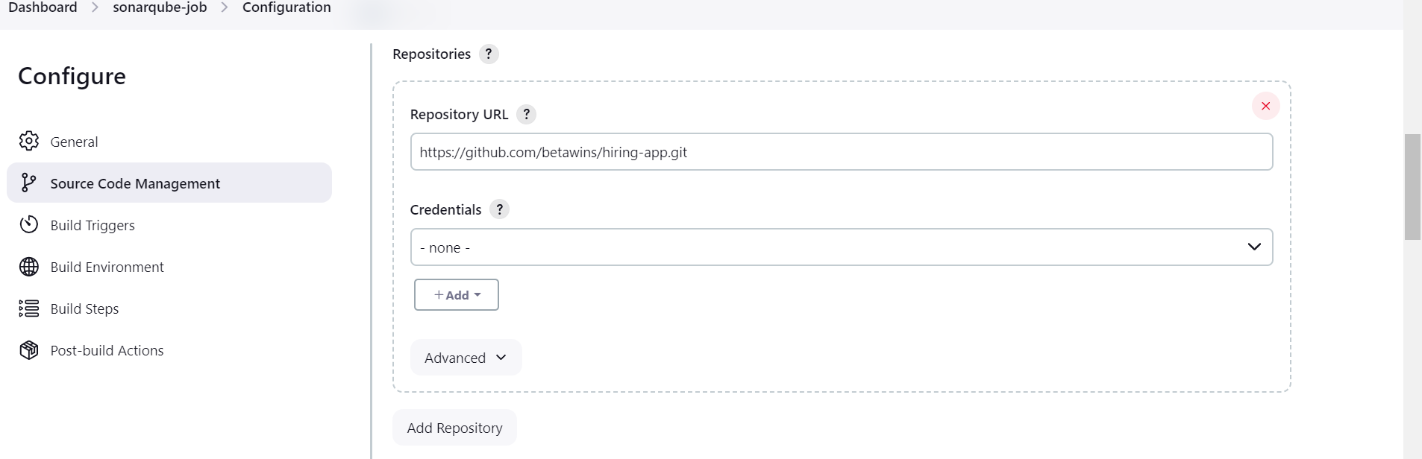

Stage2: Sonarqube Integration to check the quality of code.

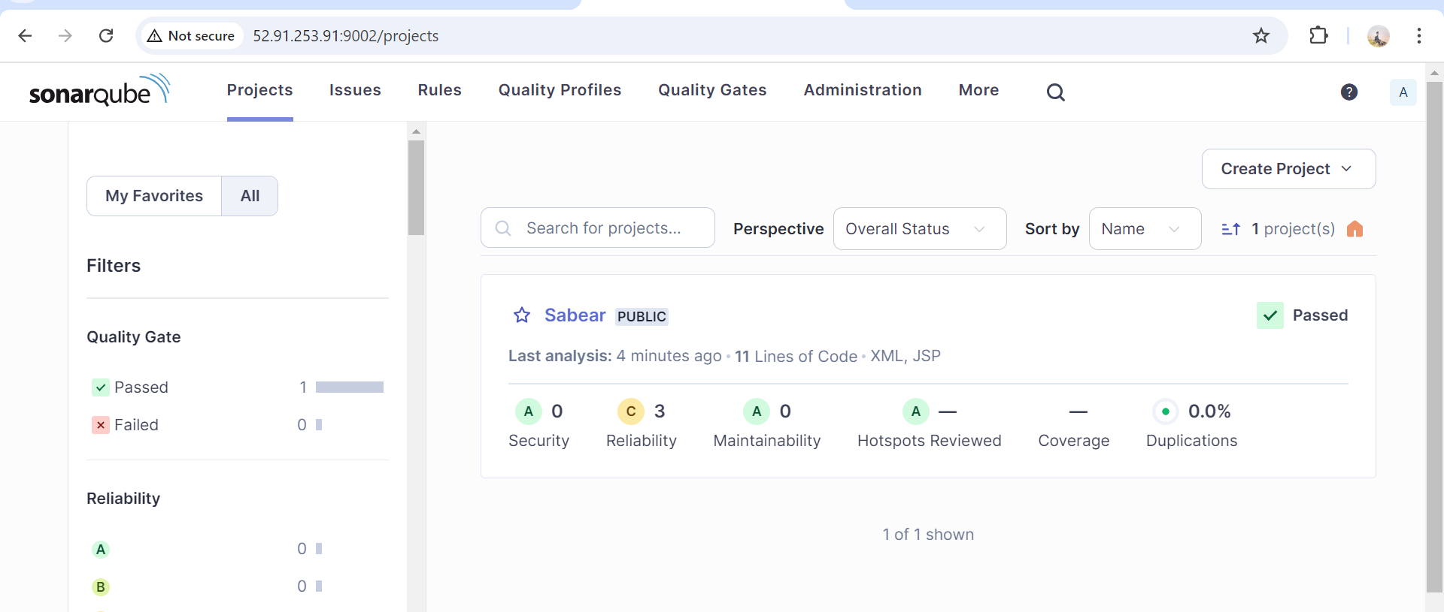

Stage3: Slack Integration to send the alerts to slack. URL: <https://github.com/betawins/hiring-app.git>

