1) Setup jenkins CICD pipeline using freestyle job using below code.

<https://github.com/betawins/hiring-app.git>

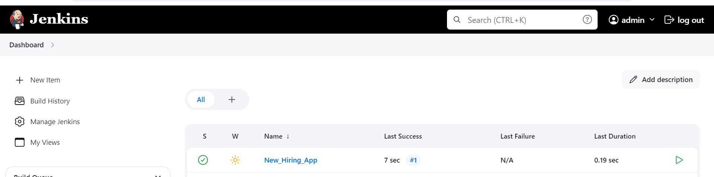

1. Git Clone

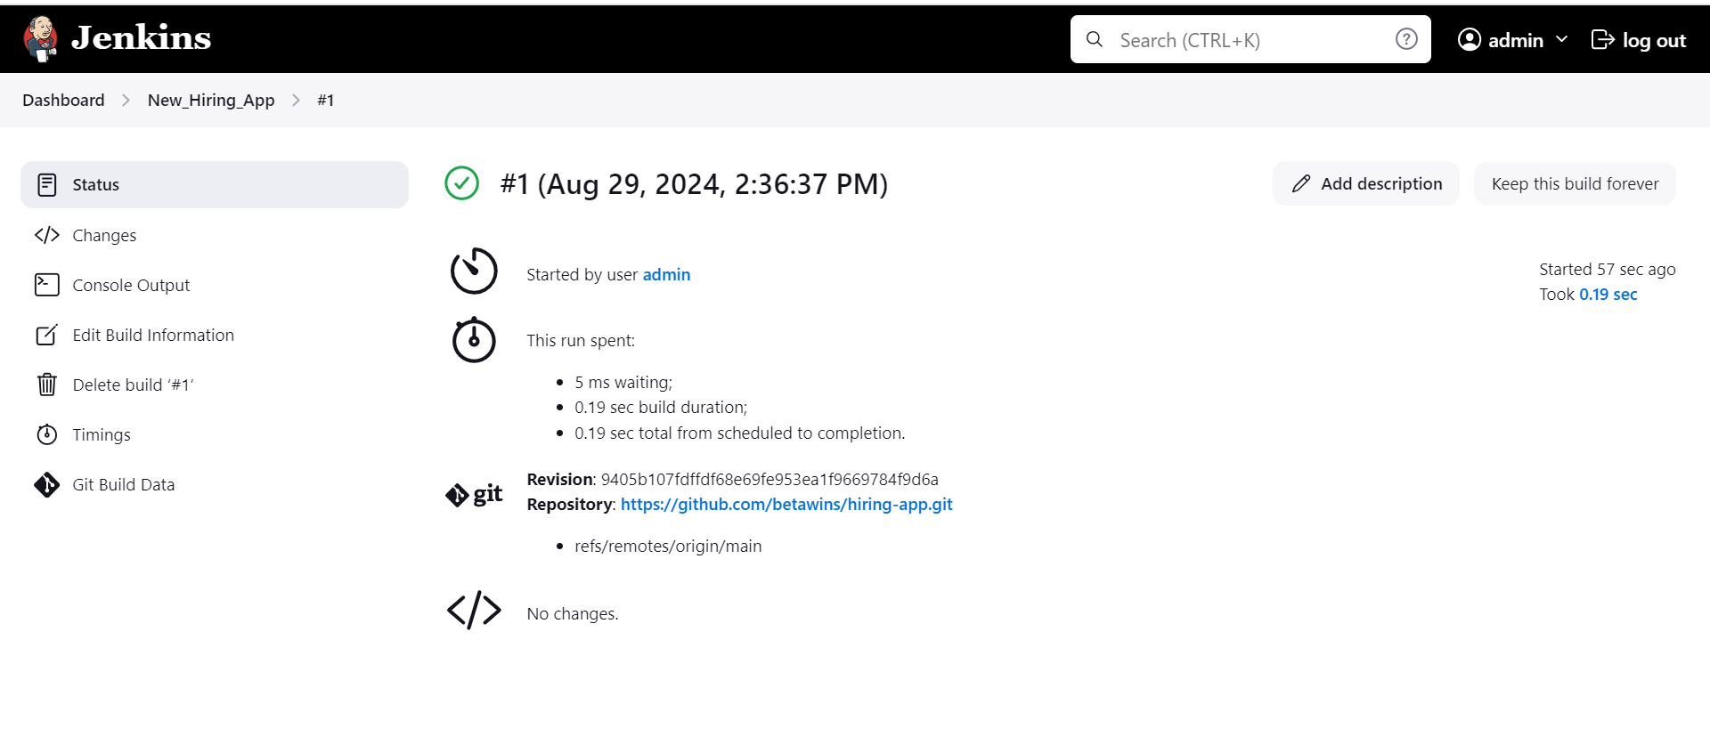

1. Sonarqube Integration

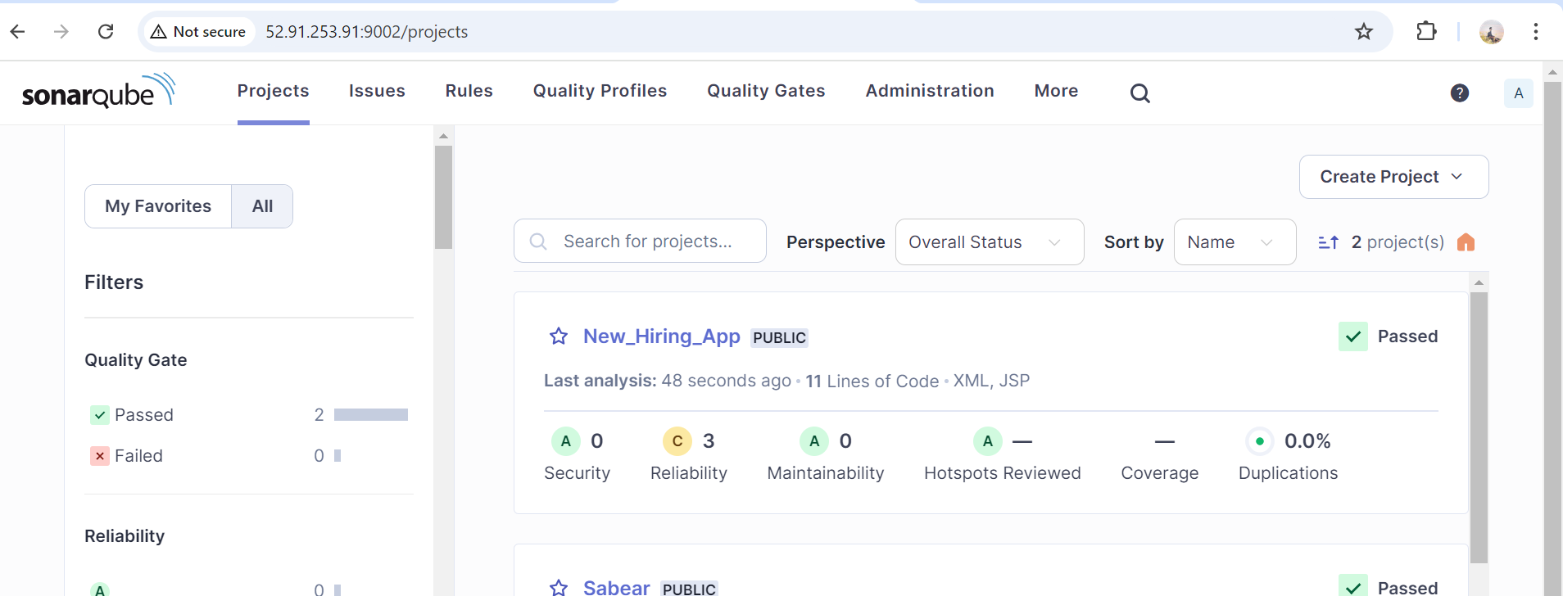

1. Maven Compilation

Added maven and you can see the .war file has been created in the target folder.

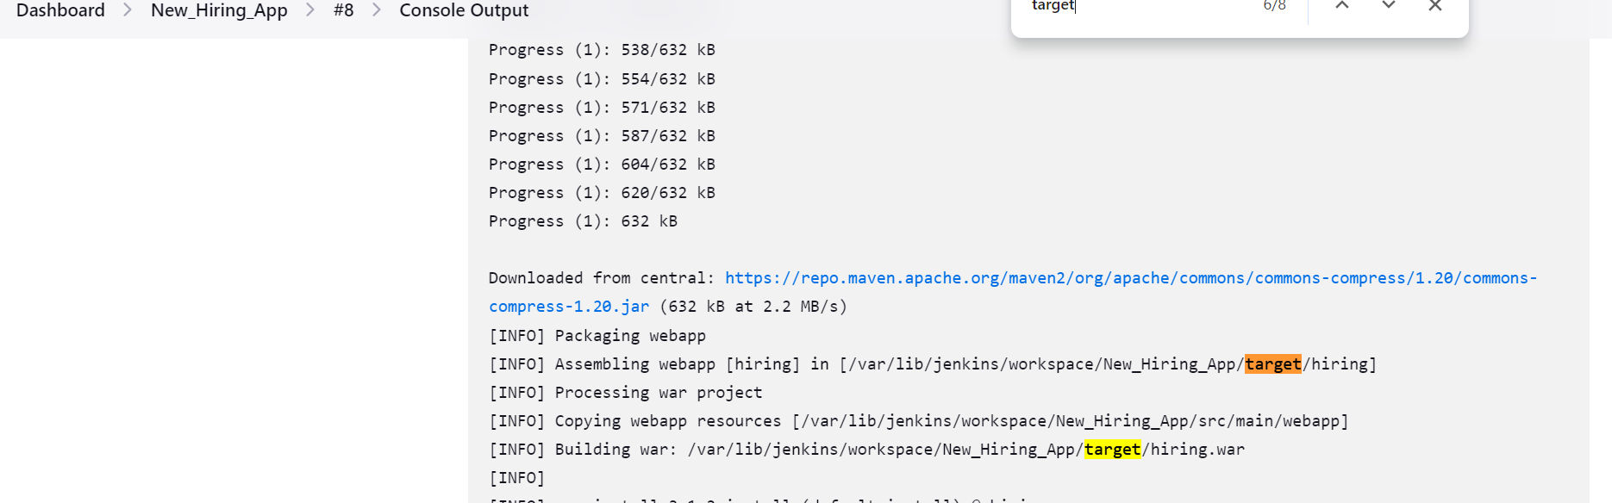

1. Nexus Artifactory

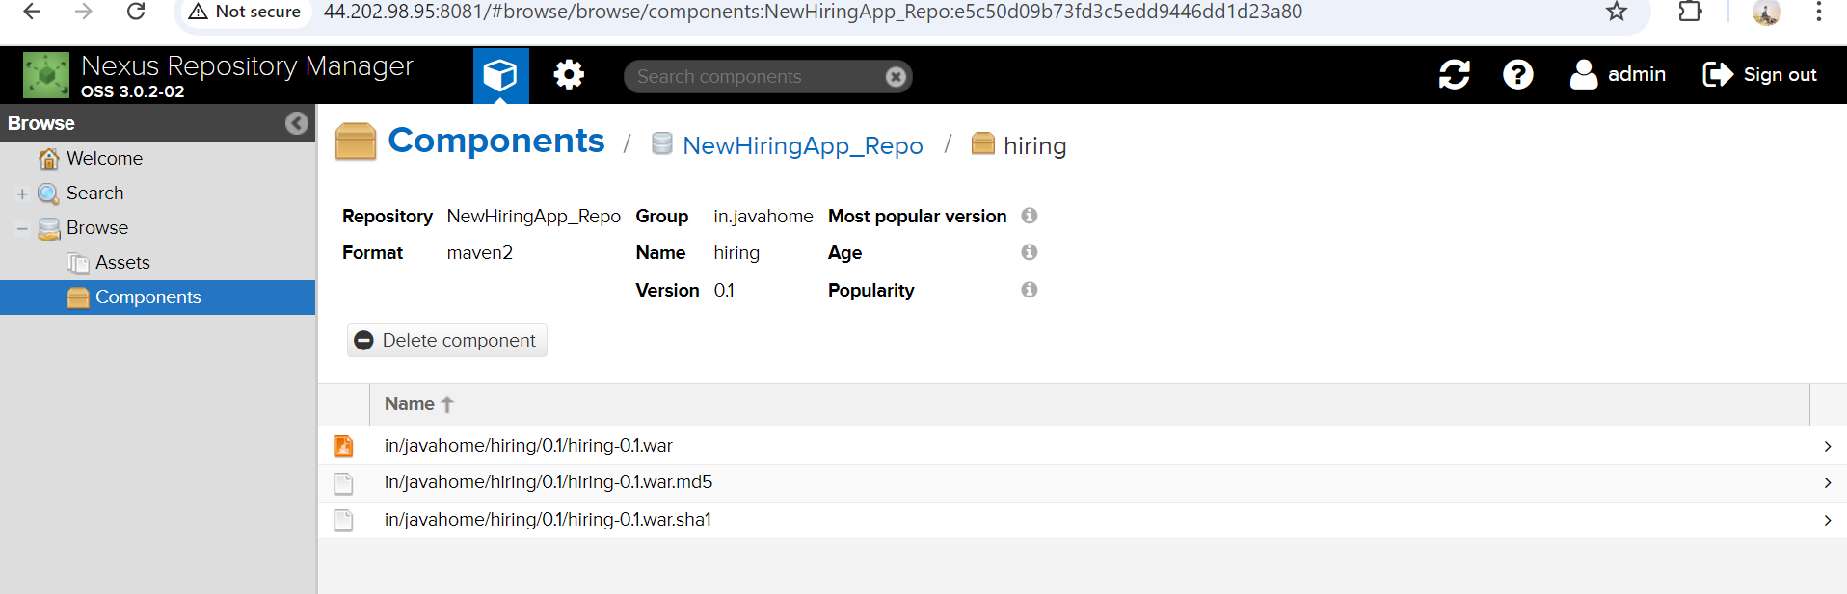

5) Slack Notification

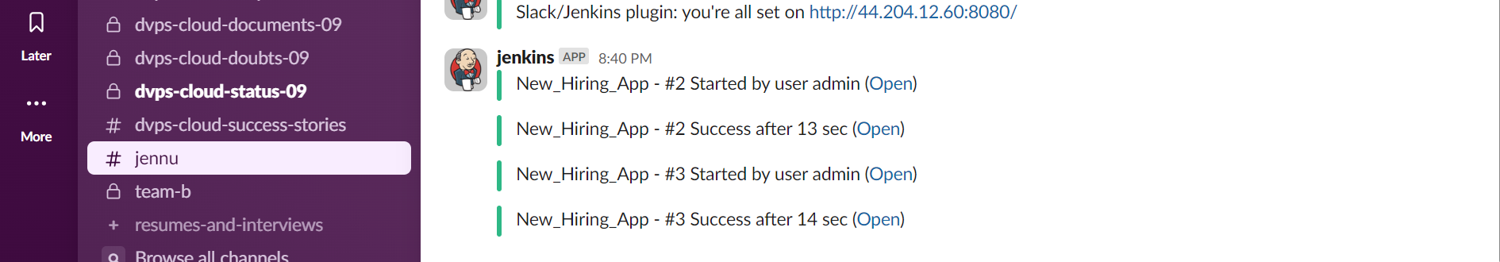

1. Deploy On tomcat

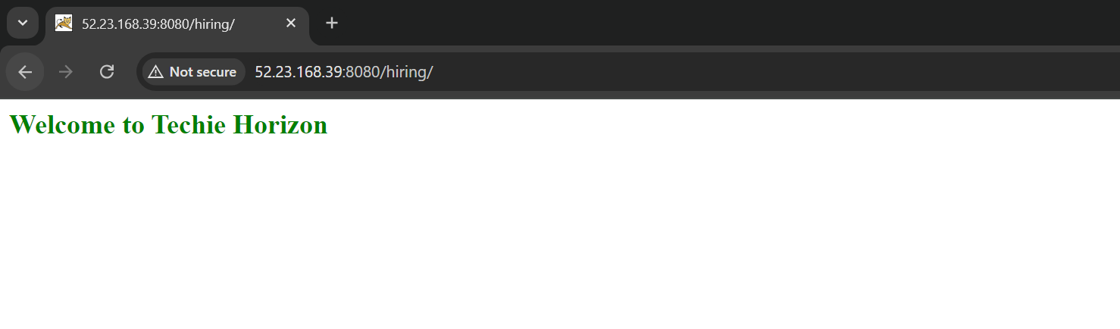

2) Setup jenkins job using freestyle job using below code.

<https://github.com/betawins/Techie_horizon_Login_app.git>

Stages:

1. Git Clone

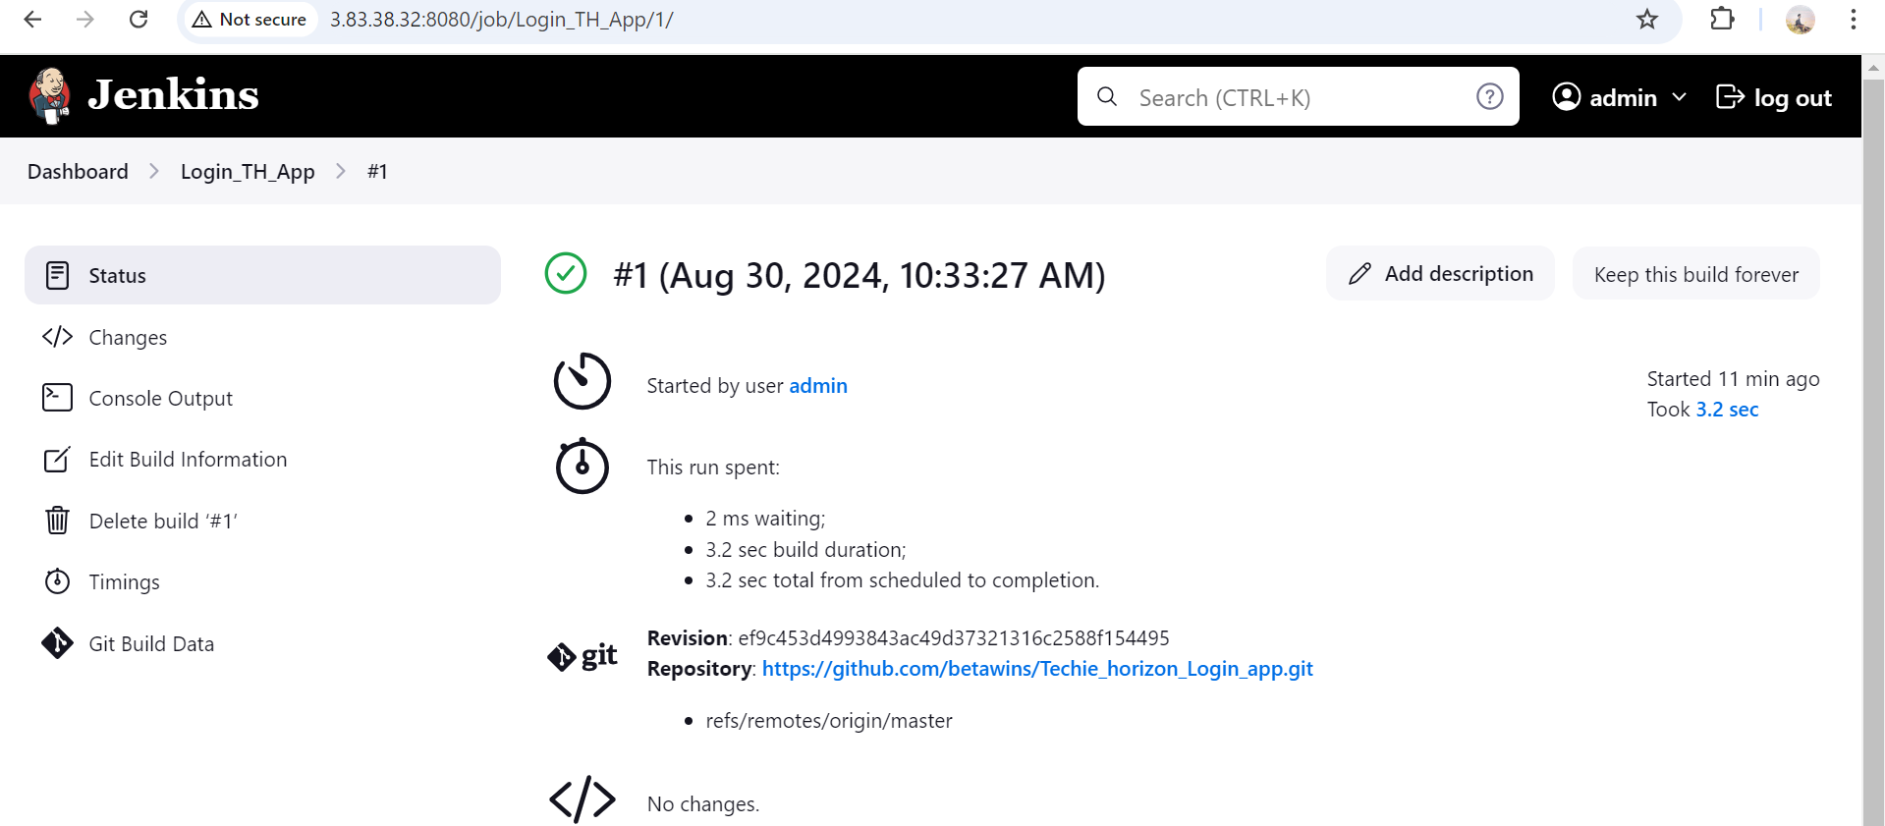

1. Sonarqube Integration

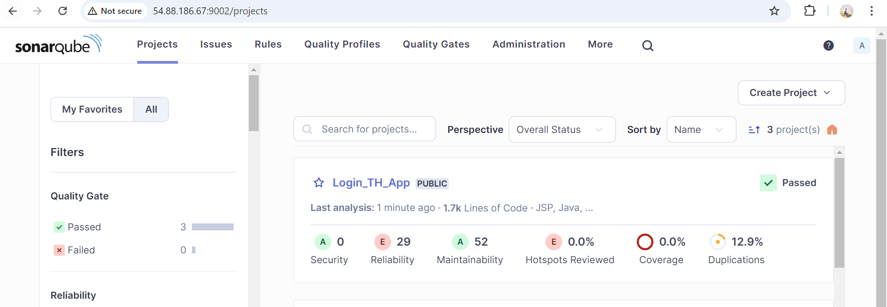

1. Maven Compilation

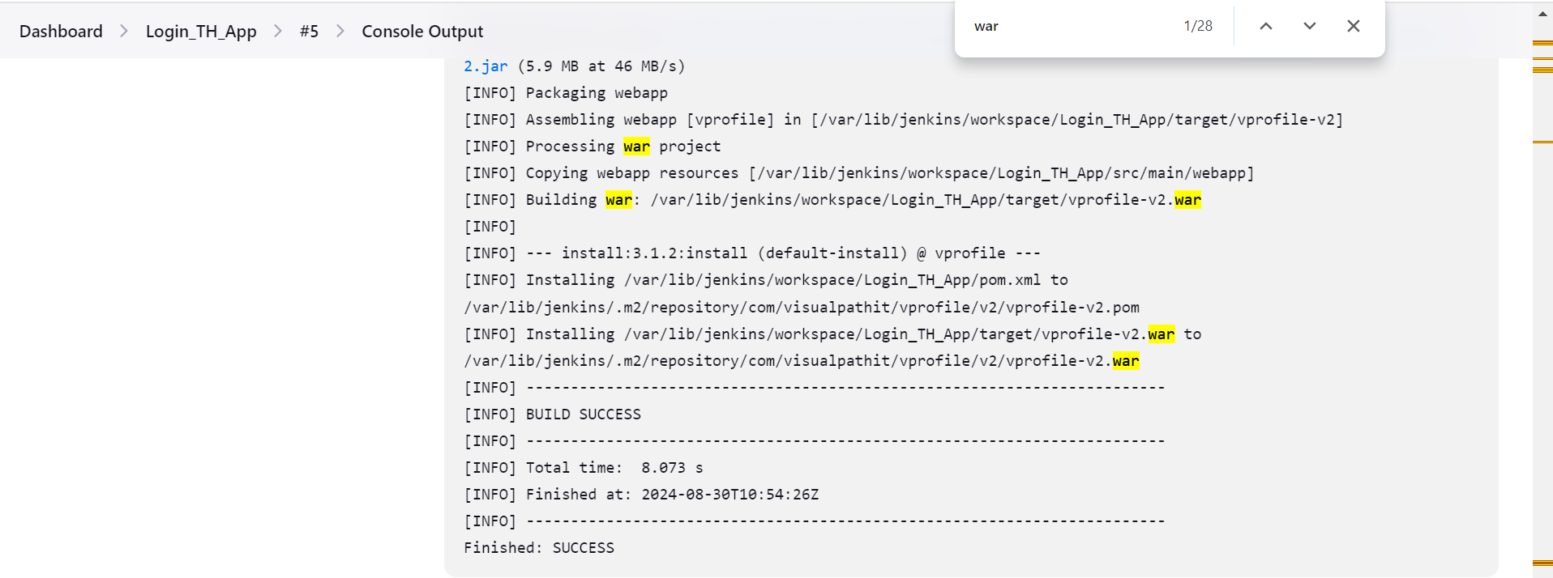

1. Nexus Artifactory

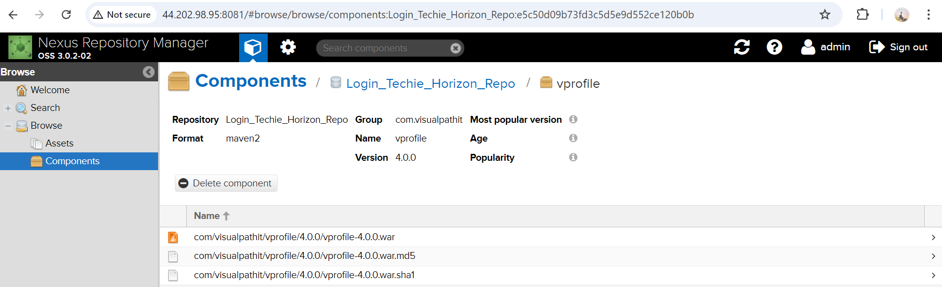

1. Slack Notification

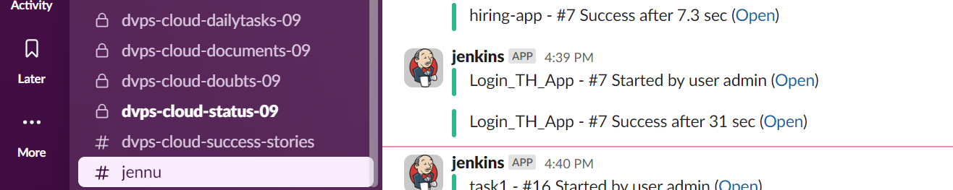

1. Deploy On tomcat

