1. Install Terraform on your PC

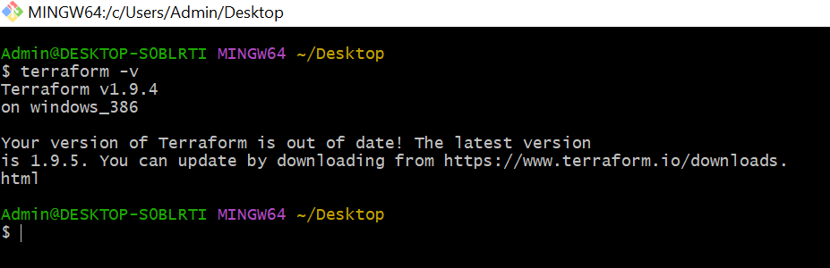

1. Execute all the templates shown in video.

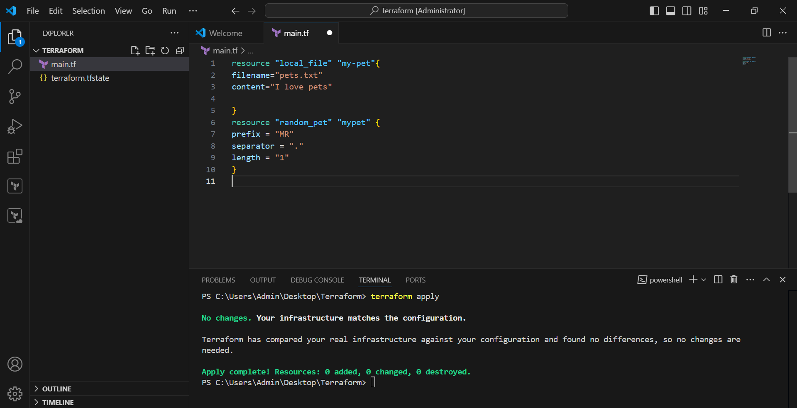

1. Note down below points, Terraform Init Terraform Plan Terraform Apply Terraform Provider.

>>Written these points in the notebook.

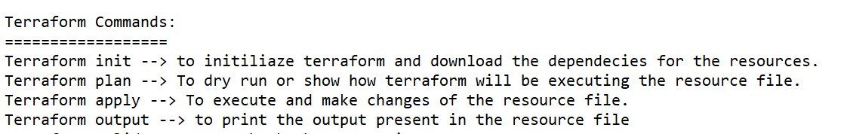

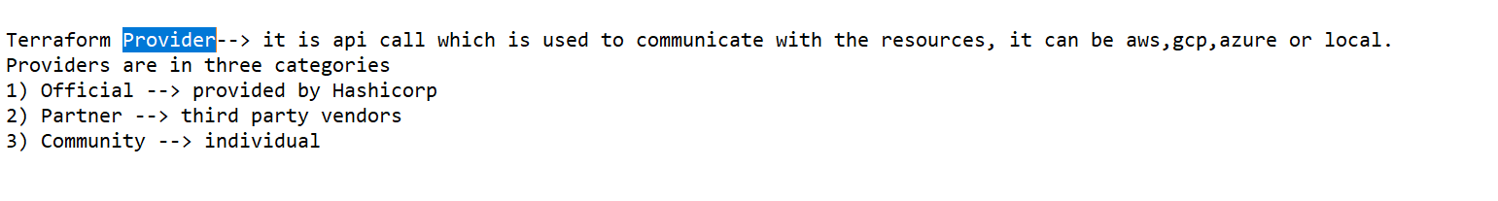

1. Integrate a sample Terraform template in jenkins.