1) Watch the terraform-02 video.

>>Watched video and prepared notes.

2) Execute all the templates shown in video.

>Created to variables and used.

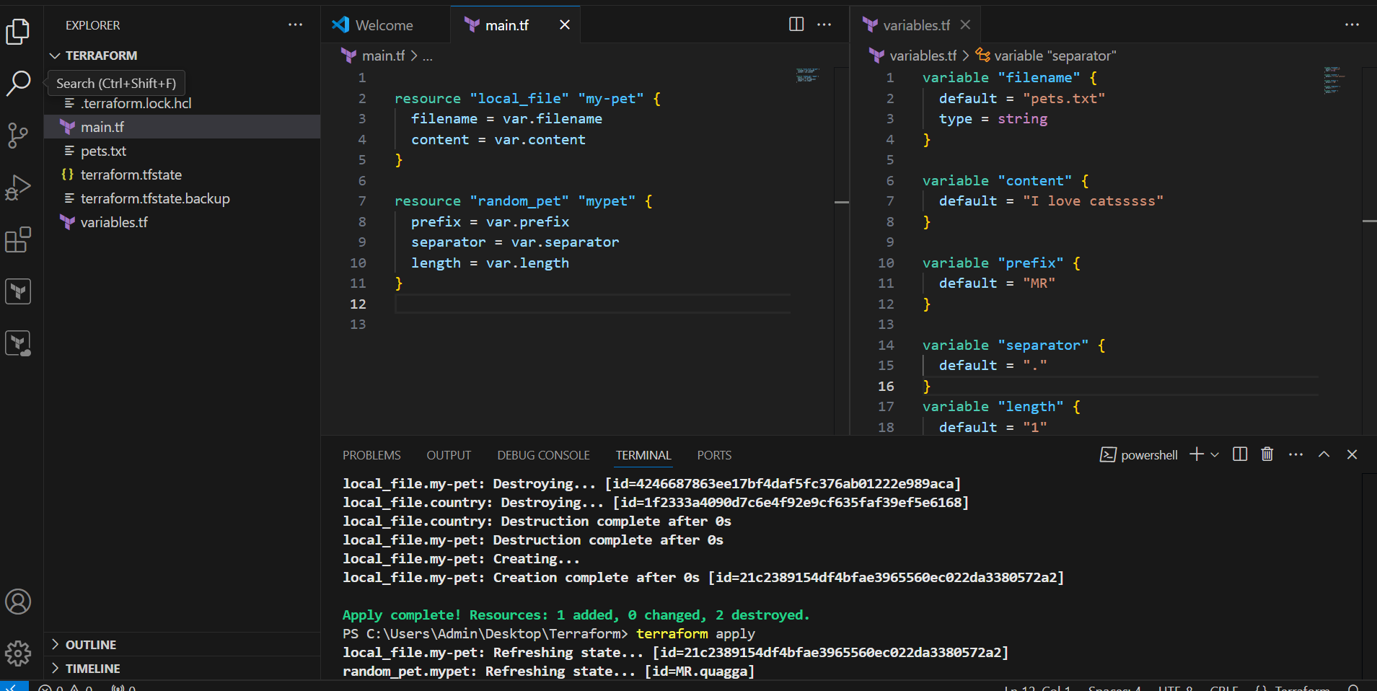

Created two empty variables and passed value at runtime.

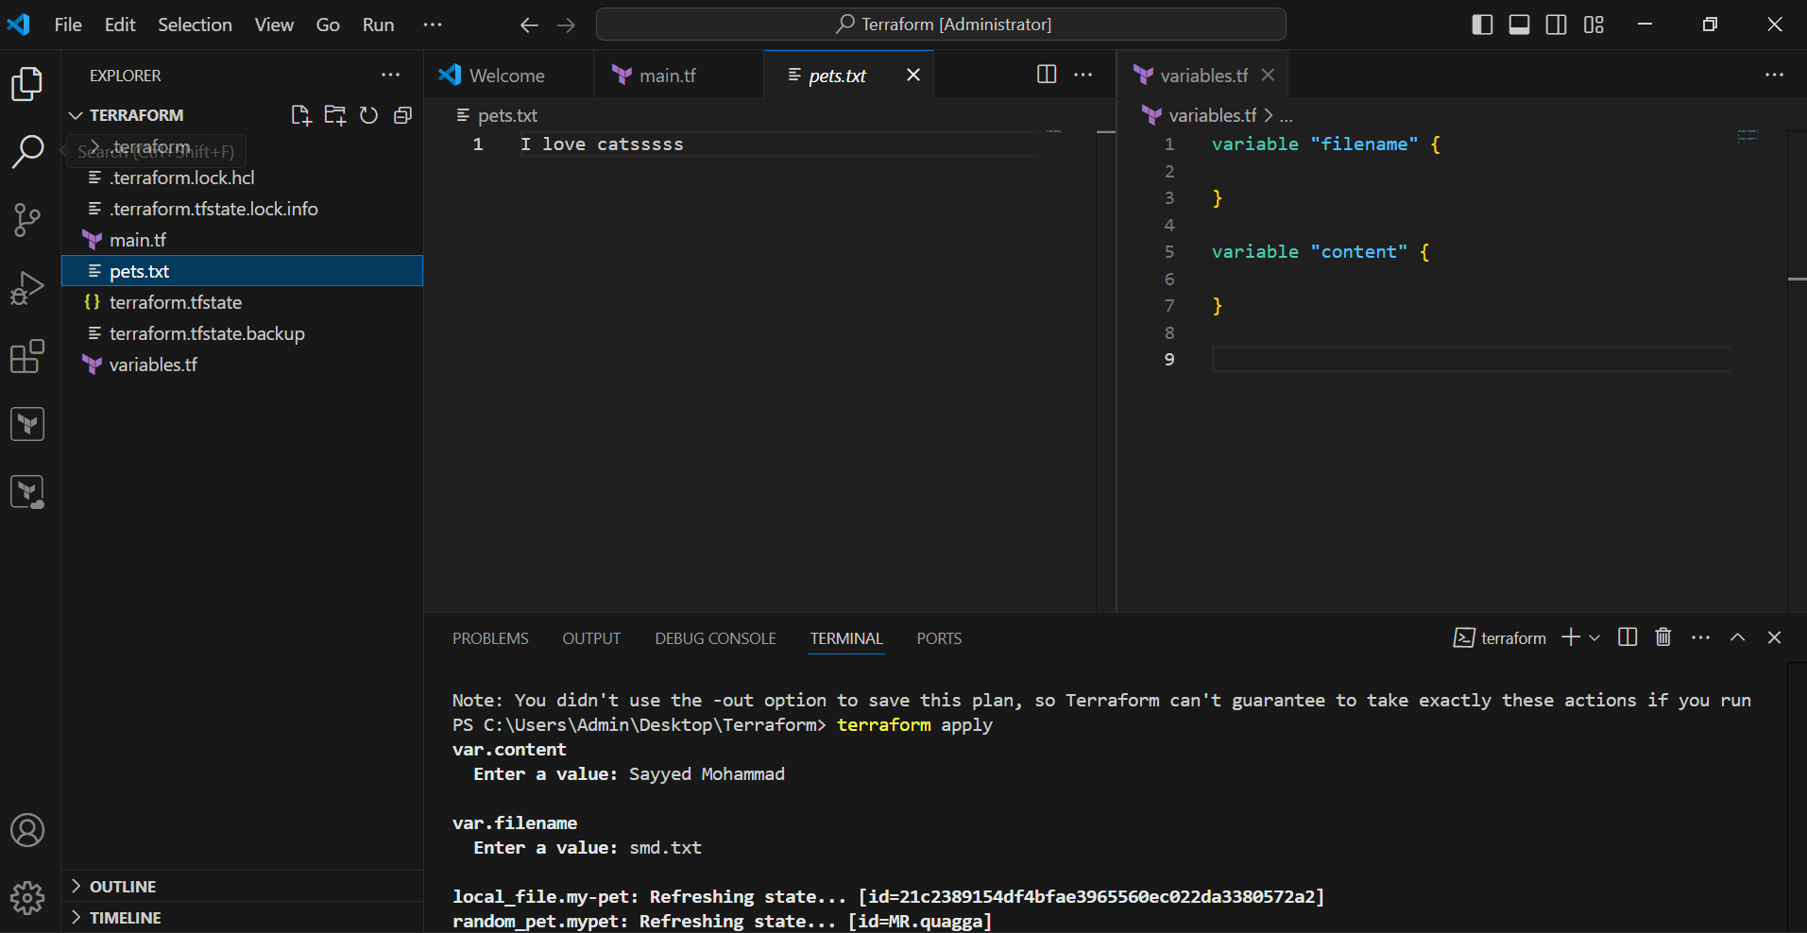

>>Manually passed value at runtime.

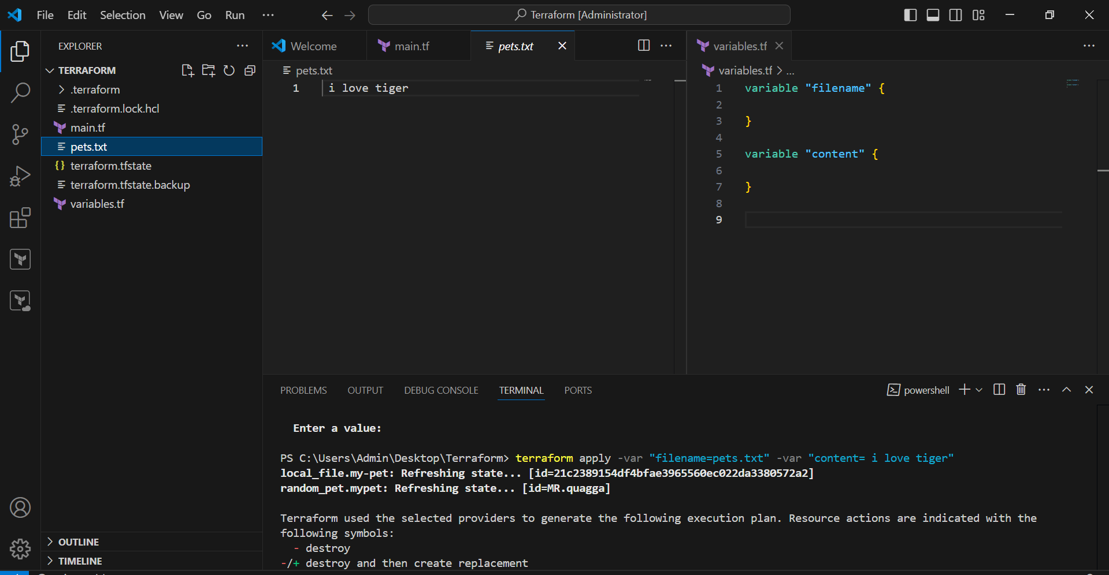

3) Integrate terraform in jenkins using Terraform plugin.