WEEK-2
1. Given an integer array nums and an integer val, remove all occurrences of val in nums in-place. The order of the elements may be changed. Then return the number of elements in nums which are not equal to val.
Consider the number of elements in nums which are not equal to val be k, to get accepted, you need to do the following things:
- Change the array nums such that the first k elements of nums contain the elements which are not equal to val. The remaining elements of nums are not important as well as the size of nums.
- Return k.
Custom Judge:
The judge will test your solution with the following code:
int[] nums = [...]; // Input array
int val = ...; // Value to remove
int[] expectedNums = [...]; // The expected answer with correct length.
// It is sorted with no values equaling val.

int k = removeElement(nums, val); // Calls your implementation

assert k == expectedNums.length;
sort(nums, 0, k); // Sort the first k elements of nums
for (int i = 0; i < actualLength; i++) {
assert nums[i] == expectedNums[i];
}
If all assertions pass, then your solution will be accepted.

Example 1:
Input: nums = [3,2,2,3], val = 3
Output: 2, nums = [2,2,_,_]
Explanation: Your function should return k = 2, with the first two elements of nums being 2.
It does not matter what you leave beyond the returned k (hence they are underscores).
Example 2:
Input: nums = [0,1,2,2,3,0,4,2], val = 2
Output: 5, nums = [0,1,4,0,3,_,_,_]
Explanation: Your function should return k = 5, with the first five elements of nums containing 0, 0, 1, 3, and 4.
Note that the five elements can be returned in any order.
It does not matter what you leave beyond the returned k (hence they are underscores).

Constraints:
- 0 <= nums.length <= 100
- 0 <= nums[i] <= 50
- 0 <= val <= 100
CODE:
class Solution {
public int removeElement(int[] nums, int val) {
int k=0;
for(int i=0;i<nums.length;i++){
if(nums[i]!=val){
nums[k]=nums[i];
k++;
}
}
return k;

}
}
2. Given an integer array nums sorted in non-decreasing order, remove the duplicates in-place such that each unique element appears only once. The relative order of the elements should be kept the same.
Consider the number of unique elements in nums to be k​​​​​​​​​​​​​​. After removing duplicates, return the number of unique elements k.
The first k elements of nums should contain the unique numbers in sorted order. The remaining elements beyond index k - 1 can be ignored.
Custom Judge:
The judge will test your solution with the following code:
int[] nums = [...]; // Input array
int[] expectedNums = [...]; // The expected answer with correct length

int k = removeDuplicates(nums); // Calls your implementation

assert k == expectedNums.length;
for (int i = 0; i < k; i++) {
assert nums[i] == expectedNums[i];
}
If all assertions pass, then your solution will be accepted.

Example 1:
Input: nums = [1,1,2]
Output: 2, nums = [1,2,_]
Explanation: Your function should return k = 2, with the first two elements of nums being 1 and 2 respectively.
It does not matter what you leave beyond the returned k (hence they are underscores).
Example 2:
Input: nums = [0,0,1,1,1,2,2,3,3,4]
Output: 5, nums = [0,1,2,3,4,_,_,_,_,_]
Explanation: Your function should return k = 5, with the first five elements of nums being 0, 1, 2, 3, and 4 respectively.
It does not matter what you leave beyond the returned k (hence they are underscores).
Constraints:
- 1 <= nums.length <= 3 * 10⁴
- -100 <= nums[i] <= 100
- nums is sorted in non-decreasing order.
CODE:
class Solution {
public int removeDuplicates(int[] nums) {
int k=1;
for(int i=1;i<nums.length;i++){
if(nums[i]!=nums[k-1]){
nums[k]=nums[i];
k++;
}
}
return k;
}
}
3. Given an integer array nums, find the subarray with the largest sum, and return its sum.

Example 1:
Input: nums = [-2,1,-3,4,-1,2,1,-5,4]
Output: 6
Explanation: The subarray [4,-1,2,1] has the largest sum 6.
Example 2:
Input: nums = [1]
Output: 1
Explanation: The subarray [1] has the largest sum 1.
Example 3:
Input: nums = [5,4,-1,7,8]
Output: 23
Explanation: The subarray [5,4,-1,7,8] has the largest sum 23.

Constraints:
- 1 <= nums.length <= 10⁵
- -10⁴ <= nums[i] <= 10⁴
CODE:
class Solution {
public int maxSubArray(int[] nums) {
int currentsum=nums[0];
int maxsum=nums[0];
for(int i=1;i<nums.length;i++){
currentsum=Math.max(nums[i],currentsum+nums[i]);
maxsum=Math.max(currentsum,maxsum);
}
return maxsum;

}
}

4. There is a biker going on a road trip. The road trip consists of n + 1 points at various altitudes. The biker starts his trip on point 0 with altitude equal 0.
You are given an integer array gain of length n where gain[i] is the net gain in altitude between points i​​​​​​ and i + 1 for all (0 <= i < n). Return the highest altitude of a point.

Example 1:
Input: gain = [-5,1,5,0,-7]
Output: 1
Explanation: The altitudes are [0,-5,-4,1,1,-6]. The highest is 1.
Example 2:
Input: gain = [-4,-3,-2,-1,4,3,2]
Output: 0
Explanation: The altitudes are [0,-4,-7,-9,-10,-6,-3,-1]. The highest is 0.

Constraints:
- n == gain.length
- 1 <= n <= 100
- -100 <= gain[i] <= 100
CODE:
class Solution {
public int largestAltitude(int[] gain) {
int currsum=0;
int maxsum=0;
for(int i=0;i<gain.length;i++){
currsum+=gain[i];
maxsum=Math.max(currsum,maxsum);
}
return maxsum;

}
}

5. Given an array of strings strs, group the anagrams together. You can return the answer in any order.

Example 1:
Input: strs = ["eat","tea","tan","ate","nat","bat"]
Output: [["bat"],["nat","tan"],["ate","eat","tea"]]
Explanation:
- There is no string in strs that can be rearranged to form "bat".
- The strings "nat" and "tan" are anagrams as they can be rearranged to form each other.
- The strings "ate", "eat", and "tea" are anagrams as they can be rearranged to form each other.
Example 2:
Input: strs = [""]
Output: [[""]]
Example 3:
Input: strs = ["a"]
Output: [["a"]]

Constraints:
- 1 <= strs.length <= 10⁴
- 0 <= strs[i].length <= 100
- strs[i] consists of lowercase English letters.
CODE:
class Solution {
public List<List<String>> groupAnagrams(String[] strs) {
Map<String,List<String>> map=new HashMap<>();
for(String str:strs){
char[] chars=str.toCharArray();
Arrays.sort(chars);
String key=new String(chars);
if(!map.containsKey(key)){
map.put(key,new ArrayList<>());
}
map.get(key).add(str);
}
return new ArrayList<>(map.values());

}
}
6. Given an integer array nums and an integer k, return the k most frequent elements. You may return the answer in any order.

Example 1:
Input: nums = [1,1,1,2,2,3], k = 2
Output: [1,2]
Example 2:
Input: nums = [1], k = 1
Output: [1]
Example 3:
Input: nums = [1,2,1,2,1,2,3,1,3,2], k = 2
Output: [1,2]

Constraints:
- 1 <= nums.length <= 10⁵
- -10⁴ <= nums[i] <= 10⁴
- k is in the range [1, the number of unique elements in the array].
- It is guaranteed that the answer is unique.
CODE:
class Solution {
public int[] topKFrequent(int[] nums, int k) {
Map<Integer,Integer> map=new HashMap<>();
for(int num:nums){
map.put(num,map.getOrDefault(num,0)+1);

}
PriorityQueue<Integer> pq=new PriorityQueue<>((a,b)->map.get(a)-map.get(b));
for(int num:map.keySet()){
pq.add(num);
if(pq.size()>k){
pq.poll();
}
}
int[] result=new int[k];
for(int i=0;i<k;i++){
result[i]=pq.poll();
}
return result;
}
}
7. In computer science, a double-ended queue (dequeue, often abbreviated to deque, pronounced deck) is an abstract data type that generalizes a queue, for which elements can be added to or removed from either the front (head) or back (tail).
Deque interfaces can be implemented using various types of collections such as LinkedList or ArrayDeque classes. For example, deque can be declared as:
Deque deque = new LinkedList<>();
or
Deque deque = new ArrayDeque<>();
You can find more details about Deque here.
In this problem, you are given N integers. You need to find the maximum number of unique integers among all the possible contiguous subarrays of size M.
Note: The time limit is 3 seconds for this problem.
Input Format
The first line of input contains two integers N and M : representing the total number of integers and the size of the subarray, respectively. The next line contains N space-separated integers.
Constraints
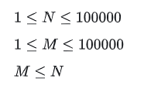
The numbers in the array will range between [0,10000000].
Output Format
Print the maximum number of unique integers among all possible contiguous subarrays of size M .
Sample Input
6 3
5 3 5 2 3 2
Sample Output
3
CODE:
import java.io.*;
import java.util.*;
public class Solution {
public static void main(String[] args) {
Scanner sc = new Scanner(System.in);
int n = sc.nextInt();
int k = sc.nextInt();
Deque<Integer> deque = new ArrayDeque<>();
HashMap<Integer, Integer> map = new HashMap<>();
int maxUnique = 0;
for (int i = 0; i < n; i++) {
int num = sc.nextInt();
deque.addLast(num);
map.put(num, map.getOrDefault(num, 0)+1);
if (deque.size() > k) {
int removed = deque.removeFirst();
map.put(removed, map.get(removed) - 1);
if (map.get(removed) == 0) {
map.remove(removed);
}
}
if (deque.size() == k) {
maxUnique = Math.max(maxUnique, map.size());
}
}
System.out.println(maxUnique);
} }
8.
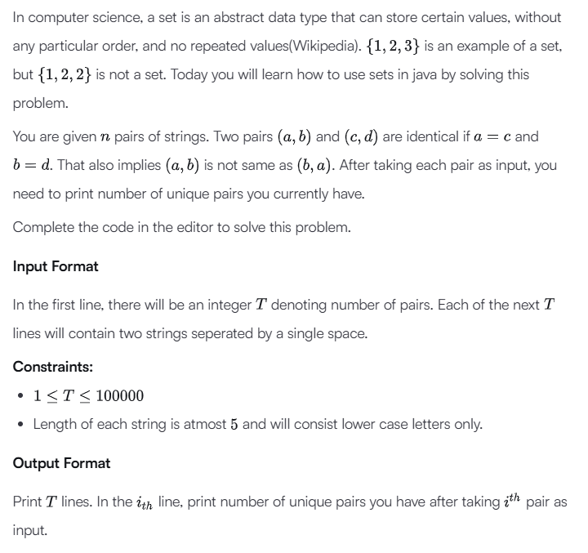
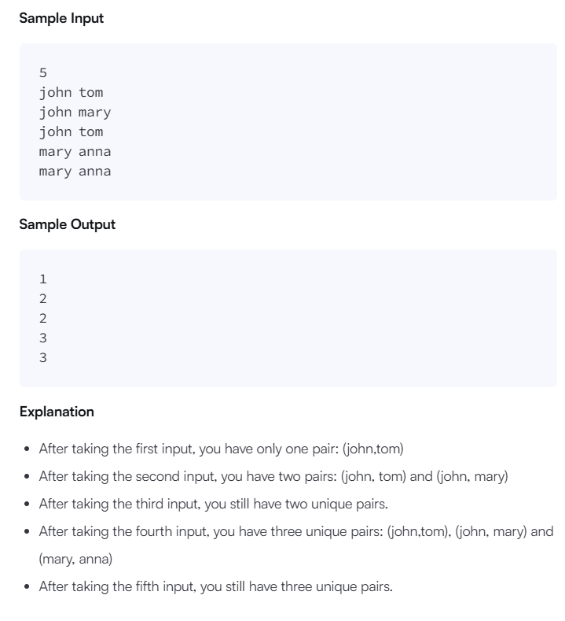
CODE:
import java.io.*;
import java.util.*;

public class Solution {
public static void main(String[] args) {
/* Enter your code here. Read input from STDIN. Print output to STDOUT. Your class should be named Solution. */
Scanner sc = new Scanner(System.in);

int T = sc.nextInt();

HashSet<String> set = new HashSet<>();

for (int i = 0; i < T; i++) {

String a = sc.next();
String b = sc.next();

set.add(a + " " + b);

System.out.println(set.size());
}
}
}

