WEEK-5
1.
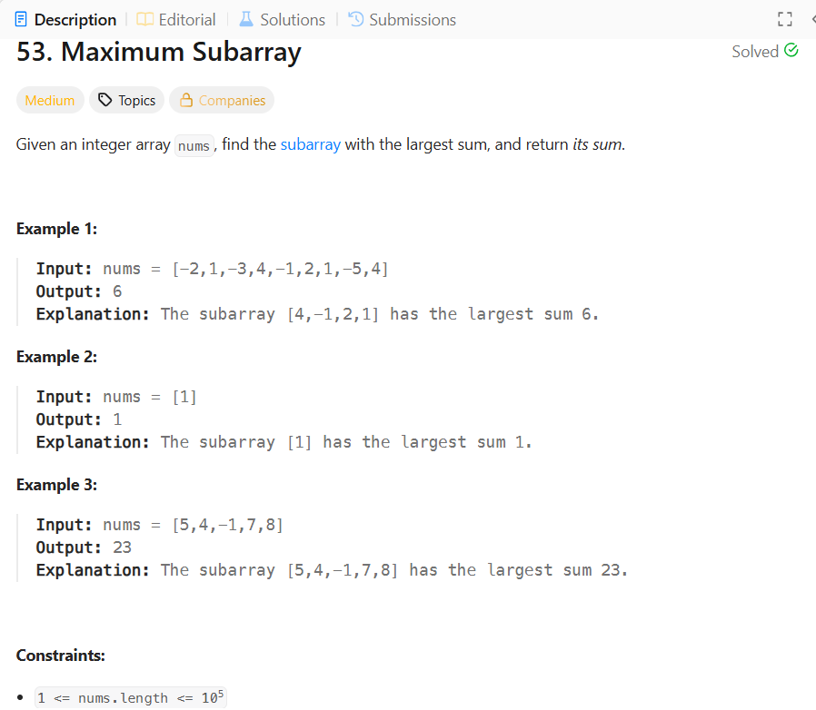
SOLUTION:
class Solution {
public int maxSubArray(int[] nums) {
int currentsum=nums[0];
int maxsum=nums[0];
for(int i=1;i<nums.length;i++){
currentsum=Math.max(nums[i],currentsum+nums[i]);
maxsum=Math.max(currentsum,maxsum);
}
return maxsum;
}
}
2.
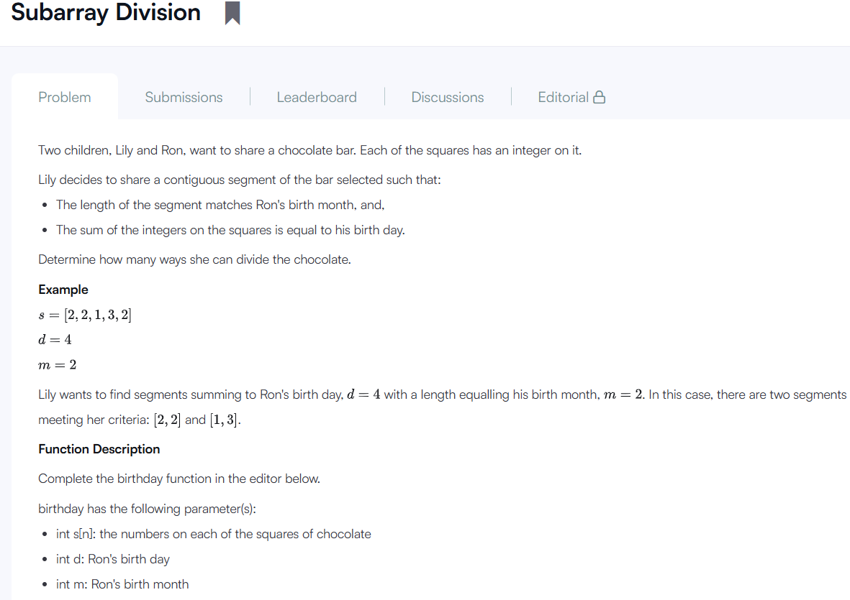
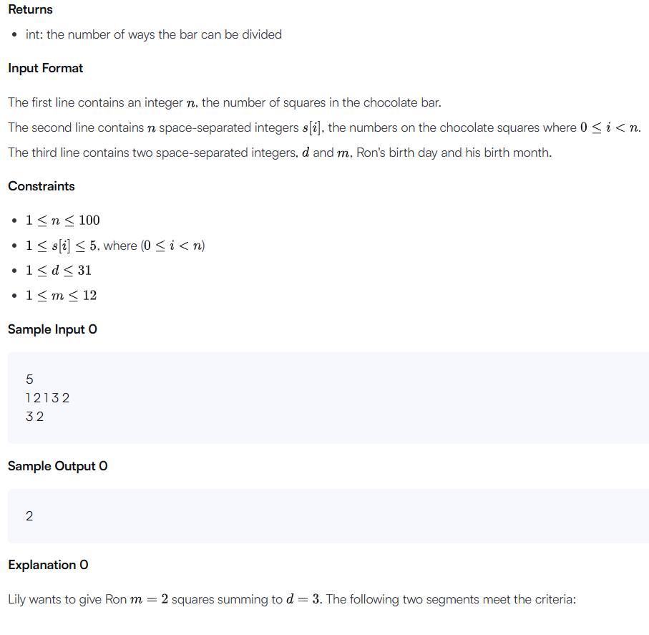
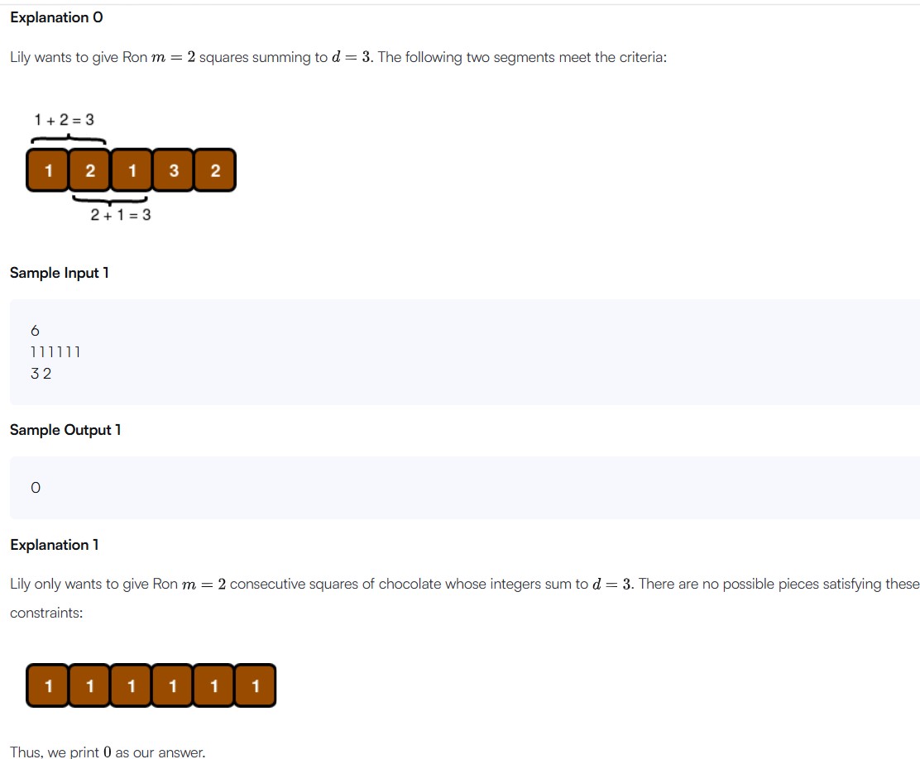
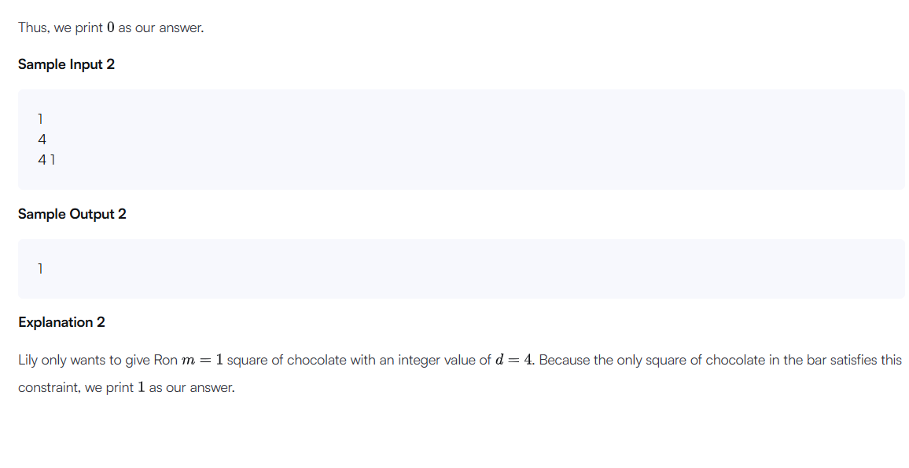

SOLUTION:
import java.io.*;
import java.math.*;
import java.security.*;
import java.text.*;
import java.util.*;
import java.util.concurrent.*;
import java.util.function.*;
import java.util.regex.*;
import java.util.stream.*;
import static java.util.stream.Collectors.joining;
import static java.util.stream.Collectors.toList;

class Result {

/*
* Complete the 'birthday' function below.
*
* The function is expected to return an INTEGER.
* The function accepts following parameters:
* 1. INTEGER_ARRAY s
* 2. INTEGER d
* 3. INTEGER m
*/

public static int birthday(List<Integer> s, int d, int m) {
// Write your code here
int count = 0;

for (int i = 0; i <= s.size() - m; i++) {
int sum = 0;

for (int j = i; j < i + m; j++) {
sum += s.get(j);
}

if (sum == d) {
count++;
}
}
return count;
}
}
public class Solution {
public static void main(String[] args) throws IOException {
BufferedReader bufferedReader = new BufferedReader(new InputStreamReader(System.in));
BufferedWriter bufferedWriter = new BufferedWriter(new FileWriter(System.getenv("OUTPUT_PATH")));
int n = Integer.parseInt(bufferedReader.readLine().trim());
List<Integer> s = Stream.of(bufferedReader.readLine().replaceAll("\\s+$", "").split(" "))
.map(Integer::parseInt)
.collect(toList());
String[] firstMultipleInput = bufferedReader.readLine().replaceAll("\\s+$", "").split(" ");
int d = Integer.parseInt(firstMultipleInput[0]);
int m = Integer.parseInt(firstMultipleInput[1]);
int result = Result.birthday(s, d, m);
bufferedWriter.write(String.valueOf(result));
bufferedWriter.newLine();
bufferedReader.close();
bufferedWriter.close();
}
}

3.
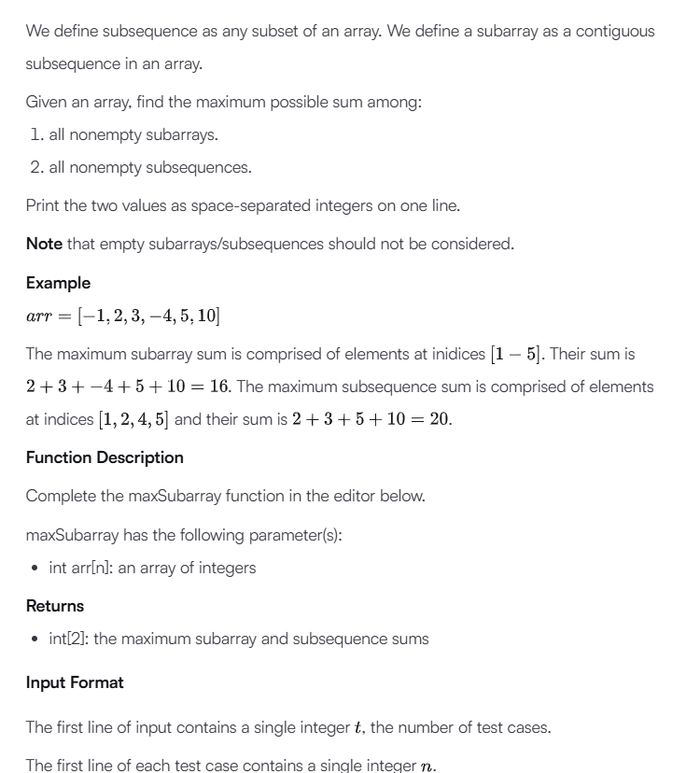
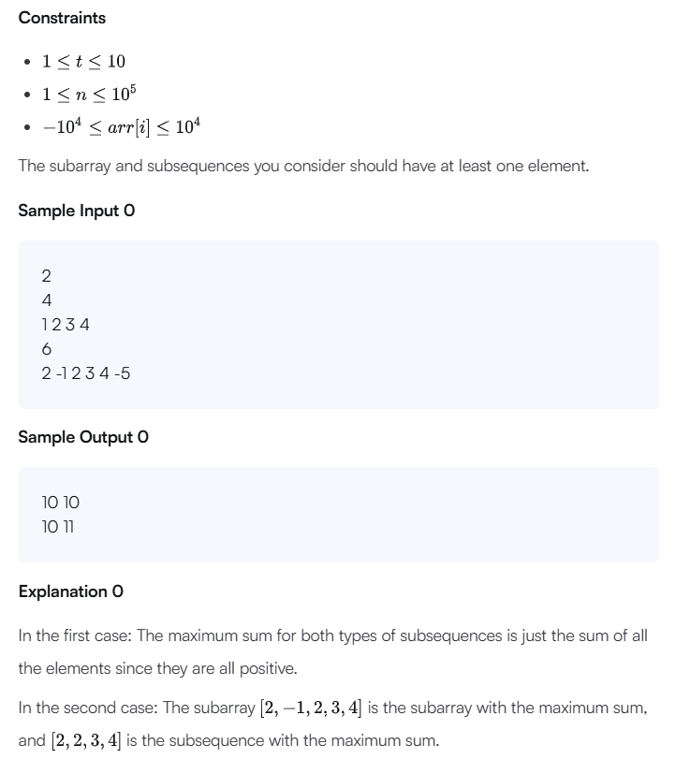
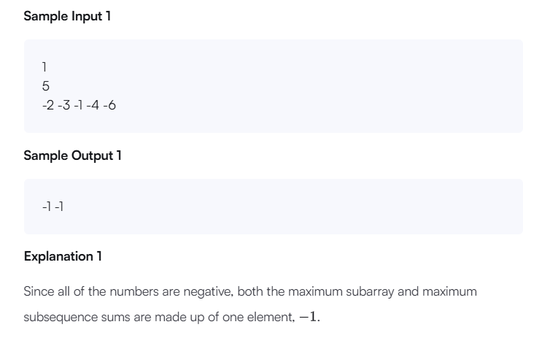
SOLUTION:
import java.io.*;
import java.math.*;
import java.security.*;
import java.text.*;
import java.util.*;
import java.util.concurrent.*;
import java.util.function.*;
import java.util.regex.*;
import java.util.stream.*;
import static java.util.stream.Collectors.joining;
import static java.util.stream.Collectors.toList;
class Result {
public static List<Integer> maxSubarray(List<Integer> arr) {
// Write your code here
int maxSubarray = arr.get(0);
int currentSum = arr.get(0);
int maxSubsequence = 0;
int largest = arr.get(0)
// Find maximum subarray
for (int i = 1; i < arr.size(); i++) {
currentSum = Math.max(arr.get(i), currentSum + arr.get(i));
maxSubarray = Math.max(maxSubarray, currentSum);
}
for (int num : arr) {
if (num > 0) {
maxSubsequence += num;
}
largest = Math.max(largest, num);
}
if (maxSubsequence == 0) {
maxSubsequence = largest;
}
List<Integer> result = new ArrayList<>();
result.add(maxSubarray);
result.add(maxSubsequence);
return result;
}
}
public class Solution {
public static void main(String[] args) throws IOException {
BufferedReader bufferedReader = new BufferedReader(new InputStreamReader(System.in));
BufferedWriter bufferedWriter = new BufferedWriter(new FileWriter(System.getenv("OUTPUT_PATH")));
int t = Integer.parseInt(bufferedReader.readLine().trim());
IntStream.range(0, t).forEach(tItr -> {
try {
int n = Integer.parseInt(bufferedReader.readLine().trim());
List<Integer> arr = Stream.of(bufferedReader.readLine().replaceAll("\\s+$", "").split(" "))
.map(Integer::parseInt)
.collect(toList());
List<Integer> result = Result.maxSubarray(arr);
bufferedWriter.write(
result.stream()
.map(Object::toString)
.collect(joining(" "))
+ "\n"
);
} catch (IOException ex) {
throw new RuntimeException(ex);
}
});

bufferedReader.close();
bufferedWriter.close();
}
}
4.
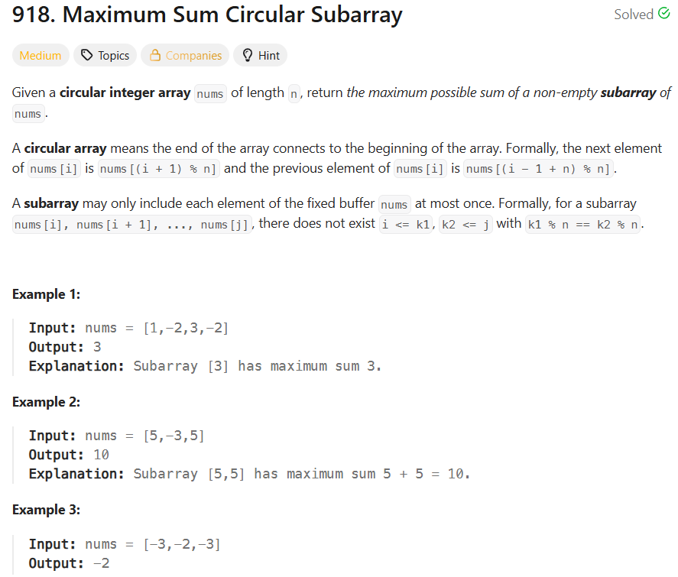
SOLUTION:
class Solution {
public int maxSubarraySumCircular(int[] nums) {
int total = 0;
int currentMax = 0;
int maxSum = nums[0];
int currentMin = 0;
int minSum = nums[0];
for (int num : nums) {
currentMax = Math.max(num, currentMax + num);
maxSum = Math.max(maxSum, currentMax);
currentMin = Math.min(num, currentMin + num);
minSum = Math.min(minSum, currentMin);
total += num;
}
if (maxSum < 0) {
return maxSum;
}
int circularSum = total - minSum;
return Math.max(maxSum, circularSum);
}
}
5. String to Integer (atoi)
Implement the myAtoi(string s) function, which converts a string to a 32-bit signed integer.
The algorithm for myAtoi(string s) is as follows:
- Whitespace: Ignore any leading whitespace (" ").
- Signedness: Determine the sign by checking if the next character is '-' or '+', assuming positivity if neither present.
- Conversion: Read the integer by skipping leading zeros until a non-digit character is encountered or the end of the string is reached. If no digits were read, then the result is 0.
- Rounding: If the integer is out of the 32-bit signed integer range [-2³¹, 2³¹ - 1], then round the integer to remain in the range. Specifically, integers less than -2³¹ should be rounded to -2³¹, and integers greater than 2³¹ - 1 should be rounded to 2³¹ - 1.
Return the integer as the final result.
Note:​​​​​​​ You must not use any built-in library function that converts a string to a number (for example, atoi, stoi, Integer.parseInt, int(), parseInt, Number()). Perform the conversion manually.

Example 1:
Input: s = "42"
Output: 42
Explanation:
The underlined characters are what is read in and the caret is the current reader position.
Step 1: "42" (no characters read because there is no leading whitespace)
^
Step 2: "42" (no characters read because there is neither a '-' nor '+')
^
Step 3: "42" ("42" is read in)
^
Example 2:
Input: s = " -042"
Output: -42
Explanation:
Step 1: " -042" (leading whitespace is read and ignored)
^
Step 2: " -042" ('-' is read, so the result should be negative)
^
Step 3: " -042" ("042" is read in, leading zeros ignored in the result)
^
Example 3:
Input: s = "1337c0d3"
Output: 1337
Explanation:
Step 1: "1337c0d3" (no characters read because there is no leading whitespace)
^
Step 2: "1337c0d3" (no characters read because there is neither a '-' nor '+')
^
Step 3: "1337c0d3" ("1337" is read in; reading stops because the next character is a non-digit)
^
Example 4:
Input: s = "0-1"
Output: 0
Explanation:
Step 1: "0-1" (no characters read because there is no leading whitespace)
^
Step 2: "0-1" (no characters read because there is neither a '-' nor '+')
^
Step 3: "0-1" ("0" is read in; reading stops because the next character is a non-digit)
^
Example 5:
Input: s = "words and 987"
Output: 0
Explanation:
Reading stops at the first non-digit character 'w'.
SOLUTION:
class Solution {
public int myAtoi(String s) {
int i = 0;
int n = s.length();
while (i < n && s.charAt(i) == ' ') {
i++;
}
int sign = 1;
if (i < n && s.charAt(i) == '-') {
sign = -1;
i++;
} else if (i < n && s.charAt(i) == '+') {
i++;
}
int result = 0;
while (i < n && s.charAt(i) >= '0' && s.charAt(i) <= '9') {

int digit = s.charAt(i) - '0';
if (result > (Integer.MAX_VALUE - digit) / 10) {
if (sign == 1) {
return Integer.MAX_VALUE;
} else {
return Integer.MIN_VALUE;
}
}
result = result * 10 + digit;
i++;
}
return result * sign;
}
}
6.
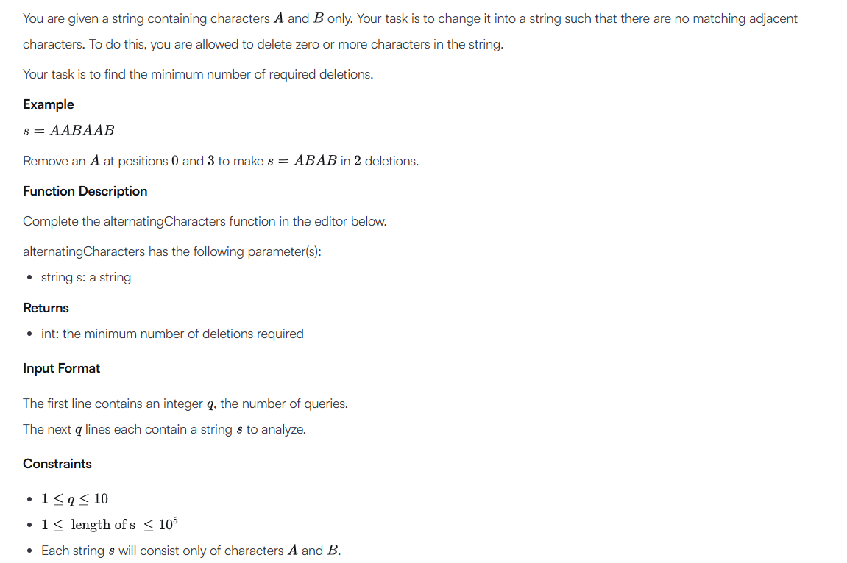

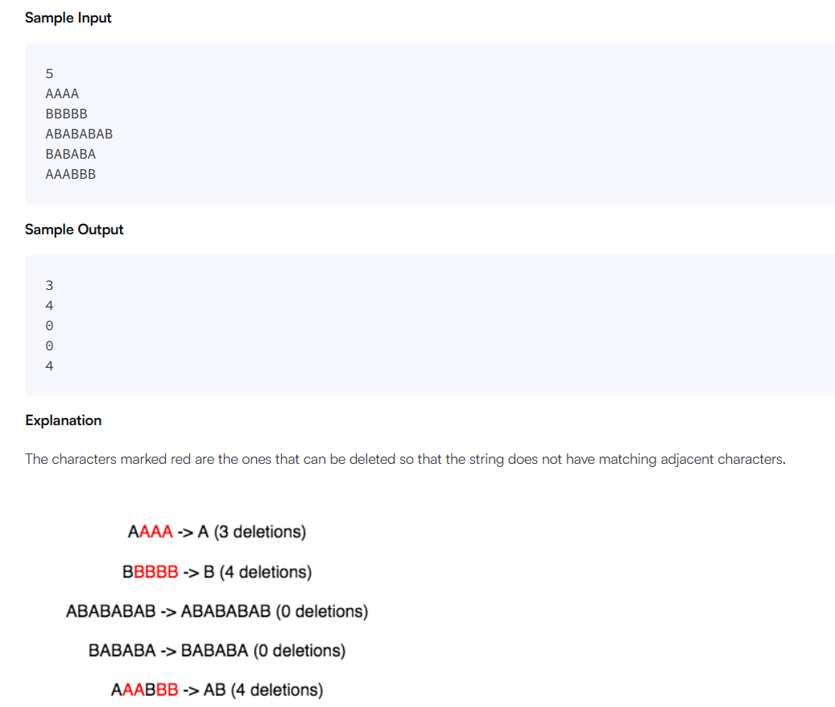
SOLUTION:
import java.io.*;
import java.math.*;
import java.security.*;
import java.text.*;
import java.util.*;
import java.util.concurrent.*;
import java.util.function.*;
import java.util.regex.*;
import java.util.stream.*;
import static java.util.stream.Collectors.joining;
import static java.util.stream.Collectors.toList;
class Result {

public static int alternatingCharacters(String s) {
int deletions = 0;
for (int i = 1; i < s.length(); i++) {
if (s.charAt(i) == s.charAt(i - 1)) {
deletions++;
}
}
return deletions;
}

}
public class Solution {
public static void main(String[] args) throws IOException {
BufferedReader bufferedReader = new BufferedReader(new InputStreamReader(System.in));
BufferedWriter bufferedWriter = new BufferedWriter(new FileWriter(System.getenv("OUTPUT_PATH")));
int q = Integer.parseInt(bufferedReader.readLine().trim());
IntStream.range(0, q).forEach(qItr -> {
try {
String s = bufferedReader.readLine();
int result = Result.alternatingCharacters(s);
bufferedWriter.write(String.valueOf(result));
bufferedWriter.newLine();
} catch (IOException ex) {
throw new RuntimeException(ex);
}
});
bufferedReader.close();
bufferedWriter.close();
}
}
7.
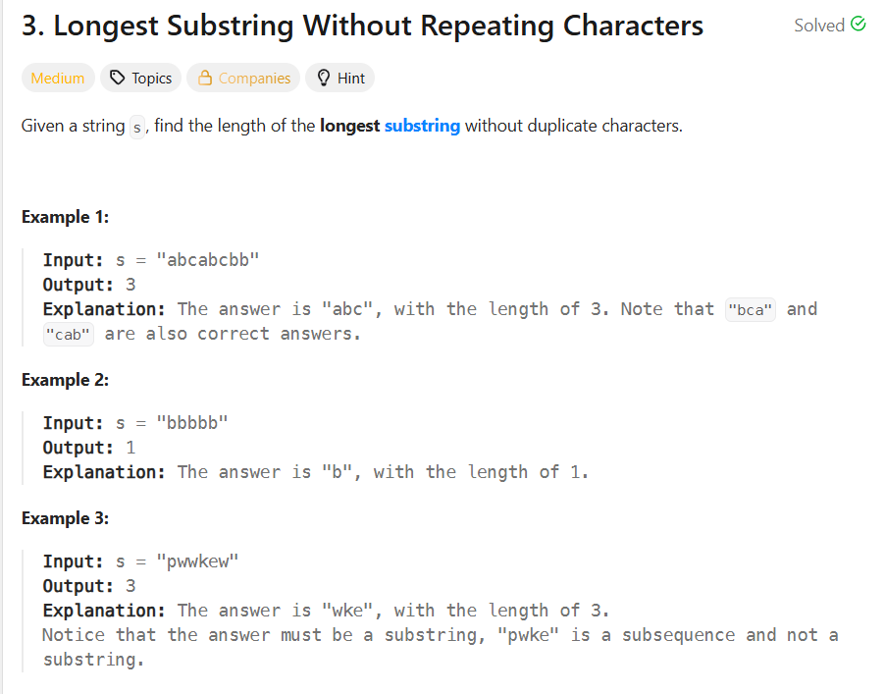
SOLUTION:
import java.util.*;
class Solution {
public int lengthOfLongestSubstring(String s) {
HashSet<Character> set = new HashSet<>();
int left = 0;
int maxLength = 0;
for (int right = 0; right < s.length(); right++) {
while (set.contains(s.charAt(right))) {
set.remove(s.charAt(left));
left++;
}
set.add(s.charAt(right));
maxLength = Math.max(maxLength, right - left + 1);
}
return maxLength;
}
}
8.
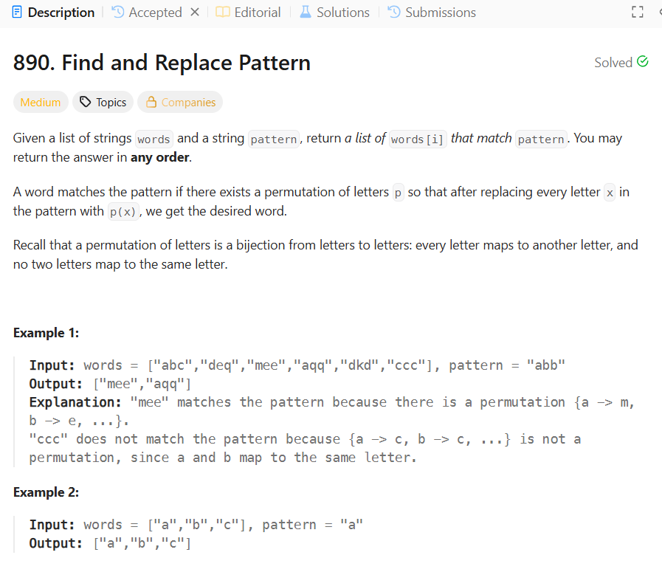
SOLUTION:
class Solution {
public List<String> findAndReplacePattern(String[] words, String pattern) {
List<String> result = new ArrayList<>();
for (String word : words) {
if (matches(word, pattern)) {
result.add(word);
}
}
return result;
}
private boolean matches(String word, String pattern) {
Map<Character, Character> map = new HashMap<>();
Map<Character, Character> reverseMap = new HashMap<>();
for (int i = 0; i < word.length(); i++) {
char w = word.charAt(i);
char p = pattern.charAt(i);
if (map.containsKey(p) && map.get(p) != w) {
return false;
}
if (reverseMap.containsKey(w) && reverseMap.get(w) != p) {
return false;
}
map.put(p, w);
reverseMap.put(w, p);
}
return true;
}
}

9.
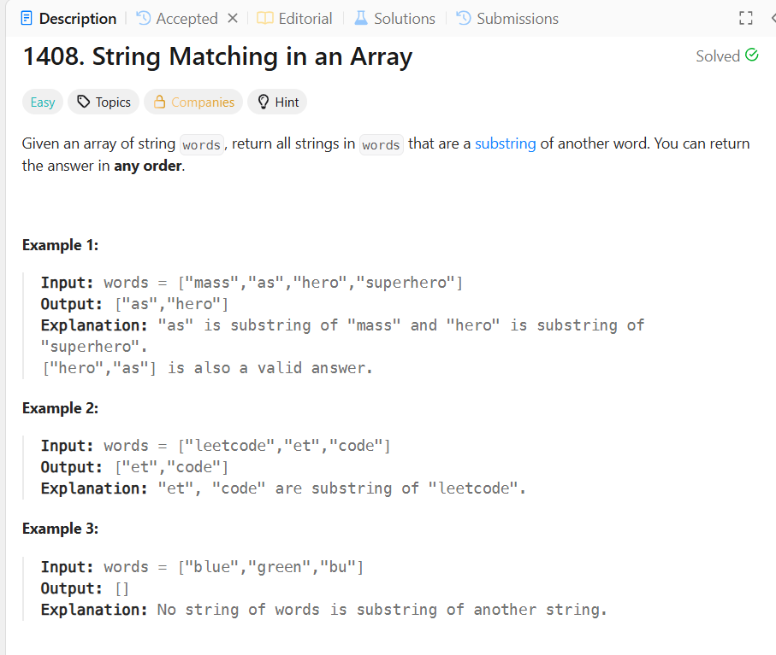
SOLUTION:
class Solution {
public List<String> stringMatching(String[] words) {
List<String> result = new ArrayList<>();
for (int i = 0; i < words.length; i++) {
for (int j = 0; j < words.length; j++) {
if (i != j && words[j].contains(words[i])) {
result.add(words[i]);
break;
}
}
}
return result;}
}
10.
Naive algorithm for Pattern Searching
Last Updated :31 Mar, 2026

Given a text string of length n and a pattern of length m, find all starting indices where the pattern occurs in the text.
Note: You may assume that n>m.
Examples:
Input: text = "geeksforgeeks", pattern = "geeks"
Output: [0, 8]
Explanation: The string "geeks" occurs at index 0 and 8 in text.
Input: text = "aabaacaadaabaaba", pattern = "aaba"
Output: [0, 9, 12]
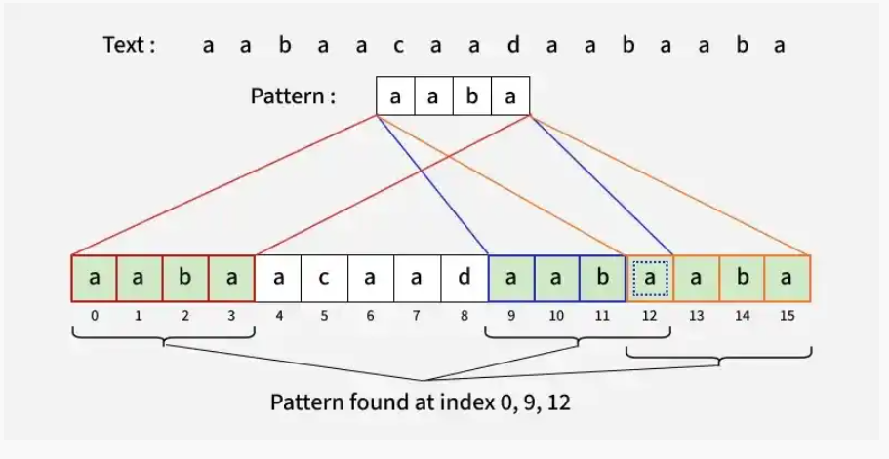
Naive Pattern Searching Algorithm
The pattern moves over the text one position at a time and characters are compared. If all characters match, the index is stored; otherwise, the next position is checked.

SOLUTION:
import java.util.ArrayList;

public class GFG {

// Function to search for all occurrences of 'pat' in 'txt' using Naive Approach
static ArrayList<Integer> search(String pat, String txt)
{
// Length of the pattern
int m = pat.length();

// Length of the text
int n = txt.length();

ArrayList<Integer> ans = new ArrayList<>();

// Slide the pattern over text one by one
for (int i = 0; i <= n - m; i++)
{
int j;

// Check for pattern match at index i
for (j = 0; j < m; j++)
{
if (txt.charAt(i + j) != pat.charAt(j))
break;
}

// If pattern matches, store index
if (j == m)
ans.add(i);
}

return ans;
}

public static void main(String[] args)
{
String txt = "aabaacaadaabaaba";
String pat = "aaba";

ArrayList<Integer> res = search(pat, txt);

for (int it : res)
{
System.out.print(it + " ");
}
}
}

