WEEK -4
1.
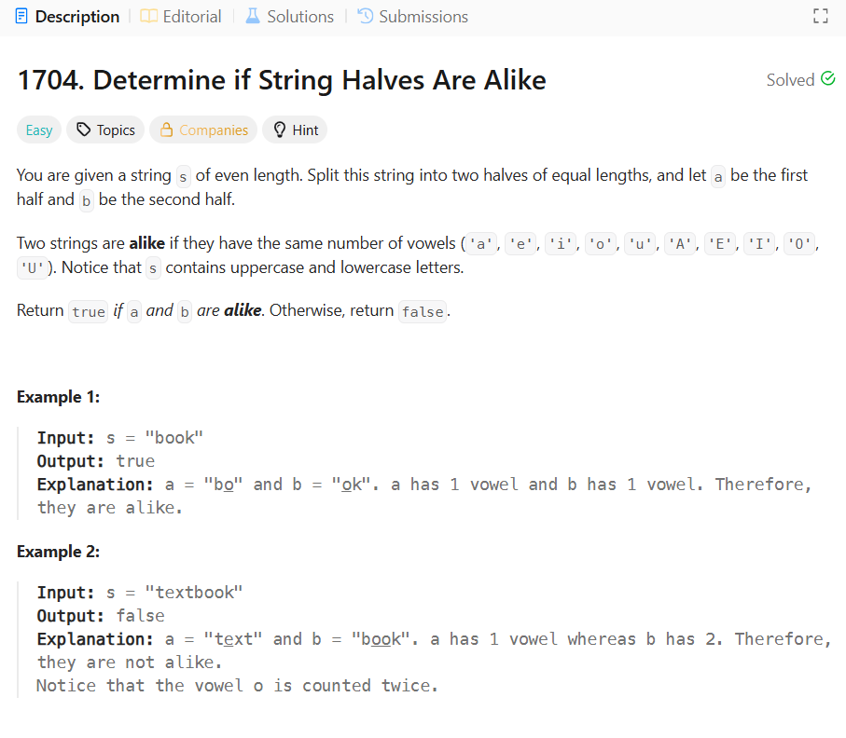
CODE:
class Solution {
public boolean halvesAreAlike(String s) {
int mid=s.length()/2;
int count1=0;
int count2=0;
for(int i=0;i<mid;i++){
if(isVowel(s.charAt(i))){
count1++;
}
}
for(int i=mid;i<s.length();i++){
if(isVowel(s.charAt(i))){
count2++;
}
}
return count1==count2;
}
public boolean isVowel(char c){
return c=='a'||c=='e'||c=='i'||c=='o'||c=='u'||c=='A'||c=='E'||c=='I'||c=='O'||c=='U';
}
}

2.
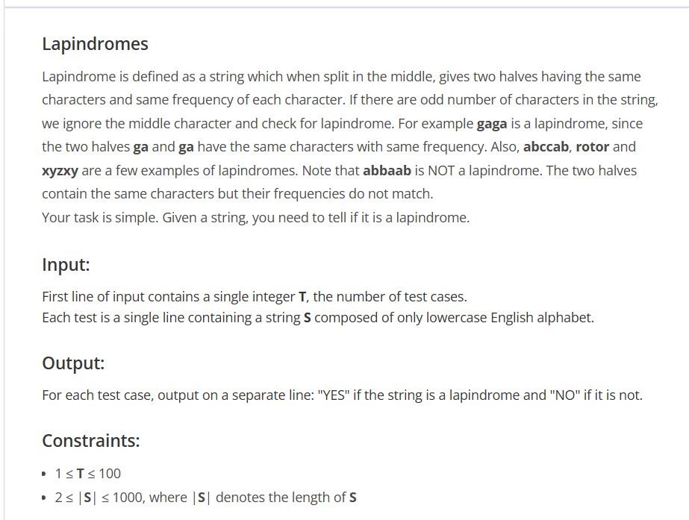
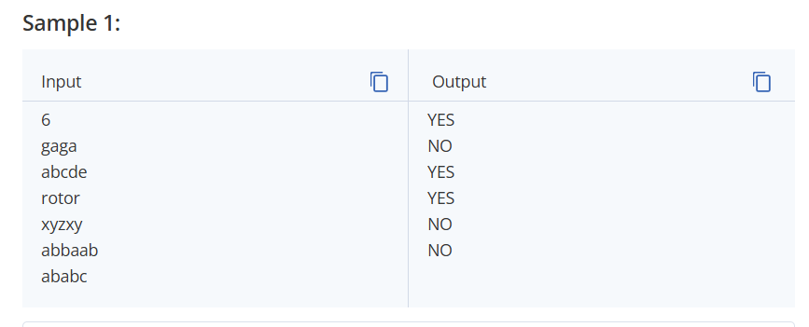
SOLUTION:
import java.util.*;
import java.lang.*;
import java.io.*;

class Codechef
{
public static void main (String[] args) throws java.lang.Exception
{
// your code goes here
Scanner sc = new Scanner(System.in);

int T = sc.nextInt();
while (T-- > 0) {
String s = sc.next();
int n = s.length();
int[] left = new int[26];
int[] right = new int[26];

for (int i = 0; i < n / 2; i++) {
left[s.charAt(i) - 'a']++;
}
for (int i = (n + 1) / 2; i < n; i++) {
right[s.charAt(i) - 'a']++;
}

if (Arrays.equals(left, right)) {
System.out.println("YES");
} else {
System.out.println("NO");
}
}

sc.close();

}
}
3. Alice and Bob each created one problem for HackerRank. A reviewer rates the two challenges, awarding points on a scale from 1 to 100 for three categories: problem clarity, originality, and difficulty.
The rating for Alice's challenge is the triplet a = (a[0], a[1], a[2]), and the rating for Bob's challenge is the triplet b = (b[0], b[1], b[2]).
The task is to calculate their comparison points by comparing each category:
- If a[i] > b[i], then Alice is awarded 1 point.
- If a[i] < b[i], then Bob is awarded 1 point.
- If a[i] = b[i], then neither person receives a point.
Example
a = [1, 2, 3]
b = [3, 2, 1]
- For elements *0*, Bob is awarded a point because a[0] < b[0].
- For the equal elements a[1] and b[1], no points are earned.
- Finally, for elements 2, a[2] > b[2] so Alice receives a point.
The return array is [1, 1] with Alice's score first and Bob's second.
Function Description
Complete the function compareTriplets with the following parameter(s):
- int a[3]: Alice's challenge rating
- int b[3]: Bob's challenge rating
Returns
- int[2]: the first element is Alice's score and the second is Bob's score
Input Format
The first line contains 3 space-separated integers, a[0], a[1], and a[2], the respective values in triplet a.
The second line contains 3 space-separated integers, b[0], b[1], and b[2], the respective values in triplet b.
Constraints
- 1 ≤ a[i] ≤ 100
- 1 ≤ b[i] ≤ 100
- Sample Input 0
- 5 6 7
- 3 6 10
- Sample Output 0
- 1 1
- Sample Input 1
- 17 28 30
- 99 16 8
- Sample Output 1
- 2 1
SOLUTION:
import java.io.*;
import java.math.*;
import java.security.*;
import java.text.*;
import java.util.*;
import java.util.concurrent.*;
import java.util.function.*;
import java.util.regex.*;
import java.util.stream.*;
import static java.util.stream.Collectors.joining;
import static java.util.stream.Collectors.toList;

class Result {

/*
* Complete the 'compareTriplets' function below.
*
* The function is expected to return an INTEGER_ARRAY.
* The function accepts following parameters:
* 1. INTEGER_ARRAY a
* 2. INTEGER_ARRAY b
*/

public static List<Integer> compareTriplets(List<Integer> a, List<Integer> b) {
int alice = 0;
int bob = 0;

for (int i = 0; i < 3; i++) {
if (a.get(i) > b.get(i)) {
alice++;
} else if (a.get(i) < b.get(i)) {
bob++;
}
}

return Arrays.asList(alice, bob);

}
}
public class Solution {
public static void main(String[] args) throws IOException {
BufferedReader bufferedReader = new BufferedReader(new InputStreamReader(System.in));
BufferedWriter bufferedWriter = new BufferedWriter(new FileWriter(System.getenv("OUTPUT_PATH")));
List<Integer> a = Stream.of(bufferedReader.readLine().replaceAll("\\s+$", "").split(" "))
.map(Integer::parseInt)
.collect(toList());
List<Integer> b = Stream.of(bufferedReader.readLine().replaceAll("\\s+$", "").split(" "))
.map(Integer::parseInt)
.collect(toList());

List<Integer> result = Result.compareTriplets(a, b);

bufferedWriter.write(
result.stream()
.map(Object::toString)
.collect(joining(" "))
+ "\n"
);

bufferedReader.close();
bufferedWriter.close();
}
}
4.
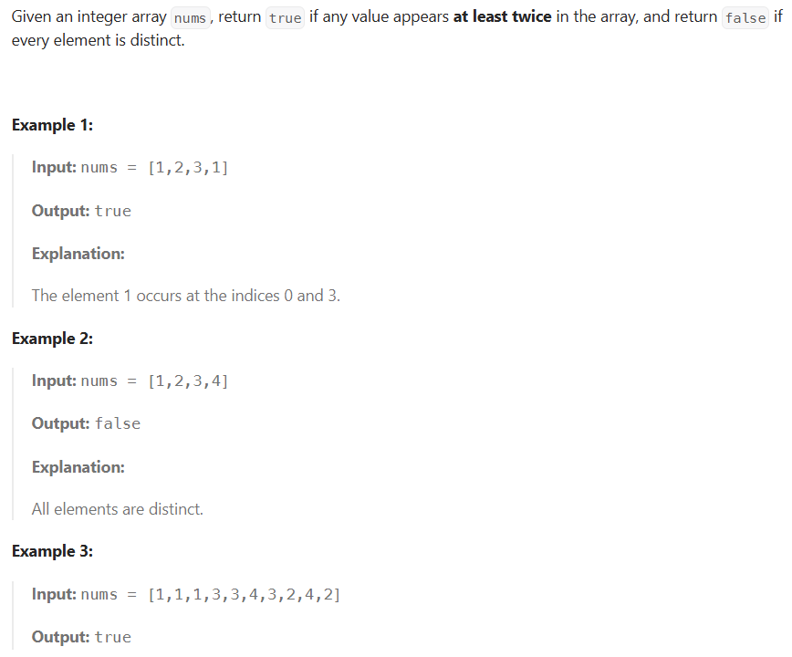
SOLUTION:
class Solution {
public boolean containsDuplicate(int[] nums) {
HashSet<Integer> set = new HashSet<>();
for (int num : nums) {
if (set.contains(num)) {
return true;
}
set.add(num);
}
return false;
}
}
5.
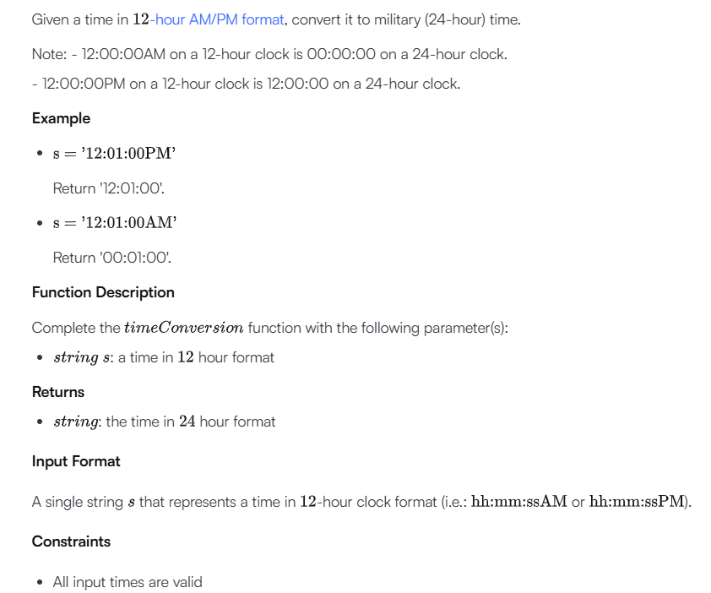
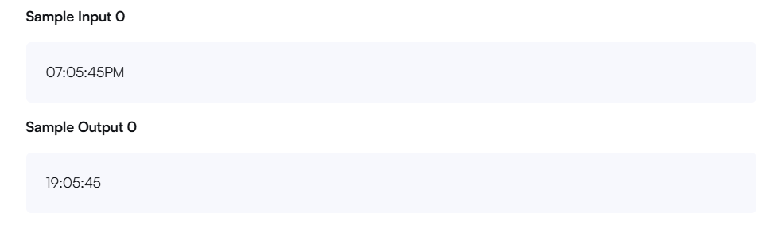
SOLUTION:
import java.io.*;
import java.math.*;
import java.security.*;
import java.text.*;
import java.util.*;
import java.util.concurrent.*;
import java.util.function.*;
import java.util.regex.*;
import java.util.stream.*;
import static java.util.stream.Collectors.joining;
import static java.util.stream.Collectors.toList;

class Result {

/*
* Complete the 'timeConversion' function below.
*
* The function is expected to return a STRING.
* The function accepts STRING s as parameter.
*/

public static String timeConversion(String s) {
// Write your code here
int hour = Integer.parseInt(s.substring(0, 2));
String ampm = s.substring(8, 10);

if (ampm.equals("AM")) {
if (hour == 12) {
hour = 0;
}
} else {
if (hour != 12) {
hour += 12;
}
}

return String.format("%02d", hour) + s.substring(2, 8);

}

}

public class Solution {
public static void main(String[] args) throws IOException {
BufferedReader bufferedReader = new BufferedReader(new InputStreamReader(System.in));
BufferedWriter bufferedWriter = new BufferedWriter(new FileWriter(System.getenv("OUTPUT_PATH")));

String s = bufferedReader.readLine();

String result = Result.timeConversion(s);

bufferedWriter.write(result);
bufferedWriter.newLine();

bufferedReader.close();
bufferedWriter.close();
}
}

6.
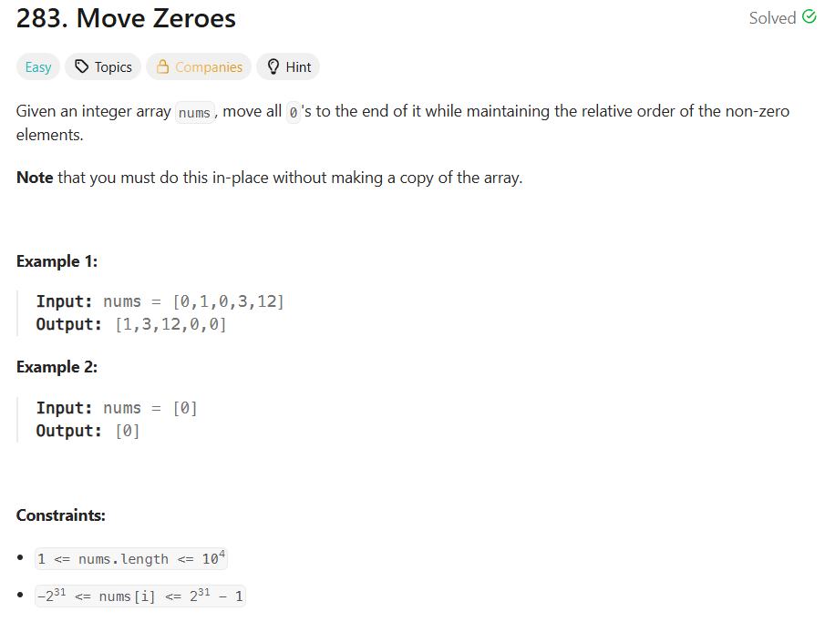
SOLUTION:
class Solution {
public void moveZeroes(int[] nums) {
int count=0;
for(int i=0;i<nums.length;i++){
if(nums[i]!=0){
nums[count]=nums[i];
count++;
}
}
while(count<nums.length){
nums[count]=0;
count++;
}
}
}
7.
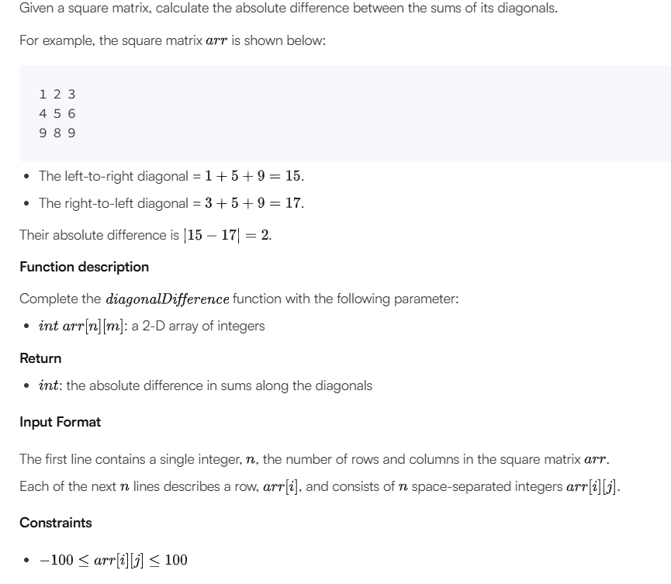
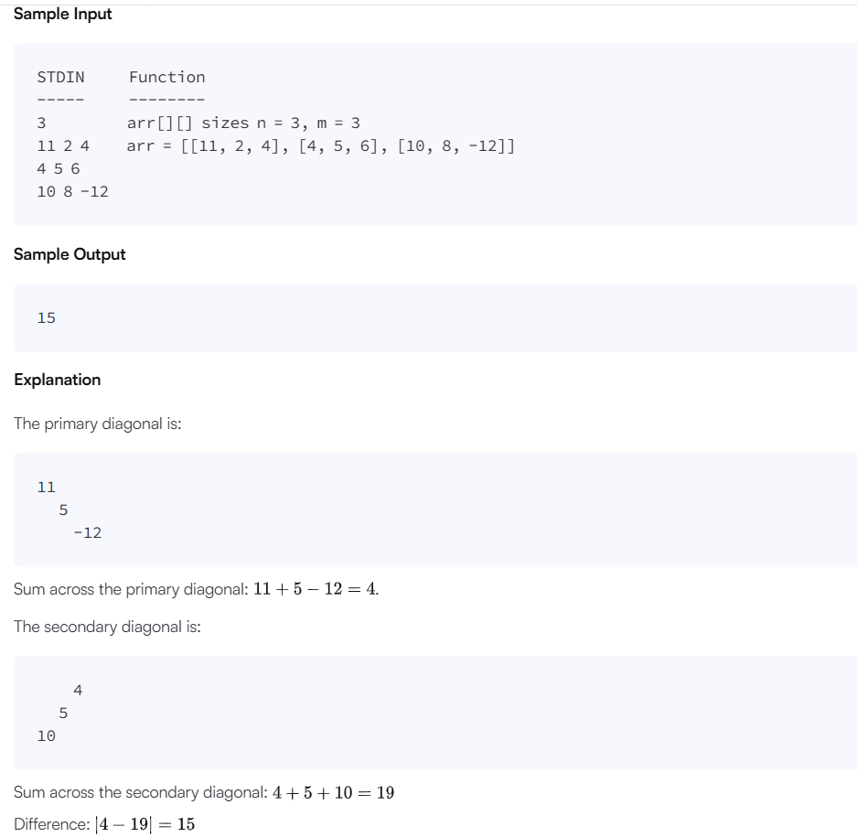
SOLUTION:
import java.io.*;
import java.math.*;
import java.security.*;
import java.text.*;
import java.util.*;
import java.util.concurrent.*;
import java.util.function.*;
import java.util.regex.*;
import java.util.stream.*;
import static java.util.stream.Collectors.joining;
import static java.util.stream.Collectors.toList;

class Result {

/*
* Complete the 'diagonalDifference' function below.
*
* The function is expected to return an INTEGER.
* The function accepts 2D_INTEGER_ARRAY arr as parameter.
*/

public static int diagonalDifference(List<List<Integer>> arr) {
int n=arr.size();
int rowsum=0;
int colsum=0;
for(int i=0;i<n;i++){
rowsum+=arr.get(i).get(i);
colsum+=arr.get(i).get(n-1-i);

}
return Math.abs(rowsum-colsum);

}

}

public class Solution {
public static void main(String[] args) throws IOException {
BufferedReader bufferedReader = new BufferedReader(new InputStreamReader(System.in));
BufferedWriter bufferedWriter = new BufferedWriter(new FileWriter(System.getenv("OUTPUT_PATH")));

int n = Integer.parseInt(bufferedReader.readLine().trim());

List<List<Integer>> arr = new ArrayList<>();

IntStream.range(0, n).forEach(i -> {
try {
arr.add(
Stream.of(bufferedReader.readLine().replaceAll("\\s+$", "").split(" "))
.map(Integer::parseInt)
.collect(toList())
);
} catch (IOException ex) {
throw new RuntimeException(ex);
}
});
int result = Result.diagonalDifference(arr);
bufferedWriter.write(String.valueOf(result));
bufferedWriter.newLine();
bufferedReader.close();
bufferedWriter.close();
}
}
8
. 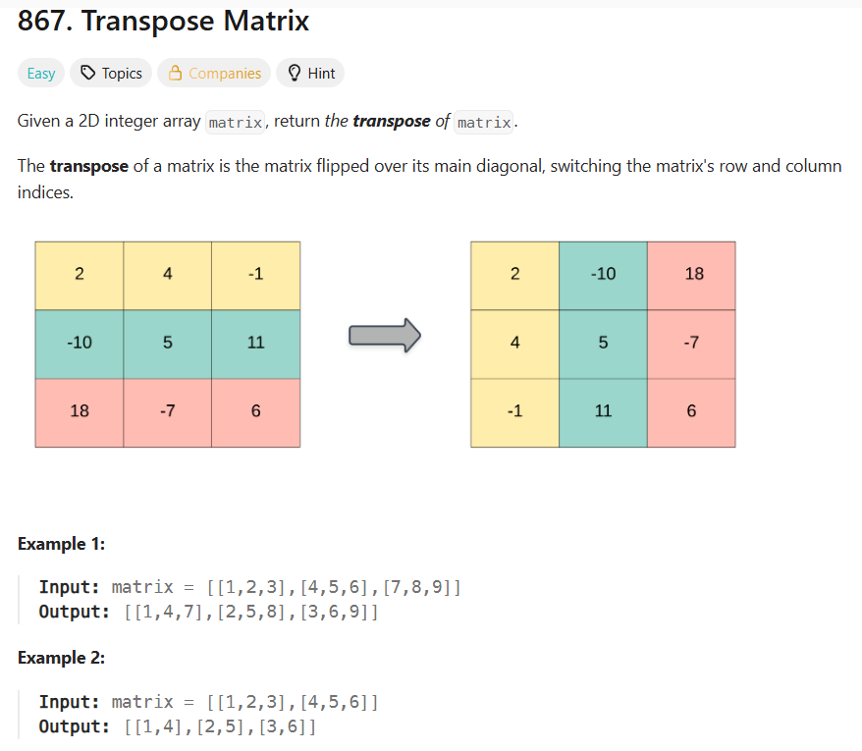
SOLUTION:
class Solution {
public int[][] transpose(int[][] matrix) {
int rows = matrix.length;
int cols = matrix[0].length;
int[][] result = new int[cols][rows];
for (int i = 0; i < rows; i++) {
for (int j = 0; j < cols; j++) {
result[j][i] = matrix[i][j];
}
} return result;
}
}
9.
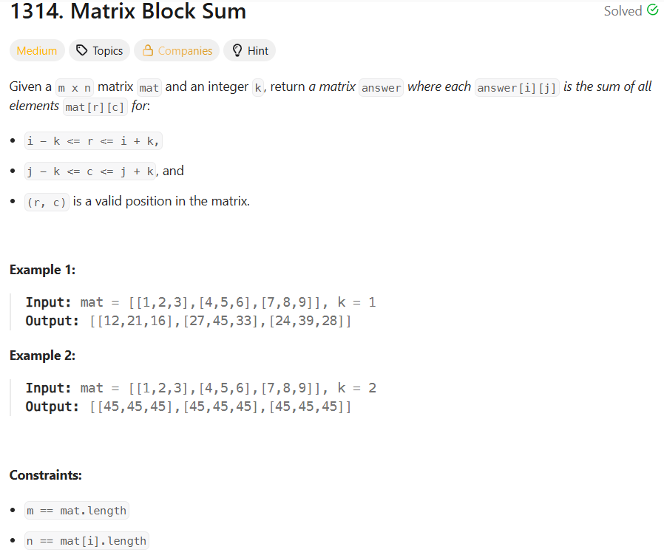
SOLUTION:
class Solution {
public int[][] matrixBlockSum(int[][] mat, int k) {
int m = mat.length;
int n = mat[0].length;

int[][] answer = new int[m][n];

for (int i = 0; i < m; i++) {
for (int j = 0; j < n; j++) {

for (int r = Math.max(0, i - k);
r <= Math.min(m - 1, i + k);
r++) {

for (int c = Math.max(0, j - k);
c <= Math.min(n - 1, j + k);
c++) {

answer[i][j] += mat[r][c];
}
}
}
}

return answer;

}
}
10.
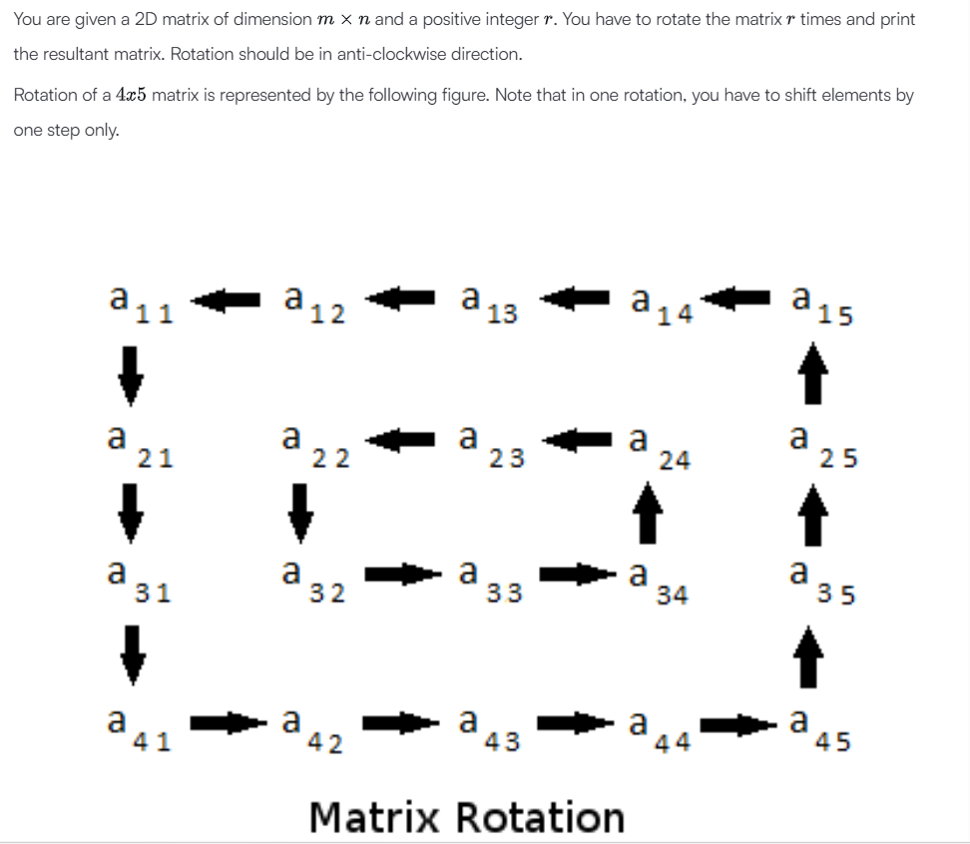
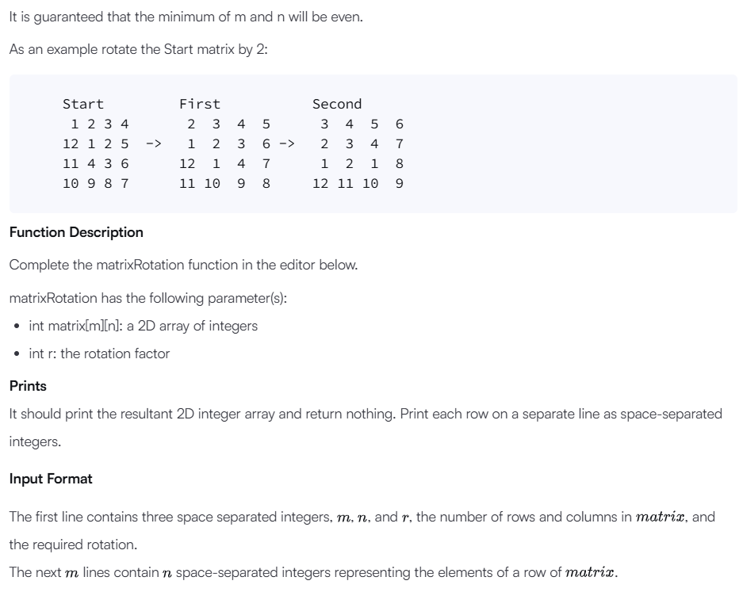
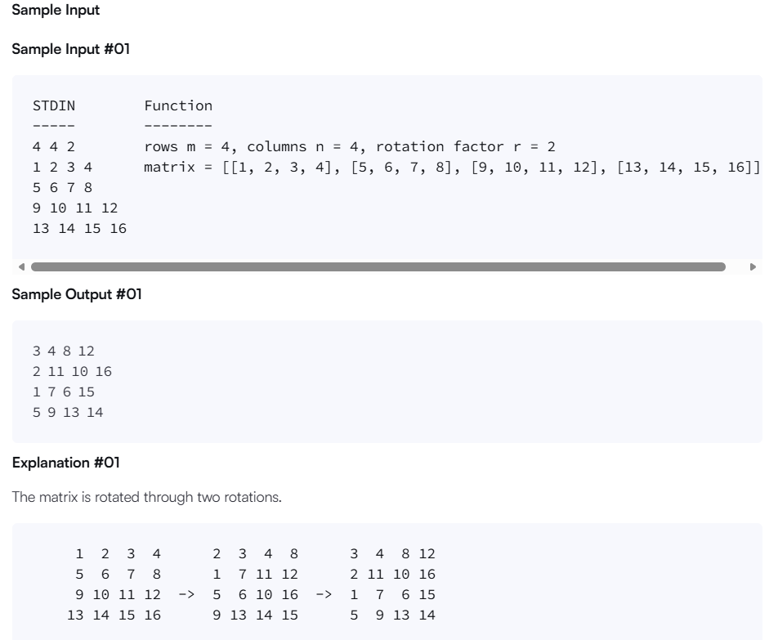
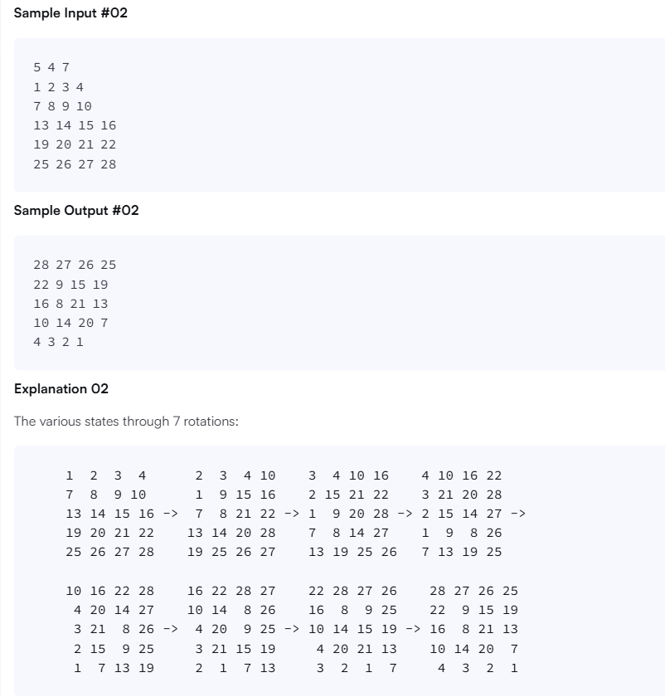
Sample Input #03
2 2 3
1 1
1 1
Sample Output #03
1 1
1 1
Explanation #03
All of the elements are the same, so any rotation will repeat the same matrix.
SOLUTION:
import java.io.*;
import java.math.*;
import java.security.*;
import java.text.*;
import java.util.*;
import java.util.concurrent.*;
import java.util.function.*;
import java.util.regex.*;
import java.util.stream.*;
import static java.util.stream.Collectors.joining;
import static java.util.stream.Collectors.toList;

class Result {

/*
* Complete the 'matrixRotation' function below.
*
* The function accepts following parameters:
* 1. 2D_INTEGER_ARRAY matrix
* 2. INTEGER r
*/

public static void matrixRotation(List<List<Integer>> matrix, int r) {
// Write your code here
int m = matrix.size();
int n = matrix.get(0).size();

int layers = Math.min(m, n) / 2;

for (int layer = 0; layer < layers; layer++) {

List<Integer> elements = new ArrayList<>();

int top = layer;
int left = layer;
int bottom = m - 1 - layer;
int right = n - 1 - layer;

// Top row: left -> right
for (int j = left; j <= right; j++) {
elements.add(matrix.get(top).get(j));
}

// Right column: top+1 -> bottom
for (int i = top + 1; i <= bottom; i++) {
elements.add(matrix.get(i).get(right));
}

// Bottom row: right-1 -> left
for (int j = right - 1; j >= left; j--) {
elements.add(matrix.get(bottom).get(j));
}

// Left column: bottom-1 -> top+1
for (int i = bottom - 1; i > top; i--) {
elements.add(matrix.get(i).get(left));
}

// Effective rotations
int rotation = r % elements.size();

// Rotate anti-clockwise
Collections.rotate(elements, -rotation);

int index = 0;

// Put back into top row
for (int j = left; j <= right; j++) {
matrix.get(top).set(j, elements.get(index++));
}

// Put back into right column
for (int i = top + 1; i <= bottom; i++) {
matrix.get(i).set(right, elements.get(index++));
}

// Put back into bottom row
for (int j = right - 1; j >= left; j--) {
matrix.get(bottom).set(j, elements.get(index++));
}

// Put back into left column
for (int i = bottom - 1; i > top; i--) {
matrix.get(i).set(left, elements.get(index++));
}
}

// Print matrix
for (List<Integer> row : matrix) {
for (int j = 0; j < row.size(); j++) {
System.out.print(row.get(j));

if (j < row.size() - 1) {
System.out.print(" ");
}
}
System.out.println();
}

}

}

public class Solution {
public static void main(String[] args) throws IOException {
BufferedReader bufferedReader = new BufferedReader(new InputStreamReader(System.in));

String[] firstMultipleInput = bufferedReader.readLine().replaceAll("\\s+$", "").split(" ");

int m = Integer.parseInt(firstMultipleInput[0]);

int n = Integer.parseInt(firstMultipleInput[1]);

int r = Integer.parseInt(firstMultipleInput[2]);

List<List<Integer>> matrix = new ArrayList<>();

IntStream.range(0, m).forEach(i -> {
try {
matrix.add(
Stream.of(bufferedReader.readLine().replaceAll("\\s+$", "").split(" "))
.map(Integer::parseInt)
.collect(toList())
);
} catch (IOException ex) {
throw new RuntimeException(ex);
}
});

Result.matrixRotation(matrix, r);

bufferedReader.close();
}
}

