WEEK-3
1
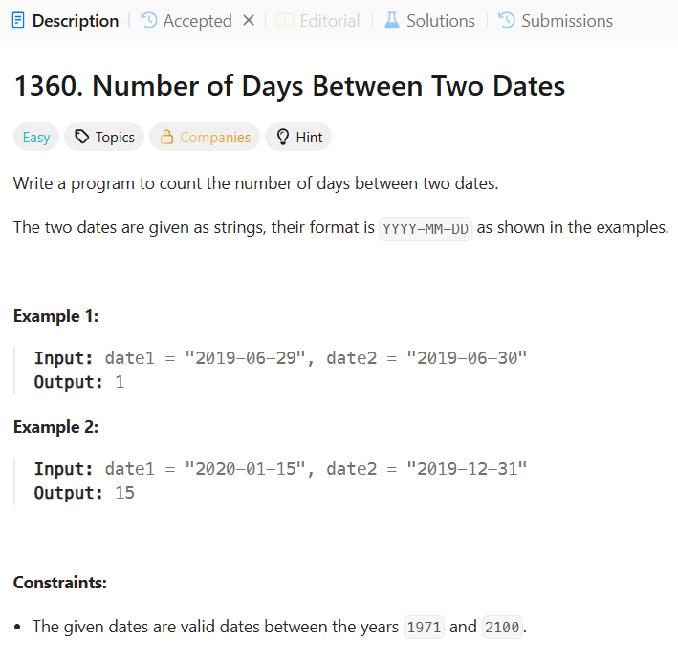
CODE:
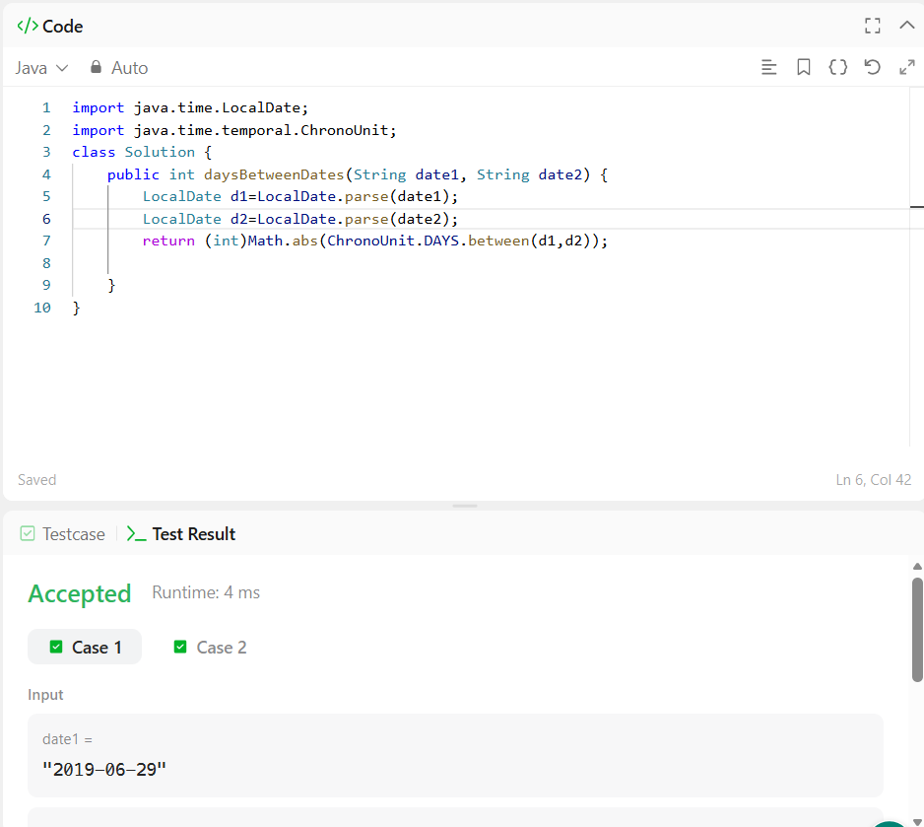
2.
Write a program to count the number of days between two dates.
The two dates are given as strings, their format is YYYY-MM-DD as shown in the examples.

Example 1:
Input: date1 = "2019-06-29", date2 = "2019-06-30"
Output: 1
Example 2:
Input: date1 = "2020-01-15", date2 = "2019-12-31"
Output: 15

Constraints:
- The given dates are valid dates between the years 1971 and 2100.
CODE:
import java.time.LocalDate;
import java.time.temporal.ChronoUnit;
class Solution {
public int daysBetweenDates(String date1, String date2) {
LocalDate d1=LocalDate.parse(date1);
LocalDate d2=LocalDate.parse(date2);
return (int)Math.abs(ChronoUnit.DAYS.between(d1,d2));

}
}

3.
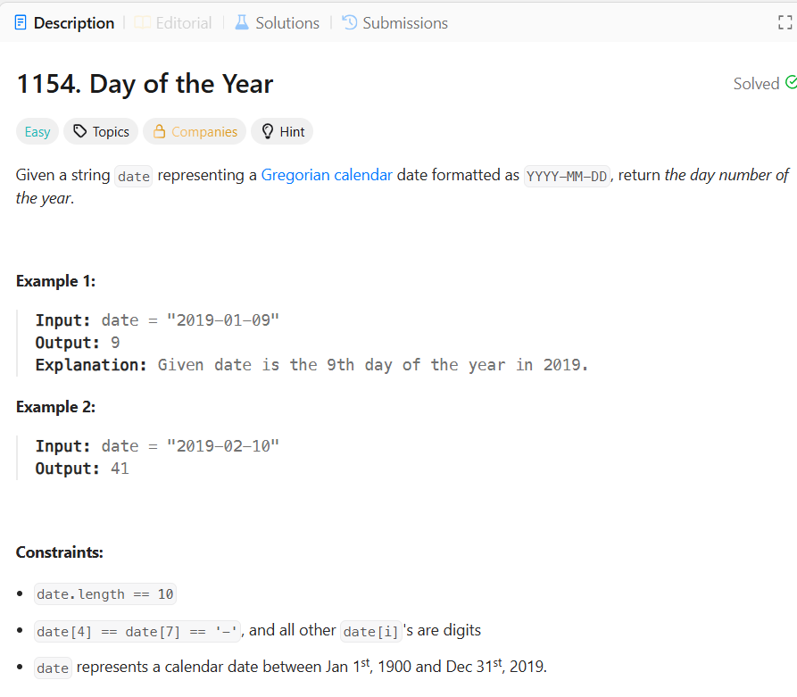
CODE:
class Solution {
public int dayOfYear(String date) {
int year=Integer.parseInt(date.substring(0,4));
int month=Integer.parseInt(date.substring(5,7));
int day=Integer.parseInt(date.substring(8,10));
int[] days={31,28,31,30,31,30,31,31,30,31,30,31};
if (isLeapYear(year)) {
days[1] = 29;
}
int result = day;
for (int i = 0; i < month - 1; i++) {
result += days[i];
}
return result;
}
public boolean isLeapYear(int year) {
if (year % 400 == 0) {
return true;
}
if (year % 100 == 0) {
return false;
}
if (year % 4 == 0) {
return true;
}
return false;
}
}

4.
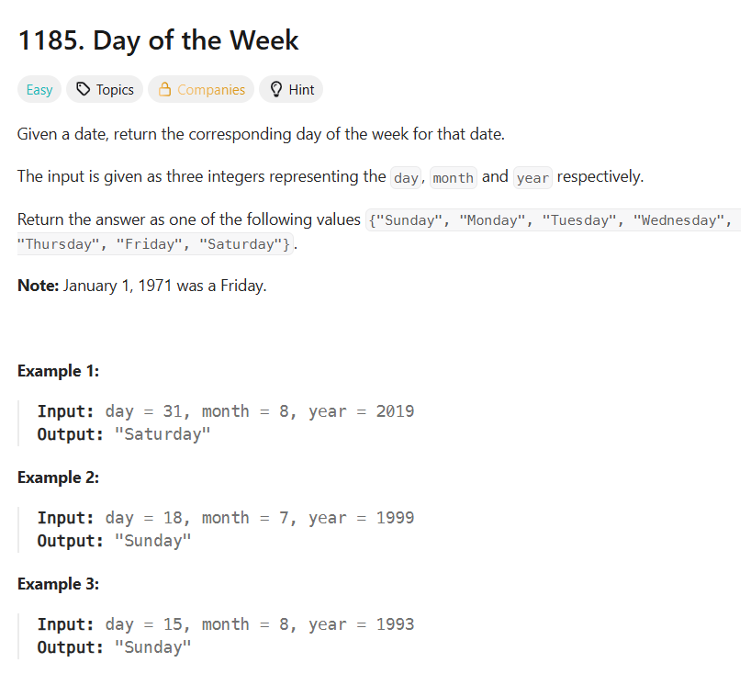
CODE:
import java.time.LocalDate;
class Solution {
public String dayOfTheWeek(int day, int month, int year) {
LocalDate date = LocalDate.of(year, month, day);

String result = date.getDayOfWeek().toString();

return result.charAt(0) + result.substring(1).toLowerCase();
}
}
5.
In computer science, a priority queue is an abstract data type which is like a regular queue, but where additionally each element has a "priority" associated with it. In a priority queue, an element with high priority is served before an element with low priority. - Wikipedia
In this problem we will test your knowledge on Java Priority Queue.
There are a number of students in a school who wait to be served. Two types of events, ENTER and SERVED, can take place which are described below.
- ENTER: A student with some priority enters the queue to be served.
- SERVED: The student with the highest priority is served (removed) from the queue.
A unique id is assigned to each student entering the queue. The queue serves the students based on the following criteria (priority criteria):
- The student having the highest Cumulative Grade Point Average (CGPA) is served first.
- Any students having the same CGPA will be served by name in ascending case-sensitive alphabetical order.
- Any students having the same CGPA and name will be served in ascending order of the id.
Create the following two classes:
- The Student class should implement:
  - The constructor Student(int id, String name, double cgpa).
  - The method int getID() to return the id of the student.
  - The method String getName() to return the name of the student.
  - The method double getCGPA() to return the CGPA of the student.
- The Priorities class should implement the method List<Student> getStudents(List<String> events) to process all the given events and return all the students yet to be served in the priority order.
Input Format
The first line contains an integer, , describing the total number of events. Each of the subsequent lines will be of the following two forms:
- ENTER name CGPA id: The student to be inserted into the priority queue.
- SERVED: The highest priority student in the queue was served.
The locked stub code in the editor reads the input and tests the correctness of the Student and Priorities classes implementation.
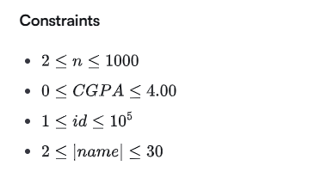
Output Format
The locked stub code prints the names of the students yet to be served in the priority order. If there are no such student, then the code prints EMPTY.
Sample Input 0
12
ENTER John 3.75 50
ENTER Mark 3.8 24
ENTER Shafaet 3.7 35
SERVED
SERVED
ENTER Samiha 3.85 36
SERVED
ENTER Ashley 3.9 42
ENTER Maria 3.6 46
ENTER Anik 3.95 49
ENTER Dan 3.95 50
SERVED
Sample Output 0
Dan
Ashley
Shafaet
Maria
Explanation 0
In this case, the number of events is 12. Let the name of the queue be Q.
- John is added to Q. So, it contains (John, 3.75, 50).
- Mark is added to Q. So, it contains (John, 3.75, 50) and (Mark, 3.8, 24).
- Shafaet is added to Q. So, it contains (John, 3.75, 50), (Mark, 3.8, 24), and (Shafaet, 3.7, 35).
- Mark is served as he has the highest CGPA. So, Q contains (John, 3.75, 50) and (Shafaet, 3.7, 35).
- John is served next as he has the highest CGPA. So, Q contains (Shafaet, 3.7, 35).
- Samiha is added to Q. So, it contains (Shafaet, 3.7, 35) and (Samiha, 3.85, 36).
- Samiha is served as she has the highest CGPA. So, Q contains (Shafaet, 3.7, 35).
- Now, four more students are added to Q. So, it contains (Shafaet, 3.7, 35), (Ashley, 3.9, 42), (Maria, 3.6, 46), (Anik, 3.95, 49), and (Dan, 3.95, 50).
- Anik is served because though both Anil and Dan have the highest CGPA but Anik comes first when sorted in alphabetic order. So, Q contains (Dan, 3.95, 50), (Ashley, 3.9, 42), (Shafaet, 3.7, 35), and (Maria, 3.6, 46).
As all events are completed, the name of each of the remaining students is printed on a new line.
CODE:
import java.io.*;
import java.util.*;
public class Solution {
static class Student {
private int id;
private String name;
private double cgpa;
public Student(int id, String name, double cgpa) {
this.id = id;
this.name = name;
this.cgpa = cgpa;
}
public int getID() {
return id;
}
public String getName() {
return name;
}
public double getCGPA() {
return cgpa;
}
}
static class Priorities {
public List<Student> getStudents(List<String> events) {
PriorityQueue<Student> pq = new PriorityQueue<>(
(a, b) -> {
if (Double.compare(a.getCGPA(), b.getCGPA()) != 0) {
return Double.compare(b.getCGPA(), a.getCGPA());
}
if (!a.getName().equals(b.getName())) {
return a.getName().compareTo(b.getName());
}
return Integer.compare(a.getID(), b.getID());
}
);
for (String event : events) {
String[] parts = event.split(" ");

if (parts[0].equals("ENTER")) {

String name = parts[1];
double cgpa = Double.parseDouble(parts[2]);
int id = Integer.parseInt(parts[3]);

pq.add(new Student(id, name, cgpa));

} else if (parts[0].equals("SERVED")) {

if (!pq.isEmpty()) {
pq.poll();
}
}
}

List<Student> result = new ArrayList<>();

while (!pq.isEmpty()) {
result.add(pq.poll());
}

return result;
}
}

public static void main(String[] args) {
/* Enter your code here. Read input from STDIN. Print output to STDOUT. Your class should be named Solution. */
Scanner sc = new Scanner(System.in);

int n = Integer.parseInt(sc.nextLine());

List<String> events = new ArrayList<>();

for (int i = 0; i < n; i++) {
events.add(sc.nextLine());
}

Priorities priorities = new Priorities();

List<Student> students = priorities.getStudents(events);
if (students.isEmpty()) {
System.out.println("EMPTY");
} else {
for (Student student : students) {
System.out.println(student.getName());
}
}

sc.close();

}
}
6.
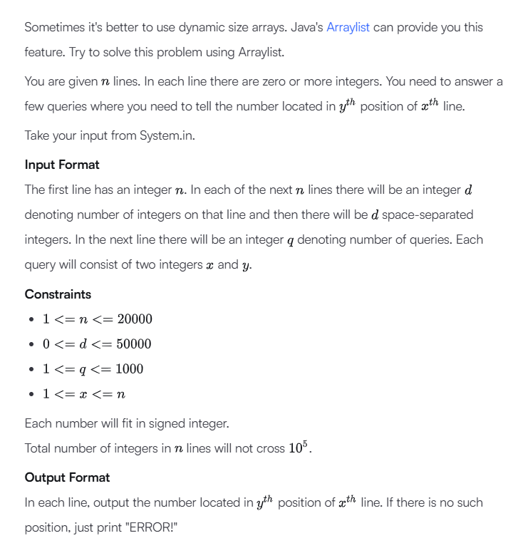
Sample Input
5
5 41 77 74 22 44
1 12
4 37 34 36 52
0
3 20 22 33
5
1 3
3 4
3 1
4 3
5 5
Sample Output
74
52
37
ERROR!
ERROR!
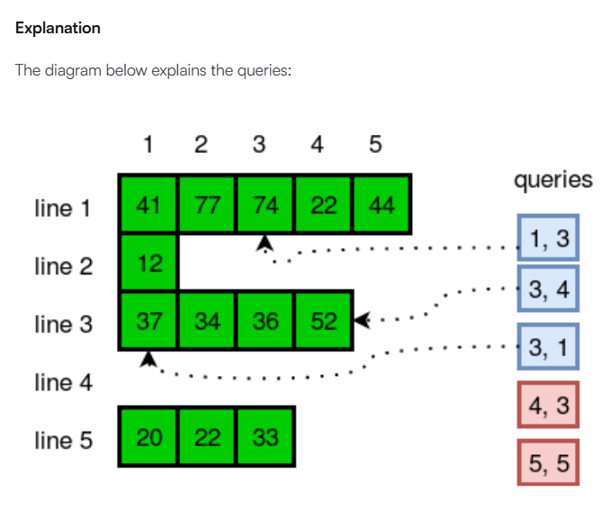

CODE:
import java.io.*;
import java.util.*;
public class Solution {
public static void main(String[] args) {
Scanner sc = new Scanner(System.in);
int n = sc.nextInt();
ArrayList<ArrayList<Integer>> lines = new ArrayList<>();
for (int i = 0; i < n; i++) {
int d = sc.nextInt();
ArrayList<Integer> list = new ArrayList<>();
for (int j = 0; j < d; j++) {
list.add(sc.nextInt());
}
lines.add(list);
}
int q = sc.nextInt();
for (int i = 0; i < q; i++) {
int x = sc.nextInt();
int y = sc.nextInt();
if (x >= 1 && x <= lines.size()
&& y >= 1 && y <= lines.get(x - 1).size()) {
System.out.println(lines.get(x - 1).get(y - 1));
} else {
System.out.println("ERROR!");
}
}
sc.close();
}
}

7.
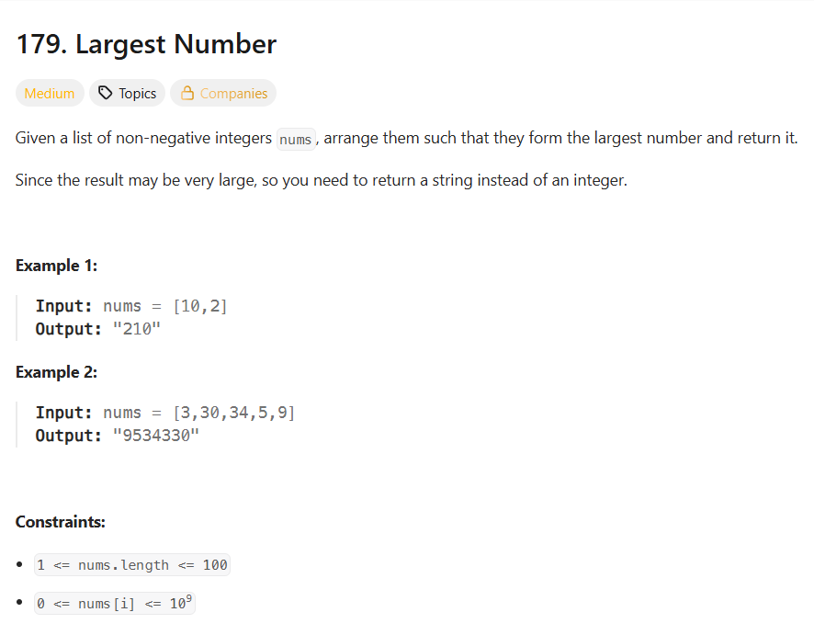
CODE:
class Solution {
public String largestNumber(int[] nums) {
String[] arr = new String[nums.length];
for (int i = 0; i < nums.length; i++) {
arr[i] = String.valueOf(nums[i]);
}
Arrays.sort(arr, (a, b) -> {
return (b + a).compareTo(a + b);
});
if (arr[0].equals("0")) {
return "0";
}

StringBuilder result = new StringBuilder();
for (String s : arr) {
result.append(s);
}
return result.toString();
}
}

