WEEK-6
1.
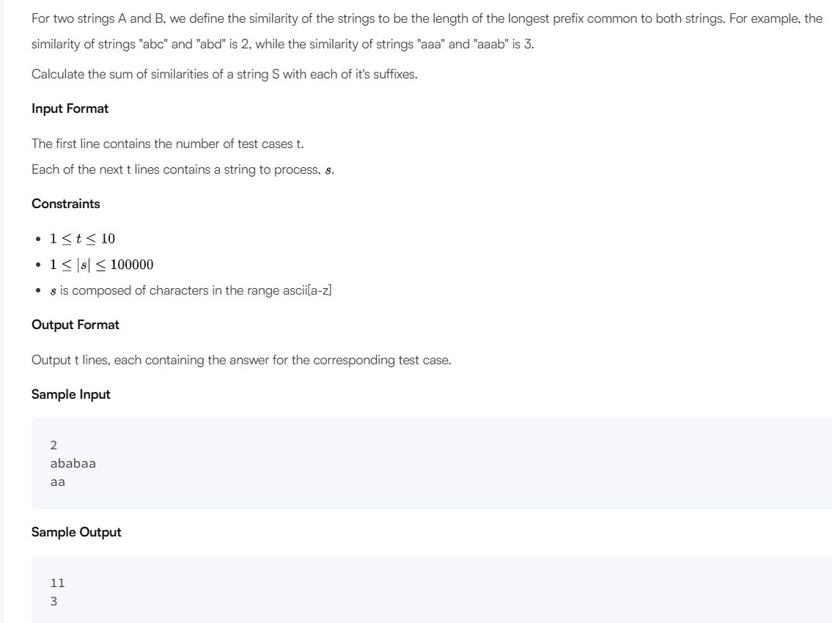
Explanation
For the first case, the suffixes of the string are "ababaa", "babaa", "abaa", "baa", "aa" and "a". The similarities of these strings with the string "ababaa" are 6,0,3,0,1, & 1 respectively. Thus, the answer is 6 + 0 + 3 + 0 + 1 + 1 = 11.
For the second case, the answer is 2 + 1 = 3.
Solution:
import java.io.*;
import java.math.*;
import java.security.*;
import java.text.*;
import java.util.*;
import java.util.concurrent.*;
import java.util.function.*;
import java.util.regex.*;
import java.util.stream.*;
import static java.util.stream.Collectors.joining;
import static java.util.stream.Collectors.toList;
class Result {
public static int stringSimilarity(String s) {
int n = s.length();
int[] z = new int[n];
int left = 0, right = 0;
int sum = n;
for (int i = 1; i < n; i++) {
if (i <= right) {
z[i] = Math.min(right - i + 1, z[i - left]);
}
while (i + z[i] < n &&
s.charAt(z[i]) == s.charAt(i + z[i])) {
z[i]++;
}
if (i + z[i] - 1 > right) {
left = i;
right = i + z[i] - 1;
}
sum += z[i];
}
return sum;
}
public static void main(String[] args) {
Scanner sc = new Scanner(System.in);
int t = sc.nextInt();
while (t-- > 0) {
String s = sc.next();
System.out.println(stringSimilarity(s));
}
sc.close();
}
}
public class Solution {
public static void main(String[] args) throws IOException {
BufferedReader bufferedReader = new BufferedReader(new InputStreamReader(System.in));
BufferedWriter bufferedWriter = new BufferedWriter(new FileWriter(System.getenv("OUTPUT_PATH")));
int t = Integer.parseInt(bufferedReader.readLine().trim());
IntStream.range(0, t).forEach(tItr -> {
try {
String s = bufferedReader.readLine();
int result = Result.stringSimilarity(s);
bufferedWriter.write(String.valueOf(result));
bufferedWriter.newLine();
} catch (IOException ex) {
throw new RuntimeException(ex);
}
});
bufferedReader.close();
bufferedWriter.close();
}
}

2.
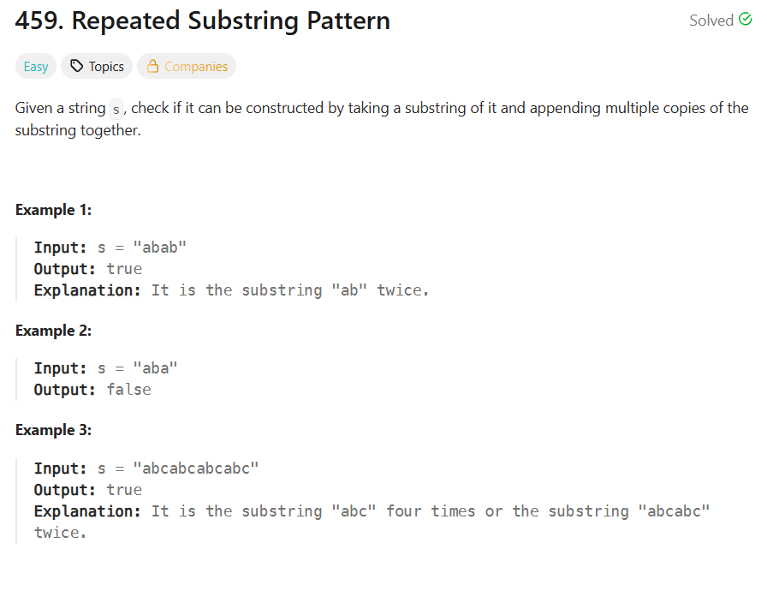
Solution:
class Solution {
public boolean repeatedSubstringPattern(String s) {
String doubled = s + s;
String result = doubled.substring(1, doubled.length() - 1);

return result.contains(s);

}
}

3.
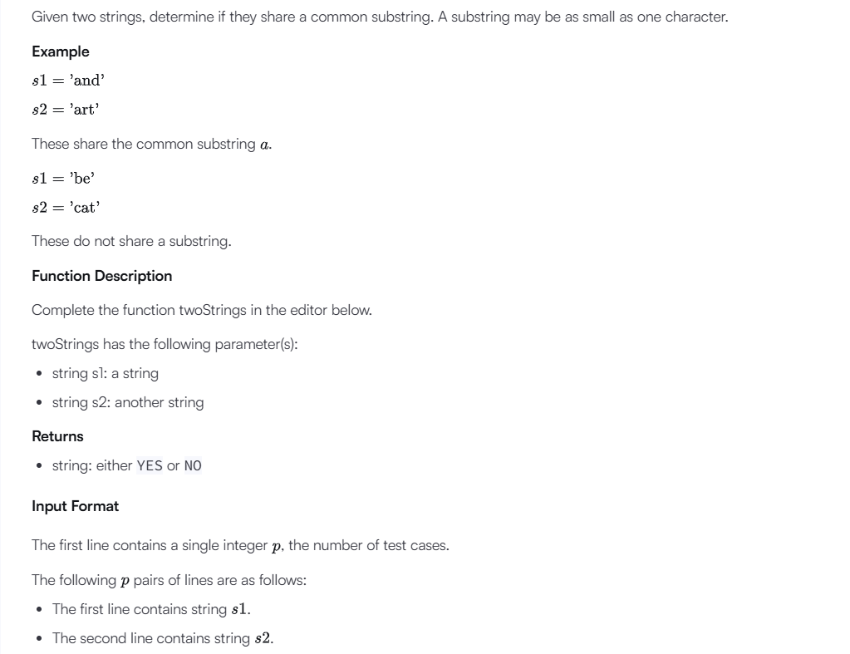
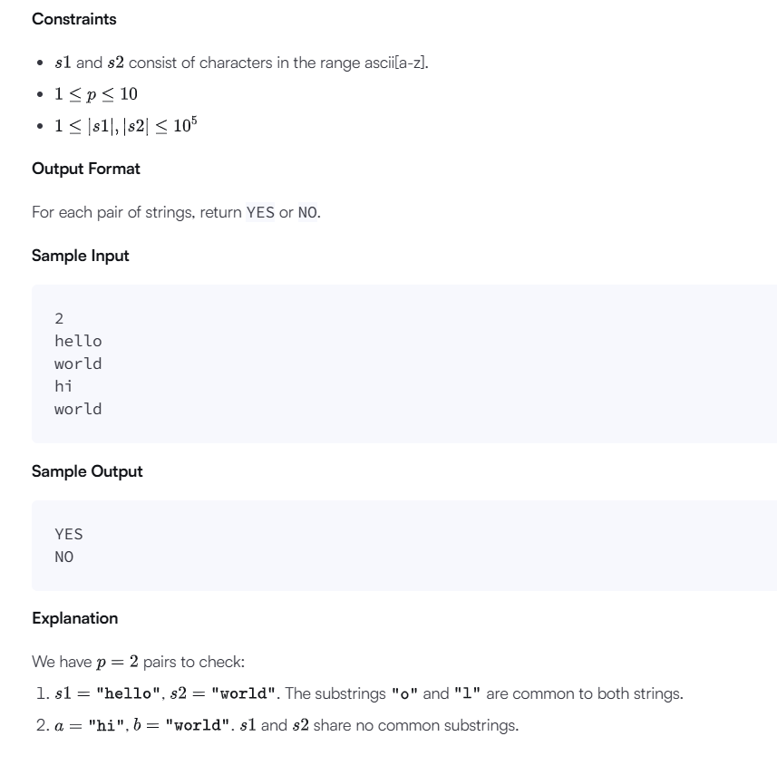
Solution:
import java.io.*;
import java.util.stream.*;

class Result {

public static String twoStrings(String s1, String s2) {
boolean[] seen = new boolean[26];

for (int i = 0; i < s1.length(); i++) {
seen[s1.charAt(i) - 'a'] = true;
}

for (int i = 0; i < s2.length(); i++) {
if (seen[s2.charAt(i) - 'a']) {
return "YES";
}
}

return "NO";
}
}

public class Solution {

public static void main(String[] args) throws IOException {
BufferedReader bufferedReader = new BufferedReader(
new InputStreamReader(System.in));

BufferedWriter bufferedWriter = new BufferedWriter(
new FileWriter(System.getenv("OUTPUT_PATH")));

int q = Integer.parseInt(bufferedReader.readLine().trim());

IntStream.range(0, q).forEach(qItr -> {
try {
String s1 = bufferedReader.readLine();
String s2 = bufferedReader.readLine();

String result = Result.twoStrings(s1, s2);

bufferedWriter.write(result);
bufferedWriter.newLine();

} catch (IOException ex) {
throw new RuntimeException(ex);
}
});

bufferedReader.close();
bufferedWriter.close();
}
}

4.
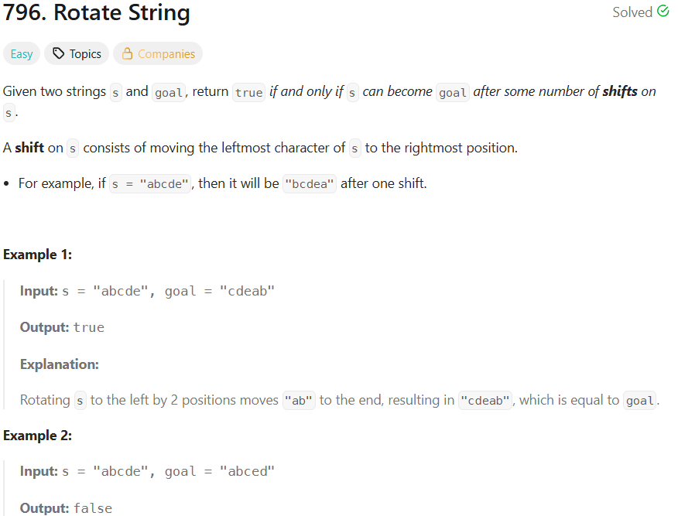
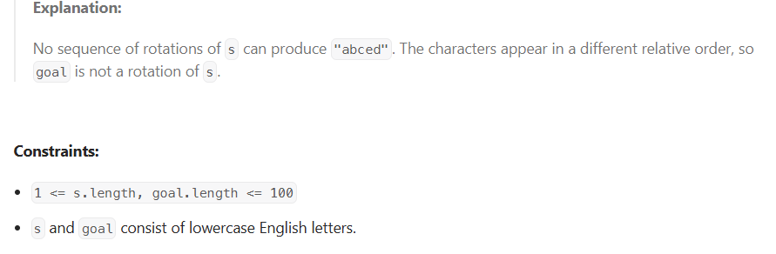
Solution:
class Solution {
public boolean rotateString(String s, String goal) {
if (s.length() != goal.length()) {
return false;
}
String doubled = s + s;
return doubled.contains(goal);}
}
5.
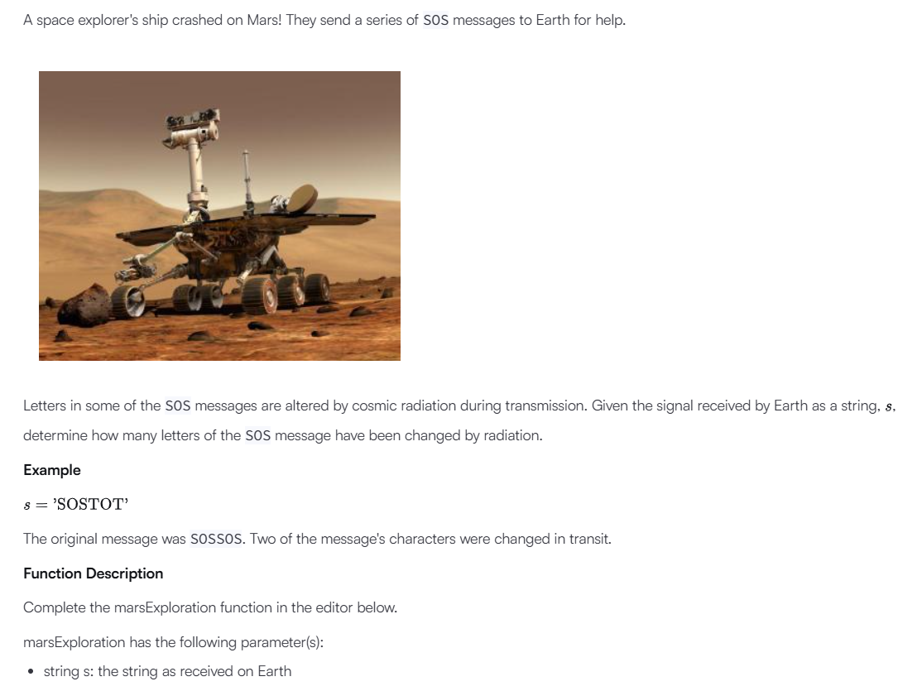
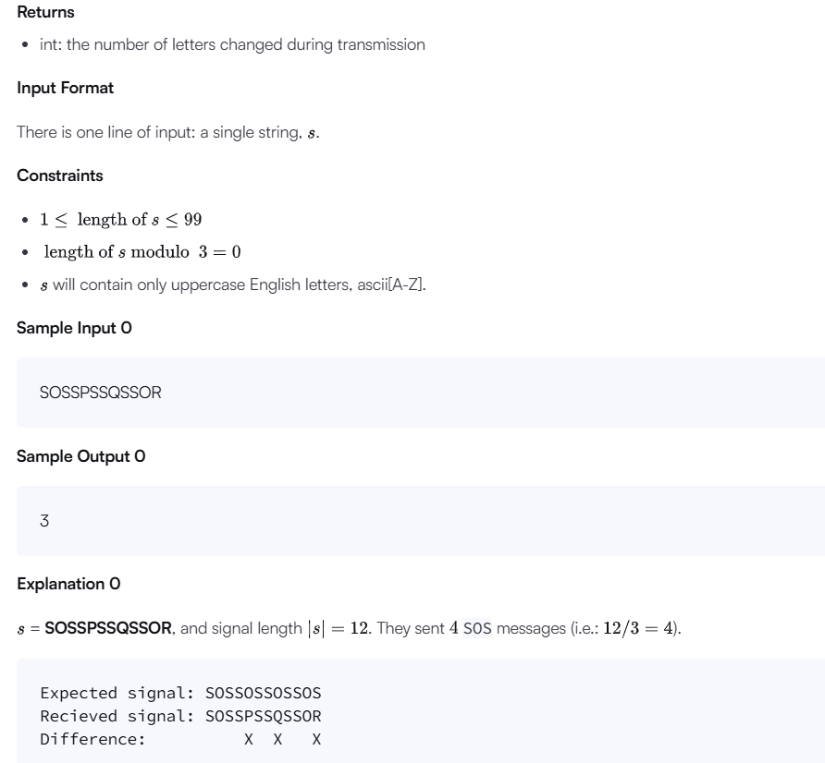
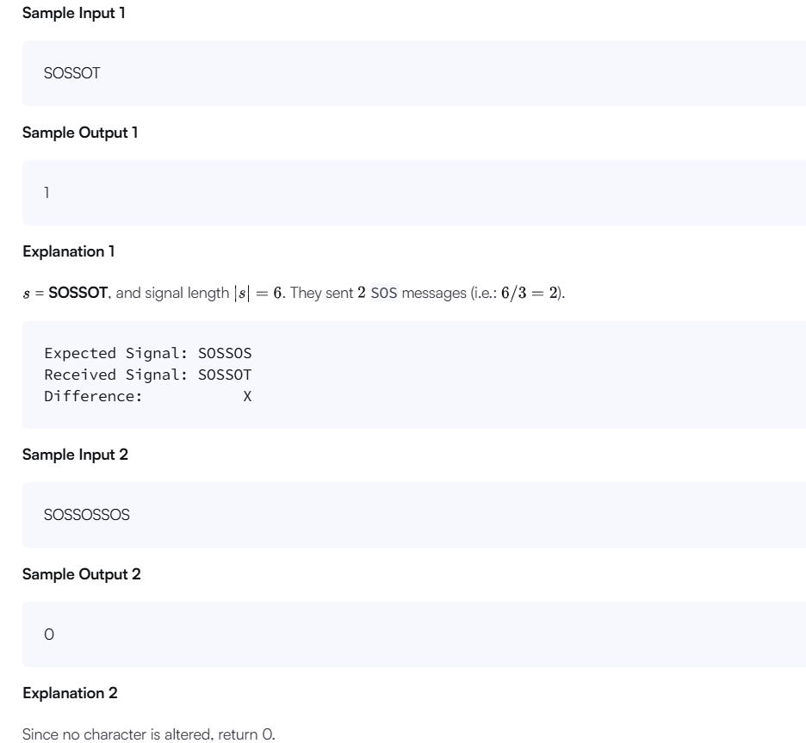

Solution:
import java.io.*;
import java.math.*;
import java.security.*;
import java.text.*;
import java.util.*;
import java.util.concurrent.*;
import java.util.function.*;
import java.util.regex.*;
import java.util.stream.*;
import static java.util.stream.Collectors.joining;
import static java.util.stream.Collectors.toList;
class Result {
public static int marsExploration(String s) {
int count = 0;
for (int i = 0; i < s.length(); i++) {
char expected = "SOS".charAt(i % 3);
if (s.charAt(i) != expected) {
count++;
}
}
return count;
}
}

public class Solution {
public static void main(String[] args) throws IOException {
BufferedReader bufferedReader = new BufferedReader(new InputStreamReader(System.in));
BufferedWriter bufferedWriter = new BufferedWriter(new FileWriter(System.getenv("OUTPUT_PATH")));
String s = bufferedReader.readLine();
int result = Result.marsExploration(s);
bufferedWriter.write(String.valueOf(result));
bufferedWriter.newLine();
bufferedReader.close();
bufferedWriter.close();
}
}

6.
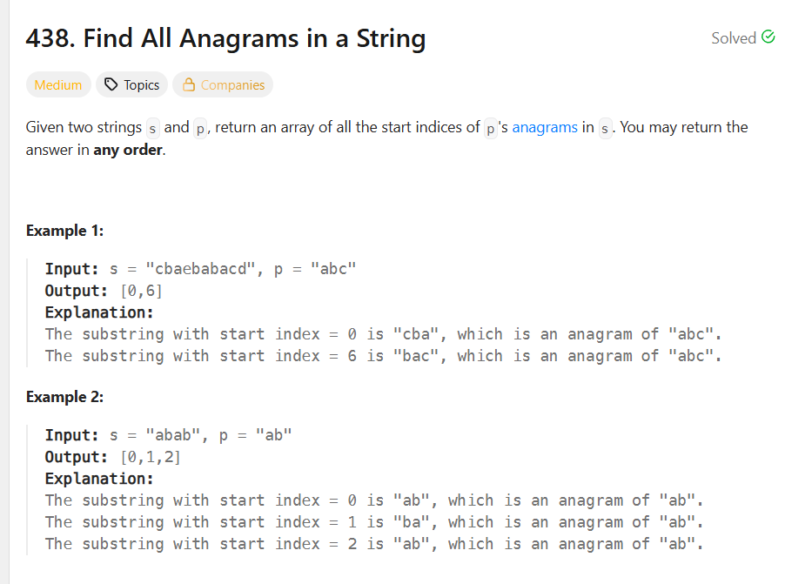
Solution:
class Solution {
public List<Integer> findAnagrams(String s, String p) {
List<Integer> result = new ArrayList<>();
int n = s.length();
int m = p.length();
if (n < m) {
return result;
}
int[] pFreq = new int[26];
int[] sFreq = new int[26];
for (int i = 0; i < m; i++) {
pFreq[p.charAt(i) - 'a']++;
sFreq[s.charAt(i) - 'a']++;
}
for (int i = 0; i <= n - m; i++) {
if (Arrays.equals(pFreq, sFreq)) {
result.add(i);
}
if (i < n - m) {
sFreq[s.charAt(i) - 'a']--;
sFreq[s.charAt(i + m) - 'a']++;
}
}
return result;
}
}

7.
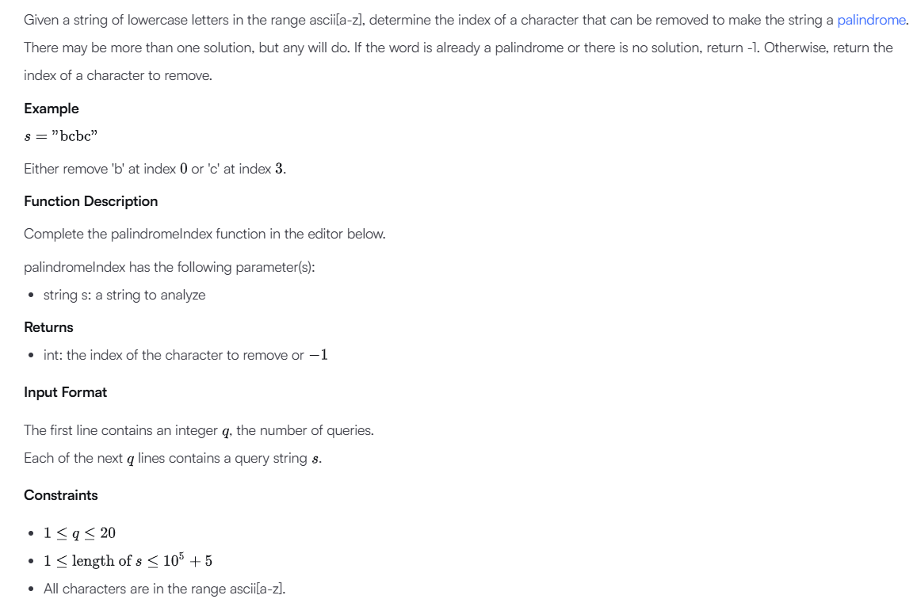

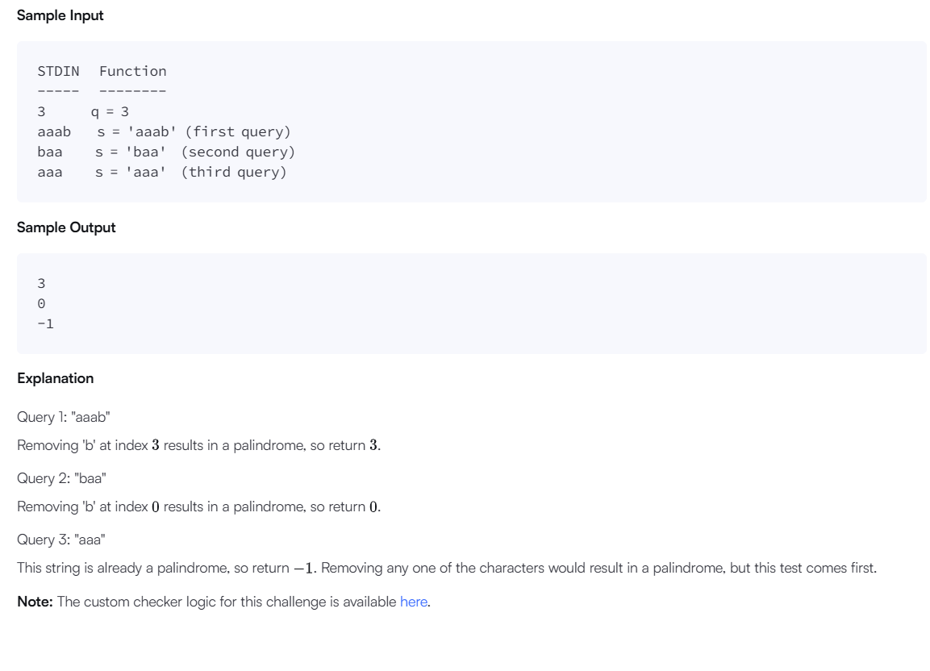

Solution:
import java.io.*;
import java.util.stream.*;

class Result {

public static int palindromeIndex(String s) {
int left = 0;
int right = s.length() - 1;

while (left < right) {
if (s.charAt(left) != s.charAt(right)) {

if (isPalindrome(s, left + 1, right)) {
return left;
}

if (isPalindrome(s, left, right - 1)) {
return right;
}

return -1;
}

left++;
right--;
}

return -1;
}

private static boolean isPalindrome(String s, int left, int right) {
while (left < right) {
if (s.charAt(left) != s.charAt(right)) {
return false;
}

left++;
right--;
}

return true;
}
}

public class Solution {
public static void main(String[] args) throws IOException {
BufferedReader bufferedReader = new BufferedReader(
new InputStreamReader(System.in));

BufferedWriter bufferedWriter = new BufferedWriter(
new FileWriter(System.getenv("OUTPUT_PATH")));

int q = Integer.parseInt(bufferedReader.readLine().trim());

IntStream.range(0, q).forEach(qItr -> {
try {
String s = bufferedReader.readLine();

int result = Result.palindromeIndex(s);

bufferedWriter.write(String.valueOf(result));
bufferedWriter.newLine();
} catch (IOException ex) {
throw new RuntimeException(ex);
}
});

bufferedReader.close();
bufferedWriter.close();
}
}
8.
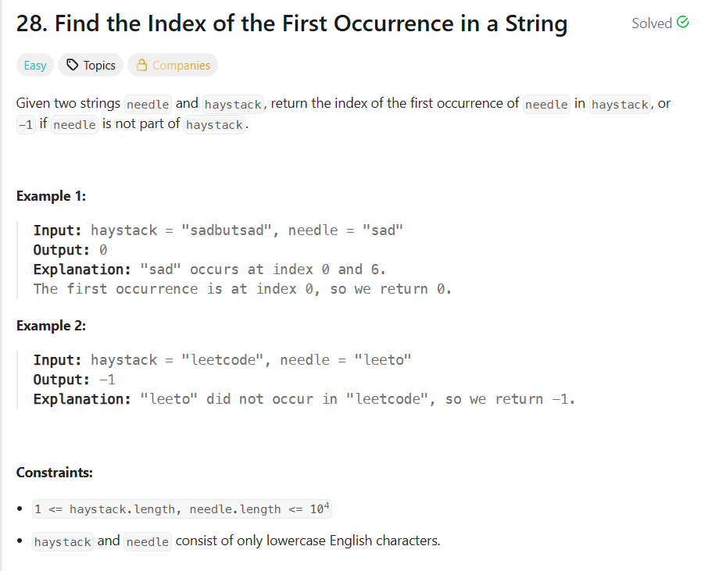
Solution:
class Solution {
public int strStr(String haystack, String needle) {
int n = haystack.length();
int m = needle.length();
for (int i = 0; i <= n - m; i++) {
if (haystack.substring(i, i + m).equals(needle)) {
return i;
}
}
return -1;
} }
9.
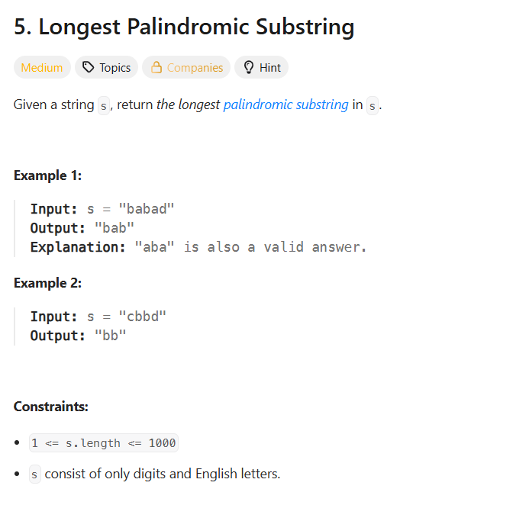
Solution:
class Solution {
public String longestPalindrome(String s) {
int start = 0, maxLen = 1;

for (int i = 0; i < s.length(); i++) {
int len1 = expand(s, i, i);
int len2 = expand(s, i, i + 1);

int len = Math.max(len1, len2);

if (len > maxLen) {
maxLen = len;
start = i - (len - 1) / 2;
}
}

return s.substring(start, start + maxLen);
}

private int expand(String s, int left, int right) {
while (left >= 0 && right < s.length()
&& s.charAt(left) == s.charAt(right)) {
left--;
right++;
}

return right - left - 1;

}
}

10.
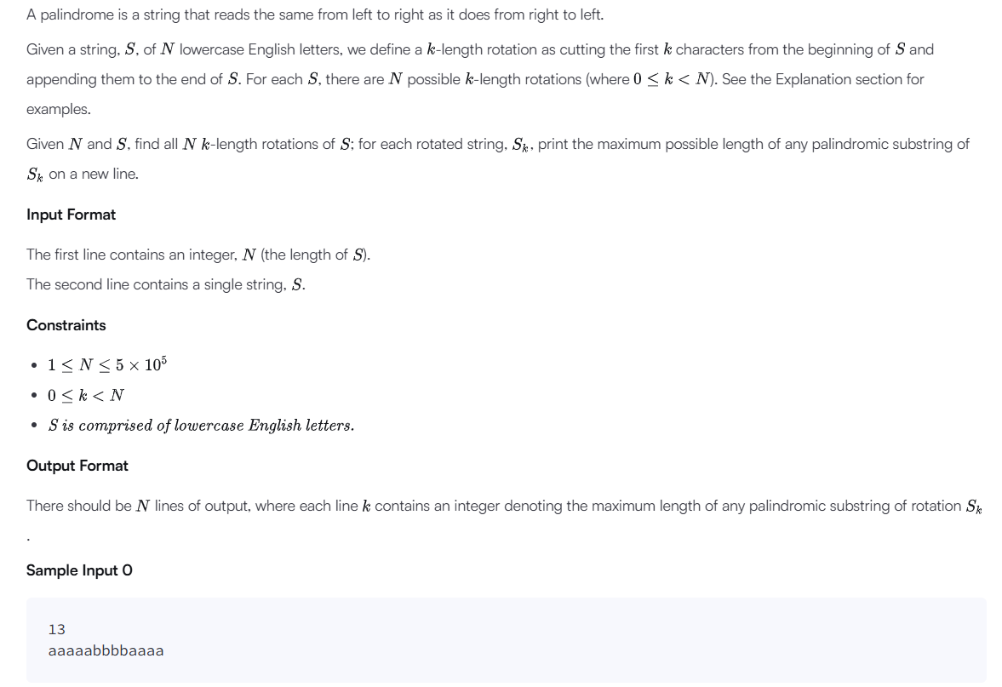
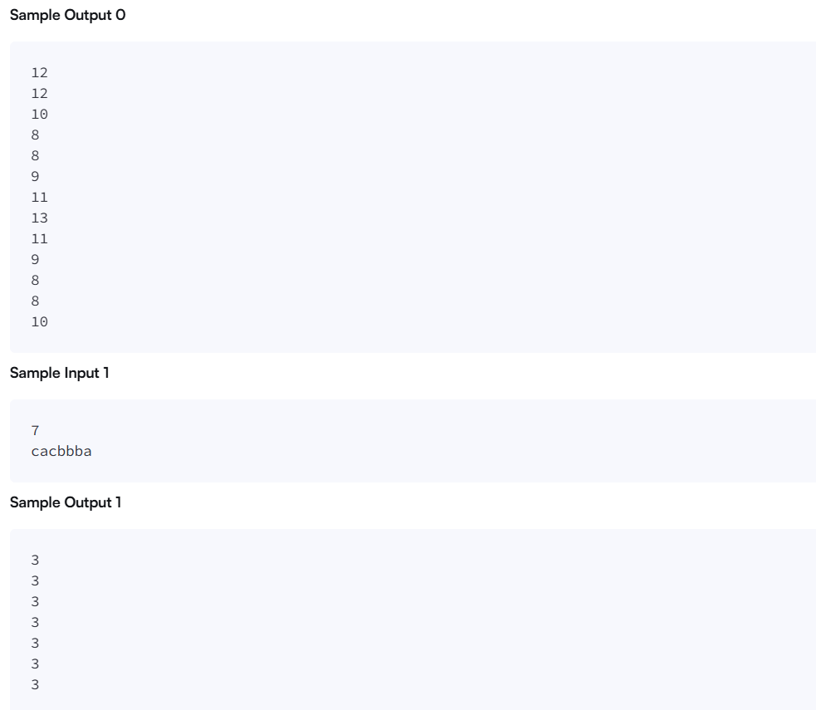
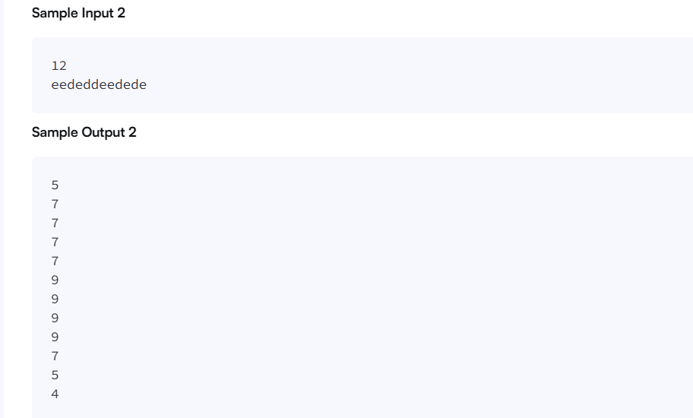
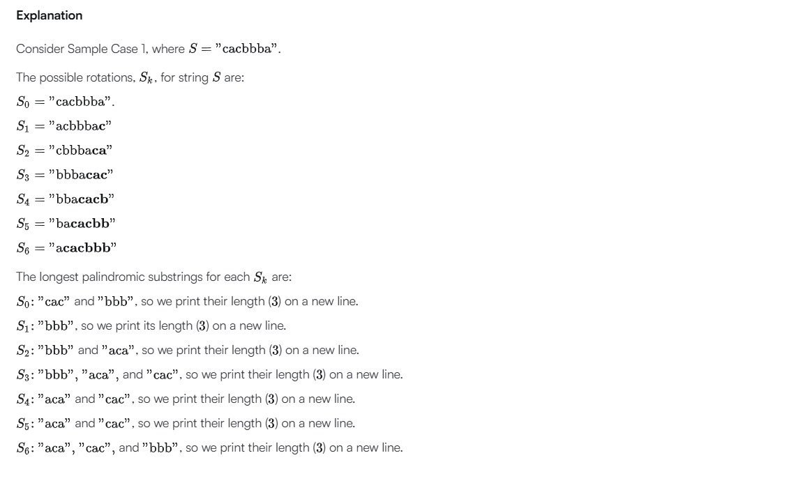
Solution:
import java.io.*;
import java.math.*;
import java.security.*;
import java.text.*;
import java.util.*;
import java.util.concurrent.*;
import java.util.function.*;
import java.util.regex.*;
import java.util.stream.*;
import static java.util.stream.Collectors.joining;
import static java.util.stream.Collectors.toList;
class Result {
public static List<Integer> circularPalindromes(String s) {
int n = s.length();
String str = s + s;
int len = str.length();
int[] odd = new int[len];
int[] even = new int[len];
int l = 0, r = -1;
for (int i = 0; i < len; i++) {
int k = (i > r) ? 1 : Math.min(odd[l + r - i], r - i + 1);
while (i - k >= 0 && i + k < len &&
str.charAt(i - k) == str.charAt(i + k)) {
k++;
}
odd[i] = k - 1;
if (i + odd[i] > r) {
l = i - odd[i];
r = i + odd[i];
}
}
l = 0;
r = -1;
for (int i = 0; i < len; i++) {
int k = (i > r) ? 0 :
Math.min(even[l + r - i + 1], r - i + 1);
while (i - k - 1 >= 0 && i + k < len &&
str.charAt(i - k - 1) == str.charAt(i + k)) {
k++;
}
even[i] = k;
if (i + even[i] - 1 > r) {
l = i - even[i];
r = i + even[i] - 1;
}
}
List<Integer> result = new ArrayList<>();
for (int start = 0; start < n; start++) {
int best = 1;
for (int center = start; center < start + n; center++) {
int radius = Math.min(
odd[center],
Math.min(center - start, start + n - 1 - center)
);
best = Math.max(best, 2 * radius + 1);
radius = Math.min(
even[center],
Math.min(center - start, start + n - 1 - center + 1)
);
best = Math.max(best, 2 * radius);
}
result.add(best);
}

return result;

}
}
public class Solution {
public static void main(String[] args) throws IOException {
BufferedReader bufferedReader = new BufferedReader(new InputStreamReader(System.in));
BufferedWriter bufferedWriter = new BufferedWriter(new FileWriter(System.getenv("OUTPUT_PATH")));
int n = Integer.parseInt(bufferedReader.readLine().trim());
String s = bufferedReader.readLine();
List<Integer> result = Result.circularPalindromes(s);
bufferedWriter.write(
result.stream()
.map(Object::toString)
.collect(joining("\n"))
+ "\n"
);
bufferedReader.close();
bufferedWriter.close();
}
}

