**Identifying Noisiest Spots and Quietest Areas of Montreal Using GIS Analysis**

*Mahyar Khatirinejad*

1. **Introduction**

The noise from different sources such as industry, car traffic, trains and airplanes are regulated by municipal governments in Canada. However, The Canada Noise Abatement Legislation is not as strong as other developed countries. The first quantitative noise bylaw was passed by Ottawa in 1979. During the recent decades, the nuisance noises have increased in urban and suburb areas due to urbanization and industrialization. Noise levels can be classified into three different ranges in terms of their effects on people. The threshold of hearing is approximately zero decibels. The noise that we can consider as quiet or loud is between 0 and 40 decibels. While, the noise between 40 and 80 decibels are nuisance noise.

Generally, nuisance noise can cause annoyance which will indirectly ended up with stress responses, symptoms and probably illness (Patricelli, Gail et al.2006). Not only noise pollution can directly lead to hearing impairment but also it causes ill-health. Different researches show the impact of noise pollution on human being. For example, a study was conducted in order to show the impact of noise pollution on children in different schools. The results presented that children from noisy school are more stressful along with higher blood pressure compare to school in quieter areas.

Moreover, noise pollution can influence the bird’s behavior. Bird’s communication rely on singing. They do different activities through singing such as attracting their mates, warning each other for predators, and also defending territory. The researches show that the noise pollution alters the bird behaviour which will effect on their communication. For example, a research that was conducted shows that the birds are interested to sing when they are not interrupted by the sounds of human transportation. Therefore, it is important to know the spots that birds interrupt by human made noise pollution. As can be seen noise pollution as an “unwanted sound” can be associated with its issues and the noisy habitats (Cohen, Sheldon, et al. 1980)

For the sake of avoiding the nuisance noise impact on human being and natural in urban areas, the governments legitimate abatements and restrictions for noise pollution. Although the noise bylaws are different from borough by borough because of their different circumstances. There are some common and general information about noise bylaw. For example, Aircraft noise is controlled by Transport Canada. Canadian airports that have noise abatement policies for aircraft takeoffs and landings include Montréal International.

Noise pollution in urban areas is usually derive from certain points such as construction building, highway traffic, train, and aircrafts noise. One of the efficient methods to reduce noise is making shields between the source and the receiver. Therefore, engineers are making different types of barriers such as Wide barriers, Wedge and Screen in urban areas along the highways or railroads to control noise (Kurze, Ulrich J. 1974). However, like other environmental issues, avoiding a noise problem is more cost efficient compare to applying these noise barriers.

This study has attempted to pursue two main aims. The first goal is obtaining two maps of the noisiest spots and quietest area of Montreal in order to help municipality or citizens of Montreal to choose the suitable spots for their future actions that could be conflict or associated with noise pollution. The second goal is providing a map of noisiest woodland spots of Montreal in order to help birdwatchers and bird fans to protect the bird habitat. Section 2 will provide a summary of what data was selected for use, and how it was provided and analyzed. Section 3 will provide an overview of the final maps created.

1. **Methodology**

Different layers have applied in this model namely, Montreal Outline, Railroads, Highways and Vegetation. All layers except airport polygon are taken from project data set provided by the class. The airport polygon was digitized through google earth by “add polygon” and then saved as the “kmz” file. All layers were projected in the same projection (WGS_1984). So, I did not need to change any layer projection through project data management tool.

* + 1. Buffers

The buffer tool makes a polygon given a radius and another point, line or polygon file. The polygon created will delineate the area around that shape. In this project, this tool is used as the first step for all three final maps. Three different buffer zones were created for each layer through the “Multiple Ring Layer” tool. Because the sound decreases over space, the rings of the multiple ring buffer represent sound decreasing over area. Here are the distances prescribed to the multiple ring buffers:-

Airport: 1) 100m, 2) 300m, 3) 500m

Highway: 1) 20m, 2) 50m, 3) 80

Rail line: 1) 100m, 2) 200m, 3) 300m

* + 1. Union

The union tool provides a geometric output of any number of feature classes and feature layers. All provided layers were in polygon geometry and there was no need to convert any layer to polygon format before using this tool. However each original shapefile contained numerous individual polygons that were “unioned” into one. Next, this tool was employed to create one layer of all noisy buffer zones. This resulted in the map of “Quietest Area of Montreal” through distinguishing the noisy area from the other part of the Montreal Island (map. 2).

* + 1. Intersection

This tool makes a feature as the intersect output where all the input features intersect with each other. This was used to determine the noisiest woodland spots of Montreal, the second final map. First of all, the vegetation layer added to the union feature. Next, the intersect tool implemented to show the woodland spots of Montreal that intersect with noise pollution area.

Finally, in order to display a map of “Noisiest Woodland Spots of Montreal” the union layer was unselected (map.3)

* + 1. Reclassification and Weighted overlay

The weighted overlay tool created an indexed raster of overlapping layers. It was used to determine the loudest areas of Montreal using the multiple ring buffered shapefiles.

This tool accepts raster inputs only. First, “Polygon to Raster” was used to change the buffered data to files. These newly created raster layers have different values and needed to be reclassified in order to represent the levels of noise. The tool reclassify was used to do this.

Now, the data is prepared to use the weighted overlay tool. This tool creates a new layer of weighted intersecting input rasters. It identifies the common areas. The weights of each input raster represent the noise levels of the multiple ring buffers. The purpose of using this tool was to show were these buffers overlapped and thus produced noisiest areas (map. 1). One feature of this tool is to set the “influence” of each input raster. It was set to equal influence because the layers calibrated to represent the associated noise by using the reclassify tool.

1. **Analysis**

Generally, map 1 and 3 representing the “Quietest Area of Montreal” and “Noisiest Spots of Montreal”, respectively. So, these silent areas could be informative for municipality of Montreal in the case of structural building hospital, school or parks that need to be establish in calm area or being away from the noisy spots. Also, it can be interesting for citizens with different reasons as well. For example, they can choose whether they want to spend their weekend in calm or noisy area or even if they are going to move to a new a place they can refer to these maps in order to choose their calm or suitable area in Montreal. As can be seen, the map 3 shows two red (less noisy) and black (noisiest) area of Montreal. For example, the two black points close by highway 20 in Kirkland and north of the airport shows that these spots are one of the nosiest spots in Montreal. (See map Noisiest Spots of Montreal).

The second map identified the woodland spots that have intersect with noisy area of Montreal (union buffer zone of three layers). The researches show that the noise pollution through interrupting the birds singing can influence the bird densities, community species richness, and their reproductive. So, it would be interesting to find the noisiest spots in birds’ habitat which would be helpful to restore their habitat or it would be interesting for the birdwatchers to know in which places they can find bird easier (Swaddle, John P et al 2007). Bird’s communication rely on singing. They do different activities through singing such as attract their mates, warn each other for predators, and also defend territory. The researches show that the noise pollution alters the bird behaviour which will effect on their communication. For example, a research that was conducted shows that the birds are interested to sing when they are not interrupted by the sounds of human transportation. Therefore, it is important to know the spots that birds interrupt by human made noise pollution. As can be seen in the second map, presenting the woodland area as suitable habitat for birds and the red spots which has intersect with the woodlands. Therefore, there is possibility to find less birds in these spots. For example, we can find high density of noisy spots (red spots) in east of the west island which the train in passing by the woodland.

1. **Conclusion**

As a conclusion, the three maps presenting the “Quietest Area of Montreal”, “Noisiest Spots of Montreal”, and “Noisiest Woodlands Spots” were identified through ArcGis 10.1. The results show that generally the north of Montreal that does not touch the train-line is quieter compared to the other area. Moreover, it would be difficult to find birds in the woodland areas which have intersection with noisy areas. Finally, the train-line usually has the most role in noise pollution in Montreal.

1. **References**

* Patricelli, Gail L., and Jessica L. Blickley. "Avian communication in urban noise: causes and consequences of vocal adjustment." The Auk 123.3 (2006): 639-649.
* Swaddle, John P., and Laura C. Page. "High levels of environmental noise erode pair preferences in zebra finches: implications for noise pollution." Animal Behaviour 74.3 (2007): 363-368.
* Cohen, Sheldon, et al. "Physiological, motivational, and cognitive effects of aircraft noise on children: moving from the laboratory to the field." American psychologist 35.3 (1980): 231.
* Kurze, Ulrich J. "Noise reduction by barriers." The Journal of the Acoustical Society of America 55.3 (1974): 504-518.

1. **Figures and Maps**

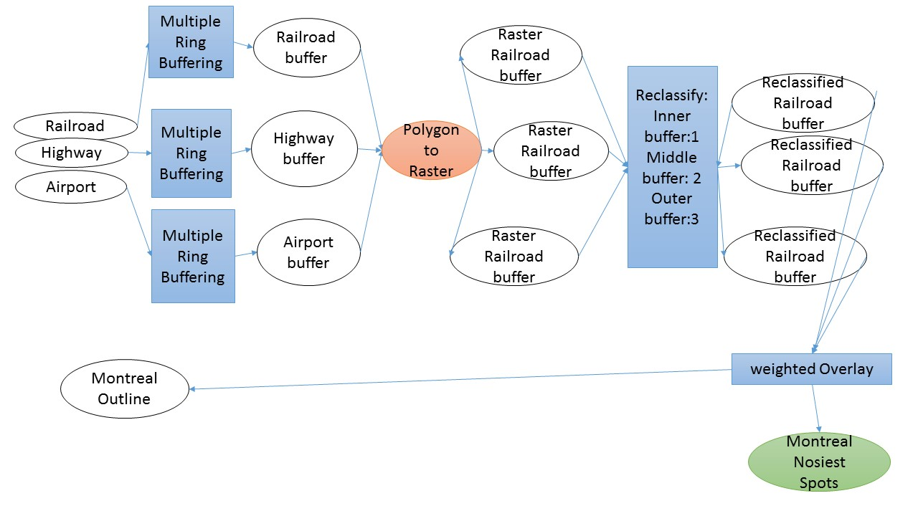

Figure 1 Noisiest Spots of Montreal

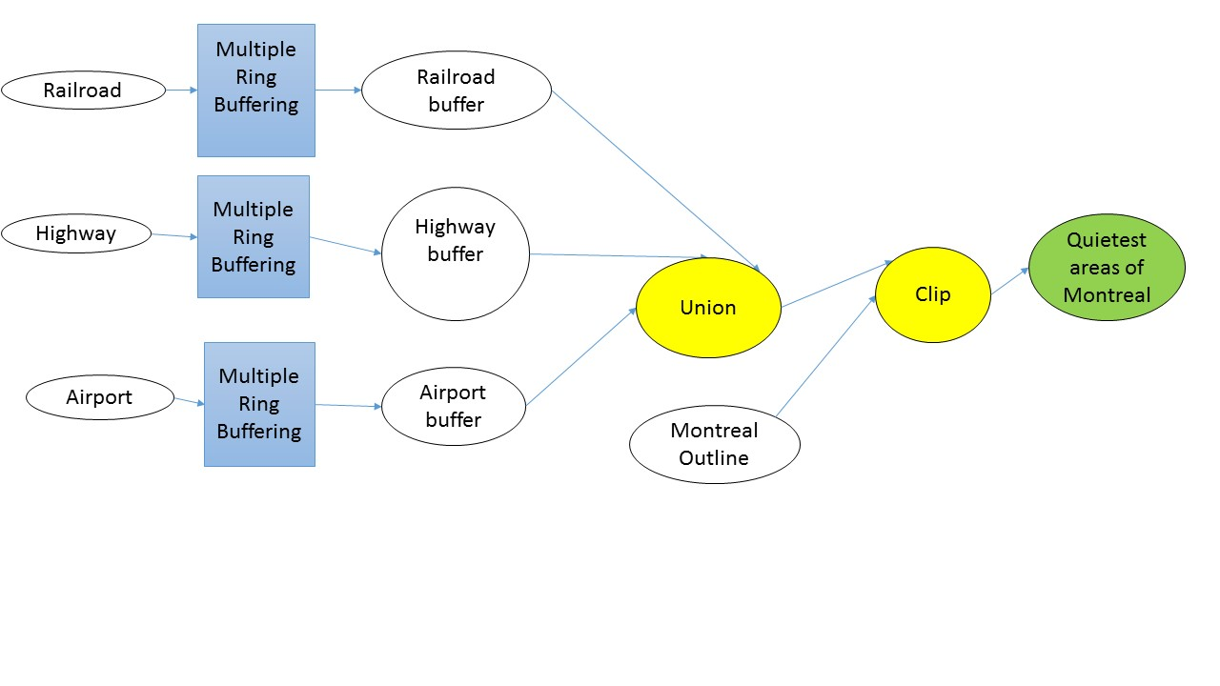

Figure 2Quietest Areas of Montreal

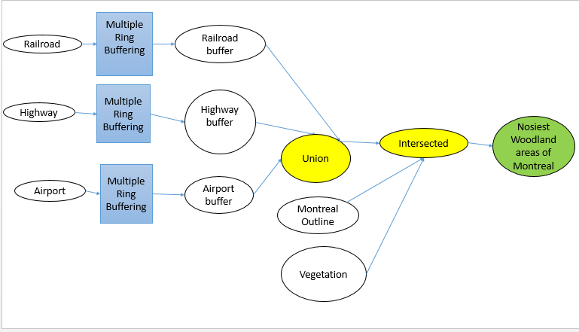

Figure 3 Noisiest Woodland Areas of Montreal

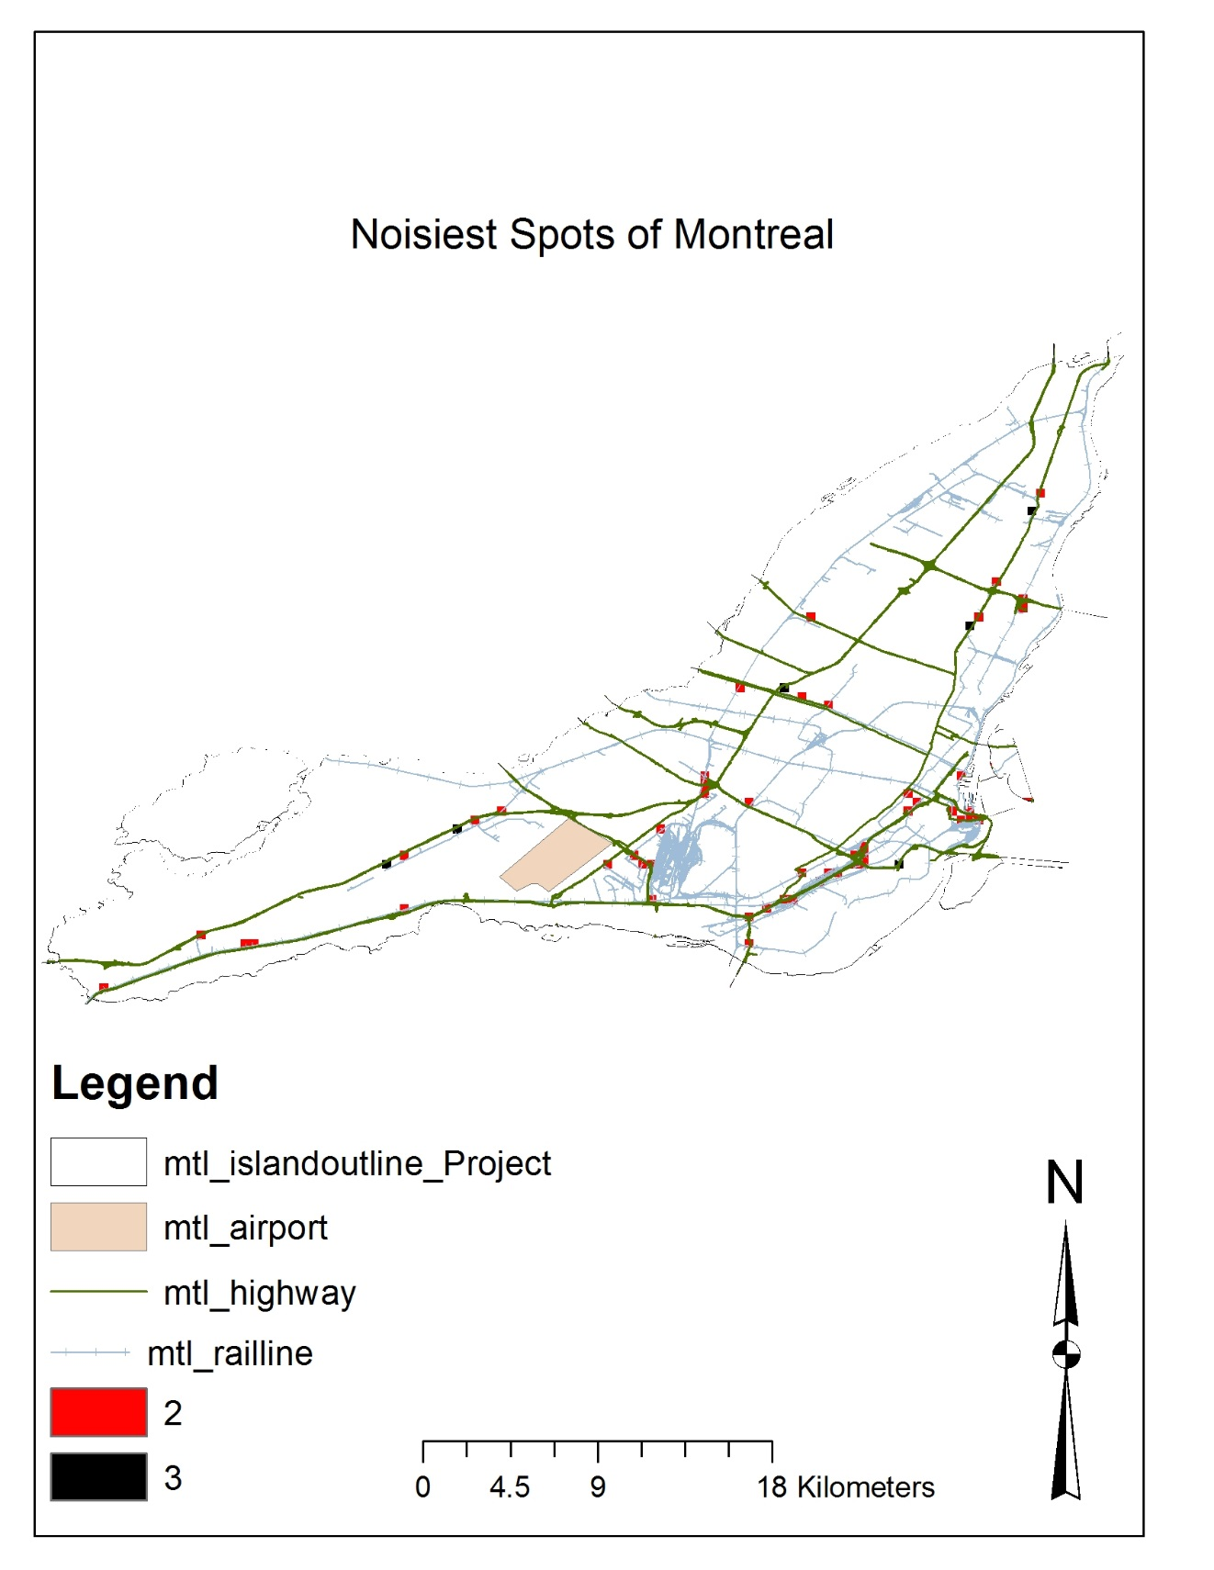

Map 1 Noisiest Spots of Montreal

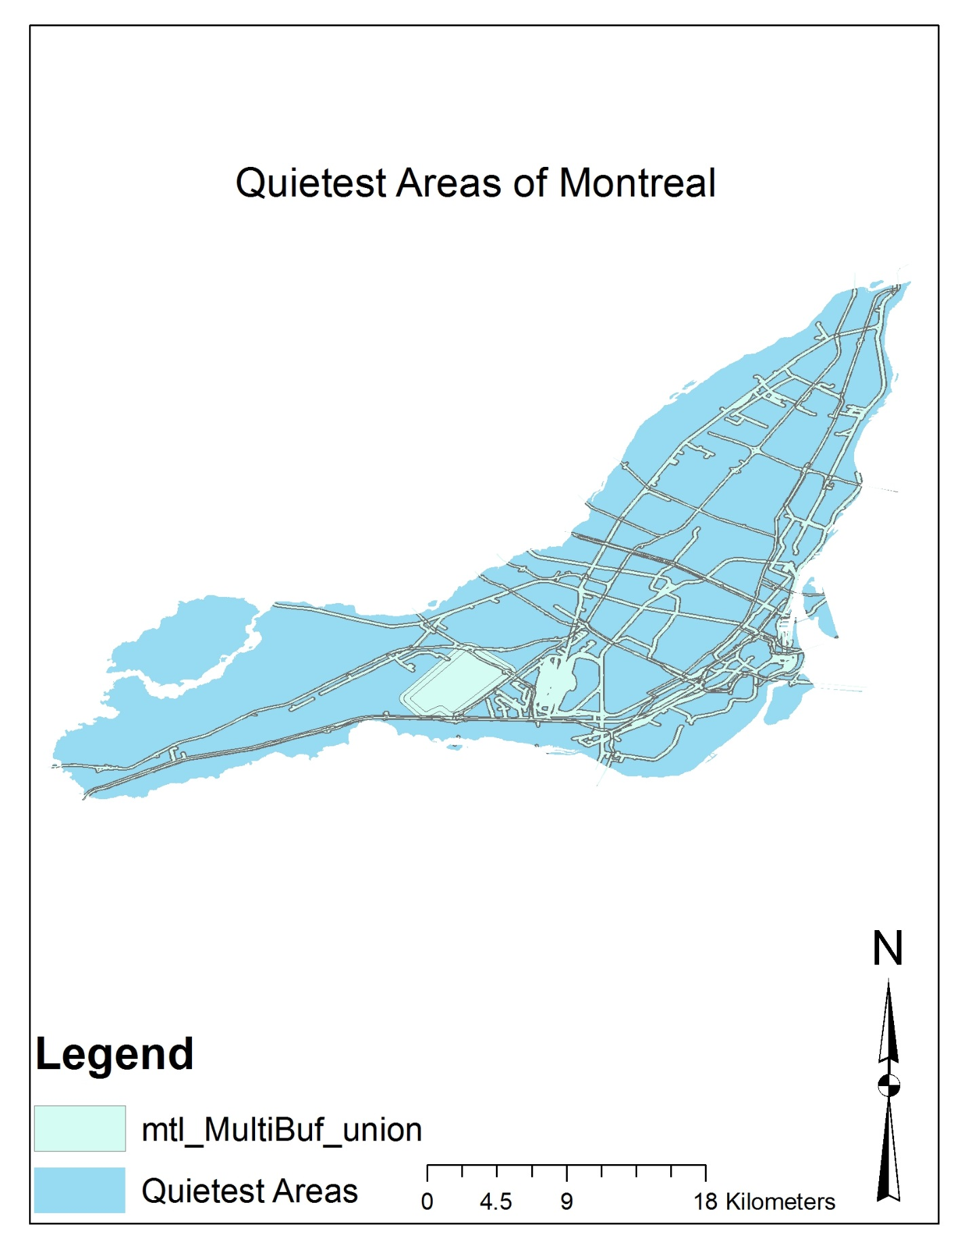

Map 2 Quietest Areas of Montreal

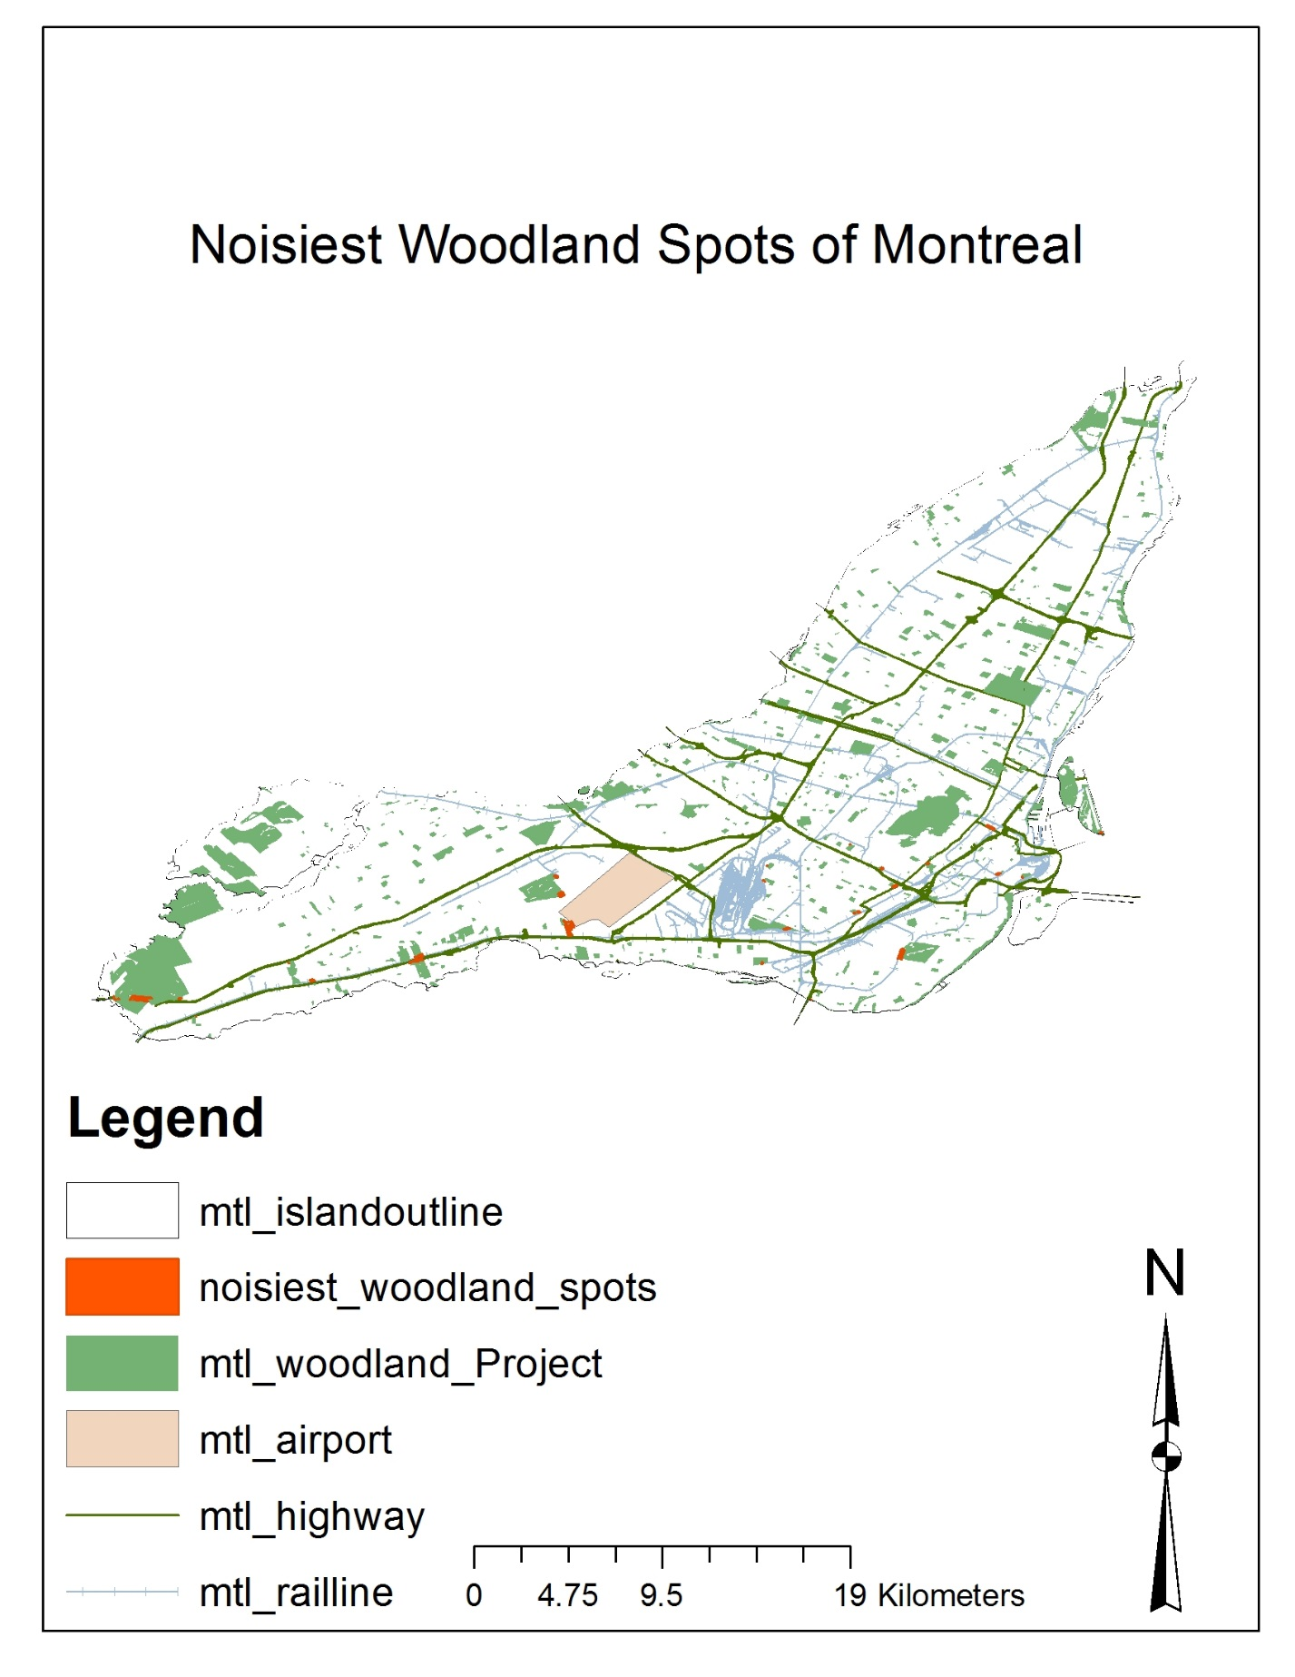

Map 3 Noisiest Woodland Spots of Montreal