Analysis - Once you’ve run the cells provided, it was your job to build on this exploratory analysis:

* The visualization provided by Estelle shows how many companies churned vs. how many companies did not churn. We can see from this that the churn rate is approximately 10%. This is actually a very good churn rate, the closer the rate is to 0%, the better.
* The next series of visualizations were created in an attempt to try and dive deeper into how churn changes based on other factors (using other columns). This is useful for us to investigate because it may help us to understand factors that drive churn.
* In the notebook we visualize churn vs. sales channel, contract type, number of products, number of years and origin/contract offer.
* For example:
  + We see that for sales channel, there are some sales channels that yield customers churning but there are also other sales channels that have no customers churning.
  + For contract type, we see quite an even split for customers churning. This is interesting because this may suggest that contract type is not a driving factor towards churn rate.
* Additionally, for some columns their distributions with churn rate included. This is useful for us to understand because based on the distribution of a column, this could affect our feature engineering later.
* We look at the distribution of consumption, subscribed power and forecast in the notebook.
* For example:
  + We notice that the distribution of consumption is very skewed, this is called a positive skew since it is biased towards lower values on the x axis.
  + This is interesting because you may decide to treat this column to reduce the skewness later on during feature engineering. But also because we may want to visualize if there are any outliers within this column.
  + To investigate outliers, we use a boxplot. From the boxplot we can see that with the column as it is there are definitely some outliers. Once again this is interesting because we may choose to remove some of these outliers later.

Skills Needed

* **Business Understanding**
* **Hypothesis Framing**
* **Communication**
* **Programming**
* **Exploratory Data Analysis**
* **Data Visualization**
* **Creativity**
* **Mathematical Modelling**
* **Model Evaluation**
* **Synthesis**
* **Client Communication**
* **Model Interpretation**

And how does a Random Forest work?

A random forest is a supervised learning algorithm which means that you must provide the algorithm with a set of features, as well as the outcome that you’re trying to predict, in our case churn.

The way it makes predictions is by building a set of decision trees on different samples of the data and by taking a majority vote to decide what prediction to make.

To visualize this, the image below shows 9 decision trees and they are all trying to predict an outcome which is either a 1 or a 0 (similar to our case, where if someone has churned you see a 1, and if they haven’t you see a 0).

The random forest would look at all the predictions generated from the 9 trees. You can see that 6 trees have predicted 1 and 3 have predicted 0. Therefore, the random forest would take the majority vote and present it’s prediction as equal to 1.

If you wish to learn more on how this algorithm works, you can read more [here](https://www.analyticsvidhya.com/blog/2021/06/understanding-random-forest/#:~:text=Random%20forest%20is%20a%20Supervised,average%20in%20case%20of%20regression.).

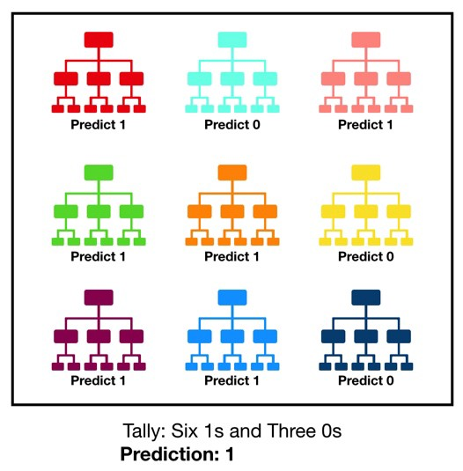

Task 4:

**Explanation:**

This final task is focused on building the predictive model using the CSV file that Estelle has shared.

* This CSV file contains a set of cleaned and engineered features so that you can focus purely on training your predictive model.
* You should download the Jupyter notebook and CSV file and run the cells provided in the notebook.
* These cells will load the data and create train and test samples of the data.
* It is important to split your data into train and test samples so then you can measure how well the trained model performs on an unseen set of data.
* This is a massively important thing to do when building a predictive model, otherwise you will have no way of measuring how well your model is able to predict churn for new customers!
* The code in the notebook provides you with skeleton code to create the random forest classifier, but it is your job to fill in the details of the code by using the documentation site provided.
* By adding in values for parameters within the random forest and by fitting the model on the training data, you will have a trained model to predict churn!

Now the most important part, evaluation of the model:

* It is left for you to decide how to evaluate the performance of the model. In general, you want to use metrics that reflect honestly how well the model has performed.
* In the notebook we use 3 metrics, accuracy, precision and recall.
* The reason why we are using these three metrics is because a simple accuracy measure (what percentage did I predict correctly) is not always a good measure to use.
* To give an example, let's say you're predicting heart failures with patients in a hospital and there were 100 patients out of 1000 that did have a heart failure.
* If you predicted 80 out of 100 (80%) of the patients that did have a heart failure correctly, you might think that you've done well! However, this also means that you predicted 20 wrong and what may the implications of predicting these remaining 20 patients wrong? Maybe they miss out on getting vital treatment to save their lives.
* As well as this, what about the impact of predicting negative cases as positive (people not having heart failure being predicted that they did), maybe a high number of false positives means that resources get used up on the wrong people and a lot of time is wasted when they could have been helping the real heart failure sufferers.
* This is just an example, but it illustrates why other performance metrics are necessary such as precision and recall, which are good measures to use in a classification scenario like this.
* After calculating the 3 metrics, we can see that we’re able to accurately identify clients that do not churn, but not so accurately identify clients that will churn. Our model is predicting a high percentage of clients to not churn, when in fact they did!
* This tells me that the current set of columns are not a good set of features to predict churn. As the data scientist, it would normally be my job to go back and try to engineer a set of features that is able to predict churn more accurately.

Finally, we produce a feature importance chart to visualise which features were indeed useful within the model and which ones weren’t.

* We can see that net margin and consumption over 12 months were important, to name a few.
* However the price sensitivity features are scattered around and do not shine through as a main driver for churn in their current form.

Finally, let's create a quick summary for the client

Before we finish up, the client wants a quick update on the project progress. Your AD wants you to draft an abstract (executive summary) of your findings so far.

**Here is your task:**

Develop an abstract slide synthesizing all the findings from the project so far, keeping in mind that this will be for the key stakeholders meeting which the Head of the SME division, as well as other various stakeholders, will be attending.

**Note:** a steering committee meeting is a meeting where the BCG team presents key findings and recommendations (and/or project progress) to key client stakeholders.

**Please use the template below and submit your summary slide in PDF format.**We'll show you an example answer on the next step

A few things to think about for this abstract include:

* What is the most important number or metric to share with the client?
* What impact would the model have on the client’s bottom line?

Please note, there are multiple ways to approach the task and that the sample answer is just one way to do it.

**If you are stuck:**

* What do you think the client wants to hear? How much detail should you go into, especially with the technical details of your work?
* Always test what you write with the “so what?” test, i.e. sharing a fact, even an interesting one, only matters if the client can actually do something useful with it. E.g. 60% of your customers are from City A is pointless, but customers in City A should be prioritized for giving discount as they are among your most valuable ones, if true, is an actionable finding.
* **“Why are you interested in this role?”**
* I recently participated in BCG's Data Science job simulation on the Forage platform, and it was incredibly useful to understand what it might be like to participate on a data science and analytics team at BCG.
* I worked on a project to create a customer churn analysis simulation using Python. This project built my data science skills in a real-world context, as well as my presentation skills through creating an executive summary of my findings for the team.
* Doing this program confirmed that I really enjoy working on data science projects and I'm excited to apply these skills on a data science team at a company like BCG.