**Algorithms Assignment 1 & 2**

**Memory Management System**

The memory management system generates blocks of size 2N where N varies from 0 to 9.

**Test Case 1:**

Generation of 10 memory blocks of different size 2N where N varies from 0 to 9.

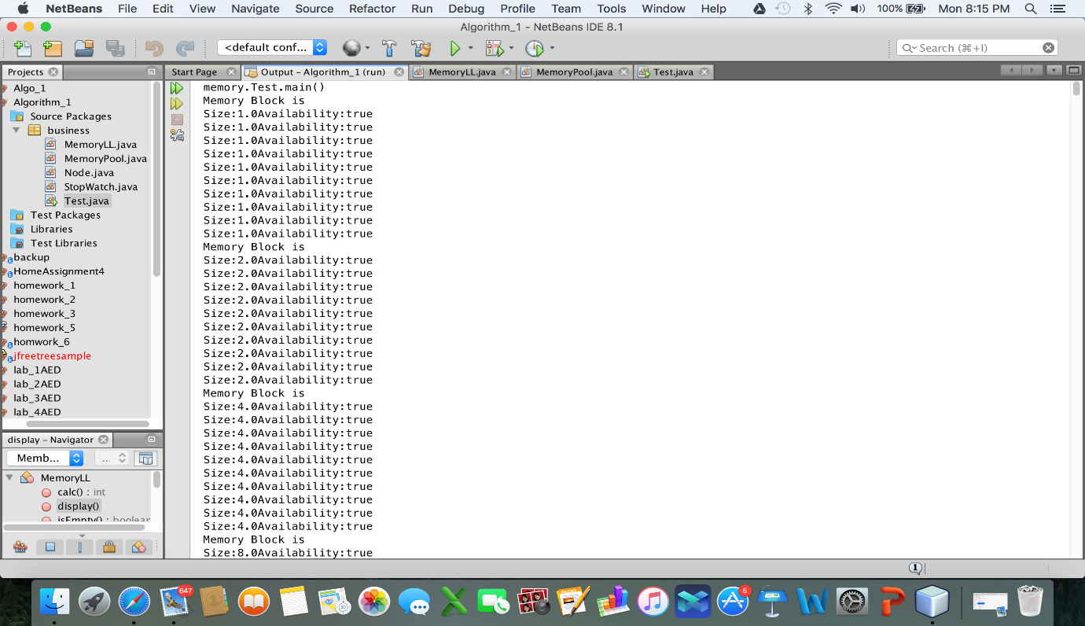

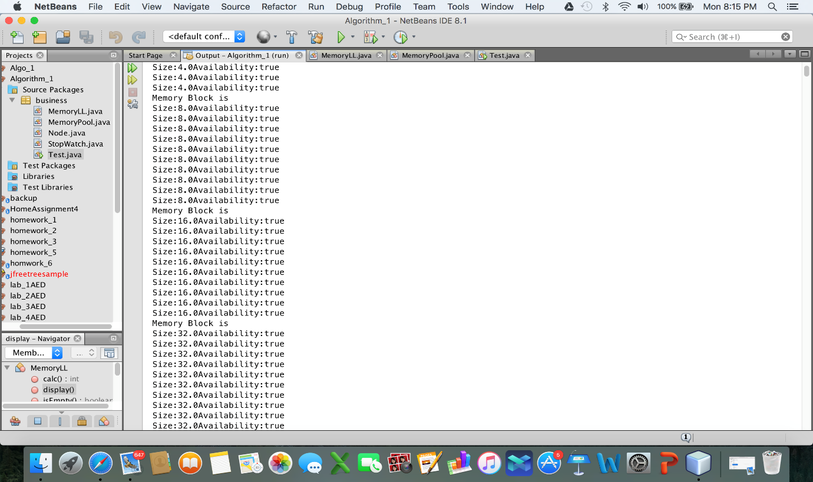

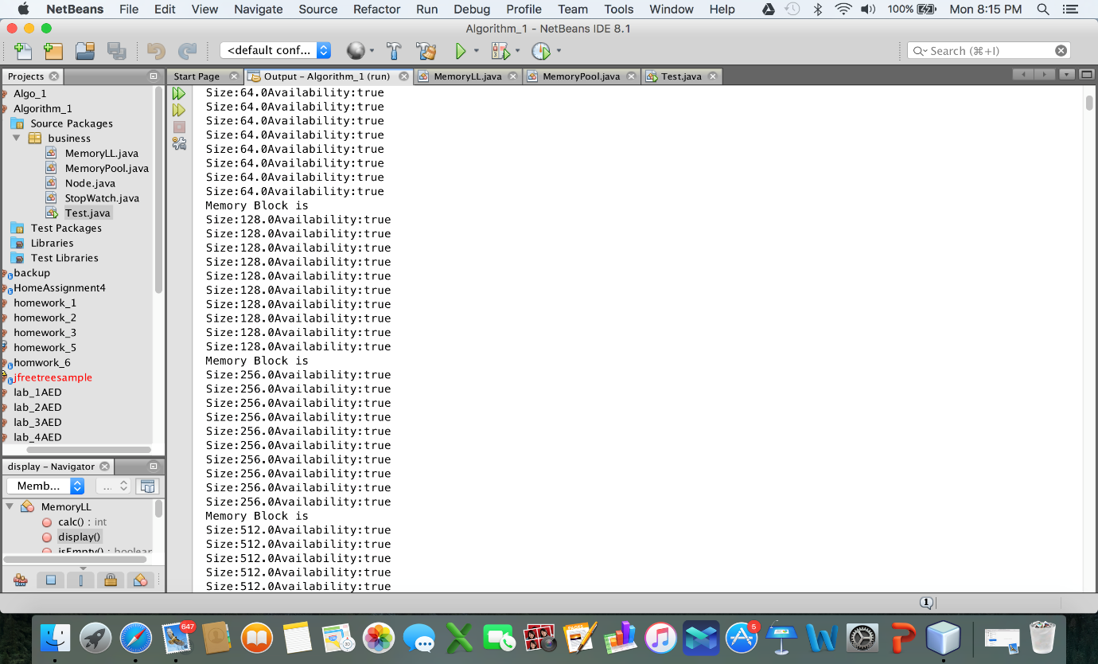

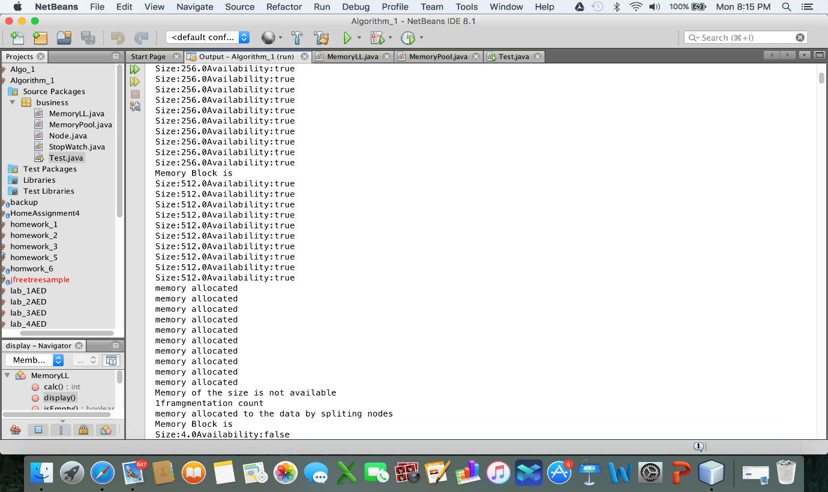

**Test Case 2:**

Memory allocation request, fragmentation, defragmentation and failed requests

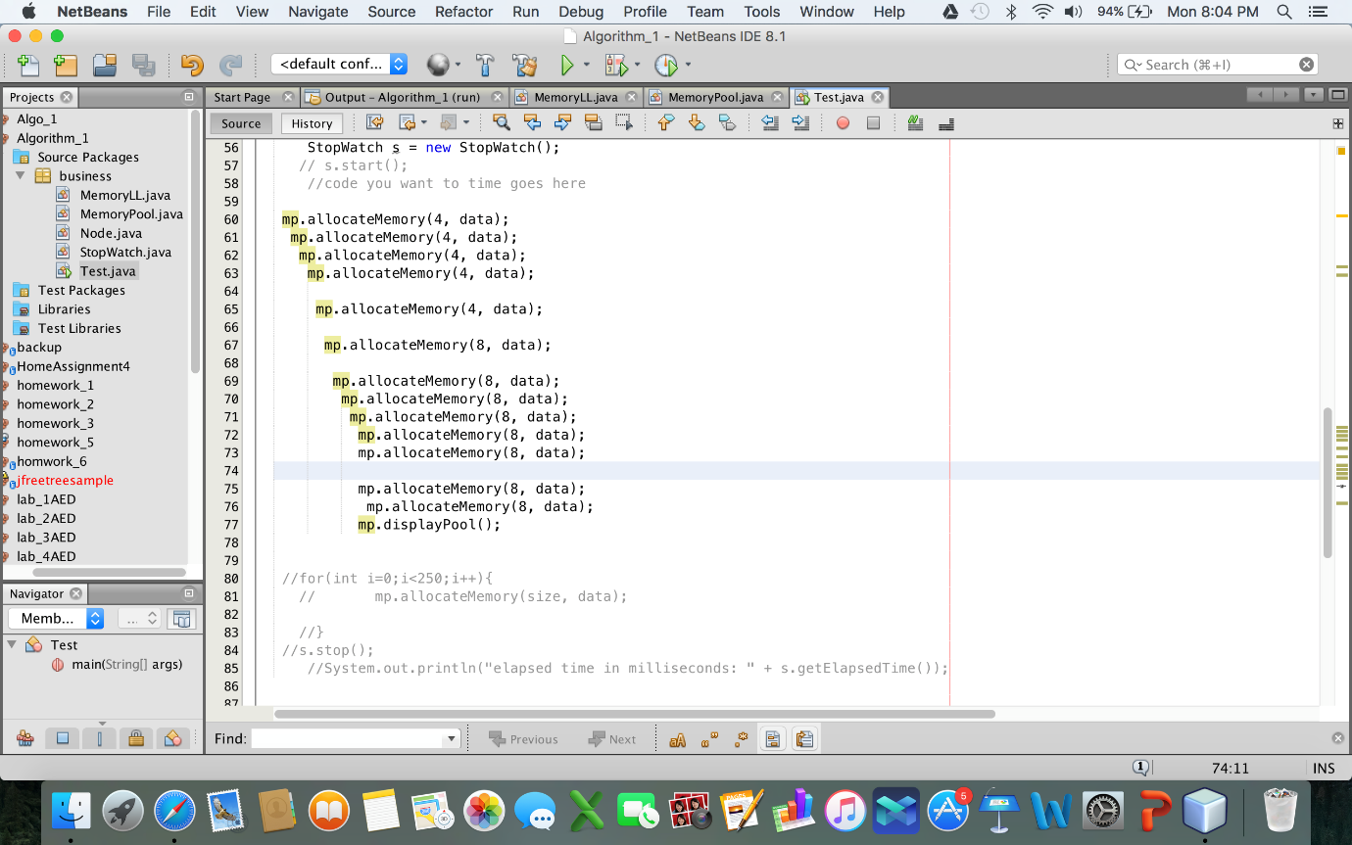



**Time taken for memory allocation:**

|  |  |  |  |
| --- | --- | --- | --- |
| **No of requests(N)** | **Time taken to complete allocation (seconds)** | **Failed Requests** | **Fragmentation** |
| 250 | 17 | 171 | 36 |
| 500 | 38 | 341 | 46 |
| 1000 | 138 | 961 | 31 |
| 2000 | 648 | 1361 | 40 |
| 4000 | 1886 | 3981 | 30 |
| 8000 | 4335 | 6722 | 20 |
| 10000 | 5187 | 9961 | 15 |
| 16000 | 9232 | 15981 | 8 |

**Graphical Representation of no. of requests and time taken to complete allocation:**

**X-axis**: Number of Requests

**Y-axis**: Total time taken to complete the request

**Inference**: As the number of requests increases the time taken to process those requests increases.

Hence it forms a **linear** graph.

**Log-Log graph for the above**

**X-axis:** Number of Requests

**Y-axis:** Total time taken to complete the request

**Graphical Representation of No of requests and no of failed requests:**

**Inference:** As the number of request increases, the number of failed requests increase as more memory is being occupied at every allocation request.

**Graphical Representation of number of requests and fragmentation count**

**Inference:** As the number of requests increases, the number of requests solved by fragmentation decreases eventually.