Practical -1

Aim: Initiate the semester-long Student Hub portal by identifying the problem scope, user roles, key modules, navigation flow, and minimum 10 pages. Create a sitemap, low-fidelity wireframe, project folder structure, README file, and GitHub repository.

Tools/Technology to be Used: VS Code, Draw.io/Figma, Git, GitHub
Site Map of Student HUB Portal

Landing Page About Us
| <──────────────|
↓
Login Page <------------------- Register
↓
Dashboard
↓
┌───────────────┐───────┐───────┐────────┐─────────────┐───────────┐
↓ ↓ ↓ ↓ ↓ ↓ ↓
Attendance Assignments Notes Timetable Results Notice Board Profile
| | | | | | |
└────────────┴──────┴──────┴─────── ┴────────────┴──────────┘
↓
Feedback
↓
Logout

Project folder structure

StudentHub Portal
│
├── Landing Page
│ ├── Home
│ ├── Contact
│ ├── Login
│ └── Register
│
├── Authentication
│ ├── Login
│ ├── Register
│
├── Student Dashboard
├── Dashboard
├── Attendance
├── Assignments
├── Notes
├── Timetable
├── Results
├── Profile
├── Feedback
└── Logout

Wireframe

Login :-

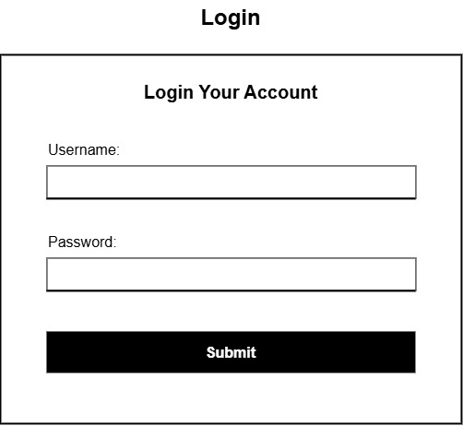

Register :-

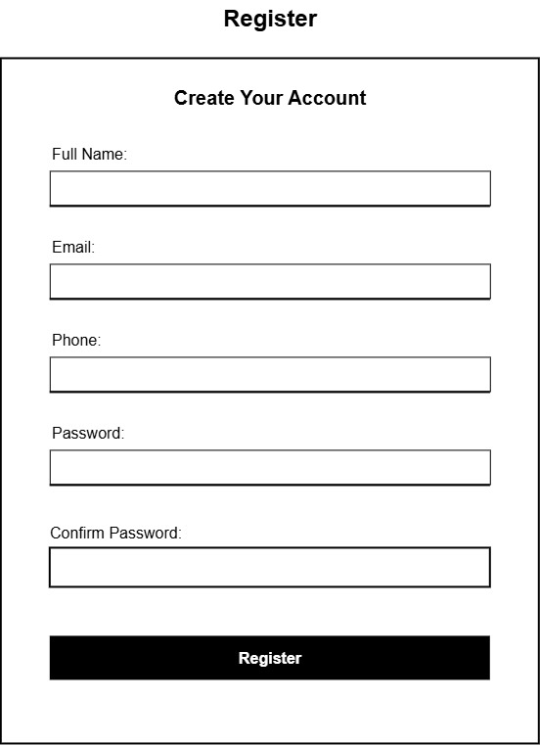

Home:-

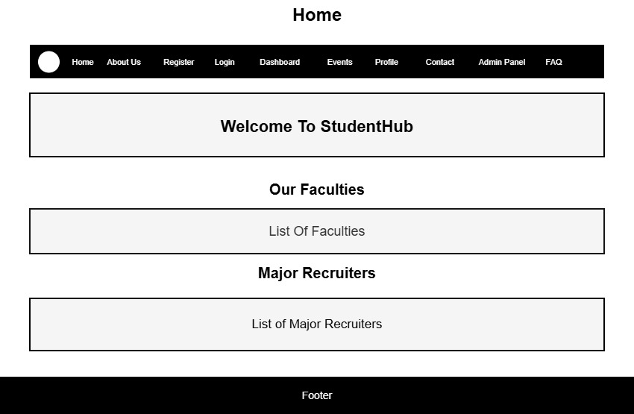
DashBoard :-
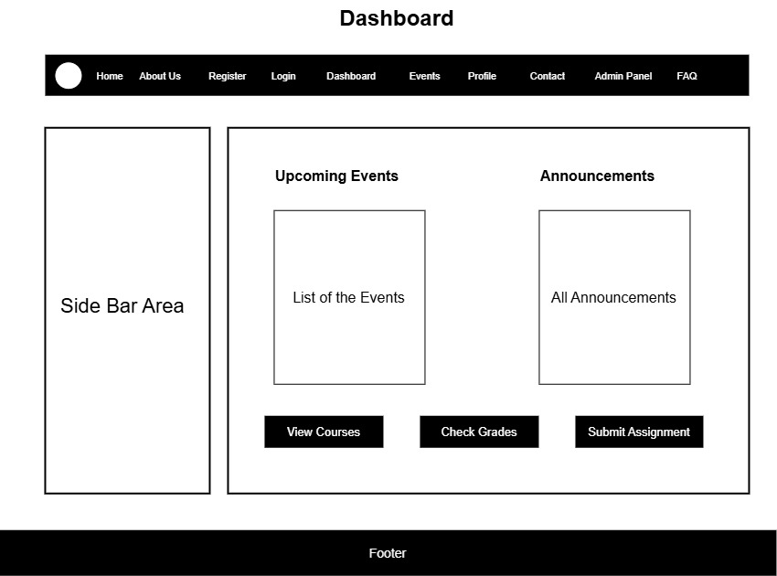
Admin :-
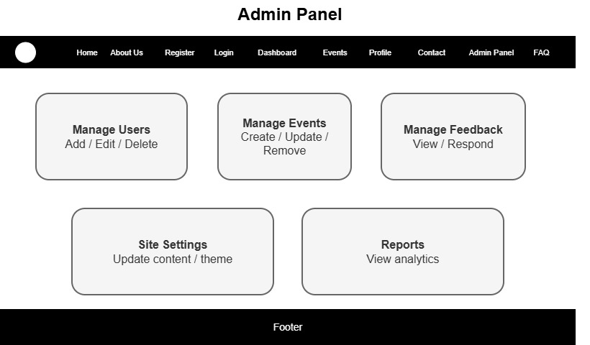

Contact :-
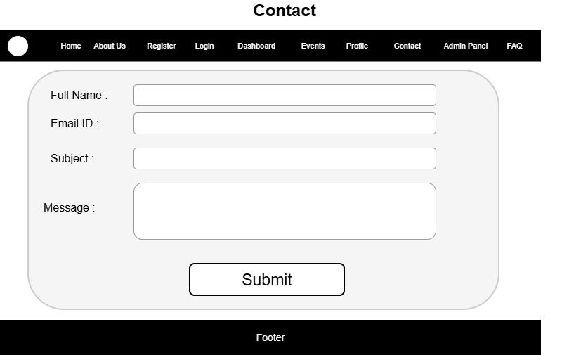
Events :-
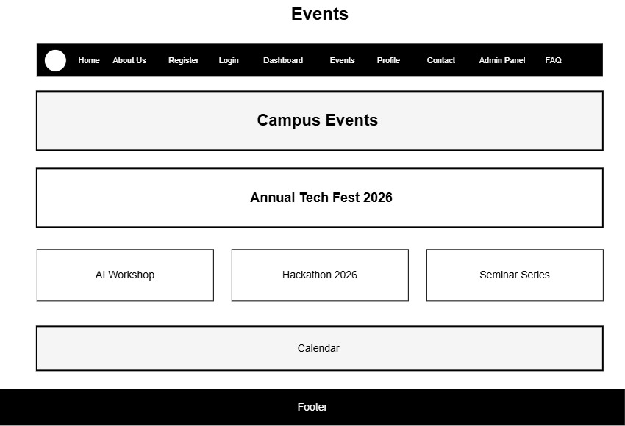

Faqs :-
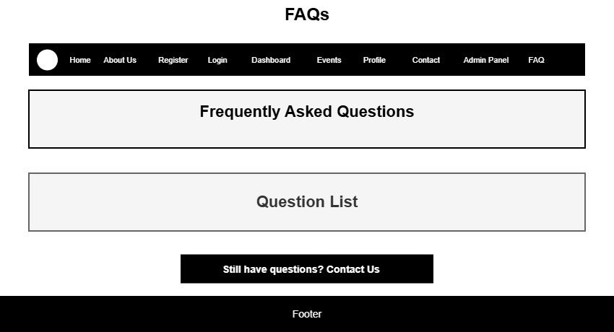
About :-
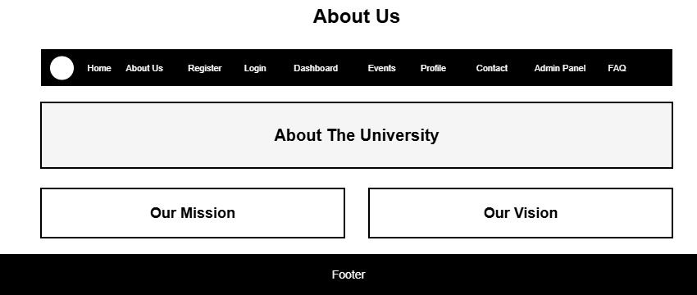
GitHub:- https://github.com/SmitChotai/studenthub

Practical Questions:

1. What is URL and parts of URL?
A URL (Uniform Resource Locator) is the address used to locate a webpage or any resource on the Internet. A URL generally consists of several parts, such as the protocol, domain name, and path. For example, in https://www.studenthub.com/student/dashboard.html, https:// is the protocol that defines how the browser communicates with the server, www.studenthub.com is the domain name that identifies the website, and /student/dashboard.html is the path that identifies the particular webpage or resource.

2. How does an HTML file get processed in a web browser?
When an HTML file is opened in a web browser, the browser first reads and parses the HTML code. It converts the HTML elements into a DOM (Document Object Model), which represents the structure of the webpage. The browser then loads and processes the associated CSS files for styling and JavaScript files for functionality. After calculating the layout and appearance of all elements, the browser renders the webpage on the screen so that the user can view and interact with it.

3. How will page navigation flow be managed among all HTML pages?
Page navigation in the StudentHub Portal will be managed using HTML hyperlinks and navigation links. The <a> tag with the href attribute can be used to connect different HTML pages. For example, the Login page can navigate to the Dashboard, and the Dashboard can provide links to Attendance, Assignments, Notes, Timetable, Results, Notice Board, Profile, and Feedback pages. A common navigation bar or sidebar can be maintained across the pages so that users can easily move between different sections of the StudentHub Portal.
4. How will GitHub commits be maintained after each practical?
GitHub commits will be maintained after completing each practical or major development task. First, the completed work will be tested to ensure that it functions correctly. The changes will then be added using git add, saved with a meaningful commit message using git commit, and uploaded to the GitHub repository using git push. For example, commits can be named "Add Landing Page", "Add Login and Registration Pages", "Create Student Dashboard", or "Add Attendance Page". This approach maintains a proper version history and makes it easy to track the development progress of the StudentHub Portal.

Conclusion:
After completing this practical, the student will understand the basic concepts of URLs and their different components and will learn how HTML files are processed and displayed by web browsers. The student will also be able to create navigation between multiple HTML pages and organize a multi-page website systematically. Additionally, the student will gain practical knowledge of using Git and GitHub for version control, maintaining meaningful commits after each practical, and tracking the development history of a web project. Overall, the student will develop a better understanding of the complete basic workflow involved in designing and managing a multi-page web application such as the StudentHub Portal.

