Helm

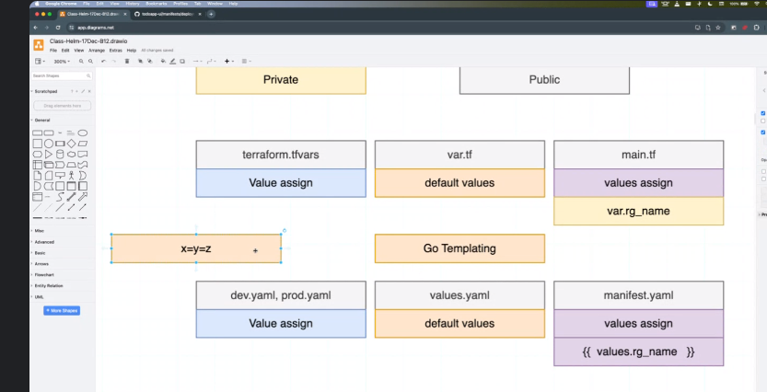

<https://helm.sh/docs/intro/install/>

<https://chocolatey.org/install#generic>

Set-ExecutionPolicy Bypass -Scope Process -Force; iex ((New-Object System.Net.WebClient).DownloadString('<http://internal/odata/repo/ChocolateyInstall.ps1>'))

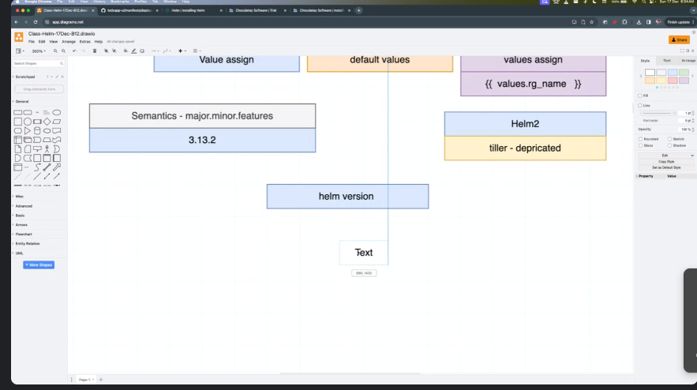

PS C:\Windows\system32> helm version

version.BuildInfo{Version:"v3.13.2", GitCommit:"2a2fb3b98829f1e0be6fb18af2f6599e0f4e8243", GitTreeState:"clean", GoVersion:"go1.20.10"}

PS C:\Windows\system32>

Helm chart

# helm

<https://github.com/devopsinsiders/todoapp-ui/tree/main/manifests>

# helm template “chart name” (it will show all the manifest files)

# helm install “any-name” “chart location”

# helm template khatrig

# helm install test-helm ./khatrig

#helm ls

# helm upgrade test-helm ./khatrig

# helm history ./khatrig

# helm rollback .khatrig 3 (To move to any version)

# helm uninstall ./khatrig