**Component 1: Checklist**

**Student Name/ ID: Susan Khatri 77202637**

**Development choice: Sublime Text / XAMPP**

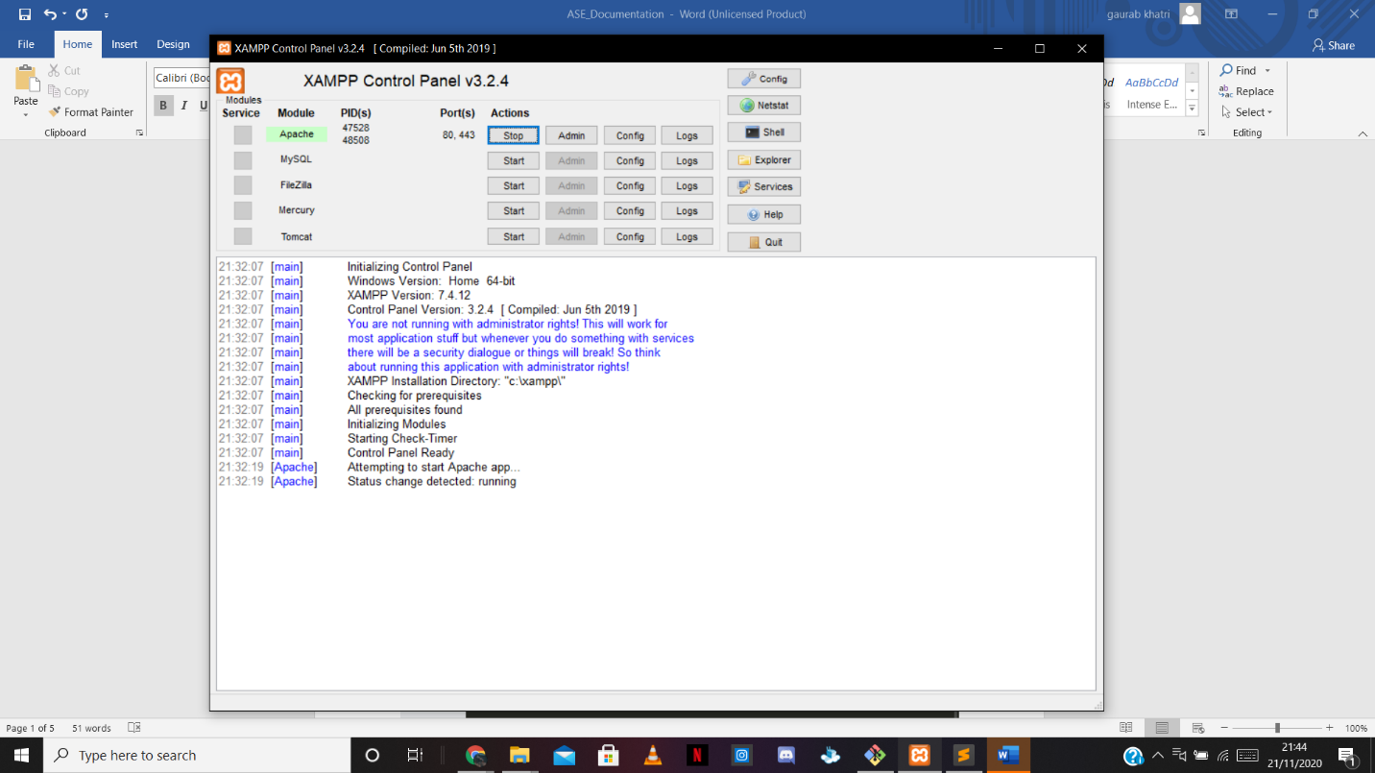

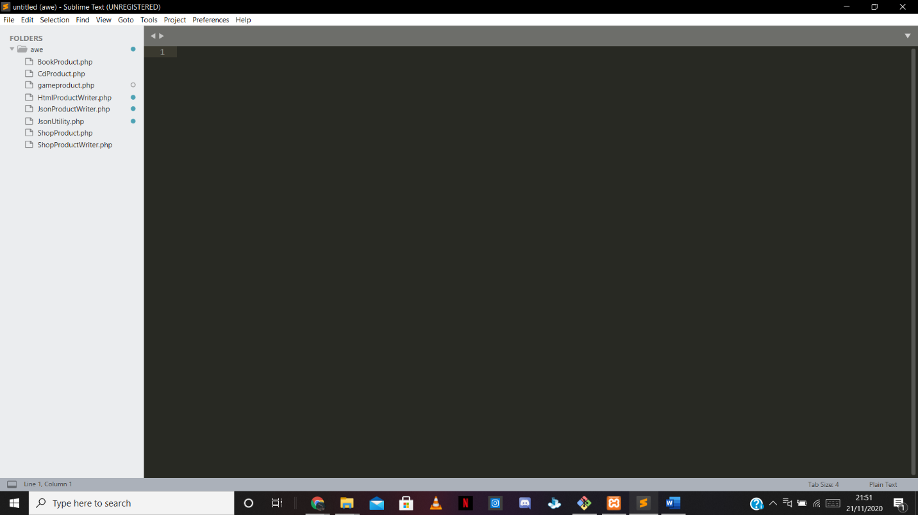

**PHP Version being used: 7.4.11**

**XDebug installed: Yes**

**(Add screenshot of output of php –v)**

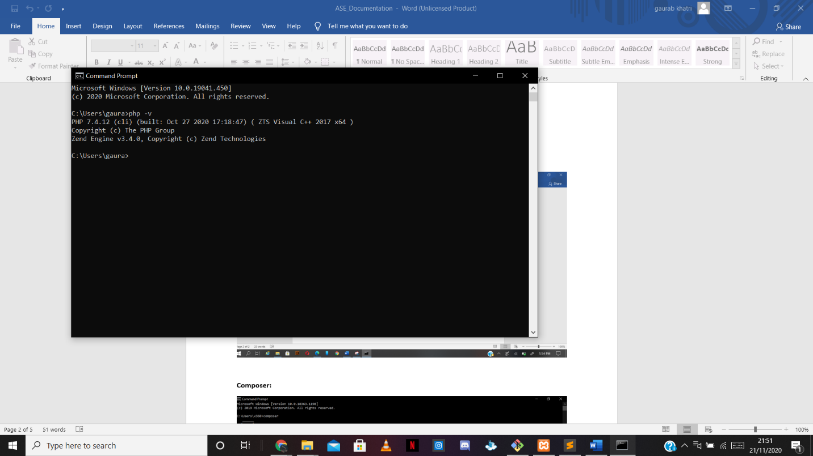

**Composer:**

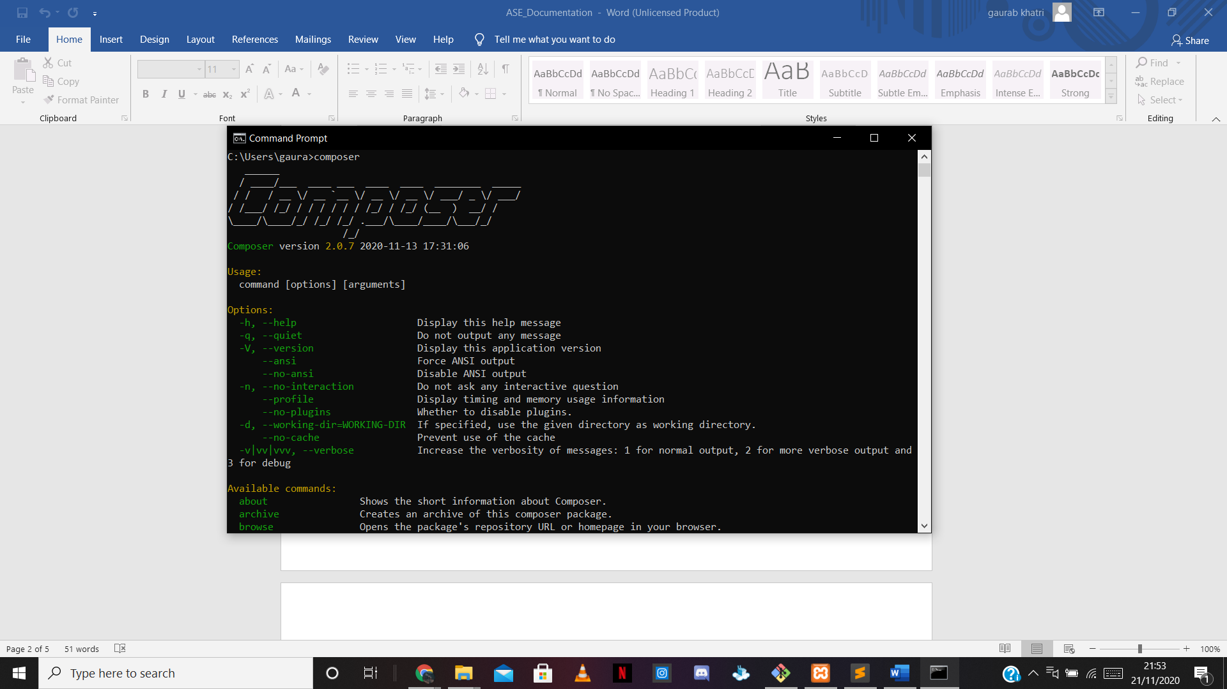

**Laravel:**

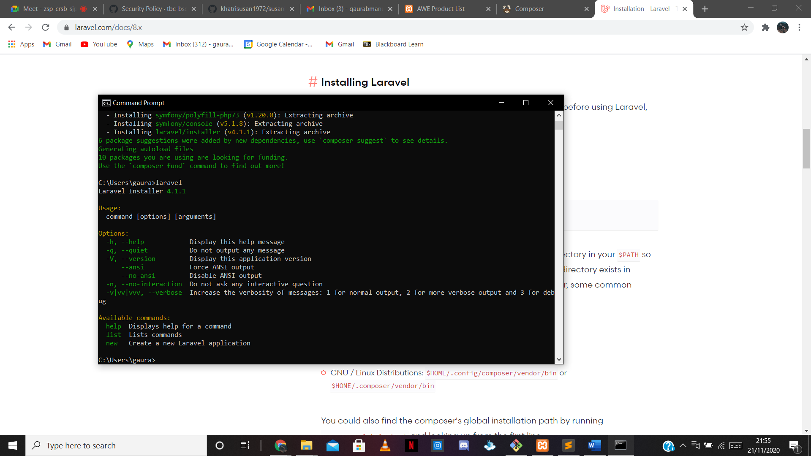

**Git email: susankhatri.1972@gmail.com**

**Git username: khatrisusan1972**

**Git account created and used:** [https://github.com/tbc-bsc-l6/component-1-khatrisusan1972.git](https://meet.google.com/linkredirect?authuser=0&dest=https%3A%2F%2Fgithub.com%2Ftbc-bsc-l6%2Fcomponent-1-khatrisusan1972.git)

**Component 1 :**

**Starting Result**

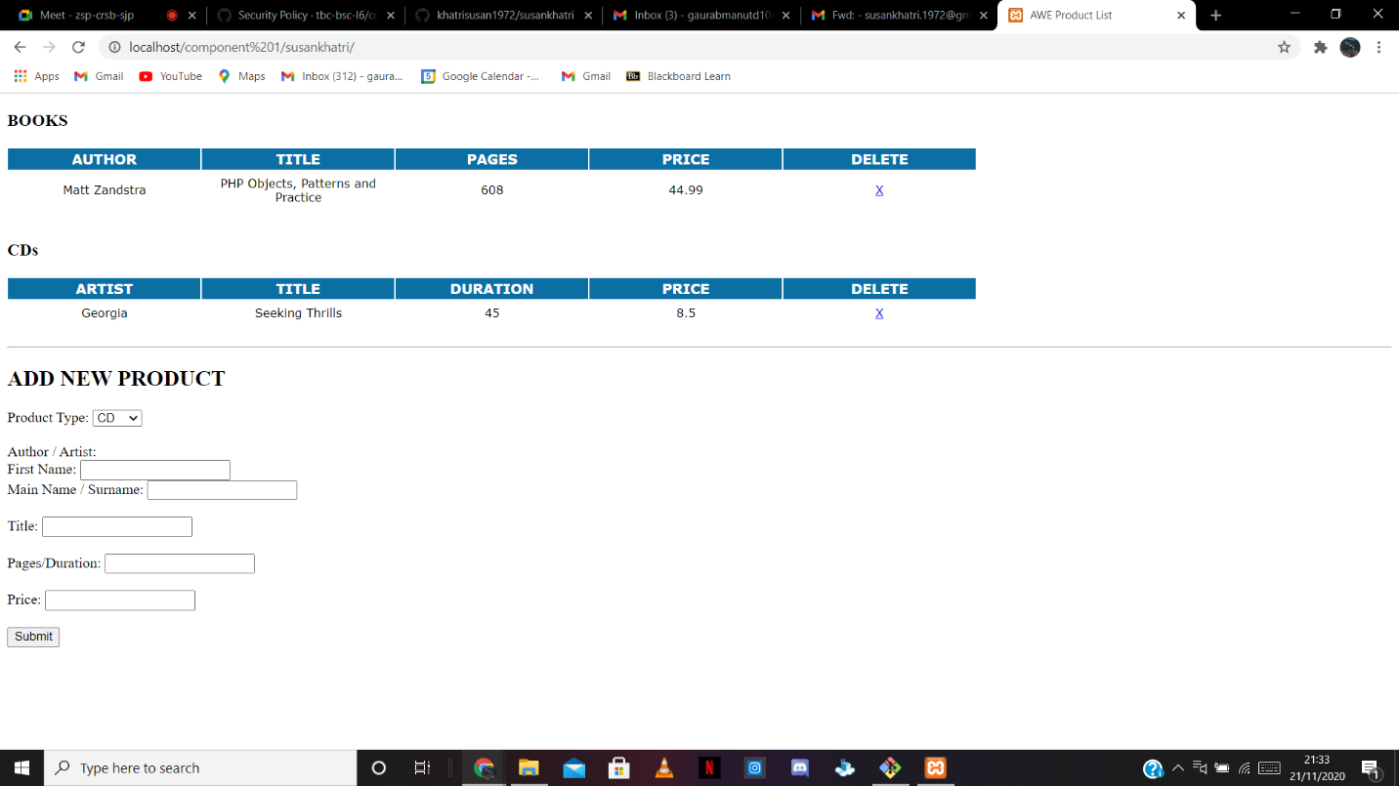

**End Result**

