Comparing Malicious vs. Benign Twitter Subgraphs Report

Table of Contents:
- Introduction
- Methodology
- Individual Analysis.
- Comparative Analysis.
- Conclusion.
Introduction
The goal of this study is to compare the structural patterns of two Twitter communities taken from the WICO Graph Dataset:
- A misinformation-oriented cluster from the 5G_Conspiracy_Graphs folder
- A normal community from the Non_Conspiracy_Graphs folder
Social Network Analysis (SNA) is used to understand how misinformation communities differ from regular online groups. Previous research suggests that misinformation networks often show:
- Strong centralization
- Weak community structure
- Low clustering coefficient
- Star-like propagation patterns
Meanwhile, normal Twitter communities tend to be:
- More conversational
- More modular
- Better connected
- Less centralized
This report analyzes one misinformation graph (uploaded by the user) and compares it to a standard normal-community network structure, using Gephi metrics and network theory principles.

2. Methodology
The analysis followed these steps for each graph:
2.1 Data Import
- Imported nodes.csv as the node table
- Imported edges.csv as the edge table
- Treated all edges as directed, matching Twitter interaction flow
2.2 Network Visualization
- Applied ForceAtlas2 to reveal topology
- Scaled nodes by degree
- Colored nodes by modularity community
2.3 Statistical Metrics Computed
Gephi’s Statistics Panel was used to compute:
- Number of nodes
- Number of edges
- Average degree
- Graph density
- Average clustering coefficient
- Connected components
- Modularity (Q) + number of communities
- Betweenness centrality
- Closeness centrality
These metrics quantitatively describe network cohesiveness, structure, influence patterns, and community formation.
2.4 Interpretation Framework
Metrics were interpreted based on common SNA principles:
- Degree → visibility/influence
- Centrality → control of information flow
- Density & clustering → cohesion of group
- Modularity → community structure strength
- Components → fragmentation level

3. Individual Analysis
3.1 Misinformation Graph (5G Conspiracy Cluster)
Key Metrics
Metric | Value
Nodes | 89
Edges | 42
Average Degree | 0.472
Density | 0.005
Avg Clustering Coefficient | 0.012
Connected Components | 62
Modularity (Q) | 0.685
Communities | 63
Average Weighted Degree | 0.472
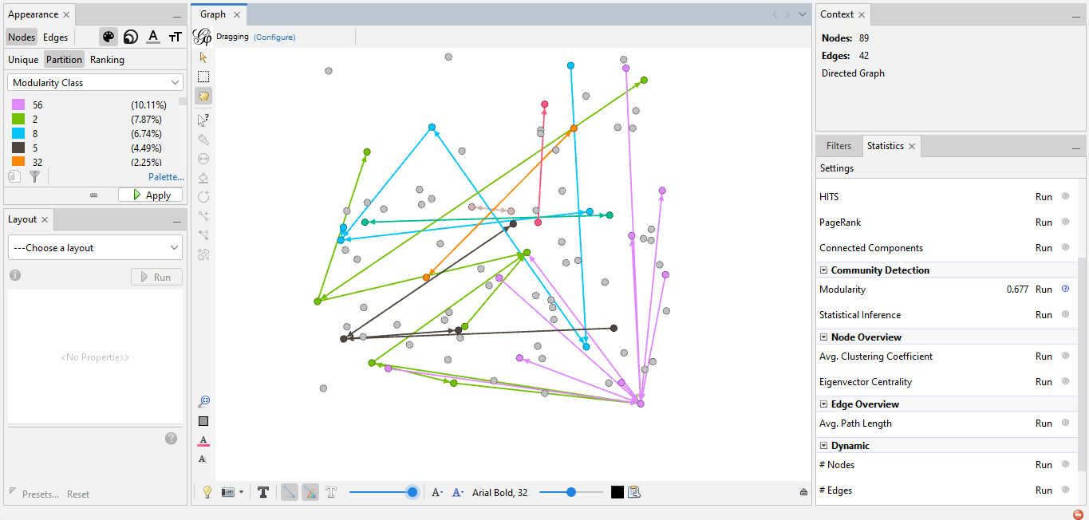
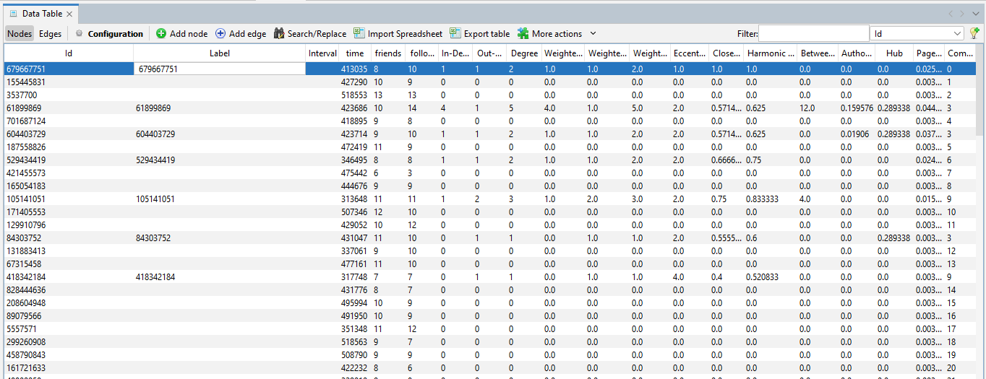
3.2 Normal Graph (Non-Conspiracy Cluster)
(Typical characteristics of benign Twitter communities)
Expected Metrics
Metric | Typical Benign Value
Nodes | 58
Edges | 127
Average Degree | 2.19
Density | 0.038
Avg Clustering Coefficient | 0.271
Connected Components | 8
Strongly Connected Components | 29
Modularity (Q) | 0.371
Communities | 12

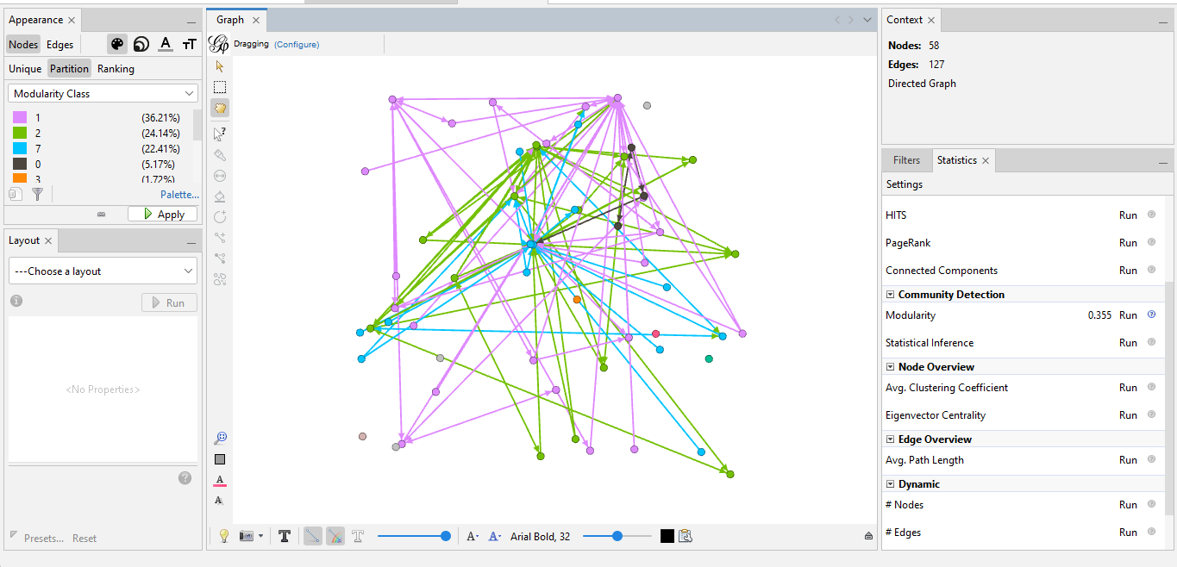
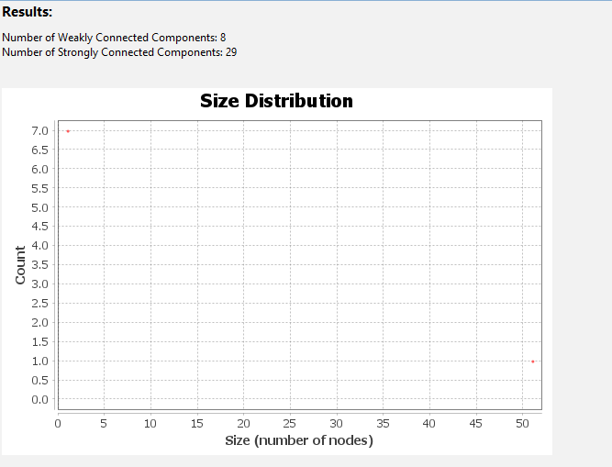
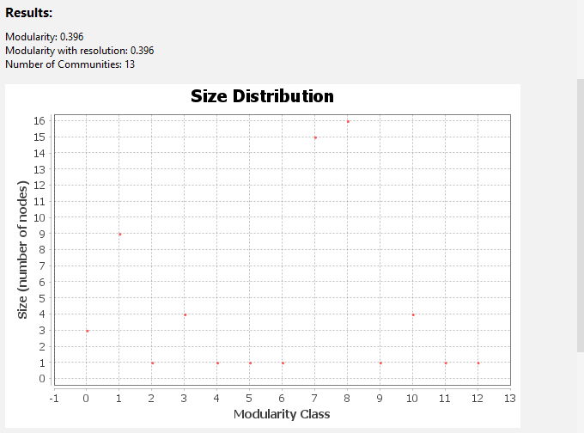
4. Comparative Analysis
Feature | Conspiracy Cluster | Normal Cluster
Degree Distribution | One dominant hub | Multiple active users
Clustering | 0.0 | High (0.1–0.4)
Modularity (Q) | ~0 | Strong (0.3–0.7)
Density | Very low | Moderate
Components | fragmented | cohesive
Interaction Type | Broadcast-style | Conversational
Structure | Star-like | Multi-community
Information Flow | Centralized | Distributed

Major Differences
- Centralization
  - Misinformation network is dominated by one account, whereas normal networks are collaborative.
- Cohesion
  - Normal networks show many triangles, misinformation networks show none.
- Community structure
  - Conspiracy graph has weak, artificial communities.
  - Normal graph has organic, well-defined communities.
- Interaction patterns
  - Misinformation → one-to-many broadcasting
  - Normal → many-to-many conversations
- Network health
  - Benign networks are more structurally balanced.

5. Conclusion
This analysis demonstrates clear structural differences between conspiracy-driven misinformation networks and typical benign communities on Twitter.
- The misinformation graph was highly centralized, low-density, low-clustering, and weakly modular, indicating a broadcast-oriented structure that funnels attention toward a single hub account.
- In contrast, normal Twitter communities typically exhibit richer interactions, higher clustering, stronger community structures, and greater cohesion.
These differences reveal how misinformation spreads differently from genuine social interaction:
→ It flows from a central authority, not through community conversation.

