Open Test Document: Fonts, Tables, Images and Pagination
  - A public-domain sample file for testing fonts, tables, images and multi-page layout
Version 1.0 · Last updated 2026-11-03 · Public domain (CC0) · Free to use, copy and modify for testing

Contents
1.0 Font Showcase 3
1.1 Typeface Samples 3
1.2 Styles and Sizes 4
1.3 Mixed Fonts in One Paragraph 4
2.0 Tables 5
2.1 Data Table (60 rows) 5
2.2 Merged Cells and Fonts 8
2.3 Configuration and Glossary 9
3.0 Images 10
3.1 Standalone Image 10
3.2 Images Inside a Table 10
3.3 Image Between Text 11
4.0 Long-Form Text 12
4.1 Aptos Narrative 12
4.2 Georgia Narrative 13
4.3 Verdana Narrative 14
4.4 Times New Roman Narrative 16
4.5 Calibri Narrative 17
4.6 Century Gothic Narrative 19
5.0 CJK Text Pages 21
5.1 Simplified Chinese 简体中文 21
5.2 Traditional Chinese 繁體中文 22
5.3 Japanese 日本語 24
5.4 Korean 한국어 25
5.5 Mixed-Script Table 27
6.0 Image Gallery 29
6.1 2x2 Gallery 29
6.2 Feature Layout 29
6.3 Filmstrip 30

1.0 Font Showcase
This section renders the same sample text in many typefaces, sizes and styles to test font handling.

1.1 Typeface Samples
Aptos: The quick brown fox jumps over the lazy dog. Pack my box with five dozen liquor jugs. How vexingly quick daft zebras jump! Sphinx of black quartz, judge my vow. 0123456789 !@#$%&*()
Georgia: The quick brown fox jumps over the lazy dog. Pack my box with five dozen liquor jugs. How vexingly quick daft zebras jump! Sphinx of black quartz, judge my vow. 0123456789 !@#$%&*()
Verdana: The quick brown fox jumps over the lazy dog. Pack my box with five dozen liquor jugs. How vexingly quick daft zebras jump! Sphinx of black quartz, judge my vow. 0123456789 !@#$%&*()
Century Gothic: The quick brown fox jumps over the lazy dog. Pack my box with five dozen liquor jugs. How vexingly quick daft zebras jump! Sphinx of black quartz, judge my vow. 0123456789 !@#$%&*()
Calibri: The quick brown fox jumps over the lazy dog. Pack my box with five dozen liquor jugs. How vexingly quick daft zebras jump! Sphinx of black quartz, judge my vow. 0123456789 !@#$%&*()
Consolas: The quick brown fox jumps over the lazy dog. Pack my box with five dozen liquor jugs. How vexingly quick daft zebras jump! Sphinx of black quartz, judge my vow. 0123456789 !@#$%&*()
Times New Roman: The quick brown fox jumps over the lazy dog. Pack my box with five dozen liquor jugs. How vexingly quick daft zebras jump! Sphinx of black quartz, judge my vow. 0123456789 !@#$%&*()
Arial: The quick brown fox jumps over the lazy dog. Pack my box with five dozen liquor jugs. How vexingly quick daft zebras jump! Sphinx of black quartz, judge my vow. 0123456789 !@#$%&*()
Courier New: The quick brown fox jumps over the lazy dog. Pack my box with five dozen liquor jugs. How vexingly quick daft zebras jump! Sphinx of black quartz, judge my vow. 0123456789 !@#$%&*()
Cambria: The quick brown fox jumps over the lazy dog. Pack my box with five dozen liquor jugs. How vexingly quick daft zebras jump! Sphinx of black quartz, judge my vow. 0123456789 !@#$%&*()
Trebuchet MS: The quick brown fox jumps over the lazy dog. Pack my box with five dozen liquor jugs. How vexingly quick daft zebras jump! Sphinx of black quartz, judge my vow. 0123456789 !@#$%&*()
Palatino Linotype: The quick brown fox jumps over the lazy dog. Pack my box with five dozen liquor jugs. How vexingly quick daft zebras jump! Sphinx of black quartz, judge my vow. 0123456789 !@#$%&*()

1.2 Styles and Sizes
8pt Aptos sample text
10pt Georgia sample text
12pt Verdana sample text
14pt Century Gothic sample text
18pt Calibri sample text
24pt Consolas sample text
Bold, italic, bold italic, strikethrough, red, blue, highlighted, Georgia 16pt purple, inline_code().

1.3 Mixed Fonts in One Paragraph
Georgia words, then Verdana words, then Courier New words, then Times New Roman words, and finally Arial words, with a Century Gothic ending. The quick brown fox jumps over the lazy dog. Pack my box with five dozen liquor jugs. How vexingly quick daft zebras jump! Sphinx of black quartz, judge my vow. 0123456789 !@#$%&*() The quick brown fox jumps over the lazy dog. Pack my box with five dozen liquor jugs. How vexingly quick daft zebras jump! Sphinx of black quartz, judge my vow. 0123456789 !@#$%&*()

2.0 Tables

2.1 Data Table (60 rows)
A long table that spans multiple pages.
ID | Name | Department | Score | Status
1001 | Record 1 | Sales | 37.1 | Active
1002 | Record 2 | Marketing | 74.2 | Active
1003 | Record 3 | Finance | 11.3 | Pending
1004 | Record 4 | Support | 48.4 | Active
1005 | Record 5 | Legal | 85.5 | Active
1006 | Record 6 | Engineering | 22.6 | Pending
1007 | Record 7 | Sales | 59.7 | Active
1008 | Record 8 | Marketing | 96.8 | Active
1009 | Record 9 | Finance | 33.9 | Pending
1010 | Record 10 | Support | 70.0 | Active
1011 | Record 11 | Legal | 7.1 | Active
1012 | Record 12 | Engineering | 44.2 | Pending
1013 | Record 13 | Sales | 81.3 | Active
1014 | Record 14 | Marketing | 18.4 | Active
1015 | Record 15 | Finance | 55.5 | Pending
1016 | Record 16 | Support | 92.6 | Active
1017 | Record 17 | Legal | 29.7 | Active
1018 | Record 18 | Engineering | 66.8 | Pending
1019 | Record 19 | Sales | 3.9 | Active
1020 | Record 20 | Marketing | 40.0 | Active
1021 | Record 21 | Finance | 77.1 | Pending
1022 | Record 22 | Support | 14.2 | Active
1023 | Record 23 | Legal | 51.3 | Active
1024 | Record 24 | Engineering | 88.4 | Pending
1025 | Record 25 | Sales | 25.5 | Active
1026 | Record 26 | Marketing | 62.6 | Active
1027 | Record 27 | Finance | 99.7 | Pending
1028 | Record 28 | Support | 36.8 | Active
1029 | Record 29 | Legal | 73.9 | Active
1030 | Record 30 | Engineering | 10.0 | Pending
1031 | Record 31 | Sales | 47.1 | Active
1032 | Record 32 | Marketing | 84.2 | Active
1033 | Record 33 | Finance | 21.3 | Pending
1034 | Record 34 | Support | 58.4 | Active
1035 | Record 35 | Legal | 95.5 | Active
1036 | Record 36 | Engineering | 32.6 | Pending
1037 | Record 37 | Sales | 69.7 | Active
1038 | Record 38 | Marketing | 6.8 | Active
1039 | Record 39 | Finance | 43.9 | Pending
1040 | Record 40 | Support | 80.0 | Active
1041 | Record 41 | Legal | 17.1 | Active
1042 | Record 42 | Engineering | 54.2 | Pending
1043 | Record 43 | Sales | 91.3 | Active
1044 | Record 44 | Marketing | 28.4 | Active
1045 | Record 45 | Finance | 65.5 | Pending
1046 | Record 46 | Support | 2.6 | Active
1047 | Record 47 | Legal | 39.7 | Active
1048 | Record 48 | Engineering | 76.8 | Pending
1049 | Record 49 | Sales | 13.9 | Active
1050 | Record 50 | Marketing | 50.0 | Active
1051 | Record 51 | Finance | 87.1 | Pending
1052 | Record 52 | Support | 24.2 | Active
1053 | Record 53 | Legal | 61.3 | Active
1054 | Record 54 | Engineering | 98.4 | Pending
1055 | Record 55 | Sales | 35.5 | Active
1056 | Record 56 | Marketing | 72.6 | Active
1057 | Record 57 | Finance | 9.7 | Pending
1058 | Record 58 | Support | 46.8 | Active
1059 | Record 59 | Legal | 83.9 | Active
1060 | Record 60 | Engineering | 20.0 | Pending

2.2 Merged Cells and Fonts

Quarterly Summary
Georgia cell | Verdana | Courier New
Georgia cell | Times | Century Gothic
Q1 | Q2 | Q3

2.3 Configuration and Glossary
Setting | Default | Accepted Values | Description
app.mode | production | development | staging | production | Runtime environment.
app.retries | 3 | <integer> | Retry attempts.
app.cache | true | true | false | Enable caching.
app.locale | en-US | <string> | Display locale.

Term | Definition
Font | A set of glyphs in a particular typeface, size and style.
Pagination | Division of content into pages.
Table | Grid of rows and columns organizing data.
Inline image | Picture placed within the flow of text.

3.0 Images

3.1 Standalone Image

Figure 1. Generated abstract pattern.

3.2 Images Inside a Table
Image | Description
 | A 200x150 image in a table cell, next to text in Georgia.

3.3 Image Between Text
Text before the image. Lorem ipsum dolor sit amet, consectetur adipiscing elit, sed do eiusmod tempor incididunt ut labore et dolore magna aliqua.

Text after the image. Ut enim ad minim veniam, quis nostrud exercitation ullamco laboris nisi ut aliquip ex ea commodo consequat.
function greet(name) {
return `Hello, ${name}!`;
}

4.0 Long-Form Text

4.1 Aptos Narrative
Lorem ipsum dolor sit amet, consectetur adipiscing elit. Integer nec odio praesent libero. Sed cursus ante dapibus diam. Sed nisi nulla quis sem at nibh elementum imperdiet. Duis sagittis ipsum praesent mauris fusce nec tellus sed augue semper porta. Mauris massa vestibulum lacinia arcu eget nulla. Lorem ipsum dolor sit amet, consectetur adipiscing elit. Integer nec odio praesent libero. Sed cursus ante dapibus diam. Sed nisi nulla quis sem at nibh elementum imperdiet. Duis sagittis ipsum praesent mauris fusce nec tellus sed augue semper porta. Mauris massa vestibulum lacinia arcu eget nulla. Lorem ipsum dolor sit amet, consectetur adipiscing elit. Integer nec odio praesent libero. Sed cursus ante dapibus diam. Sed nisi nulla quis sem at nibh elementum imperdiet. Duis sagittis ipsum praesent mauris fusce nec tellus sed augue semper porta. Mauris massa vestibulum lacinia arcu eget nulla.
Lorem ipsum dolor sit amet, consectetur adipiscing elit. Integer nec odio praesent libero. Sed cursus ante dapibus diam. Sed nisi nulla quis sem at nibh elementum imperdiet. Duis sagittis ipsum praesent mauris fusce nec tellus sed augue semper porta. Mauris massa vestibulum lacinia arcu eget nulla. Lorem ipsum dolor sit amet, consectetur adipiscing elit. Integer nec odio praesent libero. Sed cursus ante dapibus diam. Sed nisi nulla quis sem at nibh elementum imperdiet. Duis sagittis ipsum praesent mauris fusce nec tellus sed augue semper porta. Mauris massa vestibulum lacinia arcu eget nulla. Lorem ipsum dolor sit amet, consectetur adipiscing elit. Integer nec odio praesent libero. Sed cursus ante dapibus diam. Sed nisi nulla quis sem at nibh elementum imperdiet. Duis sagittis ipsum praesent mauris fusce nec tellus sed augue semper porta. Mauris massa vestibulum lacinia arcu eget nulla.
Lorem ipsum dolor sit amet, consectetur adipiscing elit. Integer nec odio praesent libero. Sed cursus ante dapibus diam. Sed nisi nulla quis sem at nibh elementum imperdiet. Duis sagittis ipsum praesent mauris fusce nec tellus sed augue semper porta. Mauris massa vestibulum lacinia arcu eget nulla. Lorem ipsum dolor sit amet, consectetur adipiscing elit. Integer nec odio praesent libero. Sed cursus ante dapibus diam. Sed nisi nulla quis sem at nibh elementum imperdiet. Duis sagittis ipsum praesent mauris fusce nec tellus sed augue semper porta. Mauris massa vestibulum lacinia arcu eget nulla. Lorem ipsum dolor sit amet, consectetur adipiscing elit. Integer nec odio praesent libero. Sed cursus ante dapibus diam. Sed nisi nulla quis sem at nibh elementum imperdiet. Duis sagittis ipsum praesent mauris fusce nec tellus sed augue semper porta. Mauris massa vestibulum lacinia arcu eget nulla.
Lorem ipsum dolor sit amet, consectetur adipiscing elit. Integer nec odio praesent libero. Sed cursus ante dapibus diam. Sed nisi nulla quis sem at nibh elementum imperdiet. Duis sagittis ipsum praesent mauris fusce nec tellus sed augue semper porta. Mauris massa vestibulum lacinia arcu eget nulla. Lorem ipsum dolor sit amet, consectetur adipiscing elit. Integer nec odio praesent libero. Sed cursus ante dapibus diam. Sed nisi nulla quis sem at nibh elementum imperdiet. Duis sagittis ipsum praesent mauris fusce nec tellus sed augue semper porta. Mauris massa vestibulum lacinia arcu eget nulla. Lorem ipsum dolor sit amet, consectetur adipiscing elit. Integer nec odio praesent libero. Sed cursus ante dapibus diam. Sed nisi nulla quis sem at nibh elementum imperdiet. Duis sagittis ipsum praesent mauris fusce nec tellus sed augue semper porta. Mauris massa vestibulum lacinia arcu eget nulla.
- Bullet one in Aptos
- Bullet two
- Bullet three
- Step one
- Step two

4.2 Georgia Narrative
Lorem ipsum dolor sit amet, consectetur adipiscing elit. Integer nec odio praesent libero. Sed cursus ante dapibus diam. Sed nisi nulla quis sem at nibh elementum imperdiet. Duis sagittis ipsum praesent mauris fusce nec tellus sed augue semper porta. Mauris massa vestibulum lacinia arcu eget nulla. Lorem ipsum dolor sit amet, consectetur adipiscing elit. Integer nec odio praesent libero. Sed cursus ante dapibus diam. Sed nisi nulla quis sem at nibh elementum imperdiet. Duis sagittis ipsum praesent mauris fusce nec tellus sed augue semper porta. Mauris massa vestibulum lacinia arcu eget nulla. Lorem ipsum dolor sit amet, consectetur adipiscing elit. Integer nec odio praesent libero. Sed cursus ante dapibus diam. Sed nisi nulla quis sem at nibh elementum imperdiet. Duis sagittis ipsum praesent mauris fusce nec tellus sed augue semper porta. Mauris massa vestibulum lacinia arcu eget nulla.
Lorem ipsum dolor sit amet, consectetur adipiscing elit. Integer nec odio praesent libero. Sed cursus ante dapibus diam. Sed nisi nulla quis sem at nibh elementum imperdiet. Duis sagittis ipsum praesent mauris fusce nec tellus sed augue semper porta. Mauris massa vestibulum lacinia arcu eget nulla. Lorem ipsum dolor sit amet, consectetur adipiscing elit. Integer nec odio praesent libero. Sed cursus ante dapibus diam. Sed nisi nulla quis sem at nibh elementum imperdiet. Duis sagittis ipsum praesent mauris fusce nec tellus sed augue semper porta. Mauris massa vestibulum lacinia arcu eget nulla. Lorem ipsum dolor sit amet, consectetur adipiscing elit. Integer nec odio praesent libero. Sed cursus ante dapibus diam. Sed nisi nulla quis sem at nibh elementum imperdiet. Duis sagittis ipsum praesent mauris fusce nec tellus sed augue semper porta. Mauris massa vestibulum lacinia arcu eget nulla.
Lorem ipsum dolor sit amet, consectetur adipiscing elit. Integer nec odio praesent libero. Sed cursus ante dapibus diam. Sed nisi nulla quis sem at nibh elementum imperdiet. Duis sagittis ipsum praesent mauris fusce nec tellus sed augue semper porta. Mauris massa vestibulum lacinia arcu eget nulla. Lorem ipsum dolor sit amet, consectetur adipiscing elit. Integer nec odio praesent libero. Sed cursus ante dapibus diam. Sed nisi nulla quis sem at nibh elementum imperdiet. Duis sagittis ipsum praesent mauris fusce nec tellus sed augue semper porta. Mauris massa vestibulum lacinia arcu eget nulla. Lorem ipsum dolor sit amet, consectetur adipiscing elit. Integer nec odio praesent libero. Sed cursus ante dapibus diam. Sed nisi nulla quis sem at nibh elementum imperdiet. Duis sagittis ipsum praesent mauris fusce nec tellus sed augue semper porta. Mauris massa vestibulum lacinia arcu eget nulla.
Lorem ipsum dolor sit amet, consectetur adipiscing elit. Integer nec odio praesent libero. Sed cursus ante dapibus diam. Sed nisi nulla quis sem at nibh elementum imperdiet. Duis sagittis ipsum praesent mauris fusce nec tellus sed augue semper porta. Mauris massa vestibulum lacinia arcu eget nulla. Lorem ipsum dolor sit amet, consectetur adipiscing elit. Integer nec odio praesent libero. Sed cursus ante dapibus diam. Sed nisi nulla quis sem at nibh elementum imperdiet. Duis sagittis ipsum praesent mauris fusce nec tellus sed augue semper porta. Mauris massa vestibulum lacinia arcu eget nulla. Lorem ipsum dolor sit amet, consectetur adipiscing elit. Integer nec odio praesent libero. Sed cursus ante dapibus diam. Sed nisi nulla quis sem at nibh elementum imperdiet. Duis sagittis ipsum praesent mauris fusce nec tellus sed augue semper porta. Mauris massa vestibulum lacinia arcu eget nulla.
- Bullet one in Georgia
- Bullet two
- Bullet three
- Step one
- Step two

4.3 Verdana Narrative
Lorem ipsum dolor sit amet, consectetur adipiscing elit. Integer nec odio praesent libero. Sed cursus ante dapibus diam. Sed nisi nulla quis sem at nibh elementum imperdiet. Duis sagittis ipsum praesent mauris fusce nec tellus sed augue semper porta. Mauris massa vestibulum lacinia arcu eget nulla. Lorem ipsum dolor sit amet, consectetur adipiscing elit. Integer nec odio praesent libero. Sed cursus ante dapibus diam. Sed nisi nulla quis sem at nibh elementum imperdiet. Duis sagittis ipsum praesent mauris fusce nec tellus sed augue semper porta. Mauris massa vestibulum lacinia arcu eget nulla. Lorem ipsum dolor sit amet, consectetur adipiscing elit. Integer nec odio praesent libero. Sed cursus ante dapibus diam. Sed nisi nulla quis sem at nibh elementum imperdiet. Duis sagittis ipsum praesent mauris fusce nec tellus sed augue semper porta. Mauris massa vestibulum lacinia arcu eget nulla.
Lorem ipsum dolor sit amet, consectetur adipiscing elit. Integer nec odio praesent libero. Sed cursus ante dapibus diam. Sed nisi nulla quis sem at nibh elementum imperdiet. Duis sagittis ipsum praesent mauris fusce nec tellus sed augue semper porta. Mauris massa vestibulum lacinia arcu eget nulla. Lorem ipsum dolor sit amet, consectetur adipiscing elit. Integer nec odio praesent libero. Sed cursus ante dapibus diam. Sed nisi nulla quis sem at nibh elementum imperdiet. Duis sagittis ipsum praesent mauris fusce nec tellus sed augue semper porta. Mauris massa vestibulum lacinia arcu eget nulla. Lorem ipsum dolor sit amet, consectetur adipiscing elit. Integer nec odio praesent libero. Sed cursus ante dapibus diam. Sed nisi nulla quis sem at nibh elementum imperdiet. Duis sagittis ipsum praesent mauris fusce nec tellus sed augue semper porta. Mauris massa vestibulum lacinia arcu eget nulla.
Lorem ipsum dolor sit amet, consectetur adipiscing elit. Integer nec odio praesent libero. Sed cursus ante dapibus diam. Sed nisi nulla quis sem at nibh elementum imperdiet. Duis sagittis ipsum praesent mauris fusce nec tellus sed augue semper porta. Mauris massa vestibulum lacinia arcu eget nulla. Lorem ipsum dolor sit amet, consectetur adipiscing elit. Integer nec odio praesent libero. Sed cursus ante dapibus diam. Sed nisi nulla quis sem at nibh elementum imperdiet. Duis sagittis ipsum praesent mauris fusce nec tellus sed augue semper porta. Mauris massa vestibulum lacinia arcu eget nulla. Lorem ipsum dolor sit amet, consectetur adipiscing elit. Integer nec odio praesent libero. Sed cursus ante dapibus diam. Sed nisi nulla quis sem at nibh elementum imperdiet. Duis sagittis ipsum praesent mauris fusce nec tellus sed augue semper porta. Mauris massa vestibulum lacinia arcu eget nulla.
Lorem ipsum dolor sit amet, consectetur adipiscing elit. Integer nec odio praesent libero. Sed cursus ante dapibus diam. Sed nisi nulla quis sem at nibh elementum imperdiet. Duis sagittis ipsum praesent mauris fusce nec tellus sed augue semper porta. Mauris massa vestibulum lacinia arcu eget nulla. Lorem ipsum dolor sit amet, consectetur adipiscing elit. Integer nec odio praesent libero. Sed cursus ante dapibus diam. Sed nisi nulla quis sem at nibh elementum imperdiet. Duis sagittis ipsum praesent mauris fusce nec tellus sed augue semper porta. Mauris massa vestibulum lacinia arcu eget nulla. Lorem ipsum dolor sit amet, consectetur adipiscing elit. Integer nec odio praesent libero. Sed cursus ante dapibus diam. Sed nisi nulla quis sem at nibh elementum imperdiet. Duis sagittis ipsum praesent mauris fusce nec tellus sed augue semper porta. Mauris massa vestibulum lacinia arcu eget nulla.
- Bullet one in Verdana
- Bullet two
- Bullet three
- Step one
- Step two

4.4 Times New Roman Narrative
Lorem ipsum dolor sit amet, consectetur adipiscing elit. Integer nec odio praesent libero. Sed cursus ante dapibus diam. Sed nisi nulla quis sem at nibh elementum imperdiet. Duis sagittis ipsum praesent mauris fusce nec tellus sed augue semper porta. Mauris massa vestibulum lacinia arcu eget nulla. Lorem ipsum dolor sit amet, consectetur adipiscing elit. Integer nec odio praesent libero. Sed cursus ante dapibus diam. Sed nisi nulla quis sem at nibh elementum imperdiet. Duis sagittis ipsum praesent mauris fusce nec tellus sed augue semper porta. Mauris massa vestibulum lacinia arcu eget nulla. Lorem ipsum dolor sit amet, consectetur adipiscing elit. Integer nec odio praesent libero. Sed cursus ante dapibus diam. Sed nisi nulla quis sem at nibh elementum imperdiet. Duis sagittis ipsum praesent mauris fusce nec tellus sed augue semper porta. Mauris massa vestibulum lacinia arcu eget nulla.
Lorem ipsum dolor sit amet, consectetur adipiscing elit. Integer nec odio praesent libero. Sed cursus ante dapibus diam. Sed nisi nulla quis sem at nibh elementum imperdiet. Duis sagittis ipsum praesent mauris fusce nec tellus sed augue semper porta. Mauris massa vestibulum lacinia arcu eget nulla. Lorem ipsum dolor sit amet, consectetur adipiscing elit. Integer nec odio praesent libero. Sed cursus ante dapibus diam. Sed nisi nulla quis sem at nibh elementum imperdiet. Duis sagittis ipsum praesent mauris fusce nec tellus sed augue semper porta. Mauris massa vestibulum lacinia arcu eget nulla. Lorem ipsum dolor sit amet, consectetur adipiscing elit. Integer nec odio praesent libero. Sed cursus ante dapibus diam. Sed nisi nulla quis sem at nibh elementum imperdiet. Duis sagittis ipsum praesent mauris fusce nec tellus sed augue semper porta. Mauris massa vestibulum lacinia arcu eget nulla.
Lorem ipsum dolor sit amet, consectetur adipiscing elit. Integer nec odio praesent libero. Sed cursus ante dapibus diam. Sed nisi nulla quis sem at nibh elementum imperdiet. Duis sagittis ipsum praesent mauris fusce nec tellus sed augue semper porta. Mauris massa vestibulum lacinia arcu eget nulla. Lorem ipsum dolor sit amet, consectetur adipiscing elit. Integer nec odio praesent libero. Sed cursus ante dapibus diam. Sed nisi nulla quis sem at nibh elementum imperdiet. Duis sagittis ipsum praesent mauris fusce nec tellus sed augue semper porta. Mauris massa vestibulum lacinia arcu eget nulla. Lorem ipsum dolor sit amet, consectetur adipiscing elit. Integer nec odio praesent libero. Sed cursus ante dapibus diam. Sed nisi nulla quis sem at nibh elementum imperdiet. Duis sagittis ipsum praesent mauris fusce nec tellus sed augue semper porta. Mauris massa vestibulum lacinia arcu eget nulla.
Lorem ipsum dolor sit amet, consectetur adipiscing elit. Integer nec odio praesent libero. Sed cursus ante dapibus diam. Sed nisi nulla quis sem at nibh elementum imperdiet. Duis sagittis ipsum praesent mauris fusce nec tellus sed augue semper porta. Mauris massa vestibulum lacinia arcu eget nulla. Lorem ipsum dolor sit amet, consectetur adipiscing elit. Integer nec odio praesent libero. Sed cursus ante dapibus diam. Sed nisi nulla quis sem at nibh elementum imperdiet. Duis sagittis ipsum praesent mauris fusce nec tellus sed augue semper porta. Mauris massa vestibulum lacinia arcu eget nulla. Lorem ipsum dolor sit amet, consectetur adipiscing elit. Integer nec odio praesent libero. Sed cursus ante dapibus diam. Sed nisi nulla quis sem at nibh elementum imperdiet. Duis sagittis ipsum praesent mauris fusce nec tellus sed augue semper porta. Mauris massa vestibulum lacinia arcu eget nulla.
- Bullet one in Times New Roman
- Bullet two
- Bullet three
- Step one
- Step two

4.5 Calibri Narrative
Lorem ipsum dolor sit amet, consectetur adipiscing elit. Integer nec odio praesent libero. Sed cursus ante dapibus diam. Sed nisi nulla quis sem at nibh elementum imperdiet. Duis sagittis ipsum praesent mauris fusce nec tellus sed augue semper porta. Mauris massa vestibulum lacinia arcu eget nulla. Lorem ipsum dolor sit amet, consectetur adipiscing elit. Integer nec odio praesent libero. Sed cursus ante dapibus diam. Sed nisi nulla quis sem at nibh elementum imperdiet. Duis sagittis ipsum praesent mauris fusce nec tellus sed augue semper porta. Mauris massa vestibulum lacinia arcu eget nulla. Lorem ipsum dolor sit amet, consectetur adipiscing elit. Integer nec odio praesent libero. Sed cursus ante dapibus diam. Sed nisi nulla quis sem at nibh elementum imperdiet. Duis sagittis ipsum praesent mauris fusce nec tellus sed augue semper porta. Mauris massa vestibulum lacinia arcu eget nulla.
Lorem ipsum dolor sit amet, consectetur adipiscing elit. Integer nec odio praesent libero. Sed cursus ante dapibus diam. Sed nisi nulla quis sem at nibh elementum imperdiet. Duis sagittis ipsum praesent mauris fusce nec tellus sed augue semper porta. Mauris massa vestibulum lacinia arcu eget nulla. Lorem ipsum dolor sit amet, consectetur adipiscing elit. Integer nec odio praesent libero. Sed cursus ante dapibus diam. Sed nisi nulla quis sem at nibh elementum imperdiet. Duis sagittis ipsum praesent mauris fusce nec tellus sed augue semper porta. Mauris massa vestibulum lacinia arcu eget nulla. Lorem ipsum dolor sit amet, consectetur adipiscing elit. Integer nec odio praesent libero. Sed cursus ante dapibus diam. Sed nisi nulla quis sem at nibh elementum imperdiet. Duis sagittis ipsum praesent mauris fusce nec tellus sed augue semper porta. Mauris massa vestibulum lacinia arcu eget nulla.
Lorem ipsum dolor sit amet, consectetur adipiscing elit. Integer nec odio praesent libero. Sed cursus ante dapibus diam. Sed nisi nulla quis sem at nibh elementum imperdiet. Duis sagittis ipsum praesent mauris fusce nec tellus sed augue semper porta. Mauris massa vestibulum lacinia arcu eget nulla. Lorem ipsum dolor sit amet, consectetur adipiscing elit. Integer nec odio praesent libero. Sed cursus ante dapibus diam. Sed nisi nulla quis sem at nibh elementum imperdiet. Duis sagittis ipsum praesent mauris fusce nec tellus sed augue semper porta. Mauris massa vestibulum lacinia arcu eget nulla. Lorem ipsum dolor sit amet, consectetur adipiscing elit. Integer nec odio praesent libero. Sed cursus ante dapibus diam. Sed nisi nulla quis sem at nibh elementum imperdiet. Duis sagittis ipsum praesent mauris fusce nec tellus sed augue semper porta. Mauris massa vestibulum lacinia arcu eget nulla.
Lorem ipsum dolor sit amet, consectetur adipiscing elit. Integer nec odio praesent libero. Sed cursus ante dapibus diam. Sed nisi nulla quis sem at nibh elementum imperdiet. Duis sagittis ipsum praesent mauris fusce nec tellus sed augue semper porta. Mauris massa vestibulum lacinia arcu eget nulla. Lorem ipsum dolor sit amet, consectetur adipiscing elit. Integer nec odio praesent libero. Sed cursus ante dapibus diam. Sed nisi nulla quis sem at nibh elementum imperdiet. Duis sagittis ipsum praesent mauris fusce nec tellus sed augue semper porta. Mauris massa vestibulum lacinia arcu eget nulla. Lorem ipsum dolor sit amet, consectetur adipiscing elit. Integer nec odio praesent libero. Sed cursus ante dapibus diam. Sed nisi nulla quis sem at nibh elementum imperdiet. Duis sagittis ipsum praesent mauris fusce nec tellus sed augue semper porta. Mauris massa vestibulum lacinia arcu eget nulla.
- Bullet one in Calibri
- Bullet two
- Bullet three
- Step one
- Step two

4.6 Century Gothic Narrative
Lorem ipsum dolor sit amet, consectetur adipiscing elit. Integer nec odio praesent libero. Sed cursus ante dapibus diam. Sed nisi nulla quis sem at nibh elementum imperdiet. Duis sagittis ipsum praesent mauris fusce nec tellus sed augue semper porta. Mauris massa vestibulum lacinia arcu eget nulla. Lorem ipsum dolor sit amet, consectetur adipiscing elit. Integer nec odio praesent libero. Sed cursus ante dapibus diam. Sed nisi nulla quis sem at nibh elementum imperdiet. Duis sagittis ipsum praesent mauris fusce nec tellus sed augue semper porta. Mauris massa vestibulum lacinia arcu eget nulla. Lorem ipsum dolor sit amet, consectetur adipiscing elit. Integer nec odio praesent libero. Sed cursus ante dapibus diam. Sed nisi nulla quis sem at nibh elementum imperdiet. Duis sagittis ipsum praesent mauris fusce nec tellus sed augue semper porta. Mauris massa vestibulum lacinia arcu eget nulla.
Lorem ipsum dolor sit amet, consectetur adipiscing elit. Integer nec odio praesent libero. Sed cursus ante dapibus diam. Sed nisi nulla quis sem at nibh elementum imperdiet. Duis sagittis ipsum praesent mauris fusce nec tellus sed augue semper porta. Mauris massa vestibulum lacinia arcu eget nulla. Lorem ipsum dolor sit amet, consectetur adipiscing elit. Integer nec odio praesent libero. Sed cursus ante dapibus diam. Sed nisi nulla quis sem at nibh elementum imperdiet. Duis sagittis ipsum praesent mauris fusce nec tellus sed augue semper porta. Mauris massa vestibulum lacinia arcu eget nulla. Lorem ipsum dolor sit amet, consectetur adipiscing elit. Integer nec odio praesent libero. Sed cursus ante dapibus diam. Sed nisi nulla quis sem at nibh elementum imperdiet. Duis sagittis ipsum praesent mauris fusce nec tellus sed augue semper porta. Mauris massa vestibulum lacinia arcu eget nulla.
Lorem ipsum dolor sit amet, consectetur adipiscing elit. Integer nec odio praesent libero. Sed cursus ante dapibus diam. Sed nisi nulla quis sem at nibh elementum imperdiet. Duis sagittis ipsum praesent mauris fusce nec tellus sed augue semper porta. Mauris massa vestibulum lacinia arcu eget nulla. Lorem ipsum dolor sit amet, consectetur adipiscing elit. Integer nec odio praesent libero. Sed cursus ante dapibus diam. Sed nisi nulla quis sem at nibh elementum imperdiet. Duis sagittis ipsum praesent mauris fusce nec tellus sed augue semper porta. Mauris massa vestibulum lacinia arcu eget nulla. Lorem ipsum dolor sit amet, consectetur adipiscing elit. Integer nec odio praesent libero. Sed cursus ante dapibus diam. Sed nisi nulla quis sem at nibh elementum imperdiet. Duis sagittis ipsum praesent mauris fusce nec tellus sed augue semper porta. Mauris massa vestibulum lacinia arcu eget nulla.
Lorem ipsum dolor sit amet, consectetur adipiscing elit. Integer nec odio praesent libero. Sed cursus ante dapibus diam. Sed nisi nulla quis sem at nibh elementum imperdiet. Duis sagittis ipsum praesent mauris fusce nec tellus sed augue semper porta. Mauris massa vestibulum lacinia arcu eget nulla. Lorem ipsum dolor sit amet, consectetur adipiscing elit. Integer nec odio praesent libero. Sed cursus ante dapibus diam. Sed nisi nulla quis sem at nibh elementum imperdiet. Duis sagittis ipsum praesent mauris fusce nec tellus sed augue semper porta. Mauris massa vestibulum lacinia arcu eget nulla. Lorem ipsum dolor sit amet, consectetur adipiscing elit. Integer nec odio praesent libero. Sed cursus ante dapibus diam. Sed nisi nulla quis sem at nibh elementum imperdiet. Duis sagittis ipsum praesent mauris fusce nec tellus sed augue semper porta. Mauris massa vestibulum lacinia arcu eget nulla.
- Bullet one in Century Gothic
- Bullet two
- Bullet three
- Step one
- Step two

5.0 CJK Text Pages
This section tests Chinese, Japanese and Korean text rendering, font fallback, punctuation and mixed-script layout.

5.1 Simplified Chinese 简体中文
快速的棕色狐狸跳过了懒惰的狗。字体测试需要覆盖常用汉字、标点符号以及数字，例如：2026年11月3日，共计1,234.56元。排版时应注意行距、字距与标点挤压，确保长段落在不同字体下依然清晰易读。快速的棕色狐狸跳过了懒惰的狗。字体测试需要覆盖常用汉字、标点符号以及数字，例如：2026年11月3日，共计1,234.56元。排版时应注意行距、字距与标点挤压，确保长段落在不同字体下依然清晰易读。快速的棕色狐狸跳过了懒惰的狗。字体测试需要覆盖常用汉字、标点符号以及数字，例如：2026年11月3日，共计1,234.56元。排版时应注意行距、字距与标点挤压，确保长段落在不同字体下依然清晰易读。
快速的棕色狐狸跳过了懒惰的狗。字体测试需要覆盖常用汉字、标点符号以及数字，例如：2026年11月3日，共计1,234.56元。排版时应注意行距、字距与标点挤压，确保长段落在不同字体下依然清晰易读。快速的棕色狐狸跳过了懒惰的狗。字体测试需要覆盖常用汉字、标点符号以及数字，例如：2026年11月3日，共计1,234.56元。排版时应注意行距、字距与标点挤压，确保长段落在不同字体下依然清晰易读。快速的棕色狐狸跳过了懒惰的狗。字体测试需要覆盖常用汉字、标点符号以及数字，例如：2026年11月3日，共计1,234.56元。排版时应注意行距、字距与标点挤压，确保长段落在不同字体下依然清晰易读。
快速的棕色狐狸跳过了懒惰的狗。字体测试需要覆盖常用汉字、标点符号以及数字，例如：2026年11月3日，共计1,234.56元。排版时应注意行距、字距与标点挤压，确保长段落在不同字体下依然清晰易读。快速的棕色狐狸跳过了懒惰的狗。字体测试需要覆盖常用汉字、标点符号以及数字，例如：2026年11月3日，共计1,234.56元。排版时应注意行距、字距与标点挤压，确保长段落在不同字体下依然清晰易读。快速的棕色狐狸跳过了懒惰的狗。字体测试需要覆盖常用汉字、标点符号以及数字，例如：2026年11月3日，共计1,234.56元。排版时应注意行距、字距与标点挤压，确保长段落在不同字体下依然清晰易读。
快速的棕色狐狸跳过了懒惰的狗。字体测试需要覆盖常用汉字、标点符号以及数字，例如：2026年11月3日，共计1,234.56元。排版时应注意行距、字距与标点挤压，确保长段落在不同字体下依然清晰易读。快速的棕色狐狸跳过了懒惰的狗。字体测试需要覆盖常用汉字、标点符号以及数字，例如：2026年11月3日，共计1,234.56元。排版时应注意行距、字距与标点挤压，确保长段落在不同字体下依然清晰易读。快速的棕色狐狸跳过了懒惰的狗。字体测试需要覆盖常用汉字、标点符号以及数字，例如：2026年11月3日，共计1,234.56元。排版时应注意行距、字距与标点挤压，确保长段落在不同字体下依然清晰易读。
快速的棕色狐狸跳过了懒惰的狗。字体测试需要覆盖常用汉字、标点符号以及数字，例如：2026年11月3日，共计1,234.56元。排版时应注意行距、字距与标点挤压，确保长段落在不同字体下依然清晰易读。快速的棕色狐狸跳过了懒惰的狗。字体测试需要覆盖常用汉字、标点符号以及数字，例如：2026年11月3日，共计1,234.56元。排版时应注意行距、字距与标点挤压，确保长段落在不同字体下依然清晰易读。快速的棕色狐狸跳过了懒惰的狗。字体测试需要覆盖常用汉字、标点符号以及数字，例如：2026年11月3日，共计1,234.56元。排版时应注意行距、字距与标点挤压，确保长段落在不同字体下依然清晰易读。

5.2 Traditional Chinese 繁體中文
快速的棕色狐狸跳過了懶惰的狗。字體測試需要涵蓋常用漢字、標點符號以及數字，例如：2026年11月3日，共計1,234.56元。排版時應注意行距、字距與標點擠壓，確保長段落在不同字體下依然清晰易讀。快速的棕色狐狸跳過了懶惰的狗。字體測試需要涵蓋常用漢字、標點符號以及數字，例如：2026年11月3日，共計1,234.56元。排版時應注意行距、字距與標點擠壓，確保長段落在不同字體下依然清晰易讀。快速的棕色狐狸跳過了懶惰的狗。字體測試需要涵蓋常用漢字、標點符號以及數字，例如：2026年11月3日，共計1,234.56元。排版時應注意行距、字距與標點擠壓，確保長段落在不同字體下依然清晰易讀。
快速的棕色狐狸跳過了懶惰的狗。字體測試需要涵蓋常用漢字、標點符號以及數字，例如：2026年11月3日，共計1,234.56元。排版時應注意行距、字距與標點擠壓，確保長段落在不同字體下依然清晰易讀。快速的棕色狐狸跳過了懶惰的狗。字體測試需要涵蓋常用漢字、標點符號以及數字，例如：2026年11月3日，共計1,234.56元。排版時應注意行距、字距與標點擠壓，確保長段落在不同字體下依然清晰易讀。快速的棕色狐狸跳過了懶惰的狗。字體測試需要涵蓋常用漢字、標點符號以及數字，例如：2026年11月3日，共計1,234.56元。排版時應注意行距、字距與標點擠壓，確保長段落在不同字體下依然清晰易讀。
快速的棕色狐狸跳過了懶惰的狗。字體測試需要涵蓋常用漢字、標點符號以及數字，例如：2026年11月3日，共計1,234.56元。排版時應注意行距、字距與標點擠壓，確保長段落在不同字體下依然清晰易讀。快速的棕色狐狸跳過了懶惰的狗。字體測試需要涵蓋常用漢字、標點符號以及數字，例如：2026年11月3日，共計1,234.56元。排版時應注意行距、字距與標點擠壓，確保長段落在不同字體下依然清晰易讀。快速的棕色狐狸跳過了懶惰的狗。字體測試需要涵蓋常用漢字、標點符號以及數字，例如：2026年11月3日，共計1,234.56元。排版時應注意行距、字距與標點擠壓，確保長段落在不同字體下依然清晰易讀。
快速的棕色狐狸跳過了懶惰的狗。字體測試需要涵蓋常用漢字、標點符號以及數字，例如：2026年11月3日，共計1,234.56元。排版時應注意行距、字距與標點擠壓，確保長段落在不同字體下依然清晰易讀。快速的棕色狐狸跳過了懶惰的狗。字體測試需要涵蓋常用漢字、標點符號以及數字，例如：2026年11月3日，共計1,234.56元。排版時應注意行距、字距與標點擠壓，確保長段落在不同字體下依然清晰易讀。快速的棕色狐狸跳過了懶惰的狗。字體測試需要涵蓋常用漢字、標點符號以及數字，例如：2026年11月3日，共計1,234.56元。排版時應注意行距、字距與標點擠壓，確保長段落在不同字體下依然清晰易讀。
快速的棕色狐狸跳過了懶惰的狗。字體測試需要涵蓋常用漢字、標點符號以及數字，例如：2026年11月3日，共計1,234.56元。排版時應注意行距、字距與標點擠壓，確保長段落在不同字體下依然清晰易讀。快速的棕色狐狸跳過了懶惰的狗。字體測試需要涵蓋常用漢字、標點符號以及數字，例如：2026年11月3日，共計1,234.56元。排版時應注意行距、字距與標點擠壓，確保長段落在不同字體下依然清晰易讀。快速的棕色狐狸跳過了懶惰的狗。字體測試需要涵蓋常用漢字、標點符號以及數字，例如：2026年11月3日，共計1,234.56元。排版時應注意行距、字距與標點擠壓，確保長段落在不同字體下依然清晰易讀。

5.3 Japanese 日本語
いろはにほへと ちりぬるを。吾輩は猫である。名前はまだ無い。日本語のテキストには、ひらがな、カタカナ、漢字が混在します。例：2026年11月3日、合計1,234.56円。長い文章でも、行間や禁則処理が正しく動作するかを確認してください。いろはにほへと ちりぬるを。吾輩は猫である。名前はまだ無い。日本語のテキストには、ひらがな、カタカナ、漢字が混在します。例：2026年11月3日、合計1,234.56円。長い文章でも、行間や禁則処理が正しく動作するかを確認してください。いろはにほへと ちりぬるを。吾輩は猫である。名前はまだ無い。日本語のテキストには、ひらがな、カタカナ、漢字が混在します。例：2026年11月3日、合計1,234.56円。長い文章でも、行間や禁則処理が正しく動作するかを確認してください。
いろはにほへと ちりぬるを。吾輩は猫である。名前はまだ無い。日本語のテキストには、ひらがな、カタカナ、漢字が混在します。例：2026年11月3日、合計1,234.56円。長い文章でも、行間や禁則処理が正しく動作するかを確認してください。いろはにほへと ちりぬるを。吾輩は猫である。名前はまだ無い。日本語のテキストには、ひらがな、カタカナ、漢字が混在します。例：2026年11月3日、合計1,234.56円。長い文章でも、行間や禁則処理が正しく動作するかを確認してください。いろはにほへと ちりぬるを。吾輩は猫である。名前はまだ無い。日本語のテキストには、ひらがな、カタカナ、漢字が混在します。例：2026年11月3日、合計1,234.56円。長い文章でも、行間や禁則処理が正しく動作するかを確認してください。
いろはにほへと ちりぬるを。吾輩は猫である。名前はまだ無い。日本語のテキストには、ひらがな、カタカナ、漢字が混在します。例：2026年11月3日、合計1,234.56円。長い文章でも、行間や禁則処理が正しく動作するかを確認してください。いろはにほへと ちりぬるを。吾輩は猫である。名前はまだ無い。日本語のテキストには、ひらがな、カタカナ、漢字が混在します。例：2026年11月3日、合計1,234.56円。長い文章でも、行間や禁則処理が正しく動作するかを確認してください。いろはにほへと ちりぬるを。吾輩は猫である。名前はまだ無い。日本語のテキストには、ひらがな、カタカナ、漢字が混在します。例：2026年11月3日、合計1,234.56円。長い文章でも、行間や禁則処理が正しく動作するかを確認してください。
いろはにほへと ちりぬるを。吾輩は猫である。名前はまだ無い。日本語のテキストには、ひらがな、カタカナ、漢字が混在します。例：2026年11月3日、合計1,234.56円。長い文章でも、行間や禁則処理が正しく動作するかを確認してください。いろはにほへと ちりぬるを。吾輩は猫である。名前はまだ無い。日本語のテキストには、ひらがな、カタカナ、漢字が混在します。例：2026年11月3日、合計1,234.56円。長い文章でも、行間や禁則処理が正しく動作するかを確認してください。いろはにほへと ちりぬるを。吾輩は猫である。名前はまだ無い。日本語のテキストには、ひらがな、カタカナ、漢字が混在します。例：2026年11月3日、合計1,234.56円。長い文章でも、行間や禁則処理が正しく動作するかを確認してください。
いろはにほへと ちりぬるを。吾輩は猫である。名前はまだ無い。日本語のテキストには、ひらがな、カタカナ、漢字が混在します。例：2026年11月3日、合計1,234.56円。長い文章でも、行間や禁則処理が正しく動作するかを確認してください。いろはにほへと ちりぬるを。吾輩は猫である。名前はまだ無い。日本語のテキストには、ひらがな、カタカナ、漢字が混在します。例：2026年11月3日、合計1,234.56円。長い文章でも、行間や禁則処理が正しく動作するかを確認してください。いろはにほへと ちりぬるを。吾輩は猫である。名前はまだ無い。日本語のテキストには、ひらがな、カタカナ、漢字が混在します。例：2026年11月3日、合計1,234.56円。長い文章でも、行間や禁則処理が正しく動作するかを確認してください。

5.4 Korean 한국어
다람쥐 헌 쳇바퀴에 타고파. 한국어 텍스트 테스트에는 한글 음절, 문장부호, 숫자가 포함되어야 합니다. 예: 2026년 11월 3일, 합계 1,234.56원. 긴 문단에서도 줄 간격과 단어 나눔이 올바르게 동작하는지 확인하세요.다람쥐 헌 쳇바퀴에 타고파. 한국어 텍스트 테스트에는 한글 음절, 문장부호, 숫자가 포함되어야 합니다. 예: 2026년 11월 3일, 합계 1,234.56원. 긴 문단에서도 줄 간격과 단어 나눔이 올바르게 동작하는지 확인하세요.다람쥐 헌 쳇바퀴에 타고파. 한국어 텍스트 테스트에는 한글 음절, 문장부호, 숫자가 포함되어야 합니다. 예: 2026년 11월 3일, 합계 1,234.56원. 긴 문단에서도 줄 간격과 단어 나눔이 올바르게 동작하는지 확인하세요.
다람쥐 헌 쳇바퀴에 타고파. 한국어 텍스트 테스트에는 한글 음절, 문장부호, 숫자가 포함되어야 합니다. 예: 2026년 11월 3일, 합계 1,234.56원. 긴 문단에서도 줄 간격과 단어 나눔이 올바르게 동작하는지 확인하세요.다람쥐 헌 쳇바퀴에 타고파. 한국어 텍스트 테스트에는 한글 음절, 문장부호, 숫자가 포함되어야 합니다. 예: 2026년 11월 3일, 합계 1,234.56원. 긴 문단에서도 줄 간격과 단어 나눔이 올바르게 동작하는지 확인하세요.다람쥐 헌 쳇바퀴에 타고파. 한국어 텍스트 테스트에는 한글 음절, 문장부호, 숫자가 포함되어야 합니다. 예: 2026년 11월 3일, 합계 1,234.56원. 긴 문단에서도 줄 간격과 단어 나눔이 올바르게 동작하는지 확인하세요.
다람쥐 헌 쳇바퀴에 타고파. 한국어 텍스트 테스트에는 한글 음절, 문장부호, 숫자가 포함되어야 합니다. 예: 2026년 11월 3일, 합계 1,234.56원. 긴 문단에서도 줄 간격과 단어 나눔이 올바르게 동작하는지 확인하세요.다람쥐 헌 쳇바퀴에 타고파. 한국어 텍스트 테스트에는 한글 음절, 문장부호, 숫자가 포함되어야 합니다. 예: 2026년 11월 3일, 합계 1,234.56원. 긴 문단에서도 줄 간격과 단어 나눔이 올바르게 동작하는지 확인하세요.다람쥐 헌 쳇바퀴에 타고파. 한국어 텍스트 테스트에는 한글 음절, 문장부호, 숫자가 포함되어야 합니다. 예: 2026년 11월 3일, 합계 1,234.56원. 긴 문단에서도 줄 간격과 단어 나눔이 올바르게 동작하는지 확인하세요.
다람쥐 헌 쳇바퀴에 타고파. 한국어 텍스트 테스트에는 한글 음절, 문장부호, 숫자가 포함되어야 합니다. 예: 2026년 11월 3일, 합계 1,234.56원. 긴 문단에서도 줄 간격과 단어 나눔이 올바르게 동작하는지 확인하세요.다람쥐 헌 쳇바퀴에 타고파. 한국어 텍스트 테스트에는 한글 음절, 문장부호, 숫자가 포함되어야 합니다. 예: 2026년 11월 3일, 합계 1,234.56원. 긴 문단에서도 줄 간격과 단어 나눔이 올바르게 동작하는지 확인하세요.다람쥐 헌 쳇바퀴에 타고파. 한국어 텍스트 테스트에는 한글 음절, 문장부호, 숫자가 포함되어야 합니다. 예: 2026년 11월 3일, 합계 1,234.56원. 긴 문단에서도 줄 간격과 단어 나눔이 올바르게 동작하는지 확인하세요.
다람쥐 헌 쳇바퀴에 타고파. 한국어 텍스트 테스트에는 한글 음절, 문장부호, 숫자가 포함되어야 합니다. 예: 2026년 11월 3일, 합계 1,234.56원. 긴 문단에서도 줄 간격과 단어 나눔이 올바르게 동작하는지 확인하세요.다람쥐 헌 쳇바퀴에 타고파. 한국어 텍스트 테스트에는 한글 음절, 문장부호, 숫자가 포함되어야 합니다. 예: 2026년 11월 3일, 합계 1,234.56원. 긴 문단에서도 줄 간격과 단어 나눔이 올바르게 동작하는지 확인하세요.다람쥐 헌 쳇바퀴에 타고파. 한국어 텍스트 테스트에는 한글 음절, 문장부호, 숫자가 포함되어야 합니다. 예: 2026년 11월 3일, 합계 1,234.56원. 긴 문단에서도 줄 간격과 단어 나눔이 올바르게 동작하는지 확인하세요.

5.5 Mixed-Script Table
Language | Sample | Font
Simplified Chinese | 你好，世界！Hello 世界 123 | Microsoft YaHei
Traditional Chinese | 你好，世界！Hello 世界 123 | PMingLiU
Japanese | こんにちは、世界！カタカナ ひらがな 漢字 | Yu Gothic
Korean | 안녕하세요, 세계! 한글 123 | Malgun Gothic

6.0 Image Gallery
A gallery of AI-generated sample images in several layouts. All images are synthetic and free to use for testing.

6.1 2x2 Gallery
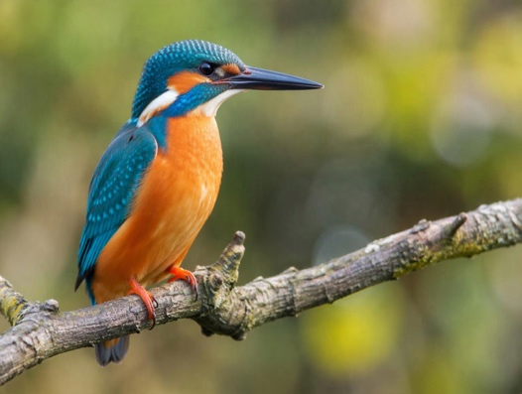  Kingfisher  Figure 2. A colorful kingfisher perched on a branch. | 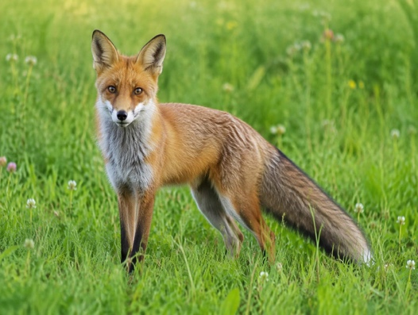  Red Fox  Figure 3. A red fox standing in a green meadow.
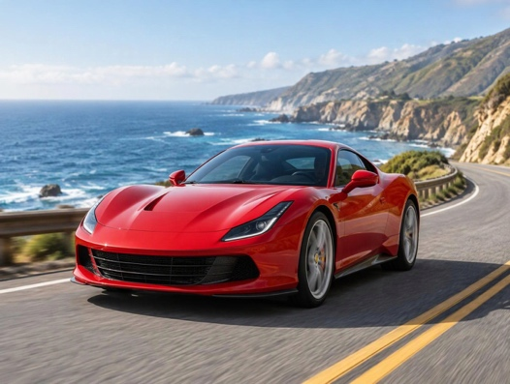  Sports Car  Figure 4. A red sports car on a coastal road. | 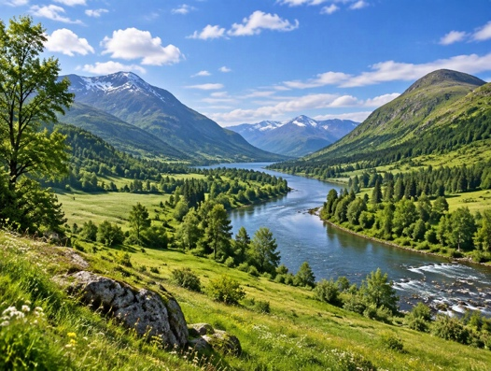  Valley Landscape  Figure 5. A green valley with a river and hills.

6.2 Feature Layout
Featured: Valley Landscape
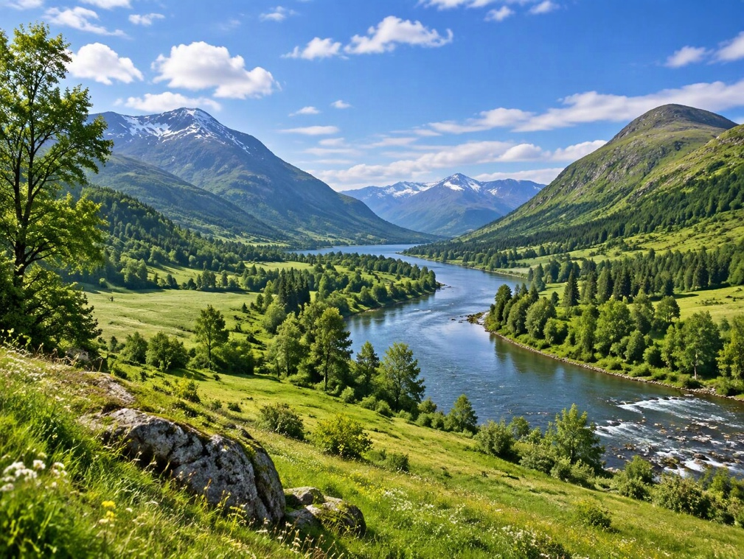
Figure 6. Featured image, repeated from the 2x2 gallery.
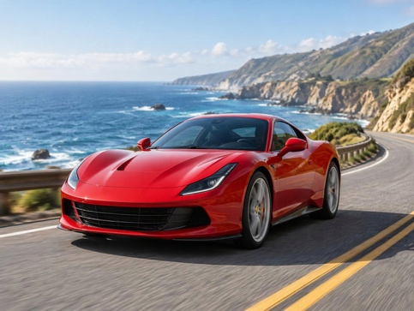  Figure 7. Sports car. | 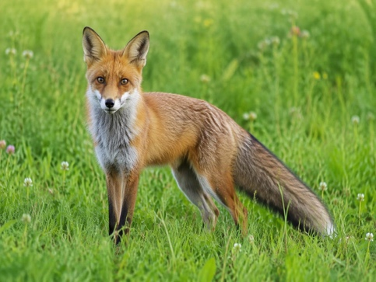  Figure 8. Red fox.

6.3 Filmstrip
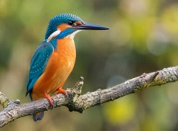 | 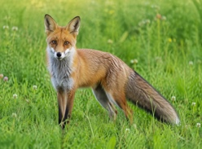 | 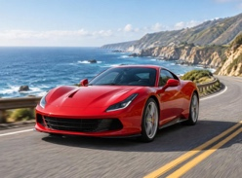 | 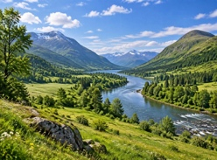
Bird | Fox | Car | Landscape

