1. One of the features on our app is a survey that you will be able to immediately take after downloading the app. In this survey, we ask questions about the user’s proportions, goals, dietary restrictions and more, so that we are able to create a customized experience just for them.

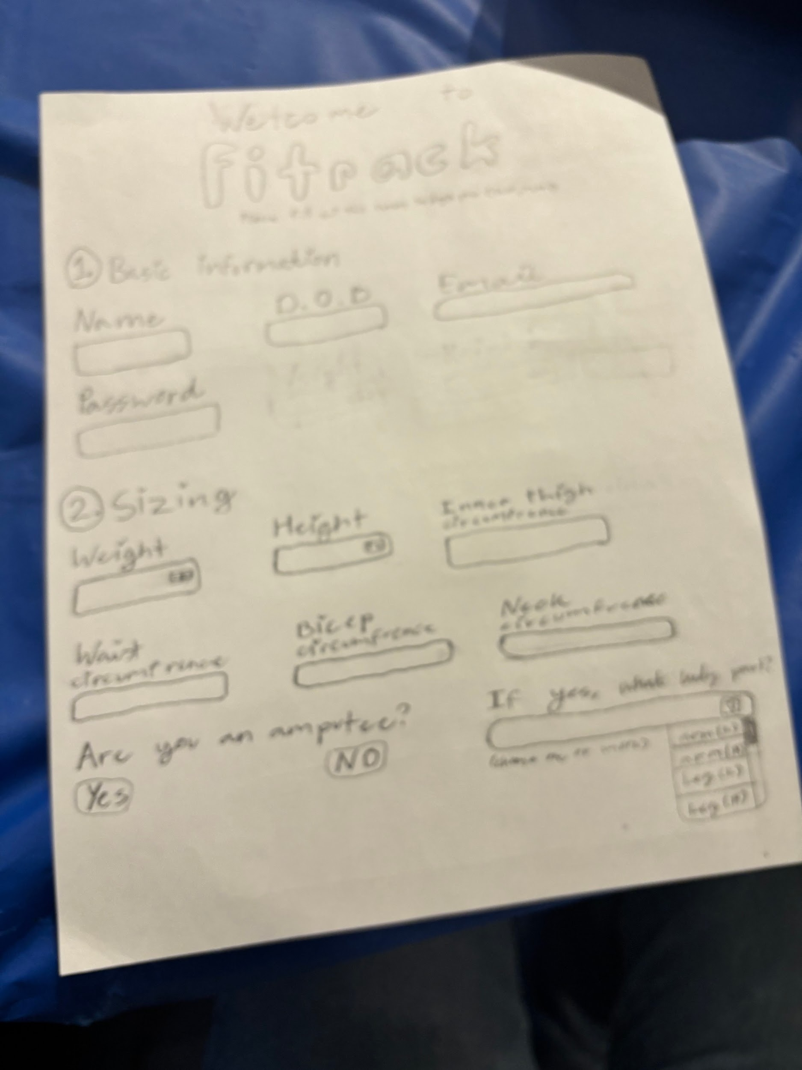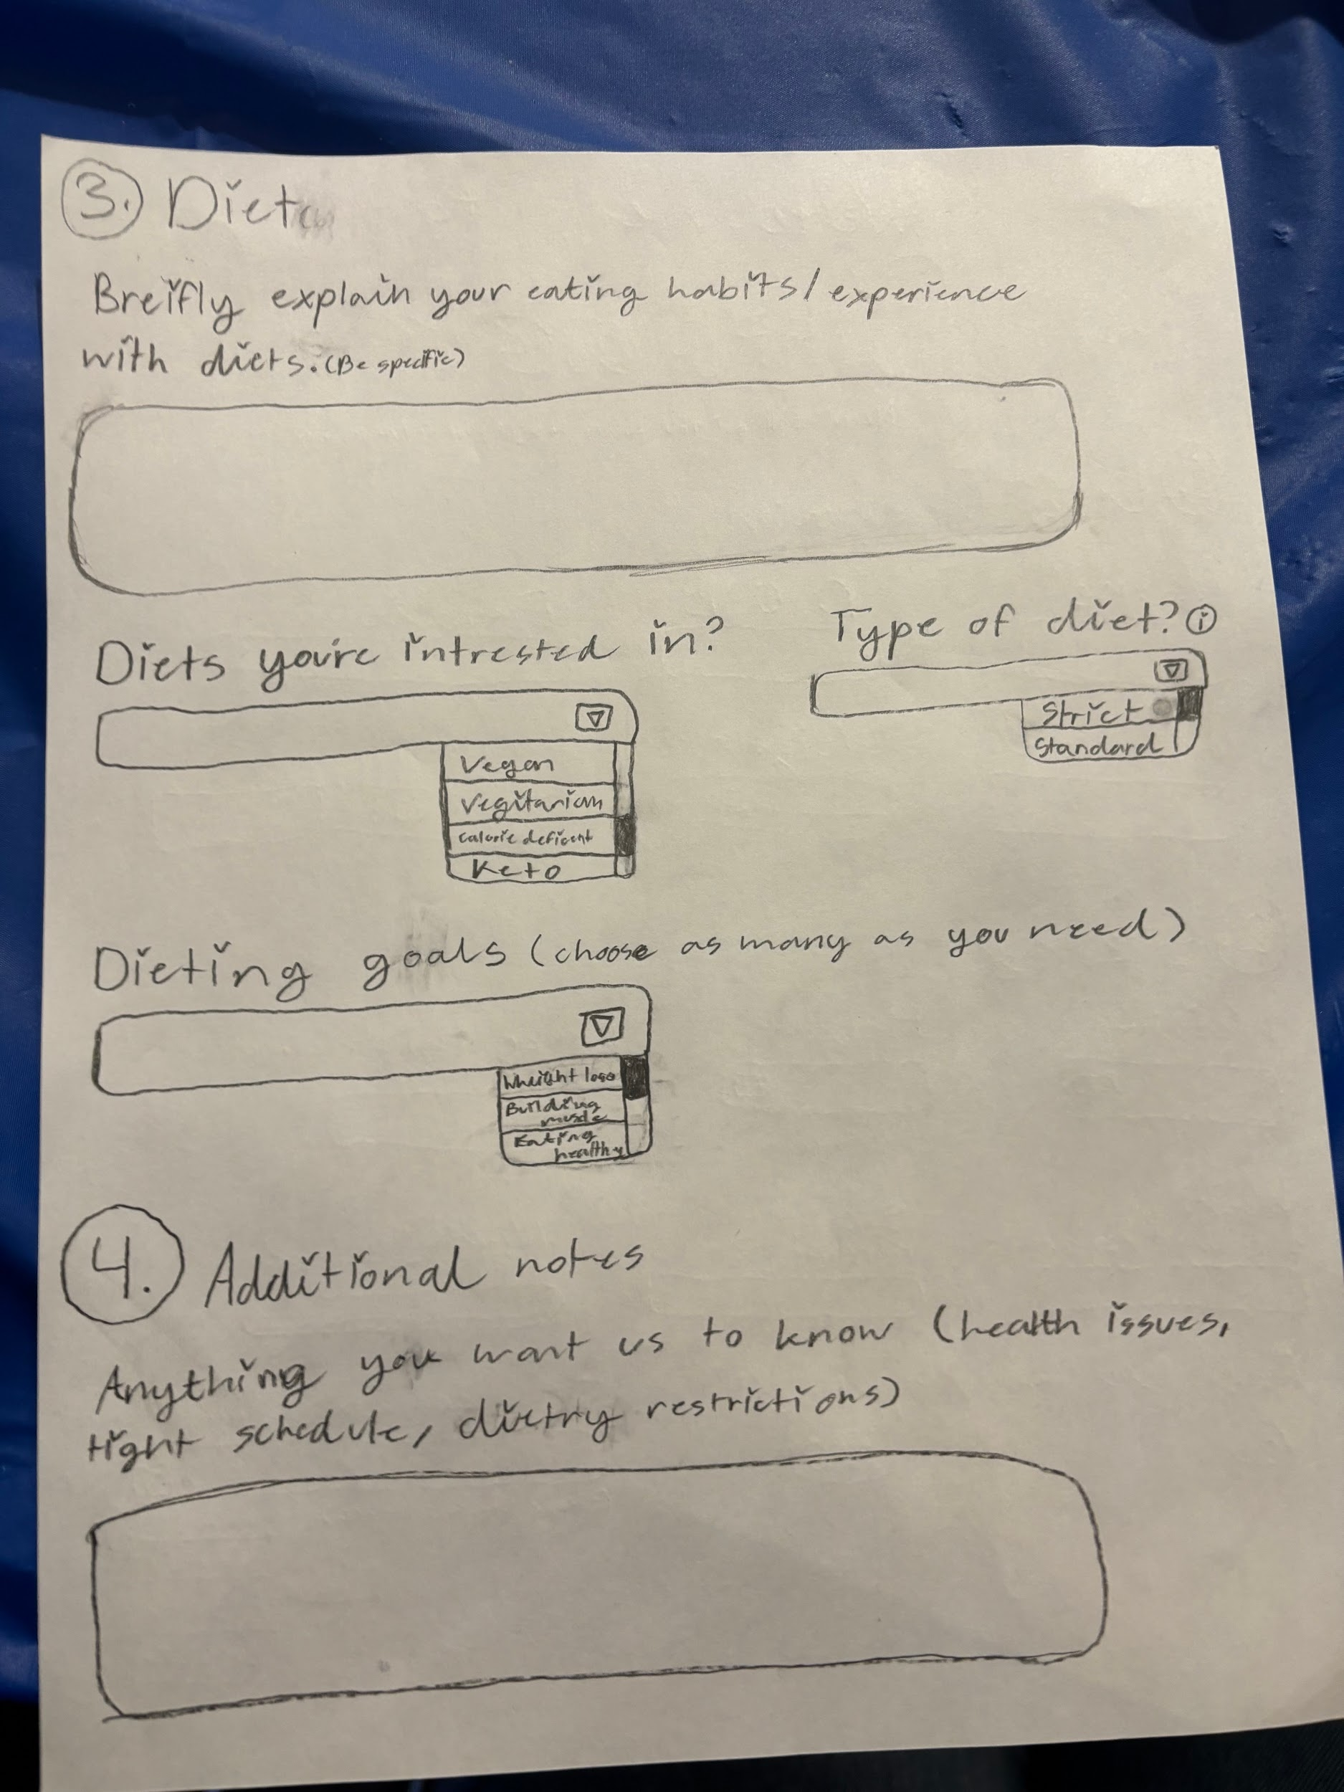

i. Even though many other apps may have a survey feature, we have noticed that the questions they asked are pretty broad and don’t give enough information to be able to create a genuinely good and effective fitness plan for the user. This is why we have decided to create a survey that actually asks for important information that other apps don’t inquire about like disabilities (amputee, wheel-chair user, deficiencies), measurements, a more variety of fitness goals (losing body fat, gaining muscles in specific areas, bulking, a combination of multiple of them) and their own personal preferences (like what exercises and diets they are interested in trying out and taking that into consideration while creating their plan).

ii. As mentioned previously, the survey will ask the user about specific details about themselves, such as their weight, height, what they want to achieve, etc. Based on these answers, the code will make a workout plan for the user and then it will be displayed in the exercise section. From there, the user can access their pre-made workout routine and follow it everyday. Over several months, people will change, so our app accounts for this as well. Through the settings section, the user has an option to retake the survey. For example, the user could have gained or lost weight after a few months, so retaking the survey will allow the program to come up with a new workout routine that will help make more progress towards their goals.

iii. If the user is creating an account for the first time, the app will direct them to fill out the survey. The data we collect is the user’s input from the survey. It is very straightforward, and this allows the user to know exactly what factors were considered when they are provided with a workout routine.

iv. In our app, the user can see how exactly the suggested workout contributes towards their goal. To illustrate, the user’s goal may be to lose weight. When they go on the exercise menu the user will see a cardio exercise. They can click on that to see more details, and they will see a written tutorial on how to do the exercise. Under this section, there will also be a brief explanation about how exactly doing cardio contributes to their goal of losing weight.

i. The code runs right at the beginning of using the app (if you are using it for the first time) and also runs whenever you want to retake the survey through the settings page during your fitness journey.

ii. The model we developed stops within the app after your personal customized plan has been made after the survey takes place. Basically, the model doesn’t run when the survey isn’t being taken.

iii. We picked these starting and ending points because the survey function isn’t necessarily needed after your fitness plan has been created. That is why it only runs right when you begin using the app and when you want to take the survey again.