NAME: KHAVIN.C
ROLL NO: 251011010
TITLE: Evidence Grounded Supplier Intelligence for Automotive Procurement

BRIEF FLOWCHART:
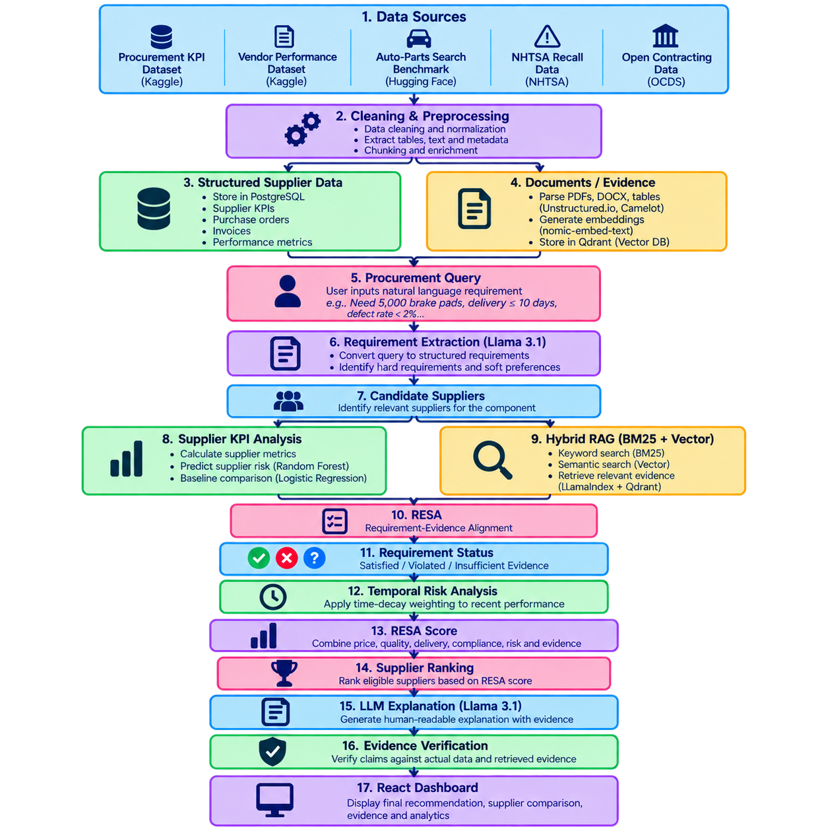

Component | Model / Method Used | Purpose
Requirement Extraction | Llama 3.1 8B | Converts the user's natural-language procurement query into structured requirements such as part, price, delivery time and defect limit
Document Embedding | nomic-embed-text | Converts procurement documents and queries into vectors
Semantic Retrieval | Vector Similarity Search – Qdrant | Finds semantically relevant procurement evidence
Keyword Retrieval | BM25 | Finds exact terms such as part numbers, PO IDs, supplier names and contract clauses
Hybrid RAG | BM25 + Vector Retrieval using LlamaIndex | Combines keyword and semantic retrieval
Supplier Risk Prediction | Random Forest | Predicts supplier risk using defect, delay, compliance, fulfilment and other supplier metrics
Risk Baseline | Logistic Regression | Used to compare and validate Random Forest performance
Temporal Risk | Exponential Time-Decay Weighting | Gives more importance to recent supplier performance
Requirement–Evidence Alignment | RESA rule/scoring mechanism | Classifies requirements as Satisfied, Violated or Insufficient Evidence
Supplier Ranking | RESA weighted scoring | Combines price, quality, delivery, compliance, risk and evidence into final supplier score
Explanation Generation | Llama 3.1 8B | Generates a human-readable reason for the supplier recommendation
Evidence Verification | Claim–Evidence Matching / Rule-based Verification | Checks whether the LLM's claims are actually supported by supplier data or retrieved documents

TECHSTACK:
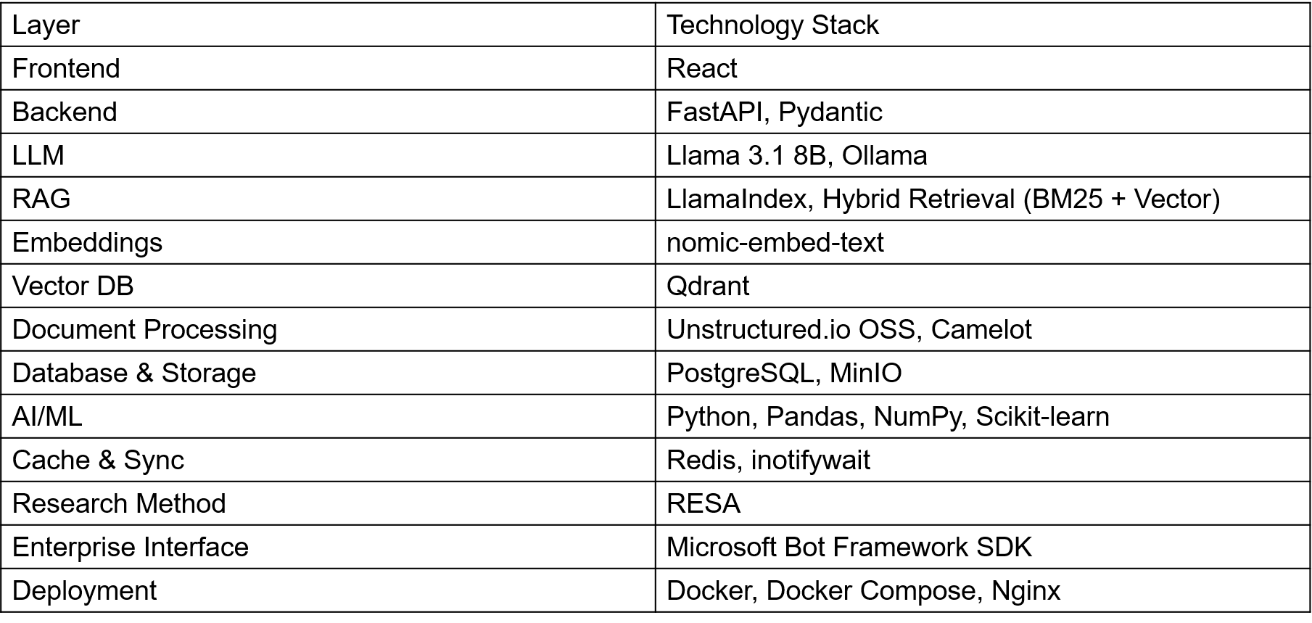

******What happens inside RESA?********
SAMPLE QUERY:
“Find a supplier for 500 brake pads, with delivery within 10 days and a defect rate below 2%. Prefer a lower price.”
Requirement | Supplier A evidence | State | Supplier B evidence | State
Supplies the requested brake pad | Matching component in quotation | Satisfied | Matching component in quotation | Satisfied
Quantity ≥ 500 | Available quantity: 800 | Satisfied | Available quantity: 1,000 | Satisfied
Delivery ≤ 10 days | Quotation states 8 days | Satisfied | Quotation states 14 days | Violated
Defect rate < 2% | Recent scorecard: 1.1% | Satisfied | No usable recent scorecard | Insufficient
Decision | All mandatory conditions supported | Eligible | Delivery requirement fails | Excluded
The evidence states mean
State | Meaning
Satisfied | Applicable, sufficiently current evidence supports the requirement
Violated | Applicable evidence establishes that the requirement is not met
Insufficient | Evidence is missing, stale, ambiguous, conflicting or otherwise inadequate

****RESA scoring and risk**********
Your current prototype uses this illustrative formula for eligible suppliers:
$$\text{RESA Score}={clip}_{0,100}\left(0.25Q+0.20P+0.20D+0.20L+0.15E-0.15R\right)$$
Symbol | Meaning | Desired direction
$$Q$$ | Quality score derived from defect performance | Higher is better
$$P$$ | Price competitiveness | Higher means more competitive
$$D$$ | Delivery speed score | Higher is better
$$L$$ | Historical delivery reliability | Higher is better
$$E$$ | Evidence coverage | Higher is better
$$R$$ | Recent performance risk indicator | Lower is better

