RESA: An Evidence-Grounded Framework for Requirement-Evidence-Supplier Alignment in Automotive Procurement

Khavin C Ms. Indumathi K
M.Tech Data Science Assistant Professor, Department of IT
Rajalakshmi Engineering College Rajalakshmi Engineering College
Chennai, India Chennai, India
ckhavin2002@gmail.com indumathi.k@rajalakshmi.edu.in

Abstract- Automotive supplier selection is usually presented as a ranking problem, but in practice a procurement decision is first a question of evidence: does a supplier actually satisfy the buyer's non-negotiable requirements, and can that claim be traced to a current source? This paper presents RESA, a Requirement-Evidence-Supplier Alignment framework for evidence-grounded automotive procurement decision support. The current first-review prototype separates hard requirement screening from preference scoring. Quotations, recent supplier scorecards, policy rules, and reference datasets are converted into explicit evidence states: Satisfied, Violated, or Insufficient Evidence. A violated mandatory condition excludes a supplier, while missing or stale evidence triggers human review rather than being silently treated as compliance. Only eligible suppliers receive a weighted suitability score based on quality, price, delivery, reliability, evidence coverage, and historical risk. The prototype is implemented as a local React dashboard using bundled JSON/CSV data and deterministic rules. A controlled four-scenario demonstration with six fictional suppliers shows how the same supplier can move between Eligible, Needs Review, and Excluded as procurement constraints change. The study is intentionally framed as a transparent first-stage decision-support prototype; semantic retrieval, LLM-based requirement extraction, and independently labelled ranking evaluation remain future work.
Keywords- automotive procurement, supplier intelligence, supplier selection, evidence grounding, explainable decision support, procurement risk, decision traceability.
I. INTRODUCTION
Supplier selection in automotive procurement is rarely a single-score decision. A buyer may care about price, but an inexpensive quotation is not useful when the supplier cannot meet the required volume, the promised lead time is too long, or the latest quality evidence is missing. Classical supplier-selection research has long recognized that procurement decisions involve multiple criteria rather than cost alone [1]-[3]. In automotive programs the problem becomes more sensitive because quality, continuity of supply, delivery reliability, and capacity can directly affect production schedules and downstream vehicle quality.
A practical weakness in many ranking dashboards is that they combine all signals immediately. When a criterion is missing, stale, or unsupported, the system may still produce a numerical score. This can make an incomplete supplier look comparable with a supplier whose evidence is complete. The resulting ranking may appear precise even though the underlying decision is uncertain. For operational procurement, that distinction matters: a failed requirement and an unknown requirement should not be treated as the same condition.
RESA was designed around that observation. The name refers to Requirement-Evidence-Supplier Alignment. Instead of asking only “Which supplier has the highest score?”, the framework asks three questions in order: What does the buyer require? What evidence exists for each supplier? What can be concluded from that evidence without guessing? The first-review implementation therefore places an evidence gate before ranking. Mandatory requirements are evaluated as Satisfied, Violated, or Insufficient Evidence. Violations lead to exclusion, insufficient evidence leads to review, and only fully evidenced candidates proceed to weighted scoring.
The current prototype is deliberately conservative. It does not claim that a language model or retrieval system is already making procurement decisions. The supplied dashboard is a React-based local application with static JSON/CSV snapshots and deterministic checks. Public datasets are used for supplier analytics, automotive relationship examples, and retrieval-benchmark inspection, while the linked supplier decision scenario is synthetic and clearly separated from those public sources. This boundary is important because the prototype is meant to demonstrate a defensible decision process before introducing more complex AI components.
The contributions of this first-stage work are: (1) a requirement-first supplier screening method that distinguishes violations from missing evidence; (2) an evidence freshness rule that prevents stale supplier records from being treated as current proof; (3) a transparent suitability formulation applied only after hard-constraint eligibility; and (4) a traceable dashboard in which each requirement check can be tied back to the quotation or scorecard used to support it. The longer-term RESA architecture will extend this foundation with hybrid retrieval and language-model assistance, but the present paper reports only what is implemented and reproducible in the submitted prototype.
II. RELATED WORK
Supplier evaluation has been studied for decades as a multi-criteria decision problem. Weber, Current, and Benton reviewed vendor-selection criteria and analytical methods and showed that price is only one part of the purchasing decision [1]. De Boer, Labro, and Morlacchi later organized supplier-selection methods across the stages of problem definition, qualification, and final choice [2]. Ho, Xu, and Dey reviewed multi-criteria decision-making approaches and emphasized that contemporary supplier evaluation combines several performance dimensions rather than relying on a single financial measure [3]. These studies provide the decision-analysis background for RESA, particularly the separation between qualification and final ranking.
Risk-aware supplier selection is also relevant. Kull and Talluri integrated supplier selection with risk measures in an automotive setting, illustrating the importance of considering uncertainty and supply risk together with performance criteria [4]. RESA follows the same practical concern but uses a simpler, inspectable risk signal in the current prototype. The intention is not to replace established MCDM methods, but to make the evidence state visible before any preference-weighted score is accepted.
Interpretability is another important requirement when decision-support outputs affect real actions. Work on explainable machine learning has argued that users need understandable reasons for model outputs before they can judge whether a result should be trusted [5]. RESA applies this idea at the data-and-rule level: the interface exposes the exact evidence record, the requirement state, and the scoring components instead of presenting only a final supplier rank.
The planned research extension also relates to retrieval-augmented systems. Retrieval-Augmented Generation (RAG) combines language generation with retrieved external evidence [6], while BM25 remains a strong lexical retrieval method [7] and sentence-level embedding approaches such as Sentence-BERT support semantic similarity search [8]. These techniques motivate the future hybrid retrieval layer planned for RESA. However, the current prototype does not report RAG accuracy or LLM performance; its evidence checks operate on exact structured records. This avoids overstating the maturity of the implementation.
III. PROPOSED RESA FRAMEWORK
The RESA workflow is organized as a sequence of evidence-preserving decisions. A procurement request first defines the component, required quantity, maximum lead time, and maximum acceptable defect rate. The framework then collects the relevant supplier quotation, recent performance scorecard, and decision policy. Public data may support analytics or domain exploration, but it is not silently joined to fictional supplier identities. Each mandatory requirement is evaluated independently so that the decision state remains inspectable.
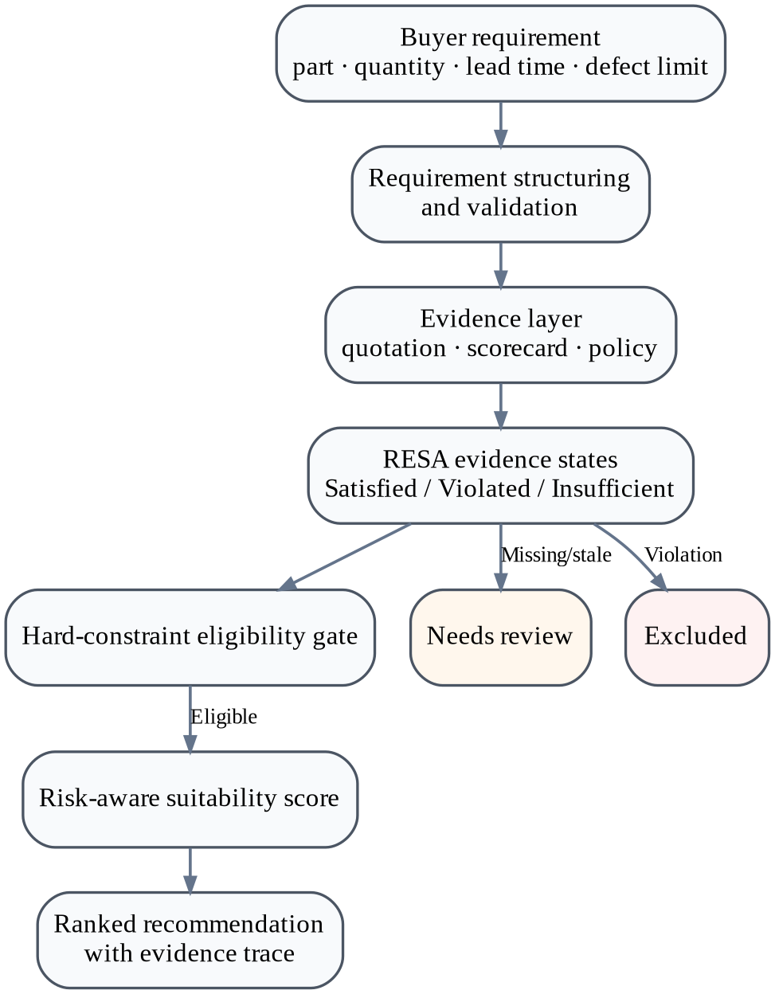
Fig. 1. RESA evidence-grounded supplier decision architecture.
A. Requirement Representation
The first-review interface represents a request as a compact structured record r = {part, quantity, days, defect}. This is intentionally simple. It allows the procurement user to change a constraint and immediately observe how the candidate set changes. In the standard brake-pad scenario, for example, the request is 500 units, delivery within 10 days, and a defect rate below 2%. The prototype treats the defect constraint as a strict inequality, reflecting the rule implemented in the dashboard engine.
B. Evidence State and Freshness
For supplier s and requirement k, RESA assigns one of three evidence states. A value is Satisfied when current evidence is present and meets the rule, Violated when current evidence is present but fails the rule, and Insufficient when the required evidence is unavailable or stale. Scorecards are considered current only when they fall within the 120-day freshness window used by the prototype. This prevents an old quality record from being interpreted as proof of current supplier performance.
state(s,k) = {Satisfied, Violated, Insufficient} (1)
The decision policy is asymmetric by design. A violation is stronger evidence than uncertainty: if at least one mandatory requirement is violated, the supplier is Excluded. If there is no violation but one or more required checks are insufficient, the supplier is marked Needs Review. Only suppliers with all mandatory checks satisfied are labelled Eligible.
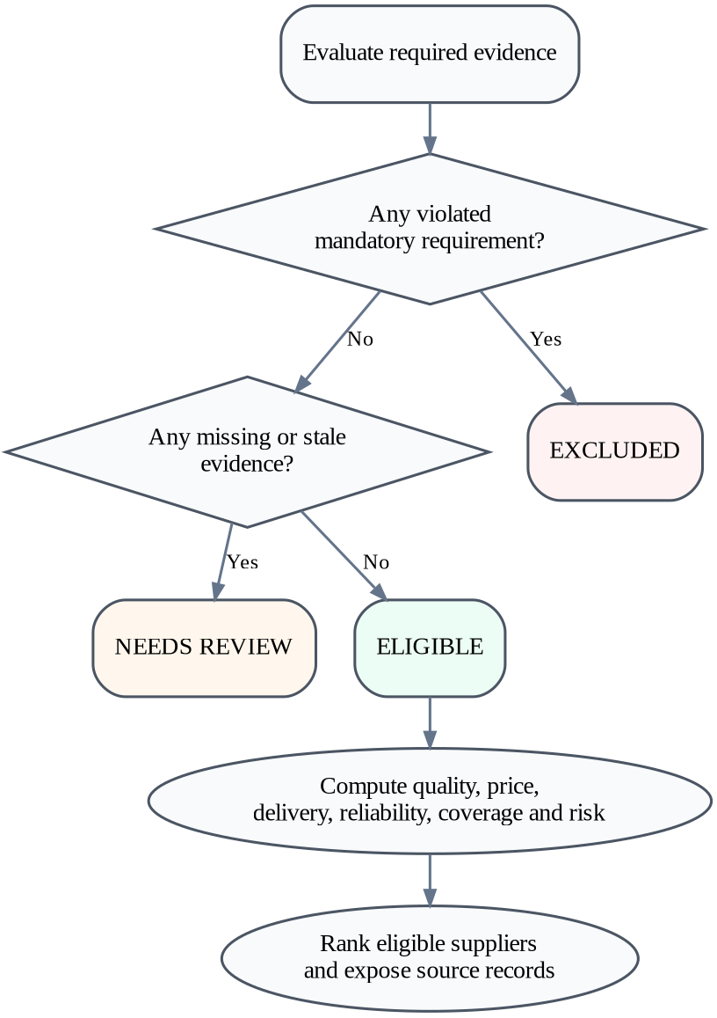
Fig. 2. Hard-constraint decision flow used before supplier scoring.
C. Component Scores
Eligible suppliers are compared using normalized quality, price, delivery, reliability, evidence coverage, and risk terms. Quality is derived from the latest fresh defect rate d_s, while reliability is the latest on-time-delivery percentage. Price is normalized within the quotations available for the requested component so that lower price receives a higher score. Delivery rewards shorter lead times, using the 20-day scaling range defined in the prototype.
Q_s = clamp(100 - 10 d_s) (2)
P_s = 100 (p_max - p_s) / (p_max - p_min) (3)
D_s = clamp(100 (20 - L_s) / 20) (4)
Evidence coverage is the percentage of four mandatory checks for which a usable value is known. Because scoring is performed only for Eligible suppliers, their coverage is complete in the present implementation; the coverage term is nevertheless retained because it makes the scoring structure explicit and supports later extensions with a larger requirement set.
C_s = 100 (known mandatory checks / 4) (5)
D. Historical Risk and Suitability
RESA also derives a recent-history risk signal from scorecards within the same 120-day window. More recent scorecards receive larger integer weights. Each monthly risk contribution combines late-delivery exposure and defect-rate exposure. The current coefficients are design settings, not learned parameters, and are therefore documented rather than presented as optimal values.
R_s = sum_i w_i [0.65(100-OTD_i) + 0.35 clamp(10d_i)] / sum_i w_i (6)
The final suitability score is calculated only after eligibility has been established. The weighting used in the first-review prototype gives the greatest share to quality and then balances price, delivery, reliability, and evidence coverage, with risk applied as a penalty. The score is bounded to the interval [0,100].
S_s = 0.25Q_s + 0.20P_s + 0.20D_s + 0.20OTD_s + 0.15C_s - 0.15R_s (7)
The weights are illustrative and were not learned from procurement outcomes. Their purpose is to make the ranking logic transparent enough for review. In a later research stage, weight calibration can be studied using procurement-expert judgments or independently labelled historical sourcing decisions.
E. Decision Traceability
A central design choice is that the result is not just a rank. Each requirement check retains a document identifier for the quotation or scorecard used in the decision. The user can therefore inspect why a supplier was accepted, excluded, or held for review. This is particularly useful for borderline cases because a procurement analyst can distinguish “supplier failed the lead-time requirement” from “lead-time commitment is missing.” The dashboard also supports exporting an assessment snapshot so that the requirement set, results, evidence states, and source descriptors can be reviewed later.
F. Dashboard Modules and Implementation Boundary
The dashboard is divided into five views that mirror the research workflow. The Decision Workspace is the operational view: it accepts the procurement constraints, evaluates candidate suppliers, and lets the user open the evidence behind each requirement. Supplier Analytics summarizes the public procurement KPI file without pretending that those records belong to the fictional demo suppliers. The Evidence Library exposes quotations, scorecards, and the policy record used by the decision engine. The Dataset Explorer documents the source files and their provenance, while the Research Evaluation view contains the four internal scenario checks. This separation is intentional because it makes clear which data support analytics, which data support the interactive demonstration, and which data are reserved for future retrieval experiments.
The first-review package also makes a strict implementation boundary explicit. It does not contain a running FastAPI backend, Qdrant index, Ollama service, embedding pipeline, or LLM-driven requirement extractor. The user interface and scoring engine can therefore be reproduced without network access or model downloads. This is useful for review because the observed supplier states can be traced to deterministic code rather than to a hidden model call. The planned AI components are treated as a next-stage extension to evidence retrieval and explanation, not as functionality already validated by the present experiment.
IV. DATA AND EXPERIMENTAL SETUP
The prototype bundles four data groups with different roles. They are intentionally not treated as one joined real-world supplier dataset. The Procurement KPI Analysis file contains 777 generic purchase-order rows and is used for aggregate supplier analytics. The Automotive Supply Chain sample contains 50 rows across suppliers, parts, vehicle models, and relationships. The Auto-Parts Search Benchmark provides 149 development queries for examining retrieval-style automotive terminology. The interactive procurement decision workspace uses a separate synthetic review scenario consisting of six fictional suppliers, twelve quotations, eighteen scorecards, and one policy record. This separation avoids implying that the public datasets describe the fictional suppliers used in the demonstration.
TABLE I. DATA SOURCES USED IN THE PROTOTYPE
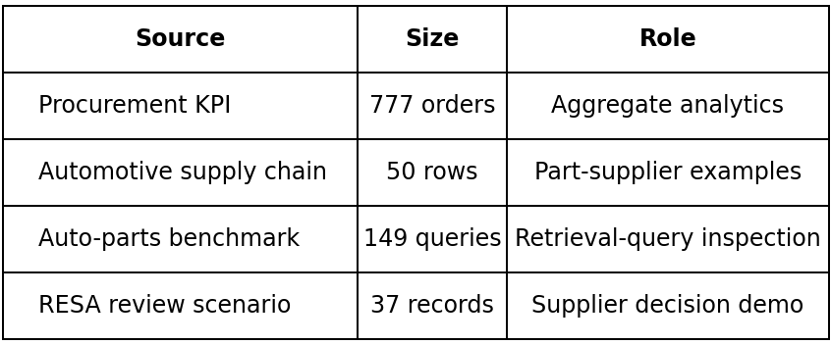
The generic KPI dataset contains 560 delivered orders; 491 delivered rows have usable date pairs, with an average observed order-to-delivery duration of approximately 10.52 days. Among the rows used for the defect calculation, the quantity-weighted defect rate is approximately 6.73%, and 82.37% of rows with a Yes/No compliance value are marked compliant. These figures are descriptive analytics from the public dataset and are not used as ground-truth labels for the synthetic supplier-ranking experiment.
The benchmark query set also reflects varied automotive language. It includes exact English requests, Hindi/Hinglish expressions, symptom descriptions, misspellings, part numbers, and brand-as-generic queries. This is useful for future retrieval experiments, but the sealed test split is not included and no retrieval metric is claimed in the current dashboard.
A. Prototype Environment
The submitted first-review system is a local React 18 application written in plain JavaScript and served over HTTP using a small Python standard-library server. React libraries and datasets are bundled locally. No pip installation, npm build step, API key, external database, or network service is required to run the review dashboard. The scoring logic is implemented in a separate engine module so that it can be validated independently from the interface. The assessment date is fixed at 11 September 2026 for reproducibility.
B. Controlled Scenarios
Four internal scenarios were defined to test whether changing a procurement constraint changes the supplier state in the expected direction: a standard brake-pad purchase, an urgent seven-day delivery request, a larger 1,500-unit order, and an air-filter purchase. These checks are implementation tests rather than model-accuracy experiments. They verify that the rules for lead time, capacity, part matching, evidence freshness, and quality thresholds are applied consistently.
C. Reproducibility and Data Provenance
Reproducibility was treated as part of the prototype design. The public raw files are bundled with a manifest that records source identifiers, access dates, file sizes, SHA-256 hashes, licenses or source terms, and known limitations. The synthetic supplier records are stored separately and are labelled as generated review data. The assessment date is fixed so that quotation validity and scorecard freshness do not change between runs. As a result, another reviewer opening the same package can reproduce the same eligibility states and weighted scores without depending on an external API or a database that may change over time.
This provenance layer is especially important for a future evidence-retrieval system. Retrieval quality cannot be judged only by whether a document appears semantically relevant; the system also needs to know what the document represents, when it was created, and whether it is appropriate evidence for a particular requirement. RESA therefore treats provenance metadata, freshness, and source identity as first-class decision inputs. In later versions, the same idea can be extended to document-level citations, supplier master-data identifiers, and authenticated source systems.
V. RESULTS AND DISCUSSION
A. Standard Brake-Pad Scenario
For the standard request of 500 brake pads, delivery within 10 days, and defect rate below 2%, two suppliers are fully eligible. Madras Mobility Parts receives the higher suitability score, 73.8, while Chennai Precision Works scores 67.7. The result is not simply a price ranking. Chennai Precision Works has the stronger recent quality and delivery history, but its quoted unit price is the highest in the candidate set. Madras Mobility Parts has a lower price while still meeting the mandatory quality, lead-time, and capacity conditions, which lifts its weighted score.
TABLE II. STANDARD BRAKE-PAD DECISION OUTCOME
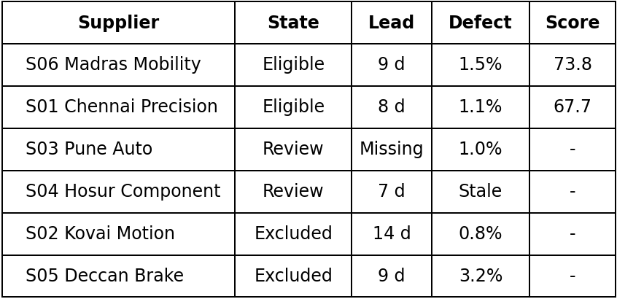
The two review outcomes illustrate why RESA separates uncertainty from failure. Pune Auto Systems has a current scorecard but no committed delivery time in the quotation, so the system cannot assert that the 10-day requirement is satisfied. Hosur Component Works has an acceptable quotation but its latest scorecard is older than the 120-day window. Neither supplier is automatically rejected, but neither is allowed into the final ranking. By contrast, Kovai Motion Components is excluded because its 14-day lead time violates the request, and Deccan Brake Technologies is excluded because its 3.2% defect rate exceeds the strict 2% limit.
B. Sensitivity to Procurement Constraints
The internal scenario checks confirm that the candidate set reacts to changes in the buyer requirement. Tightening delivery from 10 to 7 days removes both previously eligible suppliers; two suppliers remain under review because of missing or stale evidence, and four are excluded. Increasing order quantity from 500 to 1,500 units excludes Madras Mobility Parts because its quotation provides capacity for 1,000 units, leaving Chennai Precision Works as the only fully eligible supplier. Changing the requested component to an air filter reuses the matching air-filter quotations and again produces two eligible suppliers. These transitions are visible in Fig. 3.
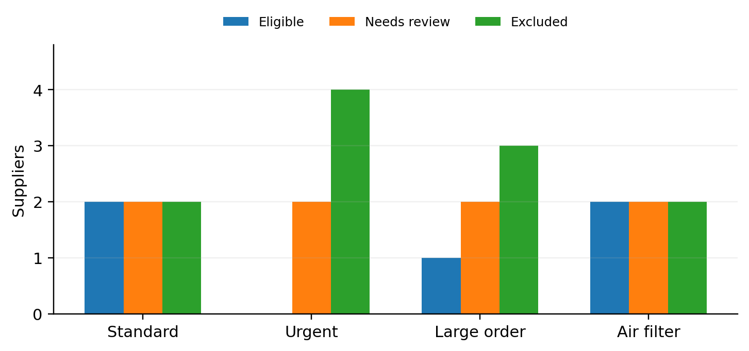
Fig. 3. Supplier decision states across the four internal review scenarios.
TABLE III. INTERNAL SCENARIO CHECKS
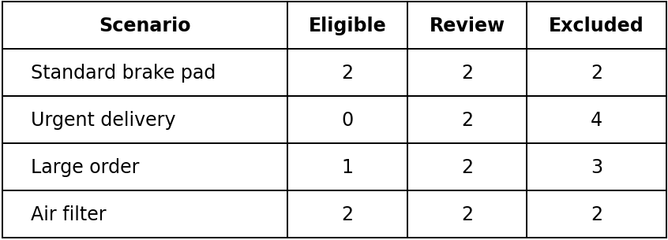
C. Interpretation
The controlled results mainly demonstrate process behavior, not predictive accuracy. The prototype does what it is designed to do: it prevents a supplier with an explicit hard-constraint failure from receiving a preference score, and it refuses to convert missing evidence into a false positive decision. That behavior is valuable because it reduces a common source of false confidence in dashboards. A high numerical score is shown only when the mandatory evidence has already passed the decision gate.
D. Score Decomposition for Eligible Suppliers
The two eligible suppliers in the standard scenario also show how the weighted score behaves after qualification. Chennai Precision Works receives strong quality and reliability contributions because its latest defect rate is 1.1% and on-time delivery is 97%. Madras Mobility Parts is slightly weaker on those measures, with a 1.5% defect rate and 94% on-time delivery, but its quotation is cheaper. Under the component-specific min-max price normalization, this price advantage is large enough to offset the difference in quality and reliability, producing the higher total score of 73.8 compared with 67.7. The result is therefore explainable in terms of visible score components rather than an opaque ranking function.
This example also exposes a design trade-off. Because price normalization is relative to the candidate quotations, the same supplier may receive a different price contribution if the comparison set changes. That is acceptable for the current demonstration, where the objective is within-request ranking, but a production system may need additional controls such as should-cost ranges, negotiated baselines, currency normalization, or historical price bands. Similar calibration questions apply to the fixed 20-day delivery scaling and the defect-rate transformation. These parameters should ultimately be tied to procurement policy or learned from historical decisions rather than left as generic defaults.
At the same time, the current evaluation is limited. The supplier scenario is synthetic, the scoring weights are manually chosen, and the four cases were created to exercise known branches of the decision logic. There is no independently annotated benchmark of real automotive sourcing decisions, no comparison with buyer decisions, and no measured RAG or LLM performance. The public procurement KPI dataset is generic rather than verified automotive transaction data, and there is no identity mapping between the public records and the fictional suppliers. These limitations mean that the current results should be interpreted as evidence of a working, transparent decision pipeline rather than proof that RESA improves real procurement outcomes.
VI. DISCUSSION AND LIMITATIONS
RESA differs from a conventional score-first supplier dashboard in one practical respect: it treats the presence and quality of evidence as part of the decision rather than as a hidden preprocessing concern. A supplier with a missing delivery commitment is not given an estimated lead-time score, and a supplier with an old scorecard is not assumed to have maintained its previous quality level. This makes the system less eager to rank, but the resulting recommendation is easier to defend because the boundary between evidence, uncertainty, and preference is explicit. In procurement settings, that conservative behavior is useful when a ranking may influence sourcing actions or require later audit.
The current design also makes weight sensitivity easier to reason about. The weighted suitability score cannot rescue a supplier that already violates a mandatory requirement. For example, an attractive price does not compensate for a lead time beyond the requested maximum, and a strong on-time-delivery record does not compensate for a defect rate above the specified threshold. This mirrors how many real sourcing decisions are discussed: first determine whether a supplier is qualified for the requirement, then compare trade-offs among the qualified candidates. RESA formalizes that sequence and keeps the evidence record attached to each step.
There are several limitations. First, the six-supplier decision dataset is synthetic and intentionally small. It was created to exercise the interface and rule branches, not to represent the full variability of automotive supplier behavior. Second, the public KPI dataset is generic procurement data and is not linked to the fictional suppliers. Third, the scoring coefficients, risk weights, and 120-day freshness rule are prototype design choices rather than values derived from expert consensus or historical optimization. Fourth, the current application evaluates structured fields directly; it does not yet resolve contradictory free-text documents, identify forged evidence, or infer requirements from unstructured purchase requests. These gaps must be addressed before the framework can be evaluated as an operational sourcing system.
The evaluation method is therefore best described as functional verification. The four scenarios check whether the implementation follows its documented decision policy. They do not establish statistical generalization, ranking accuracy, or business benefit. A stronger study would recruit procurement experts to label supplier eligibility and preference decisions, compare RESA with a score-only baseline and common MCDM methods, and test the stability of decisions under missing, stale, and conflicting evidence. It would also report inter-rater agreement and separate calibration data from final evaluation data. These steps are necessary if future versions claim improved decision quality rather than only improved traceability.
A further limitation concerns the planned use of generative AI. An LLM can make requirement capture and explanation more convenient, but it can also introduce unsupported claims if it is allowed to summarize beyond retrieved evidence. For that reason, the future architecture should keep the LLM outside the final policy gate. The model may propose a structured requirement, retrieve candidate documents, or draft a natural-language explanation, but every decisive claim should be linked to a source record and re-checked by deterministic rules. If no supporting evidence is available, the correct system behavior is to return Insufficient Evidence rather than generate a plausible completion.
The same principle applies to hybrid retrieval. Lexical search is useful for exact part numbers and contractual terms, while dense retrieval can help with paraphrases and natural-language descriptions. A combined retriever can improve coverage, but retrieval alone does not prove compliance. Future experiments should therefore measure retrieval recall separately from decision correctness and should include adversarial cases such as conflicting quotations, outdated certificates, duplicate supplier names, and partially matching documents. This separation of retrieval performance from procurement judgment is central to the evidence-grounded direction of RESA.
VII. CONCLUSION AND FUTURE WORK
This paper presented RESA, an evidence-grounded framework for Requirement-Evidence-Supplier Alignment in automotive procurement. The first-review prototype separates mandatory qualification from preference ranking, represents each requirement as Satisfied, Violated, or Insufficient Evidence, applies a 120-day scorecard freshness rule, and exposes the source record behind each decision. Eligible suppliers are then compared using a documented combination of quality, price, delivery, reliability, evidence coverage, and historical risk. In the controlled six-supplier demonstration, the framework produced different candidate sets as lead time, order quantity, and component requirements changed, while preserving a clear distinction between exclusion and uncertainty.
The next stage will focus on replacing manual structure with evidence retrieval while keeping the same decision discipline. Planned work includes a FastAPI service layer, persistent supplier and evidence stores, hybrid lexical/vector retrieval, and local language-model assistance for extracting procurement requirements and producing explanations. BM25 [7], dense sentence representations [8], and retrieval-augmented generation [6] provide relevant technical foundations, but the retrieved evidence must remain traceable and the language model must not be allowed to override mandatory rules. A useful architecture would therefore use AI to locate and summarize evidence while retaining deterministic policy checks as the final gate.
Research evaluation must also become more realistic. Future experiments should use larger supplier datasets, independently constructed scenarios, expert-labelled eligibility decisions, sensitivity analysis of the scoring weights, ablation tests for evidence freshness and risk penalties, and retrieval metrics on a held-out benchmark. Where real supplier data cannot be published, the study should clearly distinguish anonymized operational data from synthetic examples. Human review should remain part of the workflow for cases with incomplete evidence. The long-term objective is not to automate procurement judgment blindly, but to give procurement analysts a faster and more auditable way to understand which supplier claims are supported, which are violated, and which still require verification.
REFERENCES
[1] C. A. Weber, J. R. Current, and W. C. Benton, “Vendor selection criteria and methods,” European Journal of Operational Research, vol. 50, no. 1, pp. 2-18, 1991, doi: 10.1016/0377-2217(91)90033-R.
[2] L. de Boer, E. Labro, and P. Morlacchi, “A review of methods supporting supplier selection,” European Journal of Purchasing & Supply Management, vol. 7, no. 2, pp. 75-89, 2001, doi: 10.1016/S0969-7012(00)00028-9.
[3] W. Ho, X. Xu, and P. K. Dey, “Multi-criteria decision making approaches for supplier evaluation and selection: A literature review,” European Journal of Operational Research, vol. 202, no. 1, pp. 16-24, 2010, doi: 10.1016/j.ejor.2009.05.009.
[4] T. Kull and S. Talluri, “A supply risk reduction model using integrated multicriteria decision making,” IEEE Transactions on Engineering Management, vol. 55, no. 3, pp. 409-419, 2008, doi: 10.1109/TEM.2008.922627.
[5] M. T. Ribeiro, S. Singh, and C. Guestrin, “Why Should I Trust You?: Explaining the Predictions of Any Classifier,” in Proc. 22nd ACM SIGKDD Int. Conf. Knowledge Discovery and Data Mining, 2016, pp. 1135-1144, doi: 10.1145/2939672.2939778.
[6] P. Lewis et al., “Retrieval-Augmented Generation for Knowledge-Intensive NLP Tasks,” in Advances in Neural Information Processing Systems 33, 2020.
[7] S. Robertson and H. Zaragoza, “The Probabilistic Relevance Framework: BM25 and Beyond,” Foundations and Trends in Information Retrieval, vol. 3, no. 4, pp. 333-389, 2009, doi: 10.1561/1500000019.
[8] N. Reimers and I. Gurevych, “Sentence-BERT: Sentence Embeddings using Siamese BERT-Networks,” in Proc. EMNLP-IJCNLP, 2019, pp. 3982-3992.
[9] S. Kabir, “Procurement KPI Analysis Dataset,” Kaggle dataset, accessed Sep. 11, 2026. [Online]. Available: https://www.kaggle.com/datasets/shahriarkabir/procurement-kpi-analysis-dataset
[10] Graph Dataset Hub, “Automotive Supply Chain,” sample graph dataset, accessed Sep. 11, 2026. [Online]. Available: https://graph-hub.siwei.io/en/stable/datasets/supply_chain/
[11] ManmohanBuildsProducts, “Auto-Parts Search Benchmark,” Hugging Face dataset, development split, accessed Sep. 11, 2026. [Online]. Available: https://huggingface.co/datasets/ManmohanBuildsProducts/auto-parts-search-benchmark

