ENSE374 Activity 5 Report - O’Brien

Aryan Chandra, Stephanie Ndulue, Nikita Khavronin

**Project Background**

Today’s society is extremely fast paced. It is sometimes difficult to find time to meet up with friends and discuss about similar interests. This is why a powerful sense of global community is very essential in today’s society. This is especially important in promoting peace and a sense of togetherness and eradicating loneliness. Over the years, different innovations have created an avenue for people of similar interests to socialize and join communities where they feel most welcome in online. A website that helps a community of movie lovers all over the world to discuss about the movies they watch would be a step in the right direction in bringing people of diverse cultures together.

This project aims to create a one stop place online for movie watchers to find what they are looking for in terms of movie recommendations and ratings and to feel a sense of togetherness as they discuss on movies with people of like interests.

**Project Goal**

The goal of this project is to provide a website where movie watchers can discuss about movies of interest in real time with others. The website would allow users to log in, log out, view movie recommendations, view movie ratings, rate movies and most importantly, chat with other users on movies of interest.

**Documentation**

Documentation was an important aspect of this project. The documents in this project were used to clearly define the scope of our Minimum Viable Products (MVPs), assign tasks/responsibilities, and keep track of progress made. These documents include:

* **Business Case:** used to explicitly define the background and reason for embarking on this project and the possible MVPs the team had in mind. Each MVP was also emphasized upon, and advantages and disadvantages of each MVP option was explained.
* **Project Scope Statement:** used to give a detailed description of the project deliverables and features. It was also used to explain features that were out of date for the project.
* **Communication Management Plan:** used to document the meetings that were held during the initial stages of the project to set everything into place. It details the purpose of the meeting, people in attendance and time the meetings were held.
* **Project Charter:** used to give a summary of the project’s goal, objective, project stakeholders, milestones, and project risks.
* **Project Roles and Responsibilities:** used the identify the members of the team in this project and define the responsibilities of each member.
* **RACI Chart:** used to assign responsibility, accountability, consulted and informed to each stakeholder in the project.
* **Stakeholder Register:** used to identify stakeholders in the project, their roles and level of influence they have on the project.
* **Project Requirement Document:** used to define the functional and Technical Requirements of the project.
* **Stakeholder Engagement Plan:** used to give detailed description of stakeholders in the project and how each stakeholder would be engaged in order to guarantee the success of the project.

**Diagrams**

Diagrams were used in this project to provide a pictorial representation of the design and intended user experience. The diagrams created for this project are as follows:

* **UML Process Diagram:** used to describe the sequential interaction of the user and the website/project.
* **Model View Controller Diagram:** represents the architectural pattern used for developing the user interface for the project.
* **UML Class Diagram:** used to describe the objects used in the project and how they relate to each other.
* **UML Data Diagram:** shows the visual representation of the interaction of the user and the website with emphasis on the information flow.
* **Low fidelity Prototype:** used to show a pictorial representation of the intended website’s user interface.
* **User Questionnaire:** used to get feedback from potential users on the usability of the website drawn in the low fidelity prototype.

**Project Feedback**

While working on the project, we were fortunate enough to receive deeply reflected upon feedback, some of these are listed below:

1. “The MVP's could've been explained in a bit more of a detail and what it would look like when a user is exploring it not the developer itself”
2. “I would've liked it if the prototyping was done on digital software as the prototype gives the sense of what your User Interactive product is going to look like.”
3. “I noticed that the only user specified is the “Movie Watcher.” Perhaps you guys want to target a more specific audience or age group and cater the site to them?” & “People may be able to chat about movies, but It is even tough to create good community environment”

The team discussed on the feedback which was received and decided on how to manage it. Feedback was addressed in this way:

1. MVP presentation was reevaluated and rewritten from the perspective of the users to give a better explanation of the envisioned project.
2. The team decided that the low fidelity prototype drawn using the paper method was enough to clearly represent the envisioned user interface.
3. Making “movie watchers” our target audience and not being more specific was deliberately done by the team. This is because the goal of this MVP was to only provide the functionality for users who love movies to discuss with people of like interests on new movie releases. Censorship was out of scope as stated in our project scope statement.

**Project Outcome**

This project was developed with React at the front-end and Django at the back end.

**Front-end of the Website:**

The index page of the website consists of the navigation bar and the list of new movie releases. The navigation bar consists of main, featured, popular chat and FAQ. It also has the sign in and login buttons. The list of movies serves as a movie recommendation list. It also enables users view ratings and leave their own rating.

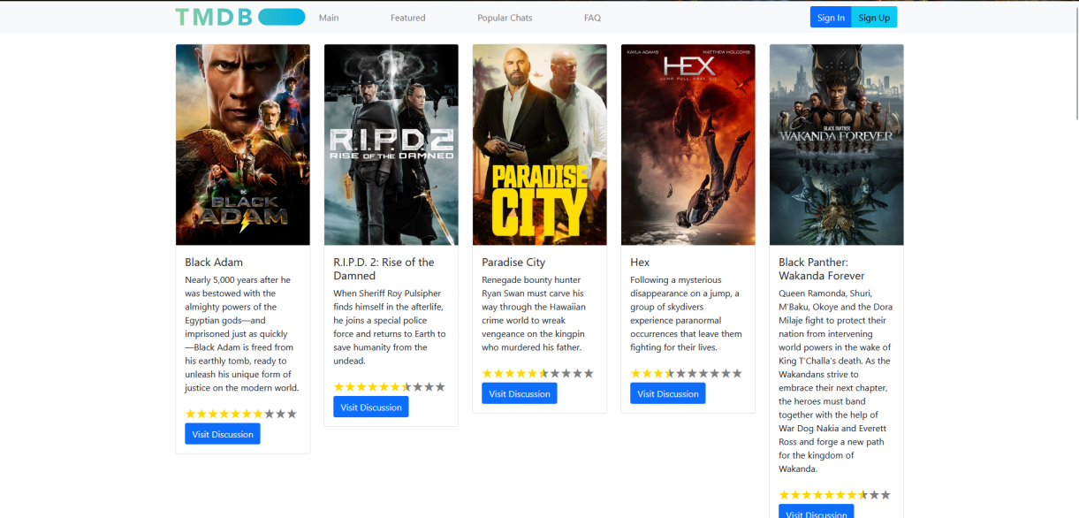

Figure 1 - Index Page

Users can find more movies by using the tab at the bottom of the page.

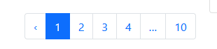

Figure 2 - Movie List Tab

When each movie is clicked on, the user is directed to the selected movie’s page. This page contains the synopsis of the movie, the rating feature, the genre of the movie and a live chat section.

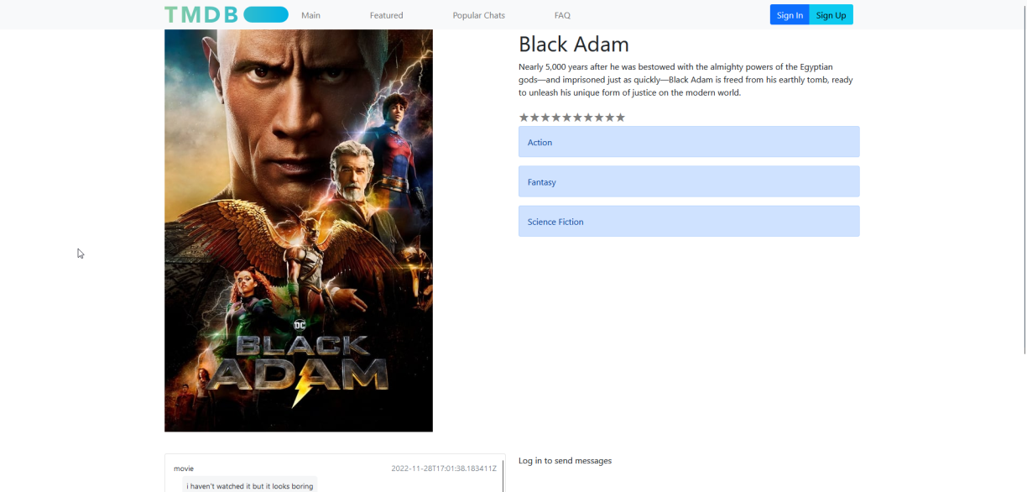

Figure 3 - Selected Movie Page

The live chat section of the page enables the user chat with other users. Users can only chat when logged in.

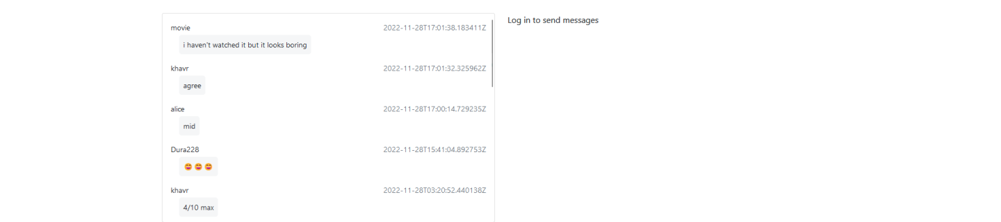

Figure 4 - Live Chat Section View for User Who Is Not Logged In.

Users can use the sign in page to log into their accounts and the sign up page to create new accounts.

Figure 5 - Sign in Page Figure 6 - Sign Up Page

When logged in, a user gains access to the text bar which allows the user to actively join the chat.

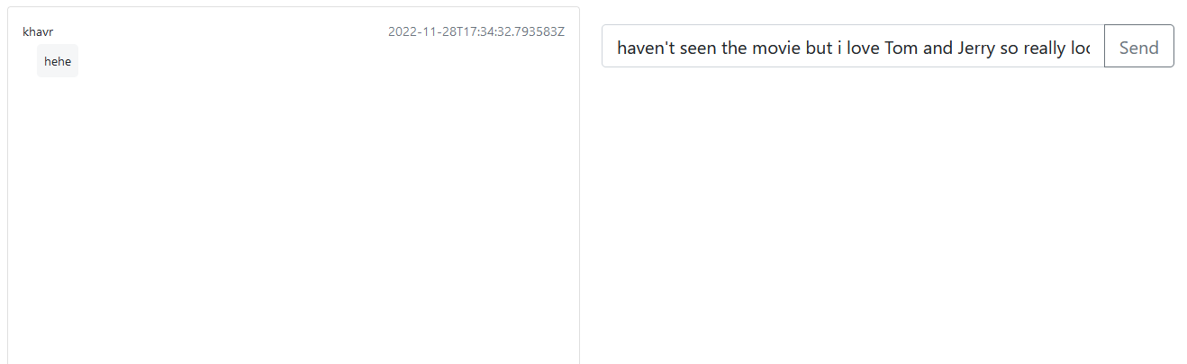

Figure 7 - sending message as logged in user

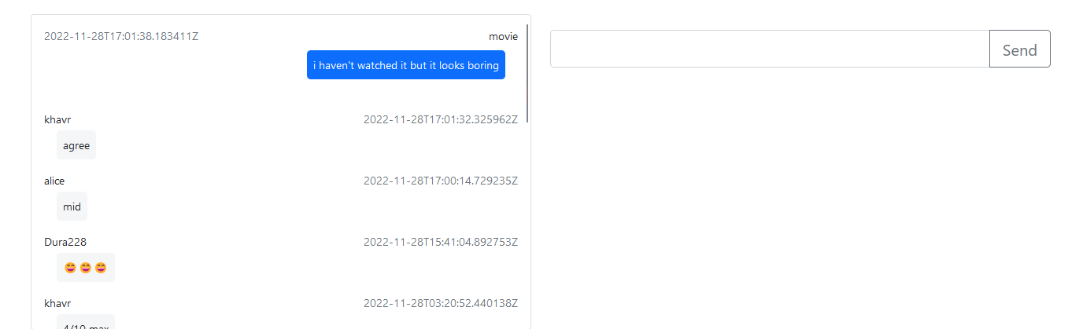

Figure 8 - Live Chat Section View for User Who Is Logged In.

Users can also sign out of their account using the sign out page.

Figure 9 - Sign Out Page

Additionally, users are allowed to add more profiles to their account. This is done by adding a new email address to their account. They also have the option to choose which email they want to set as “**Primary”**

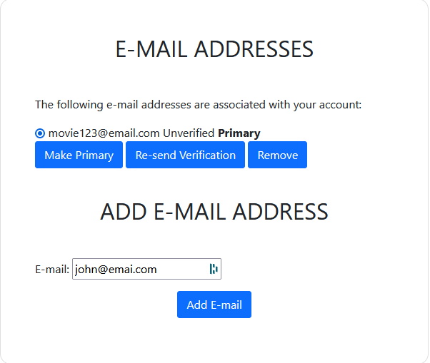 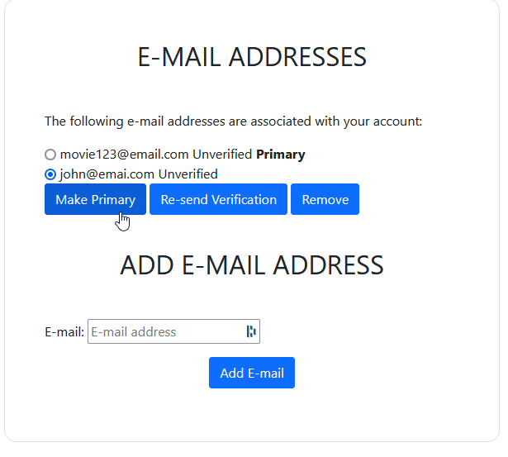

Figure 10 – adding a new email Figure 11 – setting new email as primary

**Back-end of the Website:**

The back end of the website is accessed via Django Administration. After the user has logged into the main page, if they put “./admin” in the web page URL they are directed straight to the admin page. If the said user is confirmed as an Admin, they are able to enter through to the admin page.

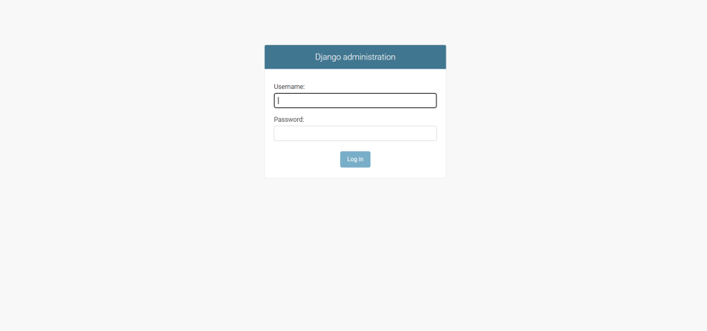

Figure 12 - Back-end Admin Login Page

From the back end, an admin can add more admins. An admin can also view and edit the user accounts, registered email address, movie chats, etc.

Figure 13 - Back-end admin dashboard

Figure 14 - Registered Email Address List

Figure 15 - Registered Users List

Figure 16 - Movie Chat List

After the admin clicks on one of the “Movie Chat” they have the option to review the message and change it to however they may. They are given the option for changing the user, Movie ID, and the message itself.

Figure 17 - Movie Chat Editing Page

**Team Reflection**

This project presented a learning opportunity for every member of team O’Brien. It was the first time we learned about project documentation and were able to practically use it. It was also the first time the members of the team had used the Django framework and React library in a project. Although presented with a lot of programming skills and time constraints, we as a team believe that the project was a success.

It is always a fun learning experience when we are presented with the opportunity to gain experience new concepts and technologies that would aid our future career. This is what this project helped us with. We were able to implement classroom teachings in a practical way which we deeply enjoyed.

One thing we felt most proud of during the project was our teamwork and communication skills. This was the first time we had the pleasure of meeting and collaborating with each other. However, we managed to learn about each other’s shortcomings and assisted where necessary. We occasionally had difficulties in setting meeting times due to our individual busy schedules and learning the framework and libraries used for this project had various levels of difficulties for everyone. In spite of all that, it did not stop our progress as we found ways to accommodate and help each other.

The teamwork and communication skills we developed during this project would definitely stay with us as we go out in industry. Additionally, we all agreed on working to improve our programming skills moving forward.

During the planning stage of this project, we agreed on using web sockets for the live chat section of the project. We were not able to get that to work and had to find other alternatives. Learning how to effectively use web sockets is definitely something we need more help with. This is to enable us to know how to integrate it into future projects.