Business Proposal

Law Firm

**Submitted By**

* Khawaja Azfar Asif-023
* Muhammad Kashir Khan-008
* Muhammad Asad-036

**Submitted To**

Sir Rafaqat Alam

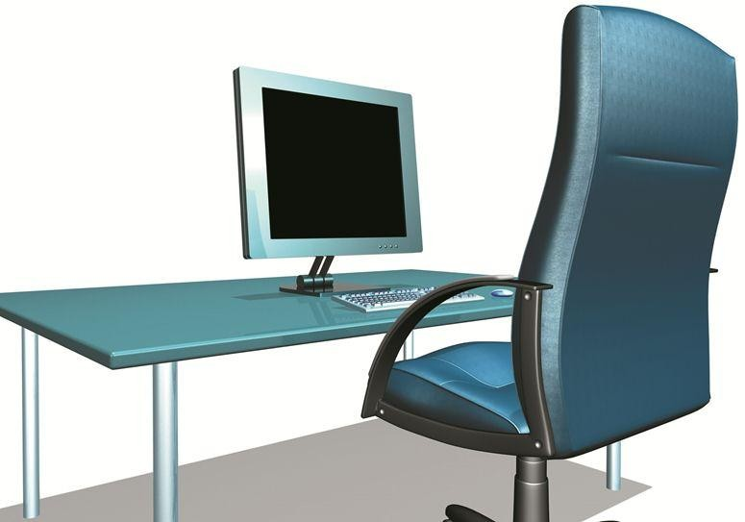

Introduction 3

Business Requirements 3

Overall Network Design Plan 4

Physical Design 4

Physical Security 4

Storage Area 5

Backup Power 5

Cabling 5

Logical Design 7

Internet Connection 7

Mesh Design 7

Access Points 7

Computers & Printers 89

File Server 8

Backup 8

Cost Break-Down 10

Networking Equipment 10

File Server 10

Computers & Printers 10

Backup Power 11

Physical Security 11

Online Backup 11

Internet Connection 11

Labor Hours 11

Ongoing Costs per Year 11

# Introduction

We are excited to be a part of the history you are creating by stepping out on your own and opening your own Law Firm. With the right network design and information system, anything is possible.

We pride ourselves in delivering the best service for our clients. We are not just a company for a one-time task. We stick with you for any future needs, including user training, ongoing support, and troubleshooting unforeseen circumstances. We work only with the best hardware in the market, without surpassing your budget or needs.

During the previous 4 weeks, we have received great feedback from you on exactly how you would like this network to be designed. Please read through this proposal carefully, and contact us with any questions you may have.

A cost break-down is included in the last section of this proposal, which will include all the specific devices we plan to install, along with the labor hours to configure them. Training cost is also included, to brief the employees on how to troubleshoot any network issues that may arise.

# Business Requirements

Described here are the business requirements we received at the beginning of the project. In the next few sections, we will show how our network design meets your requirements.

You would like wireless internet access in the waiting room for the clients, but do not want the clients to be able to see or connect to any office computers or network resources. The clients should only be able to connect to the Internet and check their email.

Both Ronald & Jeff need a networked desktop computer at their desks to perform day‐to‐day work activities. You plan to hire a receptionist and a paralegal. The receptionist will require a networked desktop computer to manage client information. The paralegal will need a wireless laptop and will need internet access in the conference room, law library, and receptionist area.

Because your firm will be handling sensitive and critically important data on a regular basis, you want to have a secure centralized file server to access and store all work files. Additionally, you want to ensure that nobody but the firm employees can log onto the firm computers and that a strict logon and access control policy is followed.

Because Ronald, Jeff, and the paralegal will be using the Internet on a regular basis, you want to make sure they have a fast and reliable, but affordable Internet connection.

You anticipate having to print a lot of legal material on a regular basis and would, in addition to the two personal LaserJet printers, also like to have a centralized high‐speed Laser printer in the receptionist area.

# Overall Network Design Plan

In the following pages, you will find the details of our plan for your company, and how we have met every one of your business requirements.

Your new network will provide you with all the benefits of gigabit networking. Your devices will communicate at speeds up to 1000 megabits per second, allowing access to information quickly and efficiently. This type of network is not common in small start-up companies but will allow for easier scalability later when you want to grow your company.

# Physical Design

Here we will describe where each device must be placed in the office, and the physical security controls we will install. Please reference the drawing at the end of this section, and refer to the Logical Design section for more specific information.

## Physical Security

Because your office is open to the public, we believe it is best that as much of the network equipment as possible be secured in the storage area. You have assured us that this room already has a locked door, and will remain locked at all times. Further, we suggest that a 4-camera closed-circuit security system be installed for evidence purposes in case of a break-in. Today, these systems are relatively inexpensive and quick to setup. A camera would be placed just below the ceiling in the corner furthest from the door, in each of these rooms: Ronald's Office, Jeff's Office, Receptionist's Area, Storage Area. These cameras will be connected using power/video cables run above the ceiling to a central digital video recorder (DVR) box in the storage area. If required this DVR can also be connected to the network to allow viewing of the video feed from home. Our cost break-down includes three sets of cable locks to prevent easy theft of the devices outside of the storage closet.

## Storage Area

Your storage area is large enough to allow the majority of the network devices to be setup on a shelf without any overheating issues. The firewall, switch 1, and Switch 2 will be placed in a vertical stack so rerouting network cables will be easy in case of troubleshooting. The private access point will be placed near the wall to the conference room, and the public access point against the opposite wall. We chose access points which support the new 802.11n protocol, easily reaching 200ft indoors by common estimates. So mobile connectivity should not be an issue.

## Backup Power

Every device in the storage area, except the public access point, will be connected to the large power supply (with a power strip for more outlets), to ensure business can continue during a power failure. The receptionist's computer, Ronald's and Jeff's computers and printers, along with the shared switch will use smaller power supplies. This leaves only three non-critical devices excluded from backup power: the high-speed printer, the public access point, and the paralegal's laptop (has its own battery).

## Cabling

Only four network cables will be run out of the storage area. Two will be run through the wall to the receptionist's desktop and the main printer. And two others will be run up into the ceiling, across the hallway, and down to Switch 3 beneath Ronald's desk. From here, individual cables will connect to Ronald's and Jeff's computers and printers. The five cables connecting the switches in a mesh layout will all be Cat6a Shielded Twisted Pair (STP) cross-over cables. This minimizes any possible interference from light fixtures and in-wall power lines. All the remaining network cables will use Cat6 Unshielded Twisted Pair (UTP). Both of these types will support full gigabit speeds.

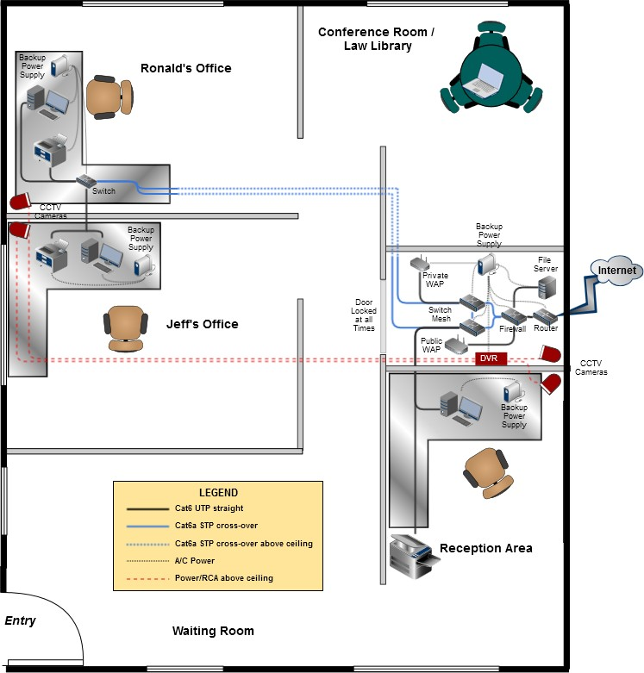

# Logical Design

In this section, we will explain how the network is laid out logically, how each device is connected to the network and configured, and why we chose this particular design. Follow along with the drawing at the end of this section.

## Internet Connection

First, our design uses a single incoming T1 line, connected to a router. Since your company's primary operation involves local data, one T1 line should be sufficient for your needs. Of the available speeds, we chose the 3.0Mbps line comparable with most DSL lines offered today.

## Mesh Design

On the company side of the router, the overall network is built around a mesh of three switches and one firewall/switch combination device. This creates a structure that is fault tolerant. Since switches route traffic based on physical addresses (MAC addresses) alone, each will build a lookup table of which port to use for which destination device. If any one of these four switches go down, the remaining switches will simply update their routing tables and reroute the traffic accordingly. Likewise, if any of the five Ethernet cables fails, the switches will also recognize this and reroute as necessary. There may be a network interruption, but only for a minute or so.

## Access Points

The firewall/switch device will have its #4 port configured as a Demilitarized Zone (DMZ). This means that any traffic coming from this port will be directed toward the router, and never toward the company's private network. An access point will be connected to this port, and will broadcast an SSID of "Publica". Your client’s connections will be encrypted using WPA2 with AES. Furthermore, the firewall can be configured to restrict traffic only to certain protocols, such as POP3, IMAP4, HTTP, HTTPS.

The company's private access point will also be encrypted with WPA2 and AES, but will use a different SSID (we'll set it to "Private" for now) and a different password. This access point will have its routing functions disabled, leaving it as a wireless switch only. This will allow the main router to give out IP addresses consistent with the rest of the network. To further protect this access point from unauthorized users, it will be set to not broadcast its SSID. For now, the primary user of this access point will be the paralegal, so it will be connected to Switch 1 on that side of the storage area.

## Computers & Printers

All four computers will have Windows 7 Pro and Microsoft Office installed. The three desktops will use static IP addresses, but the laptop will use DHCP so it can be taken home if necessary and still connect on another network too.

All three printers will be networked, so any computer can print to any printer in the office. Each desktop would be set by default to use the printer that is beside it, but the receptionist's computer can be used if speed is a priority (40ppm) or if a printer is out of ink.

Consistent with the theme of fault tolerance, the network's various devices are distributed across the four points of the mesh. The file server and public access point connect through the firewall/switch. The private access point uses Switch 1. The receptionist's computer and printer use Switch 2. And Ronald's and Jeff's computers and printers share Switch 3, allowing them to still connect to each other in the event of a complete network failure. This way, no single device can take the entire network offline. Of these four switches, the firewall/switch is the most critical. But even if it fails, the file server can simply be manually plugged into Switch 1 or 2 to restore its operation.

## File Server

The file server will run Windows Home Server, a server operating system that is much simpler to setup and operate than Windows Server 2008, but still has the ability to limit user access to files and folders. The server will be statically set to 192.168.0.5, so any shortcuts to it will always work. To be fault tolerant, the file server will contain two large hard drives in a RAID-1 configuration. A RAID-1 configuration simultaneously writes all information to both hard

drives, essentially mirroring the hard drives. If anyone hard drive fails, the system will still operate on the other one with a complete working set of data. Additionally, a prompt will appear telling the user that a hard drive has failed so a new one will simply be swapped in. The system will automatically reset and mirror the new drive with the existing one.

## Backup

Our network has various levels of redundancy incorporated, along with some aspects of fault tolerance. But lastly, to actually backup your data in case the entire network is lost, we recommend using an online backup service from CrashPlan. Their "unlimited" plan should easily meet your needs, as it will backup multiple computers for $9.99/mo. per computer. All data is encrypted on your local computer before it is ever sent to the backup servers, so the security of your clients' information is assured.

# Cost Break-Down

Item Quantity Cost/unit Total

**N**

|  |  |  |  |
| --- | --- | --- | --- |
| **networking Equipment** |  | | |
| * Router: TP-Link Safe Stream TL-R600VPN | 1x | $61.99 | $61.99 |
| *1x gigabit WAN port; 4x gigabit LAN ports; contains DHCP server, SPI firewall; supports VPN, Dynamic DNS*  <http://www.newegg.com/Product/Product.aspx?Item=N82E16833704130> | | | |
| * Firewall: Zeal Yawl USG50 | 1x | $222.44 | $222.44 |
| *2x gigabit WAN ports; 4x gigabit LAN ports; supports DMZ and VPN* |  |  |  |
| <http://www.newegg.com/Product/Product.aspx?Item=9SIA1EA0KP5771>   * Switch: TP-Link TL-SG108 | 3x | $28.99 | $86.97 |
| *8x gigabit ports; quiet without fans; no configuration necessary* |  |  |  |
| <http://www.newegg.com/Product/Product.aspx?Item=N82E16833704173>   * Access point: D-Link AirPremier DAP-2310 | 2x | $83.99 | $167.98 |

*1x gigabit input port; 802.11/b/g/n output (up to 300Mbps); supports WPA2 Personal and Enterprise; can isolate connected devices from each other; rogue access point detection; supports up to 8 VLANs*

<http://www.newegg.com/Product/Product.aspx?Item=N82E16833127394>

|  |  |  |  |
| --- | --- | --- | --- |
| * Cat-6 UTP cabling | 100ft | $0.60 | $60.00 |
| *Used for the majority of the network* |  |  |  |
| * Cat-6a STP cabling   *Used for the cables in the ceiling near light fixtures* | 100ft | $2.00 | $200.00 |

**File Server**

* Computer: Dell PowerEdge T110 II 1x $303.37 $303.37

*2.6 GHz 2-core CPU; 4GB memory; gigabit network card; supports RAID; no hard drive; no operating system*

<http://configure.us.dell.com/dellstore/config.aspx?oc=bect12b2b&model_id=poweredge-t110-2&c=us&l=en&s=bsd&cs=04>

* Hard drive: Seagate ST2000VN000 2x $119.99 $239.98

*2TB SATA, 6Gb/s speed, 64MB cache, NAS error recovery for RAID arrays*

<http://www.newegg.com/Product/Product.aspx?Item=N82E16822178391>

* O/S license: Windows Home Server 2011 64bit 1x $49.99 $49.99

*Server O/S that is simpler to setup and use than Windows Server 2008*

<http://www.newegg.com/Product/Product.aspx?Item=N82E16832416443>

**Computers & Printers**

|  |  |  |  |
| --- | --- | --- | --- |
| * Desktop: Dell Inspiron 660 | 3x | $529.99 | $1,589.97 |
| (Order MS Office 2013 Home & Business with the desktop) | 3x | $179.99 | $539.97 |

*3.1 GHz 4-core CPU; 4GB memory; 500GB hard drive; Windows 7 Pro 64bit; includes keyboard & mouse; includes 12-month subscription to McAfee LiveSafe (virus, spam, spyware, malware protection)*

[http://configure.us.dell.com/dellstore/config.aspx?c=us&cs=04&fb=1&l=en&model_id=inspiron-](http://configure.us.dell.com/dellstore/config.aspx?c=us&cs=04&fb=1&l=en&model_id=inspiron-660&oc=smi660w7p3615&s=bsd&vw=classic) [660&oc=smi660w7p3615&s=bsd&vw=classic](http://configure.us.dell.com/dellstore/config.aspx?c=us&cs=04&fb=1&l=en&model_id=inspiron-660&oc=smi660w7p3615&s=bsd&vw=classic)

|  |  |  |  |
| --- | --- | --- | --- |
| * Laptop: Dell Latitude 15 3000 with Windows 7 Pro 64bit | 1x | $589.00 | $589.00 |
| (Order MS Office 2013 Home & Business with the laptop) | 1x | $195.30 | $195.30 |

*1.7 GHz 2-core CPU; 4GB memory; 500GB hard drive; Windows 7 Pro 64bit; includes 12-month subscription to McAfee LiveSafe (virus, spam, spyware, malware protection)*

[http://configure.us.dell.com/dellstore/config.aspx?c=us&cs=04&fb=1&l=en&model_id=latitude-3540-](http://configure.us.dell.com/dellstore/config.aspx?c=us&cs=04&fb=1&l=en&model_id=latitude-3540-laptop&oc=sl35437p02&s=bsd&vw=classic) [leptophos=sl35437p02&s=bsd&vw=classic](http://configure.us.dell.com/dellstore/config.aspx?c=us&cs=04&fb=1&l=en&model_id=latitude-3540-laptop&oc=sl35437p02&s=bsd&vw=classic)

|  |  |  |  |
| --- | --- | --- | --- |
| * Personal printer: Dell B1165nfw Mono Print/Scan/Copy/Fax | 2x | $99.99 | $199.98 |
| *Supports USB, Wireless, Ethernet 10/100 connections; black & white laser; 21 pages per minute*  <http://accessories.us.dell.com/sna/productdetail.aspx?c=us&l=en&s=bsd&cs=04&sku=225-4456> | | | |
| * High-speed printer: Dell B2360dn Mono Printer | 1x | $149.99 | $149.99 |
| *Supports USB, Wireless, Gigabit Ethernet connections; black & white laser; 40 pages per minute*  <http://accessories.us.dell.com/sna/productdetail.aspx?c=us&l=en&s=bsd&cs=04&sku=225-4035> | | | |

**Backup Power**

* Large power supply: CyberPower CP1350AVRLCD 1x $144.99 $144.99

*810-Watt max; 4 outlets on battery + surge protection; 4 outlets with surge protection only*

<http://www.newegg.com/Product/Product.aspx?Item=N82E16842102070>

* Small power supply: CyberPower EC850LCD 3x $79.99 $239.97

*510-Watt max; 6 outlets on battery + surge protection; 6 outlets with surge protection only*

<http://www.newegg.com/Product/Product.aspx?Item=N82E16842102216>

* Power strip: Kensington 50688 1x $8.43 $8.43

*6 outlets; 1875 Watts max; 4ft cord*

<http://www.newegg.com/Product/Product.aspx?Item=9SIA24G0P59053>

**Physical Security**

* Camera system: Guard KG-OT401-4FW426A-500G 1x $249.99 $249.99

*4 cameras (up to 33ft at night); central 500GB hard drive; motion detection; remote viewing ability*

<http://www.newegg.com/Product/Product.aspx?Item=N82E16881377071> <http://www.kguardsecurity.com/us/p/ot401-4fw426a-us/>

* Cable lock: Kensington K64615US 3x $29.99 $89.97

*Pick-resistant lock; cut-resistant 8ft cable; can secure one desktop and multiple extra devices*

<http://www.newegg.com/Product/Product.aspx?Item=N82E16834997894>

**Online Backup**

* CrashPlan for Business, first month cost only 5 computers $9.99 $49.95

*$9.99 per month per computer; unlimited storage space; 448bit Blowfish encryption; zero-knowledge backup*

<http://www.crashplan.com/business/compare.html>

**Internet Connection**

* 3.0Mbps T1 line, first month cost only 1 month $359.00 $359.00

**Labor Hours**

|  |  |  |  |
| --- | --- | --- | --- |
| * Server setup (1 server x 4hr each) | 4hr | $40.00 | $160.00 |
| * Client machine setup (4 computers x 2hr each) | 8hr | $40.00 | $560.00 |
| * Cable wiring (4 rooms x 2hr each) | 8hr | $40.00 | $320.00 |
| * Network device setup (10 devices x 1hr each) | 7hr | $40.00 | $400.00 |
| *(1 router, 1 firewall, 3 switches, 2 access points, 3 printers)*   * Training employees on new systems | 8hr | $40.00 | $320.00 |
| **Total Up-front Costs** |  |  | **$7,559.23** |
| **Ongoing Costs per Year**   * 3.0Mbps T1 line |  |  | $4,308.00 |
| * CrashPlan for Business ($49.95/mo. x 12mo) * On-call technical support from A+ Consulting ($40/hr.) |  |  | $599.40  Varies |
| **Total Ongoing Costs per Year** |  |  | **$4,907.40** |

**Conclusion**

We are glad to report that the total cost of our plan comes in at only 3/4 of your budget. But keep in mind there are always some "hidden costs" that cannot be estimated up front, such as the cost to create documentation for the network and any new procedures you have and the cost to expand and transition later as your business grows. There is also the cost to fix major network problems if they ever occur. We are fully supportive of new businesses, so our specialized technicians will provide on-call 24/7 support for free for your first 3 months to ensure you have a smooth start-up.

Thank you for your consideration us for your business needs. We are honored to be a part of your new business venture. Please contact us when you are ready to move forward with implementing this plan.