

GROUP MEMBERS

* **KHAWAJA AZFAR ASIF-023**
* **MUHAMMAD TALHA SAEED-012**
* **MUHAMMAD KASHIR KHAN-008**
* **USAMA AMJAD-041**

## Semester Project: Restaurant Management System

## Submitted to: Sir Muhammad Sufian

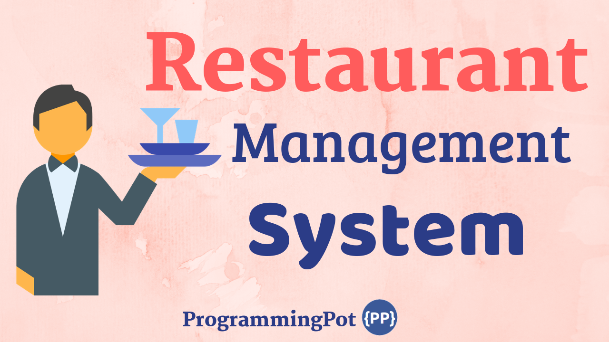

**Table OF Content**

# **Introduction**

# **Problem Statement**

# **Goal**

# **Project Features**

# **Development Phases**

# **Role**

# **UML Diagram**

# **Functional Requirement**

# **Development Language**

1. **Introduction**

We are a team of Software Engineering, with a project in industrial and Food area, working in a project management model, striving towards excellence. Our team is highly qualified in their respective work. Ultimately, our goal is to provide our clients with practical consulting solutions that adequately address the situation.

This project gives excellence in controlling the restaurant order and customer satisfaction. Our customers expect a high level of professionalism and require us to bring significant knowledge of the project we are making.

This project can be run in any food area. Instead, it is a simple POS or a complete Restaurant project. Its module can be divided into different industries—our team's commitment to delivering high-impact, quality services dedicated to the life industry. The project also needs after-delivery maintained, and we will provide it.

# **Problem Statement**

The restaurant used to maintain their record on paper, like how many customers check-in and how much Food was used and available. It's made it difficult to track the work. The Restaurant management system will make it easy to follow the record, and also it helps to check how to manage the current situation.

# **Goal**

A restaurant management project is a team-constructed project under construction—this project gives excellence in controlling the restaurant order and customer satisfaction. Our customers expect a high level of professionalism and require us to bring significant knowledge of the project we are making. The Restaurant management system will make it easy to track the record, and also it helps to check how to manage the current situation. Also, help in an efficient, cost-effective, and timely manner. We take pride in ourselves in building a solid relationship with our partners.

1. **Project Features**

* Point of sale system.
* Show order details.
* Employee Registration

# **Development Phases**

Phase 1 – Design the Application

Phase 2 – Add Login Feature

Phase 3 – Add Dashboard

Phase 4 – Create/Update Menu/Order

Phase 5 – Feedback Option

# **UML Diagram**

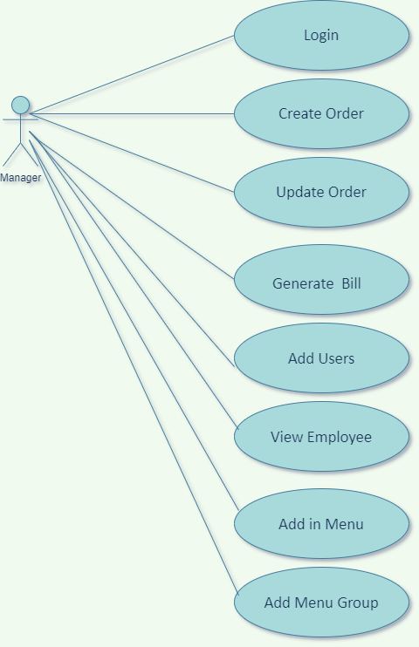

# **Functional Requirement**

* Login
* Manage Users
* Manage Orders
* Manage Menu

# **Roles**

* Restaurant Manager

# **Development Language**

As the Desktop Application falls into Layered architecture. In this, there are three more than three-layered.

* Design in C#. Which User will interact with it.
* The **Mid Layered** contains Database. The entity, Table, store of Data, and connection between the Frontend and Backend
* The **Last Layered** contains the backend. Backend will be connected with Database and Frontend. Login, Dashboard Analytics, etc. This is all done in C# language.