
COMSATS University, Islamabad Pakistan

Codable – Code Learning Platform

By

Khawaja Muhammad Rafay CIIT/FA22-BCS-038/ISB
Abdul Rafay CIIT/FA22-BCS-003/ISB

Supervisor
Prof. Majid Iqbal Khan

Bachelor of Science in Computer Science (2022-2026)

The candidate confirms that the work submitted is their own and appropriate
credit has been given where reference has been made to the work of others.


COMSATS University, Islamabad Pakistan

Codable – Code Learning Platform

A project presented to
COMSATS University, Islamabad

In partial fulfillment
of the requirement for the degree of

Bachelor of Science in Computer Science (2022-2026)

By

Khawaja Muhammad Rafay CIIT/FA22-BCS-038/ISB
Abdul Rafay CIIT/FA22-BCS-003/ISB

DECLARATION
We hereby declare that this software, neither whole nor as a part, has been copied out from any source. It is further declared that we have developed this software and accompanied report entirely on the basis of our personal efforts. If any part of this project is proved to be copied out from any source or found to be a reproduction of some other, we will stand by the consequences. No Portion of the work presented has been submitted of any application for any other degree or qualification of this or any other university or institute of learning.

Khawaja Muhammad Rafay Abdul Rafay

--------------------------- ---------------------------

CERTIFICATE OF APPROVAL
It is to certify that the final year project of BS (CS) Codable was developed by
KHAWAJA MUHAMMAD RAFAY (CIIT/FA22-BCS-038/ISB) and ABDUL RAFAY (CIIT/FA22-BCS-003/ISB) under the supervision of PROF. MAJID IQBAL KHAN and that in his opinion; it is fully adequate, in scope and quality for the degree of Bachelors of Science in Computer Sciences.

---------------------------------------
Supervisor

---------------------------------------
External Examiner

---------------------------------------
Head of Department
(Department of Computer Science)

EXECUTIVE SUMMARY
In today’s world, learning programming has become a crucial skill, but the traditional methods of teaching and practicing coding often fall short in terms of engagement, personalization, and effectiveness. Beginners face problems like struggling to build logic, being overwhelmed with syntax, lack of guided practice, and limited feedback on their mistakes. On the other hand, instructors face challenges in managing classrooms, tracking student progress, and providing timely support.
To address these issues, Codable is developed. It is an intelligent, all-in-one coding learning platform designed to guide learners through every phase of becoming a programmer, from understanding the fundamentals of programming through logic building, to structured learning, skill polishing, and finally moving towards real development. The platform integrates AI-driven feedback, adaptive question generation, and progress tracking to make the learning experience personalized and effective.
Codable includes interactive modules such as a Logic Building Canvas for flowcharts to help beginners understand the core concepts behind programming before diving into syntax. It further provides structured documentation-based lessons, quizzes, and a smart practice environment where coding questions are generated based on previous mistakes. A VS Code–like compiler is also embedded, allowing learners to experiment with real coding under the guidance of an AI assistant.
The system also supports an Instructor/Class Management Module, enabling teachers to create classrooms, assign content, track student performance, and evaluate submissions with ease. This dual approach ensures that the platform can be used both for self-learning and guided, instructor-led learning.
Codable is a scalable platform with the potential to support multiple programming languages in the future, making it a complete ecosystem for coding education.

Abstract
The rationale for developing Codable is to provide an intelligent and structured platform that makes learning programming more effective and accessible. Existing systems such as static tutorials, coding editors, and generic practice platforms primarily focus on syntax and lack interactive, adaptive, and personalized support for learners. While these approaches provide basic exposure, they often overlook concept-building, fail to adapt to individual needs, and do not offer effective classroom management for instructors. The proposed project aims to address challenges such as the absence of logic-building before syntax, limited personalized feedback, inadequate progress tracking, and the lack of integration between self-learning and instructor-led environments. The gap lies in the need for a holistic platform that bridges conceptual understanding, coding practice, and guided teaching in a single ecosystem. The objectives of the project are to introduce a Logic Building Module with interactive flowcharts for strengthening problem-solving, provide structured lessons with quizzes for systematic learning, and integrate AI-driven practice and feedback for skill polishing. It will also include a VS Code–like compiler for real-world development and an Instructor/Class Management Module for guided learning. Ultimately, the project’s significance lies in offering a comprehensive, adaptive, and scalable platform that transforms coding education for both individual learners and classrooms.

Acknowledgement
All praise is to Almighty Allah who bestowed upon us a minute portion of His boundless knowledge by virtue of which we were able to accomplish this challenging task.

We are greatly indebted to our project supervisor Prof. Majid Iqbal Khan. Without their personal supervision, advice and valuable guidance, completion of this project would have been doubtful. We are grateful to them for their encouragement and continual help during this work.

And we are also thankful to our parents and family who have been a constant source of encouragement for us and brought us with the values of honesty & hard work.

Khawaja Muhammad Rafay Abdul Rafay

--------------------------- ---------------------------

Abbreviations
SRS | Software Require Specification
PC | Personal Computer

Table of Contents
Abstract v
1 Chapter 1: Introduction and Problem Definition 4
1.1 Overview of the Project 4
1.2 Vision Statement 4
1.3 Problem Statement 5
1.4 Problem Solution 5
1.5 Objectives of the Proposed System 5
1.6 Scope 6
1.6.1 Limitations/Constraints 6
1.7 Modules 7
1.7.1 Module 1: Logic Building Module 7
1.7.2 Module 2: Skill Improvement Module 7
1.7.3 Module 4: Interactive Code Workspace 8
1.7.4 Module 5: Class & Instructor Management 8
1.7.5 Module 6: Progress Tracking and Analytics 8
1.7.6 Module 7: Personalized AI Tutor 9
1.7.7 Module 8: Smart Question Generator 9
1.7.8 Module 9: Feedback & Rating System 9
1.8 Related System Analysis/Literature Review 10
1.8.1 Literature Review 10
1.8.2 Related System Analysis 10
1.9 Tools and Technologies 11
1.10 Project Contribution 11
1.11 Relevance to Course Modules 13
2 Chapter 2: Requirement Analysis 13
2.1 Functional Requirements 13
2.2 Non-Functional Requirements 20
2.2.1 Reliability 20
2.2.2 Usability 20
2.2.3 Performance 21
2.2.4 Security 22
2.3 External Interface Requirements 22
2.3.1 User Interfaces Requirements 22
2.3.2 Software interfaces 23
2.3.3 Hardware interfaces 24
2.3.4 Communications interfaces 24
3 Chapter 3: Design and Architecture 25
3.1 System Architecture Overview 25
3.1.1 Purpose 25
3.2 Architecture Diagram 26
3.2.1 Technologies and Services 27
3.3 Architecture Style / Pattern 28
3.3.1 Layered Architecture Pattern 28
3.4 Design Models 29
3.4.1 Design Models for Procedural Approach 29
3.5 Data Design 42
3.5.1 Data Storage Approach 42
3.5.2 Major Data Entities 42
3.5.3 Data Storage Technologies 44
3.5.4 Data Processing & Organization 44
3.5.5 Summary 44
4 Chapter 4: Implementation 45
4.1 Project Methodology & Algorithms 45
4.1.1 Project Methodology 45
4.1.2 Algorithm 47
4.1.3 Pseudocode of algorithms 49
4.2 Training Results & Model Evaluation (Mandatory for AI/ML/Data Science Projects) 52
4.3 Security Techniques 53
4.4 External APIs/SDKs 54
5 Chapter 5: Testing and Evaluation 60
5.1 Unit Testing 60
5.2 Functional Testing 62
5.3 Integration Testing 64

Tables

Table 1 - Related System Analysis with proposed project solution 10
Table 2 - Tools and Technologies for Proposed Project 11
Table 3 - User Profiling & Tracking Module 15
Table 4 - AI Evaluation Module 16
Table 5 - Performance-Based Question Generator 16
Table 6 - Class Management Module 17
Table 7 - Interactive Coding Workspace 18
Table 8 - Logic Building Module 19
Table 9 - Personalized AI Tutor 20
Table 10.1 Technologies, Components, and Security Mechanisms Used in the System Architecture 27
Table 11 - Technologies, Components, and Security Mechanisms Used in the System Architecture 27
Table 12 - Technologies, Components, and Security Mechanisms Used in the System Architecture 44
Table 13 - APIs 55
Table 14 - Test 1: validateEmail() 60
Table 15 - Test 2: User model : password hash & compare 61
Table 16 - Test 4: authMiddleware.userAuth 61
Table 17 - Test 5: StudentProfile controller (create/get/update/delete) 62
Table 18 - Test 6: Code-runner (compile & run) 62
Table 19 - Functional Testing 64
Table 20 - Test 1: Signup / Auth ↔ StudentProfile creation & retrieval 65
Table 21 - Test 2: Profile lifecycle & middleware enforcement (Create → Update → Delete) 66

Figures

Figure 1 - Architecture Diagram 27
Figure 2 - Layered Architecture Pattern 29
Figure 3 - Student Learning Flow 30
Figure 4 - Code Execution & Ai Evaluation Flow 32
Figure 5 - ML Based Recommendation Engine Flow 33
Figure 6 - Student Profile Building 34
Figure 7 - Mentor – Class Management 35
Figure 8 - Mentor – Assignment & Tracking 36
Figure 9 - Plagiarism Detection Flow 37
Figure 10 - Student Progress Tracking & Analysis 38
Figure 11 - DFD Level 0 — Context Diagram 39
Figure 12 - DFD Level 1 — Diagram 0 40
Figure 13 - DFD Level 2 — P2 Student Learning Module 41
Figure 14 - DFD Level 2 — P3 Code Execution & AI Evaluation 42
Figure 15 - State Transition Diagram 43
Figure 16 - Login Screen 57
Figure 17 - Role Selection Dashboard 58
Figure 18 - Student Dashboard 58
Figure 19 - Workspace 59
Figure 20 - User Profile & Analytics 60
Figure 21 - Instructor Dashboard 61
Figure 22 - Create and view Classes (for instructor) 61

Chapter 1: Introduction and Problem Definition
Codable is an intelligent, web-based platform aimed at transforming the way programming is taught and learned. The system caters to two key user groups: self-learners who wish to build programming skills independently, and instructors who need tools to manage classes, assign learning material, and evaluate student progress. Unlike traditional methods that focus mainly on syntax and static tutorials, Codable emphasizes logical understanding, adaptive practice, AI-driven feedback, and classroom management, making programming education more structured, interactive, and scalable.
Current programming education platforms face several limitations. Most rely on syntax-based teaching and lack a strong foundation in logic-building, leaving beginners struggling to understand core concepts. Learners often receive little to no personalized feedback, making it difficult to identify and correct mistakes effectively. At the same time, instructors face challenges in monitoring student performance, assigning targeted exercises, and providing timely support in large classrooms. These gaps highlight the need for an integrated, intelligent system that combines logic-building, structured learning, personalized practice, real-world development, and class management features under one unified platform.

Overview of the Project
Codable is an intelligent, web-based platform designed to modernize and enhance the process of learning programming. Operating in the domain of computer science education, the system targets two main user groups: self-learners who want to build programming skills independently, and instructors who require effective tools to create classes, assign content, and track student performance. Traditional coding education relies heavily on syntax memorization, static tutorials, and manual practice, which often fails to ensure logical understanding, adaptive learning, or personalized feedback. Additionally, instructors face difficulties in monitoring large groups, identifying common problem areas, and providing timely evaluations. The proposed system addresses these challenges by introducing automation in learning through AI-driven feedback, adaptive question generation, progress tracking dashboards, and integrated class management features. By combining modules for logic building with flowcharts, structured lessons, coding practice, and a VS Code–like environment with AI assistance, Codable provides a comprehensive ecosystem that supports both independent learners and instructor-led classrooms, ensuring scalability, efficiency, and effectiveness in programming education.

Vision Statement
For aspiring programmers and educators who seek an engaging, adaptive, and efficient platform for learning and teaching programming, Codable is an interactive web-based code learning system that provides personalized tutorials, real-time AI-driven code evaluation, and seamless class management tools. Unlike static, one-size-fits-all platforms or traditional classroom setups, Codable empowers users with adaptive learning paths, real-time feedback, and intelligent task recommendations, ensuring continuous growth and mastery of any programming language. Our product stands out by offering a dynamic, user-centered approach that combines structured learning with hands-on practice, making coding education more interactive, scalable, and accessible to all learners.

Problem Statement
In the fast-evolving tech landscape, coding has become an indispensable skill for success, yet the journey to mastering it remains overwhelming for many learners. Aspiring programmers often struggle to find reliable resources that not only explain concepts but also provide structured guidance and personalized feedback. Existing platforms typically offer isolated tutorials or exercises, which fail to ensure interactive engagement or step-by-step progression. Beginners frequently feel lost when trying to build logical foundations, while intermediate learners face challenges in identifying and correcting mistakes effectively. At the same time, instructors encounter difficulties in managing diverse groups of learners, tracking individual progress, and providing timely, tailored support. These challenges highlight the gaps in current programming education systems and the pressing need for a more comprehensive and adaptive approach.

Problem Solution
Our proposed platform, Codable, provides a comprehensive solution for learning programming through structured, adaptive, and interactive modules. Learners begin with logic-building exercises using flowcharts, progress into structured lessons with practice tasks, and reinforce their knowledge with quizzes. To support continuous improvement, learners are assessed on their coding skills and then provided with tailored exercises to strengthen weaker areas. The integrated AI model evaluates how learners write code, how they approach problems, and how they perform, ensuring a truly personalized learning journey. A progress tracking system allows both learners and instructors to monitor growth, while the instructor module supports class management, task assignment, and AI-powered analytics of student performance. Additionally, Codable offers a workspace with a real coding environment, enabling users to practice, run, and debug code interactively with AI assistance. This unified approach ensures effective, engaging, and scalable programming education for both self-learners and instructors.

Objectives of the Proposed System
BO-1: Provide a step-by-step learning path starting from logic-building through flowcharts, progressing into structured programming tutorials, hands-on practice, and integrated quizzes to guide learners from basics to advanced concepts.
BO-2: Implement an AI-powered evaluation system that not only checks syntax, logic, and efficiency but also analyzes how learners write code, how they learn, and how they perform, offering tailored feedback and growth insights.
BO-3: Deliver a personalized and adaptive learning experience by recommending skill-improvement tasks and challenges based on learner performance, ensuring continuous skill development and confidence building.
BO-4: Enable instructors to manage classes effectively, assign coding or logic-building tasks, and access AI-driven analytics with detailed progress tracking to monitor and support individual student growth.
BO-5: Integrate a dedicated coding workspace with a smart editor that provides real-time AI assistance for coding, debugging, and logic-building, ensuring an interactive and engaging coding experience..

Scope
The scope of Codable is to provide a comprehensive and intelligent coding education platform that caters to both learners and instructors by combining structured learning, interactive practice, and AI-driven evaluation. The platform begins with a logic-building module, where learners develop problem-solving skills using flowcharts and visual representations before moving on to actual coding. This ensures that users build strong foundations in computational thinking before learning programming syntax. Once learners transition into programming, they follow a structured curriculum with tutorials, practice exercises, and quizzes, enabling step-by-step skill development. To further enhance the learning process, an AI-powered evaluation engine assesses not only the correctness of code but also its logic, efficiency, and the way learners approach problem-solving. Based on this evaluation, the system provides personalized feedback and adaptive tasks to help learners strengthen weak areas and continuously improve their skills. Learners also have access to a dedicated coding workspace with a smart code editor, offering real-time AI assistance for writing, debugging, and optimizing code. The platform includes progress tracking features, enabling learners to visualize their journey, identify growth patterns, and stay motivated. On the instructor side, the system provides a class management module that allows mentors to create and manage classes, assign coding or logic-building tasks, and monitor the performance of individual students or groups. AI-driven analytics assist instructors by automatically generating performance reports and insights, reducing their workload while improving the quality of personalized feedback they can provide. The platform also supports adaptive learning recommendations, where learners are assigned coding challenges and improvement tasks based on their prior performance and learning style. Unlike traditional static learning systems, Codable emphasizes hands-on, interactive, and guided learning that evolves with the learner’s progress. The scope covers integration of quizzes, coding practice, AI evaluation, instructor tools, and real-time collaboration features, making it suitable for both self-learners and classroom-based learning. It does not aim to replace professional integrated development environments (IDEs), but rather to provide a simplified, learning-focused workspace that simulates real coding environments in an educational context. The system will initially be launched for a single programming language but is designed to be scalable for multiple languages in the future. In summary, the scope of Codable lies in creating an end-to-end solution that bridges the gap between traditional coding tutorials and modern, intelligent learning systems, providing structured learning for beginners, skill enhancement for intermediates, and effective class management tools for instructors.

Limitations/Constraints
LI-1: The platform will initially support only the Java programming language; support for other languages may be considered in future versions.
LI-2: Real-time AI evaluation and feedback are dependent on external LLM APIs or hosted models, which may introduce latency or usage limits due to API rate restrictions or server load.
LI-3: The accuracy and quality of AI-generated suggestions and evaluations may not always be perfect and can vary based on model limitations or vague user code.
LI-4: Users must have a stable internet connection to interact with the platform features, especially those relying on cloud-based LLMs and the Monaco editor.
LI-5: The initial version of the system will be web-only and will not include a mobile application.
LI-6: Users attempting to run malicious, infinite loops, or heavy resource-consuming code may affect system performance; sandboxing and code execution limits will be applied.
LI-7: Instructor access to student performance will be limited to task and topic-related metrics and will not provide full code traceability due to privacy and fairness concerns.

Modules

Module 1: Logic Building Module
This module focuses on helping absolute beginners develop problem-solving and logical thinking skills before diving into coding. Users create flowcharts to visualize algorithms, gradually learning how to break problems into smaller steps.
FE-1: Provide either visual canvas or non-technical questionnaires to create flowcharts
Beginners are given an easy-to-use interface with standard flowchart symbols (start, input/output, process, decision, loops).
FE-2: Offer guided exercises for basic problem-solving
The system provides simple tasks (e.g., calculate the sum of two numbers, find the largest of two values) that must be solved using flowcharts.
FE-3: Convert flowcharts into pseudo-code/code for validation
Once a flowchart is complete, it can be translated into pseudo-code or real code (Java/Python/etc.) to check correctness and execution flow.
FE-4: Evaluate logic correctness and provide hints
AI evaluates whether the constructed flowchart correctly solves the problem and highlights errors (e.g., missing conditions, incorrect loops) with helpful hints.
FE-5: Track progress in logic-building tasks
The system saves completed exercises, performance, and improvement areas, ensuring the learner masters problem-solving before moving to coding.

Module 2: Skill Improvement Module
This module is designed for users who already know the basics and want to improve. It uses AI to evaluate their current level and adaptively assign challenges that strengthen weak areas.
FE-1: Allow users to select difficulty level: Beginner, Intermediate, or Advanced
Users start by selecting their perceived skill level. This initial choice helps tailor the assessment experience and sets expectations for the upcoming challenges.
FE-2: Conduct a pre-assessment test to evaluate current skill level
Before assigning learning content, the platform verifies the user’s actual proficiency with a short test. This test includes logic, OOP, arrays, and control structures.
FE-3: Assign topic-specific coding challenges
Based on assessment results, users receive coding problems that target their weakest areas. Each challenge is designed to improve specific concepts.
FE-4: Evaluate code submissions for syntax, logic, and time complexity using LLM
The submitted code is analyzed by a language model that checks for correctness, logic, and efficiency. Feedback is provided accordingly.
FE-5: Provide AI-generated tips and feedback for better logic application
When logic or structure is weak, users receive step-by-step tips and alternate approaches. This feedback helps them think better and refactor their code.

Module 4: Interactive Code Workspace
This module is a real-time code playground with an AI-powered coding assistant. It mimics a simplified version of VS Code in the browser.
FE-1: Integrate Monaco Editor for code editing
Users write and format code in the Monaco Editor, a lightweight but powerful editor used in VS Code.
FE-2: Enable code execution with output display
Users can instantly compile and run code. Output is displayed in a console area, just like in traditional IDEs.
FE-3: Support syntax highlighting and auto-completion
Enhances user experience by making the code easier to read and reducing syntax errors with smart suggestions.
FE-4: Integrate AI assistant (CodeT5+ or Copilot-like) for real-time help
As users type, an AI model assists by suggesting completions, fixing errors, or providing code explanations.
FE-5: Allow users to save code snippets and view edit history
Users can bookmark useful code, revisit past edits, and track how their code evolved over time.

Module 5: Class & Instructor Management
This module empowers mentors to manage classes, assign tasks, and monitor students. Ideal for bootcamps, coding workshops, or formal teaching environments.
FE-1: Instructor registration and dashboard access
Instructors sign up separately and gain access to a dashboard tailored for class and student management.
FE-2: Create and manage classes with enrollment codes
Instructors can create classes, generate unique codes, and invite students to join with a single link or code.
FE-3: Assign coding tasks to students based on selected topics
Instructors pick topics from the curriculum and let the system generate coding tasks accordingly.
FE-4: View, review, and evaluate student submissions and progress
Teachers get access to all student submissions, detailed feedback reports, and progress analytics.
FE-5: Set task deadlines and grading rubrics
Helps structure the learning process by setting deadlines and evaluating submissions according to defined rubrics.

Module 6: Progress Tracking and Analytics
This module tracks learner performance and provides insights into their coding journey. It helps users and instructors monitor growth, identify weak areas, and adapt learning paths accordingly.
FE-1: Track chapter, topic, and quiz completion
The system records which lessons, topics, and assessments the learner has completed. This creates a clear picture of progress through the curriculum.
FE-2: Monitor quiz and assessment performance
Stores detailed performance data such as quiz scores, pass/fail rates, number of attempts, and time taken per assessment.
FE-3: Capture coding practice activity
Logs coding problems attempted, solved, failed, and time spent per problem. Identifies common error patterns (syntax vs logic).
FE-4: Provide visual analytics and progress reports
Displays dashboards and charts showing completion percentages, score trends, and skill growth over time for learners and instructors.

Module 7: Personalized AI Tutor
This module provides real-time, AI-driven guidance tailored to each learner’s coding journey. It analyzes mistakes, explains concepts, and suggests personalized practice to strengthen weak areas.
FE-1: Offer instant feedback on code submissions
The AI reviews user code step by step, identifies syntax and logic errors, and explains them in simple terms with hints for correction.
FE-2: Suggest personalized practice questions
Based on the learner’s mistakes and weak concepts, the AI generates or recommends tailored coding problems for reinforcement.
FE-3: Provide code improvement suggestions
The tutor highlights opportunities to make code more efficient, readable, or optimized (e.g., better time complexity or cleaner syntax).
FE-4: Enable interactive Q&A support
Learners can ask the AI tutor conceptual or debugging questions, and receive context-aware explanations with examples.

Module 8: Smart Question Generator
This module dynamically generates coding questions tailored to the learner’s skill level and progress. It ensures variety, increasing difficulty, and alignment with the concepts being studied.
FE-1: Generate adaptive coding questions based on progress
The system analyzes completed topics, quiz results, and past mistakes to create relevant practice questions.
FE-2: Offer multiple difficulty levels
Questions are automatically categorized into beginner, intermediate, and advanced levels to match the learner’s growth.
FE-3: Provide diverse question formats
Includes MCQs, output prediction, debugging tasks, and full coding challenges to build well-rounded problem-solving skills.
FE-4: Avoid repetition with intelligent variation
The generator ensures that each new question is unique, preventing redundancy and keeping practice engaging.

Module 9: Feedback & Rating System
Enables a feedback loop that improves both the platform and its content through user ratings and reviews.
FE-1: Allow learners to provide feedback on tutorials and challenges
After completing content, users can submit reviews or suggestions to help content creators
FE-2: Enable instructors to give feedback on individual student submissions
Instructors can comment on a student's code in addition to the AI-generated feedback.
FE-3: Let users rate AI feedback for quality improvement
Learners can mark whether the AI’s feedback was helpful, guiding future improvements.
FE-4: Store and display average feedback scores for content
Content with high ratings can be promoted, while lower-rated items may be revised..

Related System Analysis/Literature Review

Literature Review
Previous research in intelligent programming education platforms and AI-based tutoring systems (e.g., Li et al., 2021; Kumar & Singh, 2022) highlights the role of adaptive feedback and automated code evaluation in enhancing learner engagement and coding accuracy. However, most of these systems focus solely on syntax correction or code output verification, lacking deeper evaluation of logic-building and problem-solving skills. Similarly, studies on visual learning environments for beginners (e.g., Ahmed et al., 2023) demonstrate that flowchart-based learning improves conceptual understanding but often operate as isolated modules without integration into a full coding curriculum.
Recent advancements in machine learning–driven assessment tools (e.g., Zhao et al., 2022) and personalized learning systems (e.g., Chen et al., 2023) emphasize the benefits of AI-powered recommendations to tailor learning paths based on user performance. Despite these efforts, existing systems rarely provide continuous skill improvement mechanisms that assess how a learner codes, learns, and progresses over time. Moreover, instructor management tools in prior solutions remain limited, offering little to no automation in performance tracking and analytics.
Codable addresses these gaps by integrating AI-driven learning analysis, flowchart-based logic-building, and a structured programming curriculum into a unified, interactive environment. It evaluates not only code correctness but also the learner’s logic, structure, and coding behavior, delivering personalized tasks for continuous improvement. The platform also empowers instructors through AI-powered class management, automated performance reports, and student progress visualization. By combining structured learning, adaptive feedback, and intelligent analytics, Codable extends the existing research by offering a complete, data-driven ecosystem for both learners and instructors—bridging the gap between conceptual understanding and real-world coding proficiency.

Related System Analysis
Table 1 - Related System Analysis with proposed project solution
Application Name | Weakness | Proposed Project Solution
W3Schools | Offers static tutorials with limited interactivity; lacks code evaluation and personalized feedback. | Codable provides interactive topic-wise lessons with instant quizzes, real-time code practice, and AI-generated feedback, helping users correct mistakes and improve their logic as they learn.
LeetCode | Focused mostly on coding challenges; lacks beginner-level structured learning paths and real-time feedback on logic or efficiency of code. | Codable offers beginner-to-advanced guided learning modes, with AI evaluating the correctness and time complexity of each code submission and providing suggestions for improvement.

Tools and Technologies
Table 2 - Tools and Technologies for Proposed Project
Tools  And  Technologies | Tools | Version | Rationale
 | Visual Studio Code | 1.89.1 | Code editor for both frontend and backend development
 | Postman | 10.x | API testing and debugging
 | Figma | Latest | UI/UX design and mockup creation
 | MongoDB Compass | 1.40.x | GUI for managing MongoDB database
 | Git & GitHub | Latest | Version control and collaboration
 | Technology | Version | Rationale
 | React JS | 19.x | Front-end Development
 | Node.js | 22.x | Server-side JavaScript runtime
 | Express.js | 5.x | RESTful API backend development
 | MongoDB | 8.x | NoSQL database for storing user and class data
 | Monaco Editor | Latest | Embedded browser-based code editor
 | Machine Learning (Python/Scikit-learn) | Latest | For question recommendation system
 | CodeT5+ | Latest | LLMs for code evaluation and feedback
 | React Flow or Fabric JS | Latest | To build canvas for flowcharts
 | OpenAI API (optional) | GPT-4 | AI-powered suggestions and analysis

Project Contribution
The Codable – Code Learning Platform introduces several technical and conceptual innovations aimed at transforming the way programming, specifically Java, is taught and practiced online. Unlike conventional learning platforms that separate theory from practice, Codable unifies structured learning, AI-driven evaluation, and personalized improvement in one adaptive environment.
Technical and Conceptual Contributions
- AI-Driven Code Evaluation Engine
  - Uses Natural Language Processing (NLP) and Machine Learning (ML) models (e.g., CodeT5+) to evaluate user-submitted Java code not only for correctness but also for readability, conciseness, and time complexity.
  - Provides human-like explanations for logic errors, helping learners understand why their solution failed rather than just that it failed.
- Smart Question Recommendation System
  - Implements an ML-based question generator that analyzes a learner’s previous mistakes, weak areas, and coding style to automatically generate personalized practice problems.
  - This makes practice adaptive and continuous, unlike fixed question banks on existing coding platforms.
- Personalized AI Tutor Integration
  - Embeds an interactive AI tutor that maintains contextual memory across user sessions, offering step-by-step guidance, debugging tips, and explanations during problem-solving.
  - Enables a human-tutor-like learning experience that adapts to each learner’s pace.
- Hybrid Learning Model (Textbook + Practice Integration)
  - Introduces a book-based learning module that merges structured theoretical content (scraped and adapted from trusted sources) with interactive coding exercises and quizzes.
  - Allows learners to move from reading to coding seamlessly within one interface, reducing context switching.
- Instructor-Led and Self-Learning Dual Mode
  - Supports both self-paced learners and instructor-managed classes, where instructors can assign tasks, deadlines, and grading rubrics while monitoring student progress in real-time.
  - Blends academic-style course management with automated code evaluation.
- VS Code-like Workspace Environment
  - Provides an embedded sandboxed compiler with a user interface similar to Visual Studio Code, enabling learners to write, execute, and test Java programs in a secure environment.
  - The workspace integrates with the AI engine to provide instant, context-aware code feedback.
- Integrated Progress Tracking and Analytics
  - Continuously tracks each user’s learning progress, evaluation results, and topic mastery across all modules.
  - Aggregates this data into a visual dashboard that displays trends and improvement areas, helping learners identify specific weaknesses.
- Logic-Building and Concept Reinforcement Module
  - Simplifies programming logic for beginners through non-technical learning methods, including conceptual flow breakdowns, logic-based MCQs, and guided examples.
  - Strengthens foundational thinking before code writing, improving long-term learning retention.
Contribution Impact
By combining AI, ML, compiler technology, and structured pedagogy, Codable redefines the traditional online coding experience into an intelligent, adaptive, and feedback-driven ecosystem.
These innovations collectively:
- Increase learning efficiency through personalization and automation.
- Enhance usability by integrating all learning stages (reading, coding, feedback) in one unified platform.
- Provide scalable instructor tools for academic or institutional use.
- Improve performance and engagement through adaptive learning and real-time feedback loops.
Compared to existing coding platforms, Codable stands out for its AI-tutored learning flow, ML-based problem generation, and real-time personalized evaluation, making it a smart, data-driven learning companion rather than just a code compiler or question bank.

Relevance to Course Modules
- Programming Fundamentals (PF): Applied core programming concepts, logical problem-solving, and control structures in building platform functionalities.
- Database Systems: Designed and managed structured data storage for users, quizzes, and progress tracking using a cloud-based database.
- Web Technologies: Applied modern web frameworks like React and Node.js to develop an interactive frontend and a scalable backend.
- Software Engineering Concepts: Followed SDLC phases including requirement gathering, UML-based design modeling, development, testing, and documentation.
- Artificial Intelligence (AI): Integrated AI techniques for automated code evaluation, logical error detection, and personalized learning recommendations.
- Machine Learning (ML): Applied ML models to identify user learning behaviors, recommend suitable coding challenges, and improve adaptive learning.
- DevOps: Implemented version control, automated deployment, and continuous integration using tools like GitHub and cloud hosting environments

Chapter 2: Requirement Analysis

Functional Requirements
Module 1: User Profiling & Tracking Module
Feature (derived from UI) | Functional Requirement (FR-ID: Statement) | Business Rule
User Registration Form | FR1.1: The system shall automatically create a user profile upon registration, storing details such as name, email, signup date, and selected learning path. | Each email address must be unique; profile creation requires valid user credentials.
User Dashboard | FR1.2: The system shall maintain a detailed activity log for each user, recording lessons accessed, quizzes attempted, code submissions, and time spent. | Activity data shall be timestamped and stored securely.
Progress Tracker | FR1.3: The system shall track user progress across all learning paths (logic building, quizzes, and coding practice) and update progress percentages in real time. | Progress updates trigger only upon successful completion of an activity.
Performance Analytics Panel | FR1.4: The system shall analyze topic-wise performance to identify user strengths and weaknesses based on quiz scores and AI feedback. | Performance analytics are updated after every quiz or code evaluation.
AI Evaluation Data Viewer | FR1.5: The system shall store AI evaluation data (logic quality, efficiency, and improvement scores) to dynamically refine the user’s learning profile. | AI evaluation data shall remain read-only for users but editable by system processes.
Level Indicator | FR1.6: The system shall automatically update the user’s learning level (Beginner → Intermediate → Advanced) based on progress and performance trends. | Promotion between levels is based on reaching a defined score threshold.
Progress Visualization Dashboard | FR1.7: The system shall visualize progress using graphs and charts showing performance over time, topic mastery, and coding efficiency. | Visualization updates are triggered in real time with every progress change.
Task Manager | FR1.8: The system shall maintain a list of completed and pending tasks linked to corresponding topics and modules. | Tasks marked as “completed” cannot be edited by the user.
System Integration API | FR1.9: The system shall share profile data with AI Evaluation, AI Tutor, Question Generator, and Instructor Management modules for personalized learning and reporting. | Data sharing occurs through secure internal APIs with authentication tokens.
Session Summary Panel | FR1.10: The system shall generate a performance summary report after each session, summarizing time spent, completed activities, and progress updates. | Reports are stored for a minimum of 30 days.
Instructor Dashboard | FR1.11: The system shall allow instructors to view and monitor student profiles, including progress history, strengths, and weaknesses. | Only assigned instructors can access specific student profiles.
Data Privacy Controller | FR1.12: The system shall enforce role-based access control, ensuring that only authorized users or instructors can view or modify profile data. | User data shall comply with data privacy standards and encryption protocols.
Table 3 - User Profiling & Tracking Module
Module 2: AI Evaluation Module
Feature (derived from UI) | Functional Requirement (FR-ID: Statement) | Business Rule
Code Submission Panel | FR2.1: The system shall receive and analyze user-submitted code from the coding workspace. | Code must be submitted in supported programming languages only (starting with Java).
Secure Execution Environment | FR2.2: The system shall execute user code in a secure, sandboxed environment to prevent unauthorized system-level access. | Sandbox limits CPU and memory usage to predefined thresholds.
Code Evaluation Engine | FR2.3: The system shall evaluate code based on multiple parameters, including correctness, logic accuracy, time complexity, memory efficiency, and readability. | Evaluation parameters are weighted based on difficulty level.
Error Detection Interface | FR2.4: The module shall detect and classify errors such as syntax errors, logical errors, and runtime exceptions. | All detected errors must be labeled with error type and line reference.
Feedback Display Panel | FR2.5: The system shall generate detailed feedback explaining identified issues and provide step-by-step guidance or hints for correction. | Feedback must be generated within 5 seconds after evaluation.
Performance Scoring Component | FR2.6: The system shall calculate and display an overall performance score or rating derived from evaluation metrics. | Score ranges from 0–100; performance <50 is flagged as “Needs Improvement.”
Code Comparison Viewer | FR2.7: The system shall compare the user’s latest submission with previous attempts to show performance and logic improvement trends. | Comparison results must be stored in the user’s learning history.
Integration API with User Profile | FR2.8: The module shall update the user’s profile data (progress, weaknesses, and skill metrics) after each evaluation. | Only the latest evaluation data overwrites previous performance metrics.
Evaluation History Viewer | FR2.9: The system shall store evaluation reports for future reference by learners and instructors. | Reports must be retained for a minimum of 90 days.
AI Model Optimizer | FR2.10: The system shall continuously improve feedback accuracy by training AI models on historical user performance data and common coding patterns. | Model retraining shall occur periodically without disrupting user sessions.
Table 4 - AI Evaluation Module
Module 3: Performance-Based Question Generator
Feature (derived from UI) | Functional Requirement (FR-ID: Statement) | Business Rule
Performance Data Interface | FR3.1: The system shall retrieve user feedback, detected weaknesses, and performance metrics directly from the AI Evaluation Module after each coding session. | Data retrieval occurs automatically after every code submission.
Weakness Interpretation Engine | FR3.2: The system shall interpret user weaknesses (e.g., loop logic errors, recursion misuse, poor variable handling) to determine learning areas needing reinforcement. | Each weakness is tagged under a predefined topic or subtopic.
Question Generation Engine | FR3.3: The system shall generate new coding questions targeting the specific weaknesses identified by the AI Evaluation Module. | Each generated question must target at least one identified weak area.
Difficulty Adjustment Mechanism | FR3.4: The system shall adjust the difficulty level of generated questions based on the user’s current skill level and progress trend. | Difficulty levels are defined as Beginner, Intermediate, and Advanced.
Question Variation System | FR3.5: The system shall ensure diversity by generating question variations with different constraints or input conditions to avoid repetition. | A maximum of two identical questions per topic is allowed.
Topic Mapping Panel | FR3.6: The system shall map each identified weakness to its relevant topic or subtopic (e.g., loops, arrays, recursion) for structured learning progression. | Each topic must have a unique topic ID for database mapping.
Question Queue Manager | FR3.7: The system shall automatically queue generated questions into the user’s next practice or learning sessions. | Queued questions appear in the user’s dashboard in priority order.
Data Sync with Profile Module | FR3.8: The system shall send data of newly generated and attempted questions back to the User Profiling Module to update user progress and skill metrics. | Synchronization occurs in real time after question completion.
Instructor Review Panel | FR3.9: In instructor-led mode, the system shall allow instructors to view, approve, or modify AI-generated questions before assigning them to students. | Only authorized instructors can edit or publish AI-generated questions.
Table 5 - Performance-Based Question Generator
.
Module 4: Class Management Module
Feature (derived from UI) | Functional Requirement (FR-ID: Statement) | Business Rule
Class Creation Form | FR4.1: The system shall allow instructors to create new classes by specifying class name, subject (e.g., Java), duration, and description. | Each class must have a unique class ID and an assigned instructor.
Student Management Interface | FR4.2: The system shall allow instructors to add, remove, or approve students within a class. Students may join via a class code or invitation link. | A student can be enrolled in multiple classes but only one instructor per class.
Assignment Manager | FR4.3: The system shall allow instructors to assign coding problems, quizzes, or practice sets to a class and define deadlines for submission. | Deadlines must be set within the course duration; overdue tasks are marked automatically.
Class Dashboard | FR4.4: The system shall provide instructors with a dashboard showing class-wide statistics such as average scores, completion rates, and progress distribution. | Statistics refresh automatically every 24 hours or upon manual refresh.
Student Performance Viewer | FR4.5: The system shall allow instructors to view AI Evaluation results and detailed feedback for each student to assess weaknesses and learning gaps. | Only authorized instructors can access their assigned class performance data.
Announcement Board | FR4.6: The system shall provide a communication panel where instructors can post announcements, share guidance, or pin important messages for the class. | Announcements remain visible to all enrolled students until removed by the instructor.
Analytical Insights Panel | FR4.7: The system shall generate class-level analytical insights, such as most common errors, top-performing students, and topics requiring revision. | Insights are generated weekly or upon completion of major assignments.
Data Integration API | FR4.8: The system shall fetch performance and progress data from the User Profiling and AI Evaluation Modules to display student-specific insights in the class dashboard. | Data integration follows secure API calls with role-based access validation.
Table 6 - Class Management Module
.
Module 5: Interactive Coding Workspace

Feature (derived from UI) | Functional Requirement (FR-ID: Statement) | Business Rule
Code Editor Interface | FR5.1: The system shall provide a web-based code editor with syntax highlighting, indentation, auto-completion, and real-time error detection. | The editor must support multiple programming languages, starting with Java.
Code Execution Console | FR5.2: The system shall allow users to write, compile, and execute code directly within the workspace. | Code execution is limited to a sandboxed environment for safety.
Output & Error Display Panel | FR5.3: The system shall display compilation results, runtime errors, and output in a separate console integrated within the workspace. | Output must appear instantly after execution completion.
AI Coding Assistant | FR5.4: The system shall provide real-time AI-based suggestions (similar to GitHub Copilot) for code completion, logic correction, and debugging. | Suggestions are non-intrusive and can be accepted or ignored by the user.
Code Submission Button | FR5.5: The system shall allow users to submit written code to the AI Evaluation Module for automated assessment and feedback generation. | Submissions are allowed only for supported question types or assignments.
Auto-Save System | FR5.6: The system shall automatically save user code progress, including unsaved drafts, enabling resumption of work without data loss. | Auto-save triggers every 10 seconds or upon code execution.
Version History Viewer | FR5.7: The system shall maintain multiple versions of each user’s submitted code, allowing comparison of changes and improvements. | A maximum of 10 recent versions per problem are stored.
Integrated Practice Loader | FR5.8: The system shall integrate with the Question Generator Module to load assigned coding problems directly into the workspace. | Questions load dynamically based on user’s learning path or instructor assignment.
AI Tutor Integration | FR5.9: The system shall connect with the AI Tutor Module to provide in-editor learning guidance, code explanations, and hints. | Tutor hints appear contextually based on user code behavior.
Collaborative Coding Mode | FR5.10: The system shall allow collaborative sessions between instructors and students, enabling shared editing and live feedback. | Collaboration is enabled only within active instructor-led classes.
Secure Sandbox Environment | FR5.11: The system shall execute user-submitted code in an isolated sandbox to prevent unauthorized system-level access or file manipulation. | Sandbox resource usage (CPU, memory) is monitored and limited per user session.
Table 7 - Interactive Coding Workspace
.
Module 6: Logic Building Module

Feature (derived from UI) | Functional Requirement (FR-ID: Statement) | Business Rule
Logic Learning Interface | FR6.1: The system shall allow users to learn fundamental programming logic through simplified, non-technical explanations, visual examples, or guided lessons. | Content should be beginner-friendly and avoid direct programming syntax to focus on conceptual understanding.
Logic Practice Exercises | FR6.2: The system shall provide interactive exercises to test users’ logical thinking using step-by-step reasoning tasks. | Exercises should cover sequence, conditions, and loops without requiring code writing.
Scenario-based MCQs | FR6.3: The system shall present scenario-based MCQs that challenge users to predict the correct logical flow or output. | Each scenario must have one correct answer and a detailed explanation for learning reinforcement.
Adaptive Difficulty | FR6.4: The system shall automatically adjust question difficulty based on user performance. | The system should increase complexity only if the user consistently scores above 70% on previous exercises.
Feedback and Hints | FR6.5: The system shall display feedback and hints after each question to guide users toward correct reasoning. | Hints should not reveal the correct answer directly but provide conceptual guidance.
Link with Coding Module | FR6.6: The system shall map completed logic exercises to related programming examples in the coding module. | Each logic concept should correspond to at least one simple code example in Java to build conceptual continuity.
Table 8 - Logic Building Module

Module 7: Personalized AI Tutor

Feature (derived from UI) | Functional Requirement (FR-ID: Statement) | Business Rule
AI-driven Doubt Assistant | FR7.1: The system shall allow users to ask programming-related questions and receive AI-generated explanations or solutions. | The AI must only respond to questions within the context of Java programming and learning content available on the platform.
Context-aware Feedback | FR7.2: The system shall analyze user code submissions and provide step-by-step feedback highlighting logical, syntactical, or structural errors. | The AI feedback must include the reason for the error and a suggested correction, without directly providing full solutions.
Personalized Learning Suggestions | FR7.3: The system shall recommend personalized lessons, topics, or exercises based on user mistakes and performance trends. | Recommendations should be generated using the user’s learning history, accuracy rate, and difficulty level of attempted questions.
Hint Generation | FR7.4: The system shall provide hints to help users solve a problem instead of giving direct answers. | Hints must be concise and progressively more detailed upon repeated user requests.
Real-time Code Analysis | FR7.5: The system shall evaluate user-written code in real-time and detect errors as they type. | Real-time feedback should only highlight the specific line or logic causing the issue, not alter or auto-correct the user’s code.
Learning Progress Tracking | FR7.6: The system shall monitor user interactions with the AI tutor to identify areas of improvement. | The collected data should be stored securely and used exclusively for learning personalization and analytics.
Table 9 - Personalized AI Tutor

Non-Functional Requirements

Reliability
The reliability of Codable is ensured through robust architecture, consistent testing, and automated recovery mechanisms. The system is designed to achieve a Mean Time Between Failures (MTBF) of at least 1,000 hours, ensuring stable operation during continuous use. A failure is defined as any system event that disrupts user activity such as loss of unsaved progress, inability to execute code, or interruption in AI-based feedback processing.
To minimize failures, all major modules (learning, instructor management, AI evaluation, and code editor) are independently containerized and monitored for exceptions. Error detection strategies include logging and real-time anomaly tracking through monitoring tools. In case of minor software faults, automatic retries and recovery scripts are executed; in critical cases, fail-safe mechanisms temporarily switch to cached data to preserve user progress.
Instructors and learners are notified of system disruptions through alerts, ensuring transparency and controlled recovery. Regular backups, version control, and continuous testing further enhance reliability, maintaining consistent system behavior even under heavy concurrent usage.

Usability
USE-1: The system shall provide a clean, intuitive, and responsive user interface to ensure ease of navigation for both learners and instructors.
USE-2: The system shall allow new users to complete onboarding (account setup and feature walkthrough) within 5 minutes without requiring prior technical knowledge.
USE-3: The system shall include an integrated tutorial and guided tooltips to help learners understand how to use the coding workspace, AI feedback, and learning modules effectively.
USE-4: The system shall provide meaningful error messages and recovery suggestions when a user encounters a syntax, logic, or compilation error in the coding environment.
USE-5: The interface shall maintain consistent design patterns, color schemes, and component placement across all modules (learning, instructor, and AI feedback) for familiarity and reduced cognitive load.
USE-6: The system shall support accessibility features such as adjustable text size, high contrast mode, and keyboard navigation to accommodate users with visual or motor impairments.
USE-7: The system shall minimize the number of clicks required to perform key actions (e.g., starting a lesson, submitting code, or viewing feedback) to ensure interaction efficiency.
USE-8: The system shall automatically save user progress and restore the last active session upon login to prevent data loss and enhance user experience.

Performance
PER-1: 95% of system pages, including dashboards, lessons, and instructor panels, shall load completely within 4 seconds over a 20 Mbps or faster internet connection.
PER-2: The AI evaluation engine shall generate syntax and logic feedback for user-submitted code within 5 seconds for programs up to 150 lines of code.
PER-3: The system shall support at least 500 concurrent users performing learning, code submission, and feedback retrieval operations without noticeable performance degradation.
PER-4: Code execution and output generation in the integrated coding workspace shall complete within 3 seconds for standard test cases under normal load conditions.
PER-5: User progress updates, such as quiz results or coding assessments, shall be reflected in the database and visible on the user dashboard within 2 seconds of submission.
PER-6: The instructor module shall generate performance reports for a class of up to 100 students within 10 seconds of request initiation.
PER-7: The system shall maintain a server uptime of 99.5%, ensuring reliable access for learners and instructors at all times.
PER-8: Background processes such as AI model training updates or data synchronization shall not affect the response time of user-facing components.

Security
SEC-1: The system shall ensure that only authorized users can access protected resources such as user dashboards, instructor panels, and progress data.
SEC-2: All user data, including code submissions and learning progress, shall be protected from unauthorized viewing, modification, or deletion.
SEC-3: The system shall maintain the confidentiality and integrity of all data transmitted between client and server, preventing interception or tampering.
SEC-4: User roles (learner, instructor, admin) shall be strictly enforced to prevent privilege escalation or unauthorized access to restricted functionalities.
SEC-5: The system shall detect and restrict repeated unauthorized access attempts, ensuring protection against brute-force or automated attacks.
SEC-6: Sensitive information, such as performance analytics and AI evaluation data, shall be stored and handled securely to prevent misuse or exposure.
SEC-7: The system shall log all user and administrative activities for traceability, ensuring accountability in case of security incidents.
SEC-8: The platform shall maintain resilience against data corruption or injection attacks, ensuring system stability under all operational conditions.
SEC-9: Access to internal system operations and AI models shall be restricted to designated administrative entities with verified authorization.

External Interface Requirements

User Interfaces Requirements
UI-1: The user interface will follow a modern, minimalistic design consistent with the Codable platform’s theme, featuring blue and white as primary colors with accent tones for highlights and buttons.
UI-2: All screens will support a minimum resolution of 1366x768 pixels and will be fully responsive across desktop, tablet, and mobile devices for accessibility.
UI-3: Navigation will remain consistent throughout the platform, with main sections including Dashboard, Learn, Practice, AI Tutor, Workspace, and Profile.
UI-4: Shortcut keys will be provided for frequently used actions (for example, Ctrl+S to save code, Ctrl+Enter to run code, and Ctrl+K to open the AI assistant).
UI-5: Each learning and coding interface will include help icons, tooltips, and interactive walkthroughs to guide new users.
UI-6: The user interface will comply with internationalization (i18n) and localization (l10n) standards, allowing for future multi-language support.
UI-7: The platform will use consistent UI components (buttons, cards, modals, inputs) across modules for uniform user experience.
UI-8: The Monaco Editor will be integrated for code writing, featuring syntax highlighting, auto-completion, and error highlighting.
UI-9: The system will include dark and light mode options to enhance usability and user comfort.
UI-10: Visual feedback such as loading indicators, progress bars, and success/error alerts will be displayed for all user actions.

Software interfaces
SI-1: MongoDB Database
SI-1.1: The system shall connect to the MongoDB (version 6.0 or later) or MySQL database through the Mongoose ORM or Prisma for storing and retrieving user data, progress, assessments, and generated questions.
SI-2: Node.js Runtime Environment
SI-2.1: The backend shall operate in a Node.js (v18+) environment using Express.js to manage API routing, request handling, and integration with frontend and AI modules.
SI-3: AI Evaluation Service
SI-3.1: The system shall integrate with OpenAI API (GPT-based models) or a fine-tuned LLM model (e.g., CodeT5+) through HTTPS requests for AI-based code evaluation, feedback generation, and tutoring.
SI-4: Frontend Framework
SI-4.1: The user interface shall communicate with the backend through RESTful APIs using React.js (v18+) for dynamic content rendering and interaction handling.
SI-5: Code Editor Integration
SI-5.1: The platform shall integrate the Monaco Editor (used in VS Code) via its JavaScript API for real-time code writing, syntax highlighting, and error detection.
SI-6: Cloud Storage and Deployment
SI-6.1: The system shall integrate with AWS S3 for file and code storage and AWS EC2 / Elastic Beanstalk for deployment and hosting of backend and frontend services.
SI-7: Authentication and User Management
SI-7.1: The system shall utilize JWT (JSON Web Tokens) for secure user authentication and bcrypt for password encryption.
SI-8: Analytics and Tracking Tools
SI-8.1: The system shall interface with Google Analytics API (or an equivalent tracking system) for monitoring user activity and engagement.
SI-9: Email and Notification Services
SI-9.1: The platform shall use Nodemailer integrated with SMTP or a cloud email service (such as SendGrid) for sending verification emails, password resets, and instructor notifications.
SI-10: Version Control and CI/CD Tools
SI-10.1: The project shall integrate with GitHub for version control and GitHub Actions for automated testing and deployment workflows.

Hardware interfaces
No direct hardware interfaces are required beyond standard client devices (PCs, laptops, and mobile devices) and servers running Ubuntu 64-bit.

Communications interfaces
CI-1: The system shall communicate with users through email notifications for account verification, password reset, and important updates such as class invitations or performance reports.
CI-2: The system shall use HTTPS protocol for all client–server communications to ensure secure data exchange.
CI-3: The system shall support WebSocket-based real-time communication for collaborative coding sessions, AI tutor chat interactions, and live instructor feedback.
CI-4: The system shall integrate with SMTP servers to handle outgoing emails such as verification links, progress summaries, and instructor announcements.
CI-5: The system shall be accessible through all major web browsers (Google Chrome, Mozilla Firefox, Microsoft Edge, Safari) ensuring compatibility and consistent performance.
CI-6: The system shall log all communication-related activities (e.g., sent notifications, API requests) for monitoring and debugging purposes.

Chapter 3: Design and Architecture

System Architecture Overview
Codable is designed as a modular and scalable learning platform that combines real-time code execution, AI-driven tutoring, AI-driven evaluation metrices and instructor-led classroom management. The system follows a client-server architecture where users interact through web or mobile interfaces, and all operations are processed by backend services over secure APIs.
The platform consists of the following major components:
- Frontend (Web)
Provides the user interface for students and instructors, delivering course content, coding editors, dashboards, and assessments. Communicates with the backend via REST APIs.
- Backend Services (Node.js/Express)
Acts as the core logic layer responsible for user management, course and chapter handling, code submissions, progress tracking, and instructor tools.
- Authentication & Authorization
Uses JWT-based authentication and role-based access control (RBAC) to secure all user actions and protect restricted features.
- AI & ML Services (Python)
Integrates external LLMs to analyze code, provide feedback, generate personalized questions, and support user skill evaluation.
- Compiler Integration (Websockets)
Executes Java programs using a custom backend compiler powered by javac and JavaParser, with real-time WebSocket communication for instant feedback and safe, interrupt-driven execution.
- Database Layer
Stores users, courses, submissions, progress data, logs, and analytics. A caching layer (Redis) improves performance.
- External Integrations
Includes cloud storage, email services, and third-party AI/ML APIs.
- Security Layer
Ensures secure system operation through HTTPS, JWT validation, firewalls/WAF, input sanitization, and rate limiting.
This architecture provides a clean, scalable, and secure foundation, enabling Codable to support interactive learning, AI-driven insights, and efficient instructor management.

Purpose
The purpose of system architecture overview is to provide a conceptual, big-picture view of the Codable system. It explains the overall structure of the platform by identifying the major modules, where they reside within the system, the technologies involved, and how data and control flow between components. This high-level overview helps stakeholders understand how the system functions before moving into the detailed architecture and implementation in the following sections.

Architecture Diagram
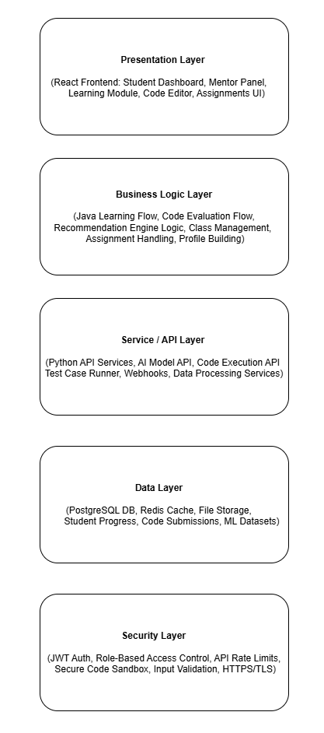
Figure 1 - Architecture Diagram

Technologies and Services
Table 10.1 Technologies, Components, and Security Mechanisms Used in the System Architecture
Component | Description | Technology Used | Security Mechanism
Frontend App | User interface for students, mentors, and open Java workspace | React.js with tailwindCSS | SSL/TLS, Input Validation, Role-Based UI Rendering
Backend API (Core Services) | Handles user auth, student/mentor operations, classes, progress tracking, assignments | Node.js (Express.js) | JWT Auth, RBAC, Rate Limiting, Input Sanitization
AI Service (Python API) | Python microservice that calls AI/LLM models, processes user data, and generates personalized learning material | Python (FastAPI / Flask) | Token-Based Access, HTTPS, Data Validation
Code Execution Engine | Real-time code execution using WebSockets; compiles Java with javac and analyzes code using Java Parser | WebSockets, Java Compiler (javac), Java Parser | Sandboxed Execution, Process Isolation, Timeout Limits
Database | Stores users, performance, code submissions, classes, AI evaluations, progress history | MongoDB / PostgreSQL | Encryption at Rest, RBAC, Parameterized Queries
Authentication & Authorization Service | Manages login, signup, JWT tokens, password hashing, user roles | Node.js Auth Middleware, JWT, Bcrypt | Hashed Passwords, Secure Token Storage, Refresh Token Rotation
Mentor Management System | Allows mentors to manage classes, students, assignments, and view progress/plagiarism | Express.js Backend Module | Role-Based Access, Activity Logging
External Integrations | AI API calls, email service, plagiarism detection | Python LLM APIs, SMTP/SendGrid | API Key Protection, HTTPS, Tokenization
Table 11 - Technologies, Components, and Security Mechanisms Used in the System Architecture
Figure: Component-Level Breakdown of Technologies and Security Mechanisms in the System

Architecture Style / Pattern

Layered Architecture Pattern
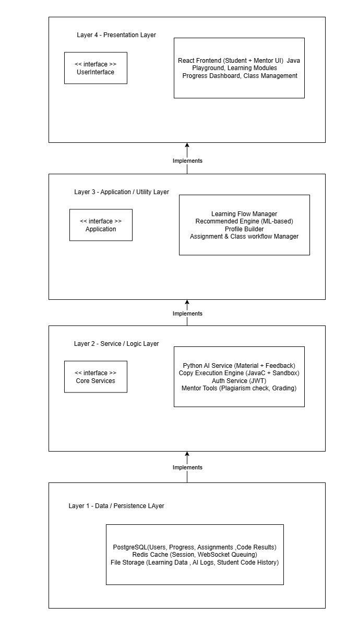
Figure 2 - Layered Architecture Pattern

Design Models

Design Models for Procedural Approach
Activity Diagrams
- Student Learning Flow
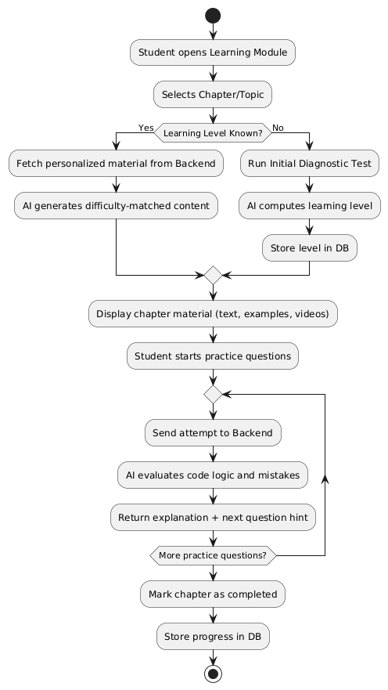
Figure 3 - Student Learning Flow

- Code Execution & Ai Evaluation Flow
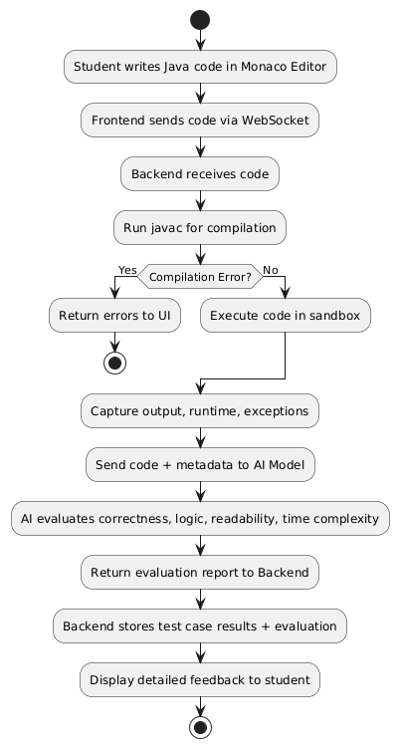
Figure 4 - Code Execution & Ai Evaluation Flow

- ML Based Recommendation Engine Flow
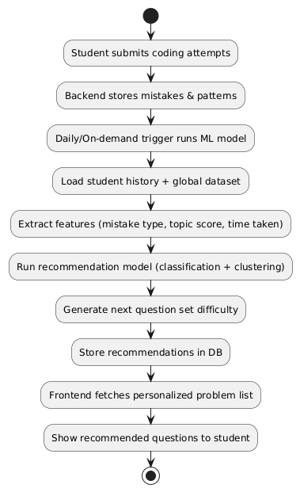
Figure 5 - ML Based Recommendation Engine Flow

- Student Profile Building

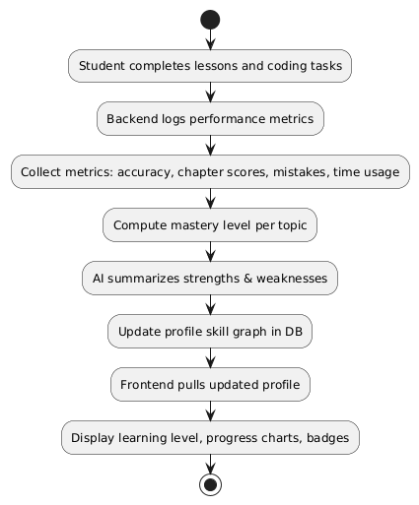
Figure 6 - Student Profile Building

- Mentor – Class Management

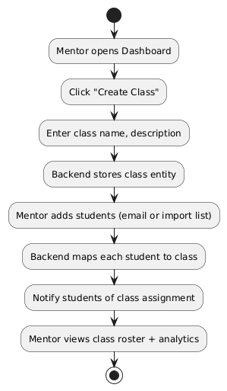
Figure 7 - Mentor – Class Management

- Mentor – Assignment & Tracking

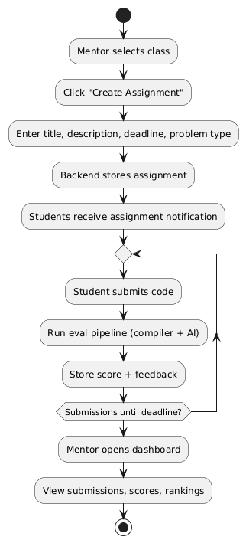
Figure 8 - Mentor – Assignment & Tracking

- Plagiarism Detection Flow

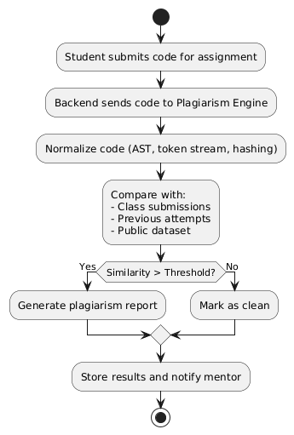
Figure 9 - Plagiarism Detection Flow

- Student Progress Tracking & Analysis

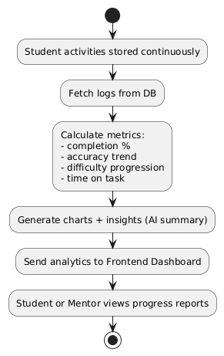
Figure 10 - Student Progress Tracking & Analysis

Data Flow Diagrams

- DFD Level 0 — Context Diagram

Shows CODABLE as a single system interacting with external entities (Student, Mentor, AI Model, Compiler) and the high-level data flowing between them
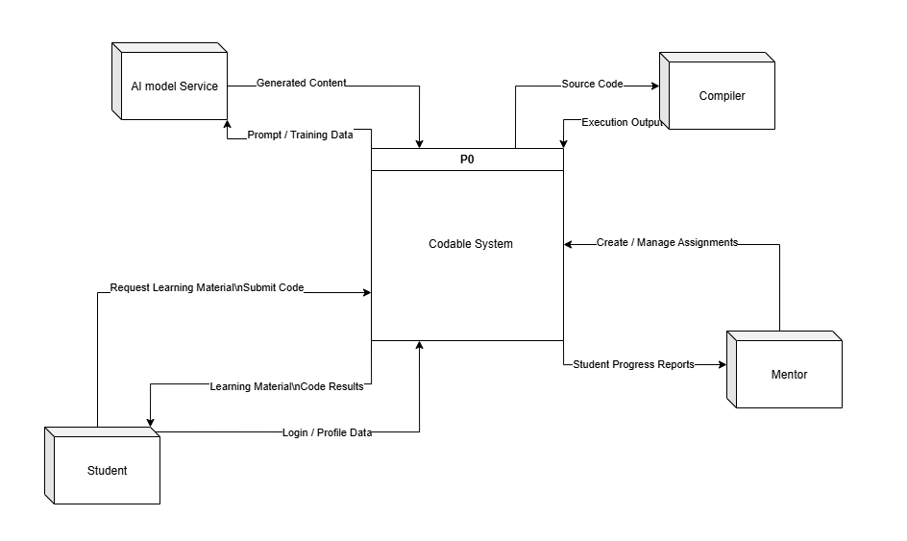
Figure 11 - DFD Level 0 — Context Diagram

- DFD Level 1 — Diagram 0

Breaks CODABLE into major internal processes (authentication, learning, code execution, performance tracking, mentor tools) and shows how they interact with the main data stores.
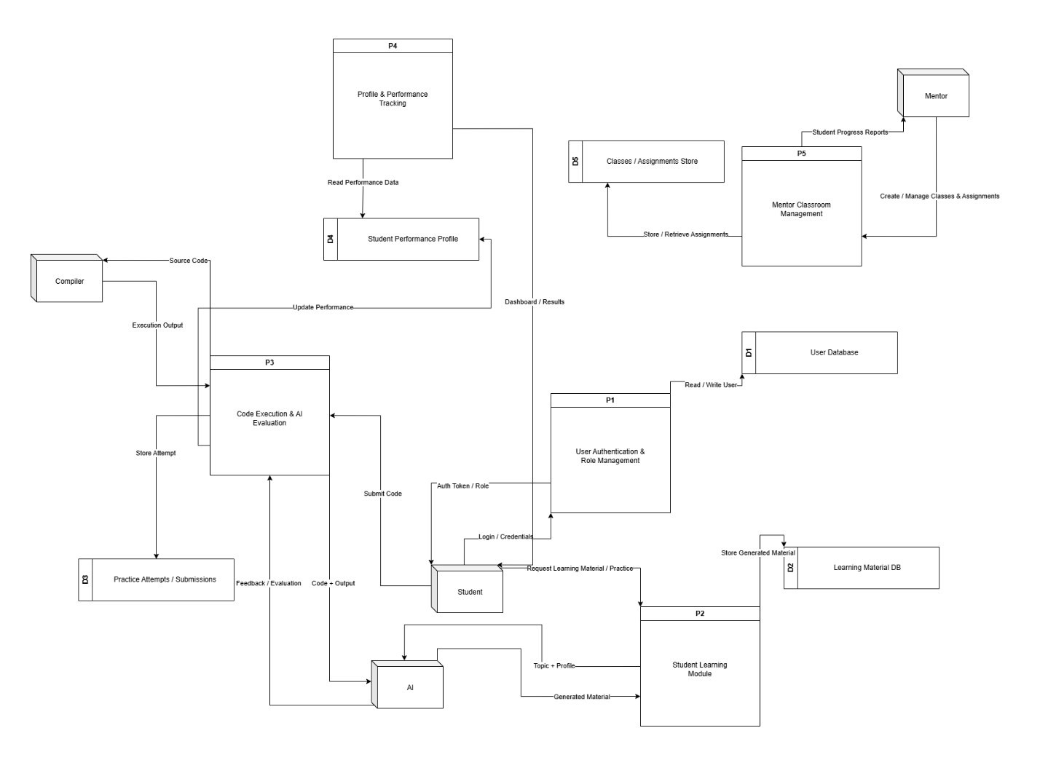
Figure 12 - DFD Level 1 — Diagram 0

- DFD Level 2 — P2 Student Learning Module

Details how personalized learning material is generated by fetching a student’s profile, determining their level, preparing an AI prompt, and storing the final content.
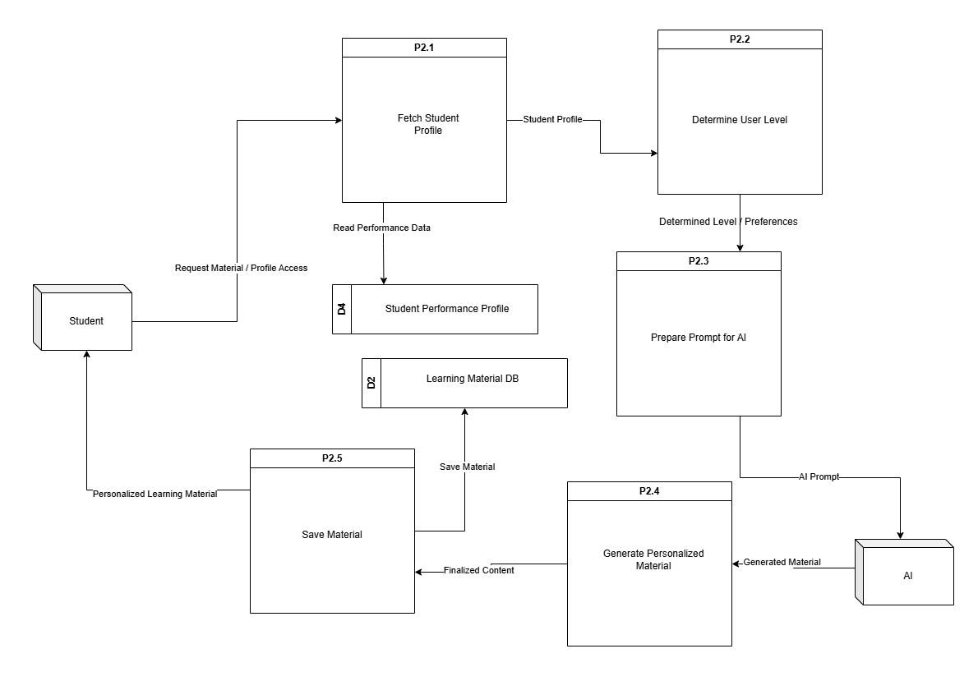
Figure 13 - DFD Level 2 — P2 Student Learning Module

- DFD Level 2 — P3 Code Execution & AI Evaluation

Shows the step-by-step flow of code validation, compiler execution, AI-based evaluation, storing attempts, and updating student performance.
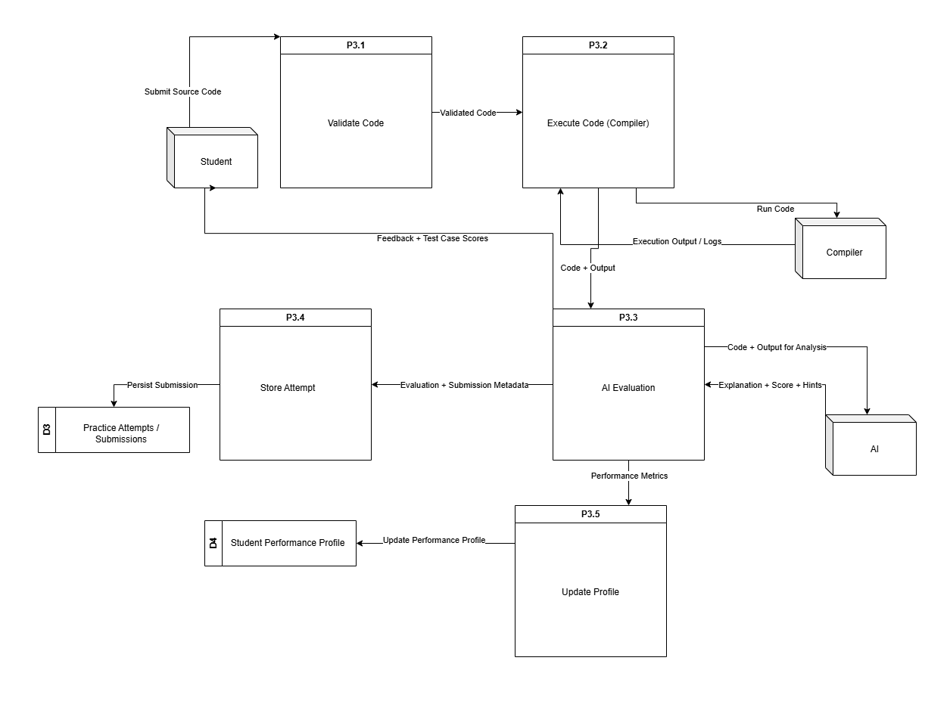
Figure 14 - DFD Level 2 — P3 Code Execution & AI Evaluation

State Transition Diagram
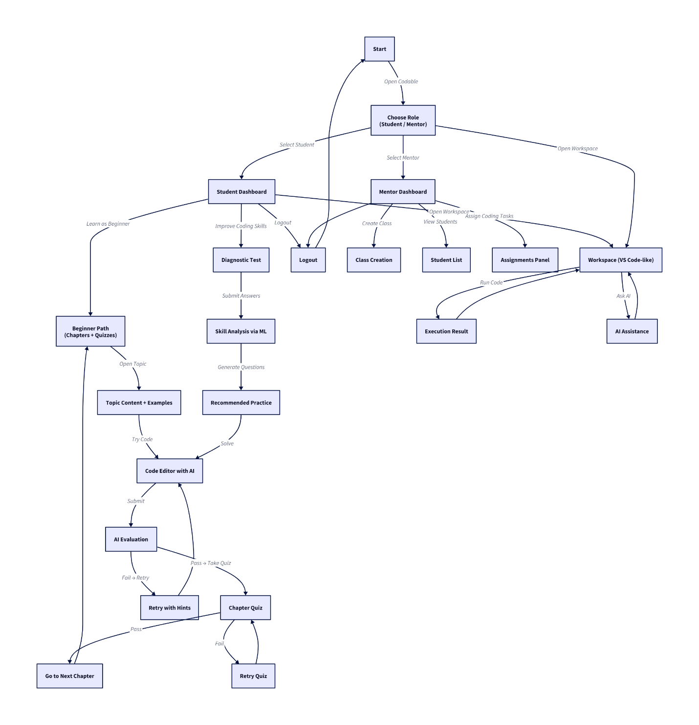
Figure 15 - State Transition Diagram

Data Design
This section describes how the information domain of the Codable platform is converted into structured data models and stored across different system components. The system uses a combination of Node.js backend services, a Python AI service, and a Database Layer (MongoDB or PostgreSQL) to manage and organize all user, learning, and performance data.

Data Storage Approach
Codable uses a centralized database where all major entities: users, classes, assignments, code submissions, progress metrics, and AI evaluations, are stored in well-defined data structures. These data models ensure consistent access patterns for both the student-facing and mentor-facing workflows.
The platform follows a modular data structure where each service interacts with specific entities:
- The Node.js backend handles core system entities (users, roles, classes, submissions).
- The Python AI service stores AI-generated content and evaluation metadata back into the database.
- The Code Execution Engine sends execution results that are saved as submission records.

Major Data Entities
The system primarily manages the following major entities:
1. User Entity
Stores information for both students and mentors.
Includes profile details, authentication credentials, role, learning level, and activity logs.
2. Student Learning Profile
Tracks:
- Progress through chapters/topics
- Test results
- AI-generated personalized material
- Weakness areas (concept, logic, syntax)
- Skill metrics
3. Classes (Mentor Module)
Contains:
- Class details
- Students enrolled
- Assignments
- Class-level analytics
4. Assignments / Tasks
Stores mentor-created assignments:
- Problem description
- Test cases
- Deadlines
- Submissions and grading
5. Code Submissions
Each submission includes:
- Submitted code
- Code execution output
- Test cases passed/failed
- AI evaluation feedback
- Time of submission
6. AI-Generated Content
Data created by the Python AI service:
- Personalized learning material
- Topic recommendations
- Difficulty-adjusted exercises
- Code improvement suggestions
7. Progress Tracking Data
Stores continuous metrics such as:
- Number of attempts
- Coding accuracy
- Time spent
- Improvement graphs
- Chapter completion history
8. Authentication & Authorization Data
Includes:
- JWT tokens
- Hashed passwords
- Role-based permissions
- Authentication logs

Data Storage Technologies
Codable can use one of the following database solutions:
Storage Component | Technology | Usage
Primary Database | MongoDB or PostgreSQL | Users, classes, submissions, profiles, assignments
Caching Layer (Optional) | Redis | Session caching, token storage, performance optimization
File Storage (Optional) | Cloud Storage (AWS S3 / Local Storage) | Large files, logs, lesson resources
AI Metadata Storage | Same DB | AI evaluation and recommended content
Table 12 - Technologies, Components, and Security Mechanisms Used in the System Architecture

Data Processing & Organization
- CRUD Operations performed through REST APIs (Node.js).
- AI Evaluation Processing through Python microservice.
- Real-time submission results through WebSockets.
- Relational or Document structure used depending on chosen database:
  - PostgreSQL → structured relational schemas
  - MongoDB → flexible nested documents

Summary
The Data Design ensures that all components of the system: learning engine, mentor tools, AI modules, and code execution engine, maintain consistent, secure, and scalable access to all required information. The data structures support personalized learning, detailed analytics, class management, and continuous skill evaluation.

Chapter 4: Implementation

Project Methodology & Algorithms
This section outlines the core methodology and algorithms used in Codable, focusing on the intelligent and rule-driven components rather than basic CRUD operations. It highlights how the system enforces learning workflows, evaluates code, generates personalized study material, and recommends exercises based on user performance. The described methods include the AI-driven content generation pipeline, code evaluation logic, adaptive learning algorithms, and mentor-side management rules that govern assignments, progress tracking, and skill assessment.

Project Methodology
This section outlines the overall approach used to build Codable, including how each development stage was planned and executed. It briefly explains the workflow followed for designing the curriculum, creating the AI-based evaluation modules, integrating the editor, and developing the ML-driven recommendation system.
- Data Collection
  - What data we are collecting:
    - User activity logs:
    - Page views, navigation events, button clicks, and code editor actions (run, stop, save).
    - Code submissions:
    - Source code text, selected programming language, compile/runtime errors, and code complexity metrics.
    - Performance records:
    - Task and quiz scores, completion timestamps, number of attempts, and topic mastery levels.
    - Session and telemetry data:
    - Session durations, editor focus/blur events, network errors, and device/browser metadata.
    - Authentication metadata:
    - Email, join date, user role (student/mentor/admin), and membership tier (from the User model).
    - Feedback and interaction data:
    - Student feedback on exercises, mentor comments, and peer review ratings.
  - How we are collecting data:
    - Frontend event emitters:
      - React components dispatch events (e.g., onClick, onSubmit, onRunCode) which are sent via POST requests to backend telemetry and analytics endpoints.
    - WebSocket streams:
      - Real-time code execution events (stdout, stderr, execution status) are streamed from the backend to the frontend using WebSockets for immediate feedback.
    - Backend persistence:
      - Data is stored in a PostgreSQL database (tables: User, StudentProfile, UserProgress, CodeRuns, ActivityLogs).
      - Supplementary data (e.g., embeddings, logs) may be stored in ChromaDB or flat files.
    - External monitoring/logs:
      - Server and API logs are collected using monitoring agents (e.g., Prometheus, Grafana) for system health and security auditing.
  - Why this data is important:
    - Populate Profile & Analytics UI:
      - Enables display of user streaks, join date, email, location, bio, and progress analytics.
    - Persistence for user progress:
      - Supports features like leaderboards, identification of weak areas, and personalized recommendations.
    - Data pipeline for analytics/ML:
      - Feeds future analytics and machine learning models for predictive mastery, adaptive content, and personalized suggestions.
    - Debugging and security monitoring:
      - Facilitates detection of failed compiles, suspicious activity, and system errors for rapid troubleshooting and security enforcement.
- Data Preprocessing
  - Missing Values:
    - Identify missing optional fields (avatar, bio, social links) and substitute defaults (null or empty string)
    - For numeric metrics (timeSpent), substitute 0 or use median imputation if aggregating historical data
  - Duplicates:
    - Use unique keys (userId + timestamp or runId) to deduplicate code run records
    - De-duplicate analytics events by client-generated eventId when available.
  - Normalization:
    - Normalize continuous metrics before modelling: min-max scaling or standardization (z-score) for features like timeSpent, linesOfCode
    - Categorical encoding: one-hot or ordinal encoding for membershipTier, topic tags
  - Aggregation / Anonymization:
    - Aggregate events to daily/weekly buckets for dashboards (dailyActivity)
    - Anonymize or hash user identifiers for datasets used externally or for ML experiments
  - Validation:
    - Validate JSON schema for incoming telemetry (types, bounds) using middleware (Joi / custom validators)
    - Enforce type checks, value bounds, and required fields to prevent corrupt or invalid data from entering the database.
  - Storage format:
    - Persist cleaned records in MongoDB documents and export ML datasets as CSV/Parquet when training offline
    - Export datasets for offline ML training or analytics as CSV or Parquet files, ensuring all preprocessing steps (cleaning, normalization, anonymization) are applied.
- Feature Extraction & Selection
  - Key Features:
    - Code Features:
      - linesOfCode, numberOfFunctions, compileErrorsCount, runtimeErrorsCount, codeComplexityScore (e.g., cyclomatic complexity).
    - Interaction Features:
      - totalTimeSpent, avgSessionDuration, sessionsPerWeek, codeRunFrequency, editorFocusEvents.
    - Performance Features:
      - tasksCompleted, successRate (completed/attempts), quizScores, topicMasteryLevel.
    - Behavior Features:
      - editorIdleTime, inputRequests (e.g., Scanner usage in Java), frequency of code runs per session, time between attempts.
    - Profile Features:
      - membershipTier, joinDate (account age), location (region/country), userRole (student/mentor/admin).
  - Extraction and Selection:
    - Code Parsing:
      - Parse code submissions using static analysis tools to extract AST metrics (token count, bracket depth, number of imports, codeComplexityScore).
    - Sessionization & Aggregation:
      - Derive time-based aggregates from raw activity logs (e.g., sessionization by sessionId, calculation of avgSessionDuration, and sessionsPerWeek).
    - Feature Filtering:
      - Remove low-variance features (those with little to no change across users) and highly correlated features (using a correlation threshold, e.g., Pearson’s r > 0.9) to reduce redundancy.
    - Domain Knowledge:
    - Prioritize features that align with educational goals, such as combining timeSpent and attempts to estimate mastery, or using code complexity to gauge learning progress.
  - Model Training
    - Algorithm(s): State the machine learning or AI models used (e.g., Random Forest, CNN, LSTM).
    - Training: Mention dataset split (train/test) and evaluation method.
    - Why: Explain why this model was chosen for the problem.
- Deployment
  - What tech is used:
    - Frontend: React (Vite) SPA with routes for roles, workspace, and profile pages
    - Backend: Express server with REST endpoints and WebSocket code-run service
    - Database: MongoDB for Users and StudentProfiles
    - Real-time: WebSocket server for compile/run streams
    - Monitoring: logging + optional metrics dashboards
  - How it can be deployed:
    - Host backend on a Node-capable host (e.g., VPS, cloud VM, or managed services); use NGINX reverse proxy + TLS
    - Use MongoDB Atlas or managed MongoDB for persistence
    - Serve the built frontend via CDN or static host (Netlify, Vercel) with CORS configured
    - For WebSocket TLS (wss://) use same host or dedicated domain behind NGINX
    - CI/CD: GitHub Actions to run tests and deploy builds
  - Why:
    - Real-time feedback (WebSocket) improves learning flow
    - Persistent profiles and analytics enable personalized learning and progress tracking
    - Production safety via sandboxing and secure auth protects users and infrastructure

Algorithm
This section presents the key algorithms powering Codable, focusing on intelligent features. Each algorithm includes its name, input, output, and pseudocode, avoiding trivial operations and highlighting logic-driven and ML-based processes used in the system.

Table 4.1: Algorithms
Algorithm Name | Details
JavaCodeCompileAndRun (WebSocket Code Runner) | Input: sessionId (string), sourceCode (string), runOptions { timeoutMs, stdinAllowed, outputLimitBytes }  Output: streamed messages to client ({type:'compile-error'|'stdout'|'stderr'|'done'}) and finalResult { exitCode, runtimeMs, status }  Description / High-level steps:  - Create isolated temporary working directory for sessionId.  - Persist sourceCode as Main.java.  - Spawn javac to compile; capture compile stderr.  - If compile fails → send compile-error and cleanup.  - If compile succeeds → spawn java process, stream stdout/stderr to client over WS, accept stdin messages from client.  - Enforce ExecutionGuard constraints (timeout, output limits).  - On process exit or enforced kill → send done message and cleanup temp directory.
ExecutionGuard (Timeout & Output Enforcement) | Input: processHandle, guards { maxRuntimeMs, maxOutputBytes }  Output: guardResult { status: 'ok'|'killed-timeout'|'killed-output', reason }  Description / High-level steps:  - Monitor elapsed runtime; if exceeds maxRuntimeMs, terminate process.  - Accumulate emitted output size; if exceeds maxOutputBytes, terminate process.  - On process exit clear monitors and return status.
StudentProfileUpsert (Single-Profile Rule) | Input: userId, payload { fullName?, avatar?, bio?, location?, socialLinks? }  Output: profileDocument, status {'created'|'updated'}  Description / High-level steps:  - Query StudentProfile by userId.  - If not found → create profile (use User.name or email local-part as default fullName), save and return created.  - If found → merge provided fields (partial update), save and return updated.  - Ensure uniqueness constraint on userId to prevent duplicates.
Ai/Ml Alogirthm here

Pseudocode of algorithms
- Algorithm: JavaCodeCompileAndRun
procedure JavaCodeCompileAndRun(sessionId, sourceCode, runOptions)
tempDir ← CreateTempDir(sessionId)
WriteFile(tempDir + "/Main.java", sourceCode)

compileProc ← SpawnProcess("javac", ["Main.java"], cwd=tempDir)
compileErrors ← CaptureStderr(compileProc)
wait compileProc to finish

if compileProc.exitCode ≠ 0 then
SendToClient(sessionId, { type: "compile-error", data: compileErrors })
Cleanup(tempDir)
return
end if

SendToClient(sessionId, { type: "compile-success" })
runProc ← SpawnProcess("java", ["Main"], cwd=tempDir, stdio=pipes)
startTime ← Now()

start ExecutionGuard(runProc, runOptions)

concurrently:
stream runProc.stdout → SendToClient(sessionId, { type: "stdout", data })
stream runProc.stderr → SendToClient(sessionId, { type: "stderr", data })
on ws message of type 'stdin' write to runProc.stdin

wait for runProc to exit or be killed
runtimeMs ← Now() - startTime
SendToClient(sessionId, { type: "done", exitCode: runProc.exitCode, runtimeMs })
Cleanup(tempDir)
end procedure

- Algorithm: ExecutionGuard
procedure ExecutionGuard(processHandle, guards)
startTime ← Now()
totalOutput ← 0

on process stdout or stderr chunk:
totalOutput += chunk.length
if totalOutput > guards.maxOutputBytes then
Kill(processHandle)
return { status: "killed-output", reason: "output limit exceeded" }
end if
end on

every 100ms:
if Now() - startTime > guards.maxRuntimeMs then
Kill(processHandle)
return { status: "killed-timeout", reason: "timeout" }
end if
end every

on process exit:
clear interval
return { status: "ok" }
end procedure

- Algorithm: StudentProfileUpsert
procedure StudentProfileUpsert(userId, payload)
existing ← StudentProfile.findOne({ userId })
if existing == null then
user ← User.findById(userId)
profile ← new StudentProfile({
userId,
fullName: payload.fullName OR user.name OR localPart(user.email),
avatar: payload.avatar OR null,
bio: payload.bio OR "",
location: payload.location OR { city:"", country:"" },
socialLinks: payload.socialLinks OR { github:"", linkedin:"", twitter:"" }
})
profile.save()
return { profile, status: "created" }
else
if payload.fullName provided then existing.fullName ← payload.fullName end if
if payload.avatar provided then existing.avatar ← payload.avatar end if
if payload.bio provided then existing.bio ← payload.bio end if
if payload.location provided then merge location fields end if
if payload.socialLinks provided then merge social links end if
existing.save()
return { profile: existing, status: "updated" }
end if
end procedure

Training Results & Model Evaluation (Mandatory for AI/ML/Data Science Projects)
- Describe:
  - Dataset used (name, source, pre-processing)
  - Training setup (platform, GPU/CPU, batch size, epochs)
  - Performance metrics
  - Screenshots of graphs (loss, accuracy, confusion matrix, ROC if applicable)

Security Techniques
Authentication:

- JWT-based auth: tokens signed with process.env.JWT_SECRET and issued at login (token expiry configured).
- Password hashing: bcrypt used in User model pre('save') hook (salt rounds ≈ 10).
- Auth middleware: authMiddleware.userAuth verifies token (reads token from request header token) and sets req.userId for protected routes.
- Request validation middleware: authMiddleware.validate(schema) present and used on auth routes.

Transport & secrets:

- Environment secrets loaded via dotenv (JWT secret, DB URI, etc.).
- CORS configured in server (FRONTEND_ORIGIN) to limit origins.

Input validation & persistence

- Route-level request validation middleware applied to critical endpoints (auth/profile).
- Mongoose schemas enforce required/unique fields (e.g., unique email, unique userId on StudentProfile) and use timestamps (createdAt/updatedAt).

Runtime safety for code execution

- WebSocket code-runner implemented:
- Uses per-session temporary working directory for compilation/execution.
- ExecutionGuard enforces max runtime and output limits; kills runaway processes.
- Streams compile/runtime stdout & stderr back to client; supports stdin messages.
- Cleans up temp dirs and terminates processes on disconnect or guard triggers.

- Logging & error handling

- Basic structured error logging (console.error) in controllers/middlewares and centralized error responses.
- Auditable events for profile CRUD and code-run errors are produced (logged).

External APIs/SDKs
This section covers all third-party SDKs, libraries and external APIs used in the project. It distinguishes between (a) external networked services/APIs you call at runtime (e.g., Stripe, Cloudinary, external LLMs) and (b) third-party libraries/SDKs installed via npm that provide functionality within the app (e.g., Express, Mongoose, Monaco Editor). For each item we list a short description, the purpose it serves in the system, and the specific files, functions or endpoints where it is integrated. Use the table below to document exact version numbers and invocation points.
Name of API /SDKS and version | Description | Purpose of usage | List down the API endpoint/function/class in which it is used
bcryptjs | Password hashing library | Hashing passwords and compare on login | src/models/User.js (pre('save') hash, comparePassword method)
jsonwebtoken | JWT creation/verification | Issue tokens at login and verify in auth middleware | src/models/User.js (generateToken), src/middlewares/authMiddleware.js (userAuth verification)
ws (WebSocket) | WebSocket server library | Real-time compile/run streaming between client and server | src/websocket/codeRunner.js (startWebSocketServer, connection/message handlers)
axios | Promise HTTP client (frontend) | API requests from frontend to backend (auth, profile) | src/services/userApi.js (getUserProfile, updateUserProfile, etc.), used across pages/components
@monaco-editor/react (monaco-editor) | Browser code editor | IDE editor in Workspace page | src/pages/Workspace/Workspace.jsx (MonacoEditor component integration)
lucide-react | Icon components | UI icons used in header, splash, etc. | src/pages/Student/ProfileAndAnalytics/components/ProfileHeader.jsx etc
recharts | Charting library | Render analytics charts on Profile & Analytics pages | src/pages/Student/ProfileAndAnalytics/* (charts components)
dotenv | Environment variable loader | Load process.env values (JWT_SECRET, DB URI) | src/server.js (dotenv.config()
cors | CORS middleware | Restrict allowed frontend origin for API access | src/server.js (app.use(cors({...})))
Table 13 - APIs
  - User Interface

Login Screen
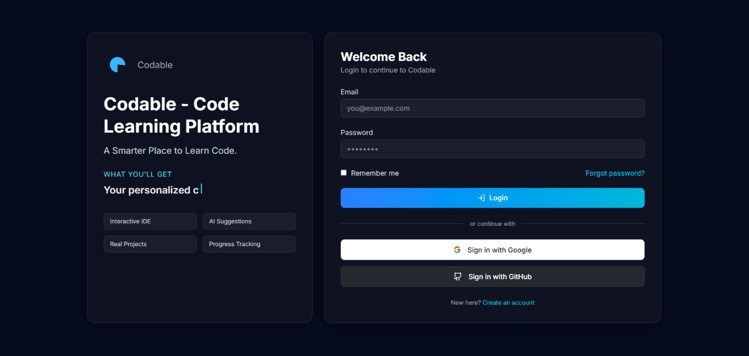
Figure 16 - Login Screen
  - Purpose: Authenticate users.
  - Key components: email/password fields, "Login" button, "Forgot password" link.
  - Primary actions: submit credentials, show errors.
Role Selection Dashboard
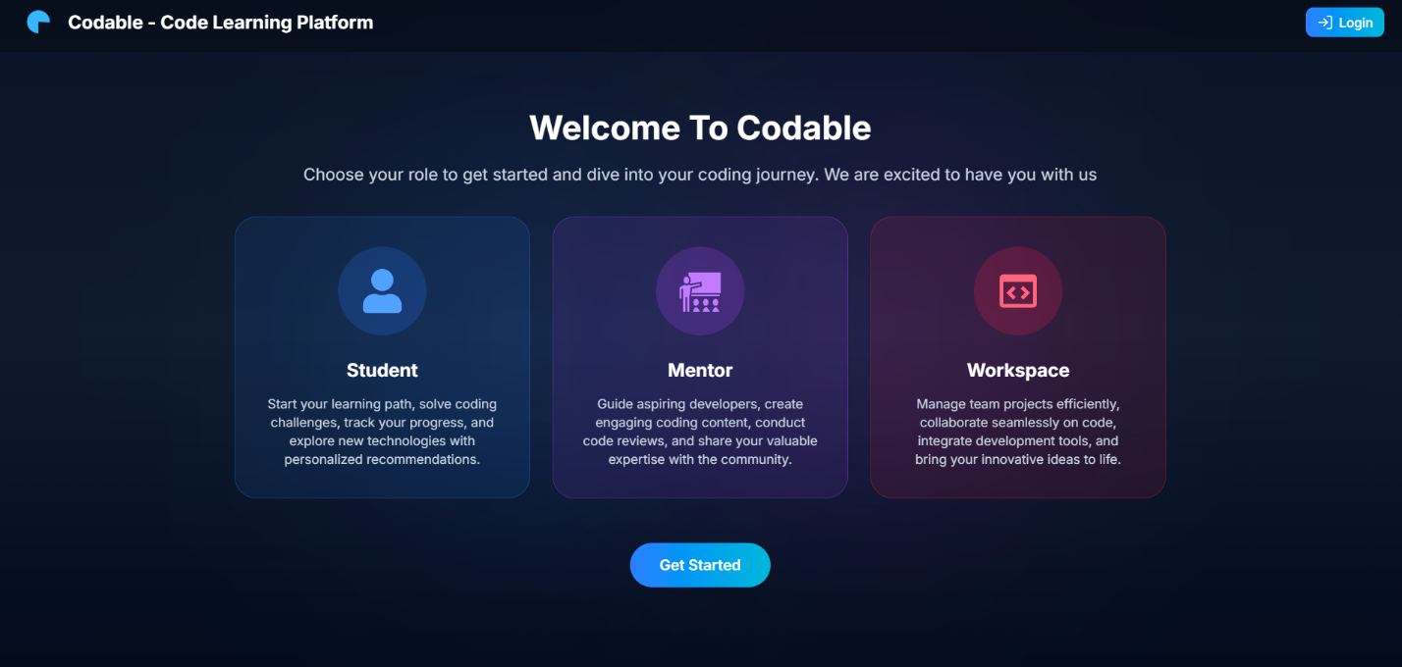
Figure 17 - Role Selection Dashboard
  - Purpose: First-time landing and choose role (student/mentor).
  - Key components: branding/logo, brief pitch, role buttons, continue CTA.
  - Primary actions: select role → navigate to onboarding or dashboard.
  - Client: sessionStorage flag to show once per session
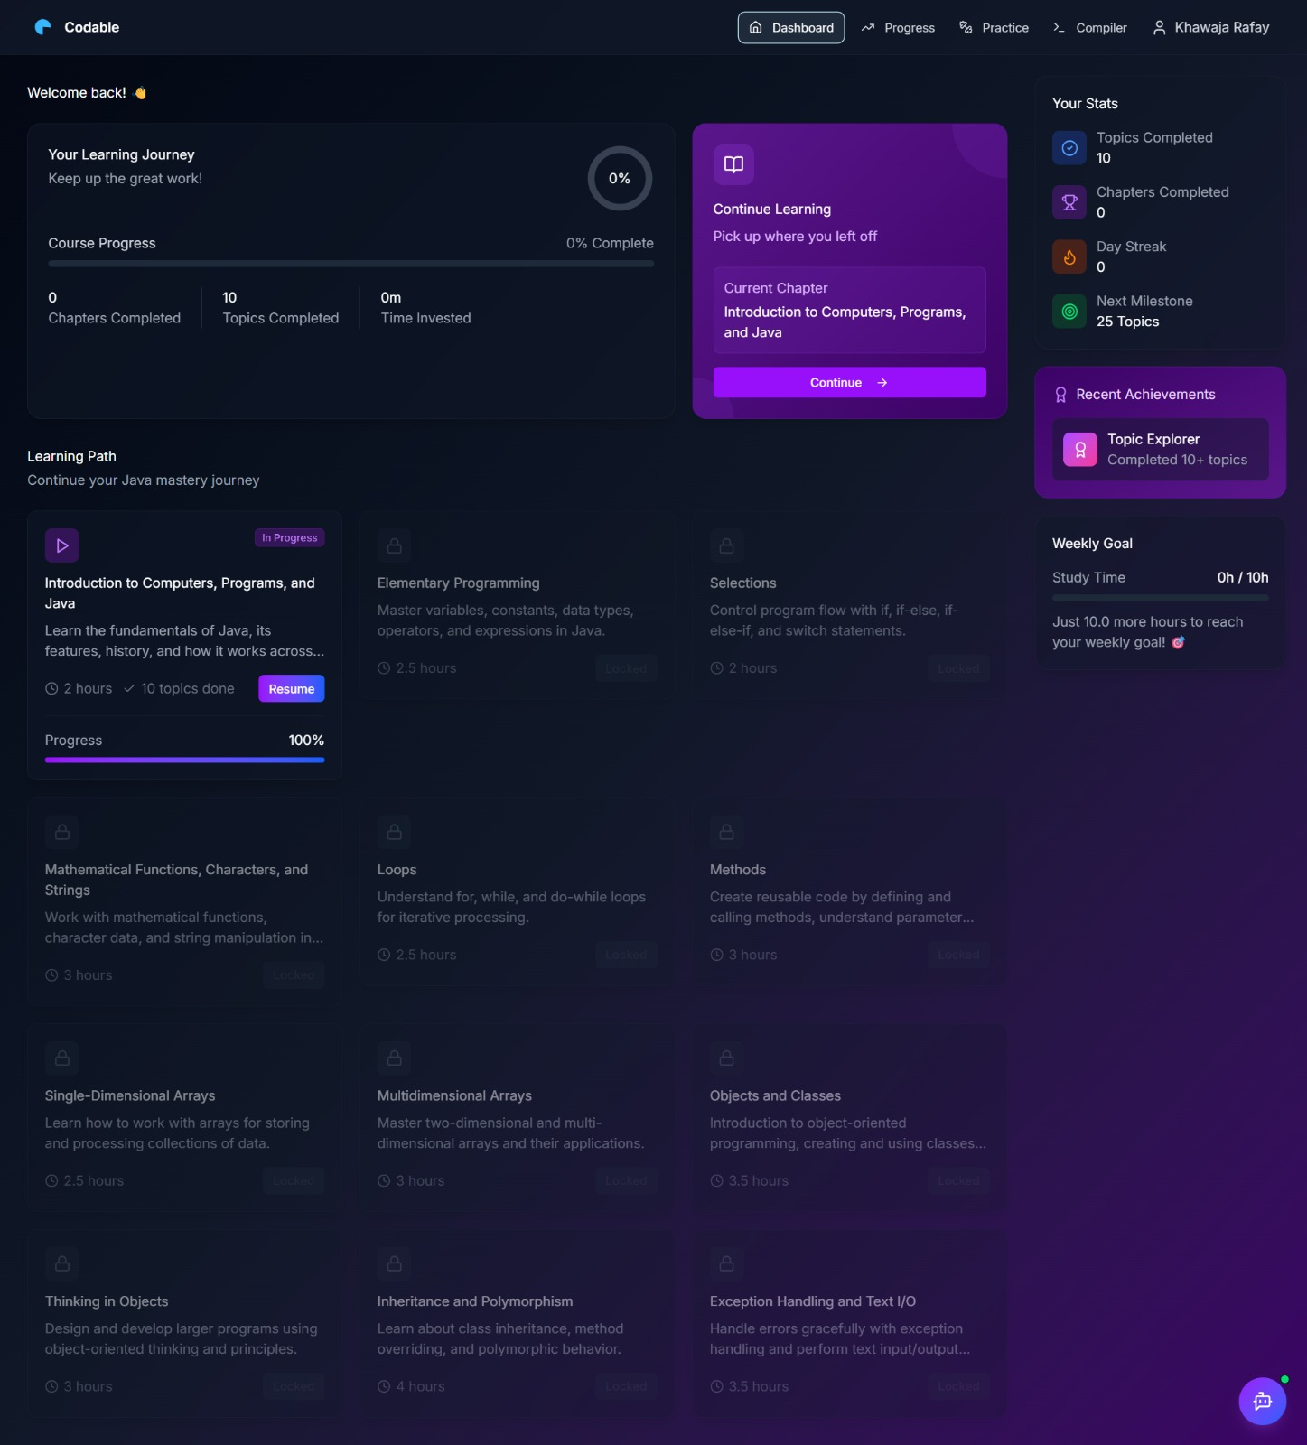
Student Dashboard

Figure 18 - Student Dashboard

- Purpose: Entry hub showing progress, quick actions and recommended tasks.
- Key components: stats cards, recent activity, quick links (Workspace, Courses), notifications.
- Primary actions: open workspace, continue course, view profile.
Workspace
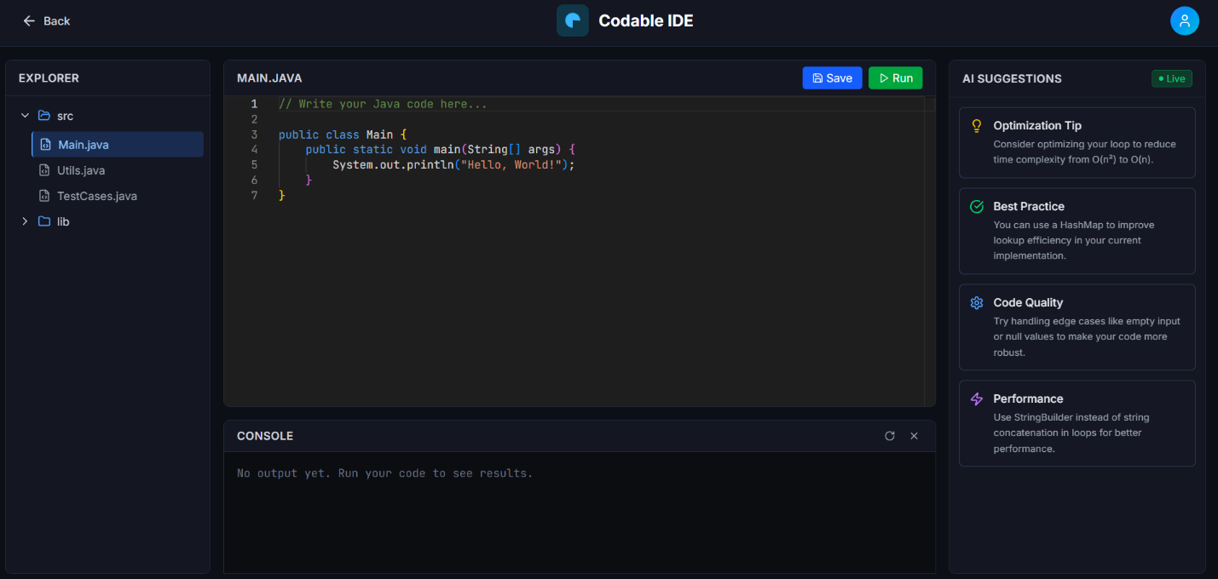
Figure 19 - Workspace
  - Purpose: Write, compile and run Java code in-browser.
  - Key components: Monaco editor, Run/Stop buttons, stdin input, stdout/stderr console, file tabs.
  - Primary actions: edit code, click Run → stream compile/runtime output, provide stdin.

User Profile & Analytics
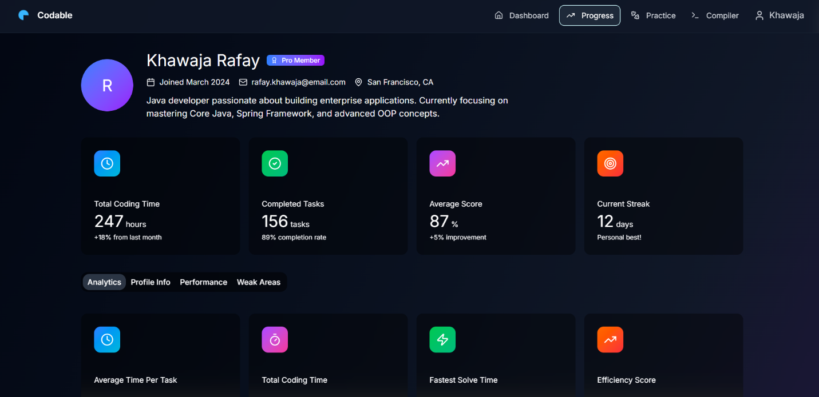
Figure 20 - User Profile & Analytics
  - Purpose: Provide users a single place to view and update their personal information and identity details.
  - Key components: Avatar, name, membership badge, bio, location, social links, join date, and an Edit button.
  - Primary actions: View profile info, open edit form, update details, and save changes with validation.
Instructor Dashboard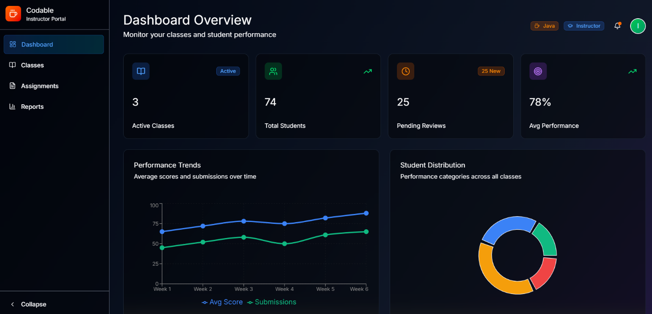
Figure 21 - Instructor Dashboard

- Purpose: Manage users, view metrics, moderate content.
- Key components: user list, search, role controls, platform analytics charts.
- Primary actions: edit user profiles, promote/demote roles, review code runs.
Create and view Classes (for instructor)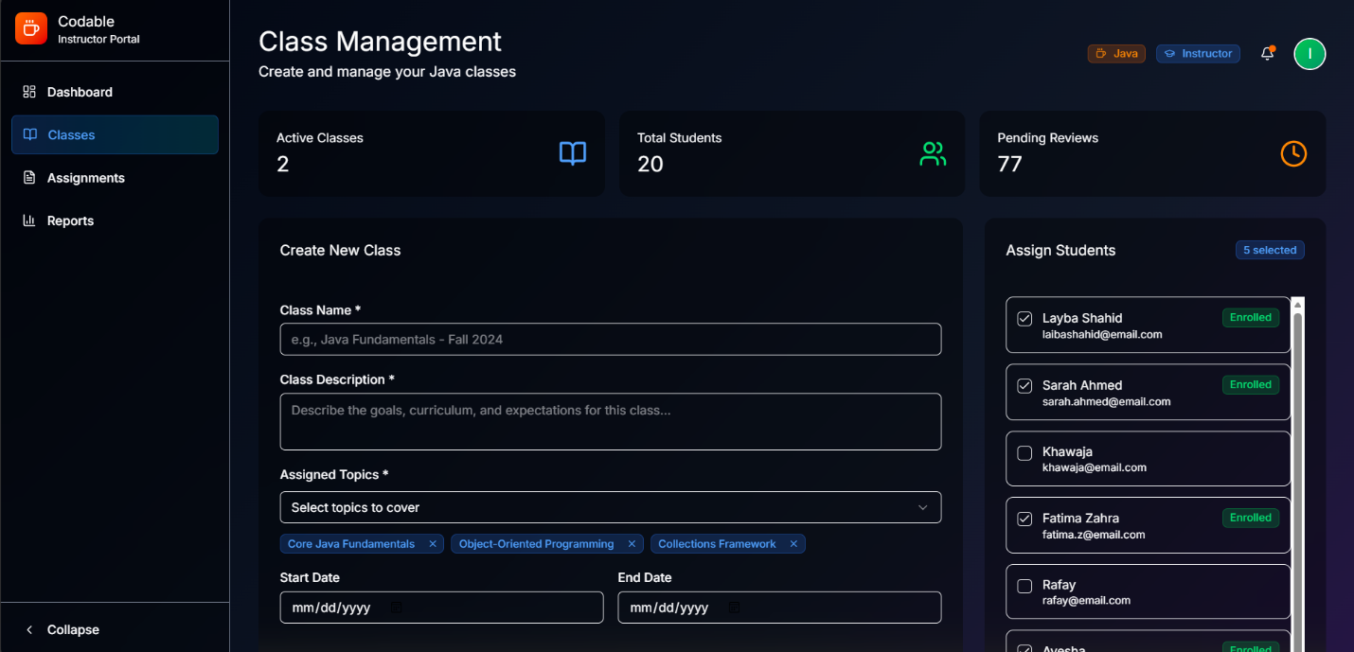
Figure 22 - Create and view Classes (for instructor)
- Purpose: Create and publish a class/cohort with schedule, resources and visibility settings.
- Key components: Title & short description, rich-details editor, topics/tags selector, level & capacity inputs, schedule/date pickers, visibility & enrollment code, action bar (Preview, Save Draft, Publish)
- Primary actions: Fill required fields → Preview class card → Save draft or Create/Publish
Intreractive Learning Content
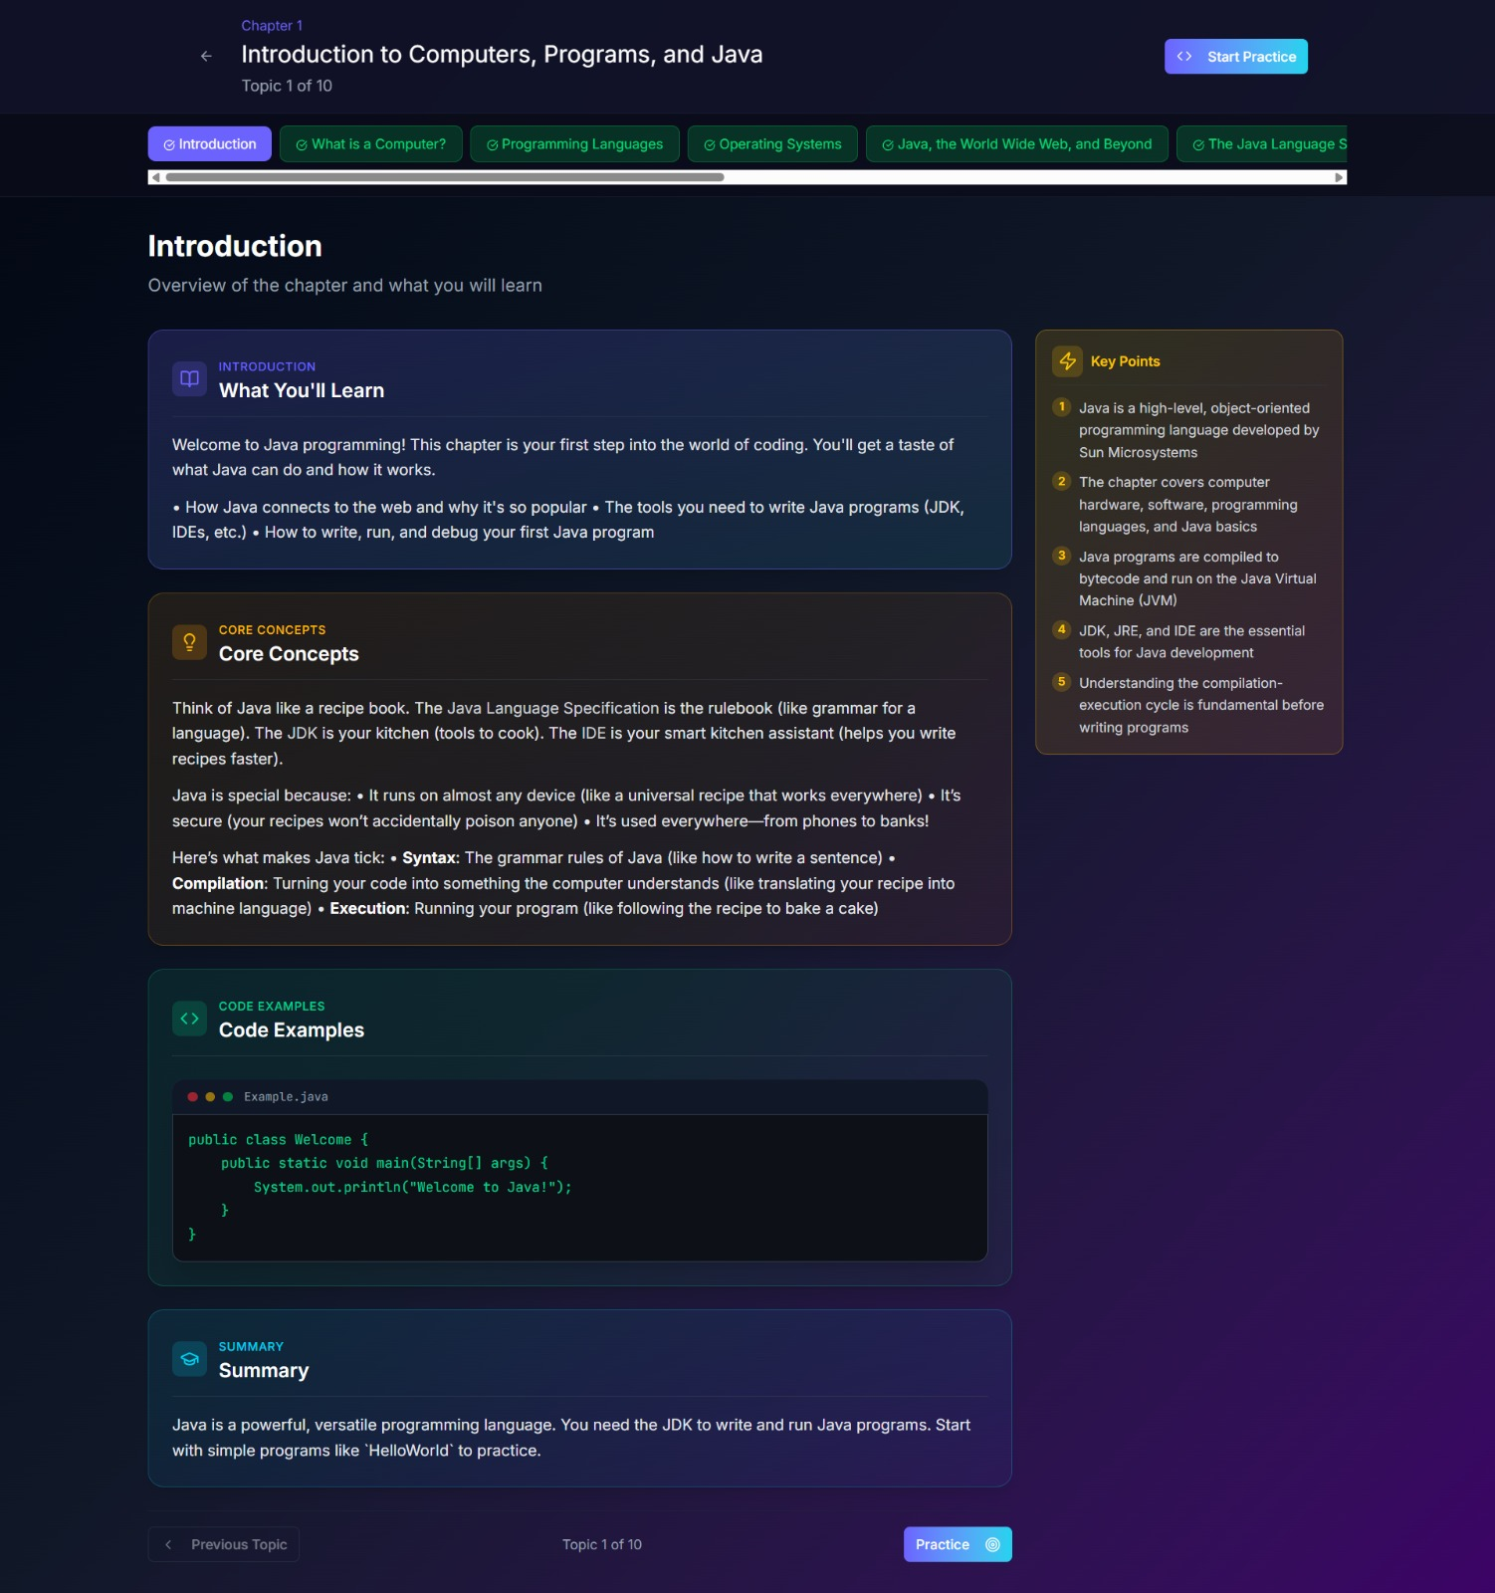
The AI-generated interactive textbook. Instead of walls of text, it breaks complex concepts into bite-sized components: concise introductions, visual step-by-step analogies, critical "Dos and Don'ts," and real-world application examples fetched directly from our RAG knowledge base.
Topic Quiz Interface
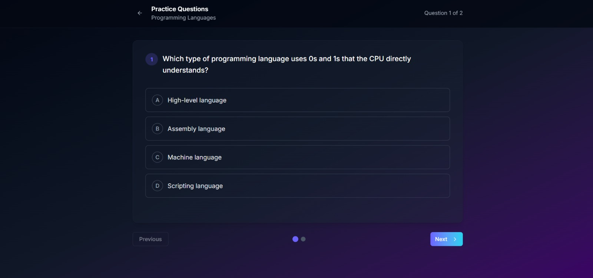
The immediate knowledge check. After reading a topic, the dynamic BKT Engine presents contextual multiple-choice questions to immediately evaluate the student's mastery of the specific micro-concepts just taught.

AI Remediation Feedback Screen
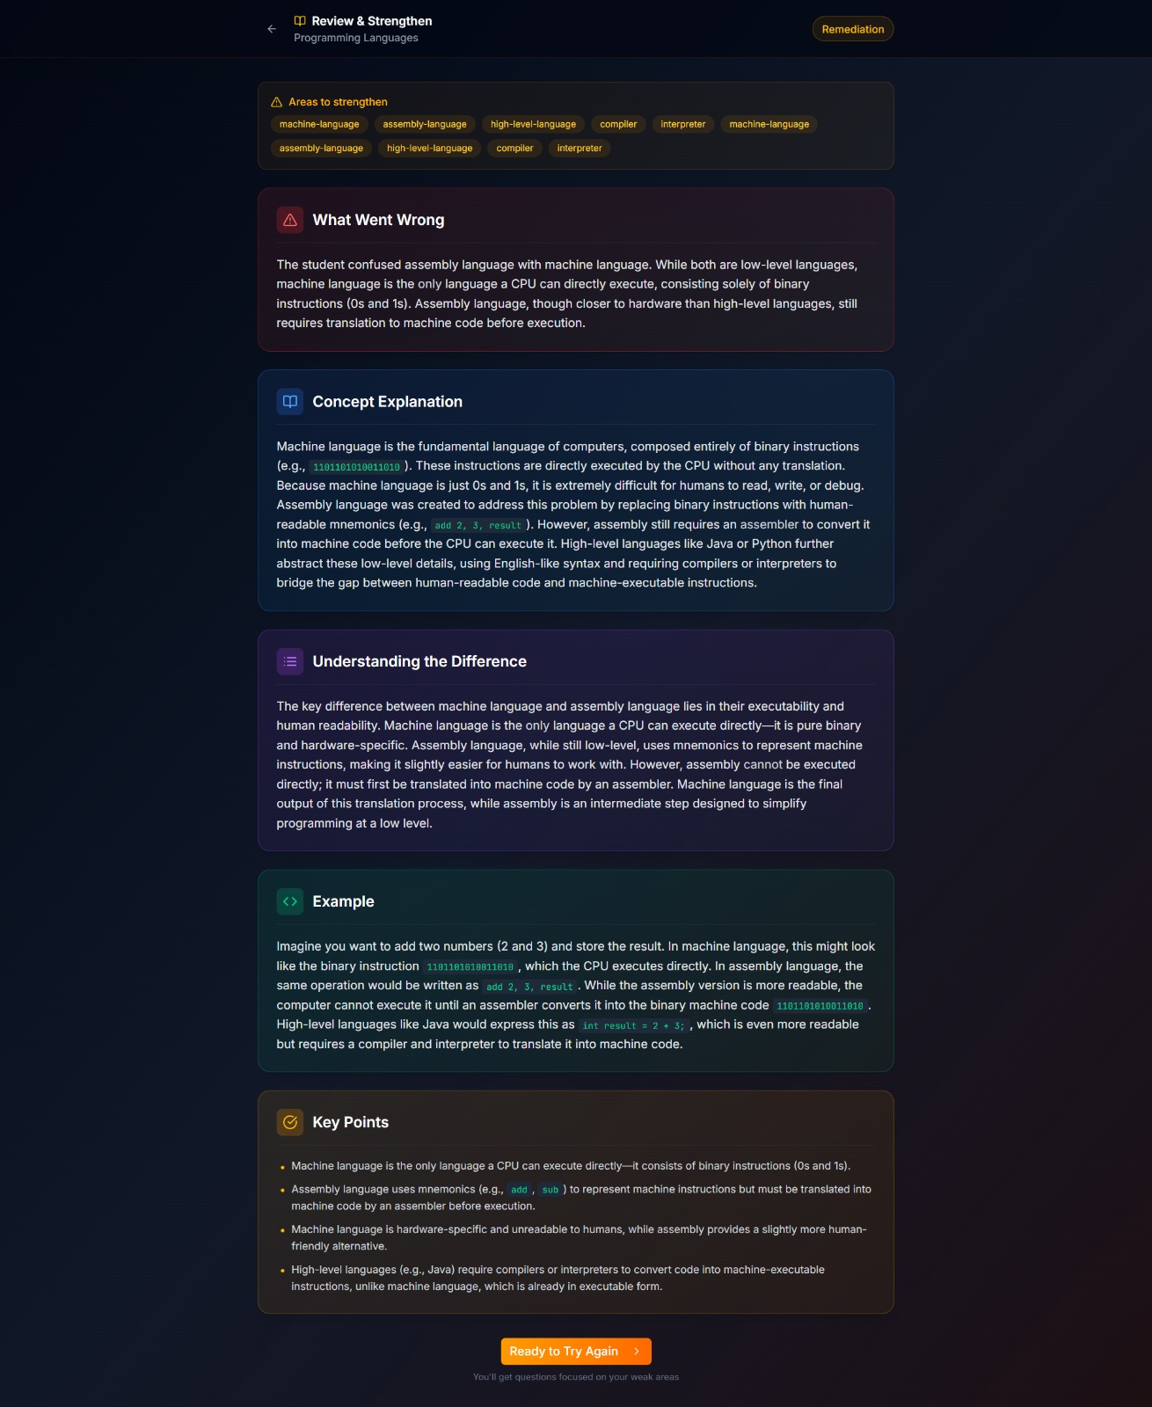
The core adaptive loop. If a student fails a quiz, this intelligent screen steps in. It explicitly highlights why their answer was wrong, providing an on-the-fly, personalized AI explanation (e.g., explaining a Logic Error) to correct their specific misunderstanding before moving forward.
Chapter Practice Workspace
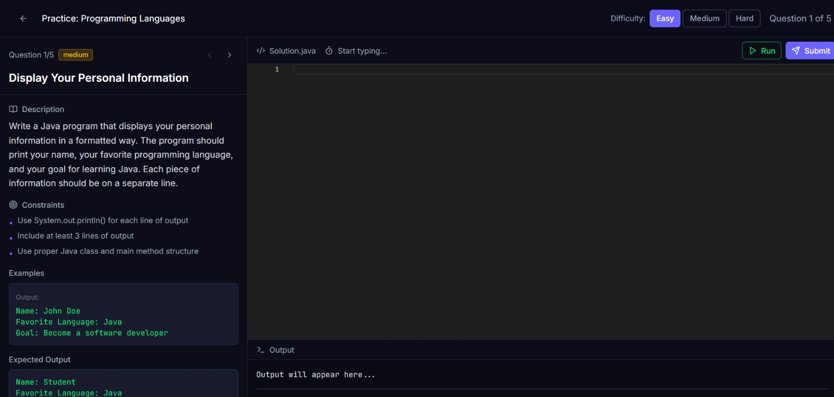
The ultimate coding crucible. A fully integrated, browser-based IDE where students write real Java solutions to AI-generated coding challenges. Connected via WebSocket to our secure Node.js compilation engine for instantaneous execution feedback.

Chapter 5: Testing and Evaluation

This section is to perform testing of the system and to ensure that the system working as intended. This is also to check that the system meets the requirements stated earlier. Besides that, system testing will help in finding the errors that may be hidden from the user

Unit Testing
Unit testing verifies the smallest testable components of the software (e.g., individual functions, methods, or classes) in isolation. The purpose is to ensure that each unit performs as expected, independent of the full system.

Test 1: validateEmail()
No. | Test case / Test script | Attribute & Value | Expected Result | Actual Result
1 | Call validateEmail() with valid email | "abc@gmail.com" | Validates as correct email (True) | True
2 | Call validateEmail() with invalid email | "abc.gmail.com" | Rejects input and returns False | False
3 | Call validateEmail() with empty string | "" | Rejects input and returns False | False
Table 14 - Test 1: validateEmail()
Test 2: User model : password hash & compare
No. | Test case / Test script | Attribute and Value | Expected Result | Actual Result
1 | Save user with plain password | password: "password123" | Stored password != "password123" (hashed) | False
2 | comparePassword() with correct password | comparePassword("password123") | Returns true | True
3 | comparePassword() with wrong password | comparePassword("wrongpass") | Returns false | False
Table 15 - Test 2: User model : password hash & compare
Test 3: Auth controller (login/register)
No. | Test case / Test script | Attribute and Value | Expected Result | Actual Result
1 | Save user with plain password | password: "password123" | Stored password != "password123" (hashed) | False
2 | comparePassword() with correct password | comparePassword("password123") | Returns true | True
3 | comparePassword() with wrong password | comparePassword("wrongpass") | Returns false | False

Test 4: authMiddleware.userAuth
No. | Test case / Test script | Attribute and Value | Expected Result | Actual Result
1 | Call protected route without token header | no token header | 401 Unauthorized | False
2 | Call with invalid/expired token | token: "invalid" | 401 Unauthorized | False
3 | Call with valid token | token: valid JWT for userId X | next() called; req.userId === X | True
Table 16 - Test 4: authMiddleware.userAuth
Test 5: StudentProfile controller (create/get/update/delete)
No. | Test case / Test script | Attribute and Value | Expected Result | Actual Result
1 | POST /api/student/profile when none exists | payload {fullName,...} with auth token | 201 Created, profile created | True
2 | POST /api/student/profile when profile exists | same user repeated | 400 Bad Request (profile exists) | False
3 | GET /api/student/profile with valid token | auth token | 200 OK, returns profile + populated email/joinDate | True
4 | PUT /api/student/profile partial update | payload {bio:"new"} | 200 OK, bio updated | True
5 | DELETE /api/student/profile | valid token | 200 OK, profile removed | True
Table 17 - Test 5: StudentProfile controller (create/get/update/delete)
Test 6: Code-runner (compile & run)
No. | Test case / Test script | Attribute and Value | Expected Result | Actual Result
1 | Send valid HelloWorld Java code via WS run | class Main { public static void main... System.out.println("Hello"); } | WS messages: compile-success then stdout with "Hello" then done | True
2 | Send code with compile error via WS | malformed Java code | WS message: compile-error contains compiler stderr | False
3 | Long-running infinite loop code | code with while(true) | ExecutionGuard kills process after timeout; receive killed-timeout | False
Table 18 - Test 6: Code-runner (compile & run)

Functional Testing
Functional testing validates that the system modules work correctly as a whole, ensuring that the developed system meets its specifications and requirements. Unlike unit testing, which focuses on internal functions, functional testing evaluates user-facing features through the UI or APIs.

No. | Test Case | Attribute and value | Expected Result | Actual Result
1 | Login as Student | email: student@example.com, password: password123 | Redirect to Student dashboard; navbar shows student links | TBD — execute test
2 | Login as Mentor | email: mentor@example.com, password: mentorpass | Redirect to Mentor dashboard; mentor controls visible | TBD — execute test
3 | Signup new user (student) | name, email newuser@example.com, password | 201 Created; token returned; optional create StudentProfile step triggered | TBD — execute test
4 | Splash screen visibility | Fresh browser session open site | Splash displays once; after timeout or dismiss, app shows routes; on page reload same session splash not shown | TBD — execute test
5 | Access protected route without token | GET /api/student/profile (no token) | 401 Unauthorized or redirect to login | TBD — execute test
6 | Create Student Profile (first-time) | POST /api/student/profile with valid payload + auth token | 201 Created; profile stored; GET /api/student/profile returns populated profile + email and joinDate | TBD — execute test
7 | Edit Student Profile (UI) | Open Edit modal, change bio & location, Save | PUT /api/student/profile called; UI updates with new bio/location; server returns 200 and updated data | TBD — execute test
8 | Workspace run — successful program | Send HelloWorld Java via WS run | WS messages: compile-success → stdout "Hello" → done; console shows output | TBD — execute test
9 | Workspace run — compile error handling | Send malformed Java via WS run | WS message: compile-error with compiler stderr; UI shows compile error panel | TBD — execute test
10 | Workspace run — execution timeout | Send infinite-loop code via WS run | ExecutionGuard kills process after timeout; client receives done/killed-timeout; UI shows timeout message | TBD — execute test
11 | Mentor create class (UI) | Fill form: title, description, schedule, publish | POST /api/mentor/classes returns 201; redirect to class detail/management | TBD — execute test
12 | Membership upgrade | PUT /api/student/membership/upgrade { tier: "pro" } + auth | 200 OK, membershipTier updated to pro; UI shows Pro badge | TBD — execute test
13 | Logout & token invalidation | Click Logout (frontend) or remove token | Protected routes return 401; user sent to login | TBD — execute test
Table 19 - Functional Testing

Integration Testing
Integration testing verifies that different modules of the system work together correctly. Unlike unit testing (which checks isolated functions) and functional testing (which checks features from a user’s perspective), integration testing focuses on the interfaces, linkages, and data flow between modules developed by different team members.

Test 1: Signup / Auth ↔ StudentProfile creation & retrieval

No. | Test case / Test script | Attribute and value | Expected result | Actual result
1 | Register new user → Login to get token | POST /auth/signup { name, email: newuser@example.com, password } → POST /auth/login { email, password } | Signup returns 201 (or success); login returns token and user info | TBD — execute test
2 | Create StudentProfile using token | POST /api/student/profile with header token: <JWT> and body { fullName, bio, location, socialLinks } | 201 Created; StudentProfile saved with userId referencing User._id | TBD — execute test
3 | GET profile and validate populated fields | GET /api/student/profile with header token: <JWT> | 200 OK; response contains profile fields and populated userId.email and userId.createdAt (joinDate) | TBD — execute test
4 | Prevent duplicate profile creation | POST /api/student/profile again with same token | 400 Bad Request (profile already exists) | TBD — execute test
Table 20 - Test 1: Signup / Auth ↔ StudentProfile creation & retrieval

Test 2: Profile lifecycle & middleware enforcement (Create → Update → Delete)
No. | Test case / Test script | Attribute and value | Expected result | Actual result
1 | Access protected endpoint without token | GET /api/student/profile (no token header) | 401 Unauthorized (authMiddleware.userAuth blocks access) | TBD — execute test
2 | Create profile, then partial update | POST /api/student/profile (auth token) then PUT /api/student/profile { bio: "New bio" } | POST returns 201; PUT returns 200 and profile.bio updated in DB | TBD — execute test
3 | Verify persistence after update | GET /api/student/profile (auth token) | 200 OK; bio value matches updated text and updatedAt changed | TBD — execute test
4 | Delete profile and validate removal | DELETE /api/student/profile (auth token) then GET /api/student/profile | DELETE returns 200; subsequent GET returns 404 (not found) | TBD — execute test
Table 21 - Test 2: Profile lifecycle & middleware enforcement (Create → Update → Delete)

