Discover the Advantages of [Steelmates](https://www.steelmates.co.nz) Glasshouses for Your Gardening Needs

Introduction

In the realm of gardening and horticulture, glasshouses play an integral role in nurturing and protecting plants throughout the year. [Steelmates](https://www.steelmates.co.nz), a pioneering company in the New Zealand market, has established itself as a leading provider of glasshouses, leveraging its expertise to offer high-quality and affordable gardening solutions. This guest post explores the essential keywords associated with purchasing glasshouses online and illustrates how Steelmates has tailored its offerings to meet the needs of New Zealand gardeners and beyond.

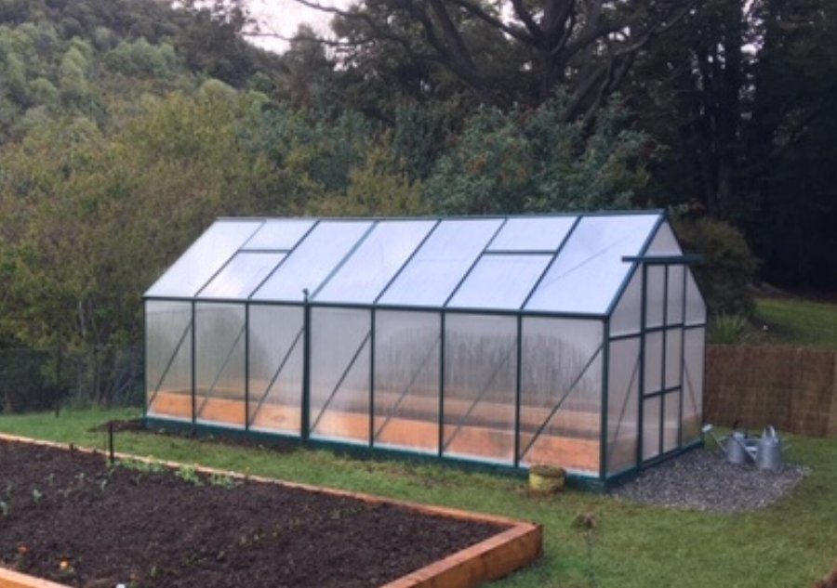

Keyword Research and Market Trends

Understanding consumer search trends is critical for effectively reaching potential customers looking for glasshouses. Key phrases that are commonly used include:

"[Glasshouse](https://www.steelmates.co.nz/greenhouse) for sale NZ"

"High-quality glasshouses"

"Affordable greenhouse"

"Buy glasshouse online"

"Durable glasshouses in New Zealand"

These keywords highlight a demand for quality, affordability, and accessibility in the [glasshouse](https://www.steelmates.co.nz/greenhouse) market. They also emphasize the importance of durability, reflecting New Zealand's diverse climates and the need for long-lasting gardening solutions.

Steelmates: A Leader in Glasshouse Innovation

Steelmates started its journey in 2009 by importing and selling outdoor furniture and quickly became a household name due to its competitively priced and high-quality garden sheds. This initial success in Auckland soon expanded nationwide, with the establishment of a Christchurch branch in 2011 to better serve the South Island. Today, Steelmates not only continues to thrive in the garden shed market but has also become a top supplier of glasshouses through its direct online sales on its website and Trade Me NZ.

Product Offerings and Unique Features

Steelmates designs and manufactures glasshouses that cater to a variety of gardening needs. Our glasshouses are crafted using the latest techniques and the best materials to ensure they stand up to New Zealand’s challenging weather conditions. Key features of our glasshouses include:

Robust Construction: Utilizing high-quality materials such as aluminum frames, our glasshouses ensure durability and stability.

Optimal Growth Environment: Designed to maintain the perfect climate for plant growth, our glasshouses allow for year-round gardening.

Affordable Prices: By designing and manufacturing our own products, we keep costs down, passing these savings onto our customers.

Versatility: Available in various sizes and styles, our [glasshouses](https://www.steelmates.co.nz/greenhouse) meet the diverse needs of both amateur gardeners and professional horticulturists.

Local Presence and Global Reach

From its warehouse in Otahuhu, Auckland, Steelmates manages a sophisticated distribution network that caters not only to the local market but also to customers globally. This local presence enables Steelmates to provide exceptional customer service and fast delivery times across New Zealand.

Customer Feedback and Continuous Improvement

Over the years, feedback from our valued customers has played a crucial role in refining our glasshouses. Understanding the pros and cons of our products has enabled us to enhance their design and functionality, ensuring they meet the high expectations of New Zealanders and the demands of local hardware stores.

Conclusion

Steelmates remains dedicated to its philosophy of providing quality products and services at affordable prices. Our glasshouses are a testament to our commitment to excellence and customer satisfaction. For gardeners looking to extend their growing seasons and protect their plants in a controlled environment, Steelmates offers the perfect solution with our superior glasshouses.

Call to Action

Explore our range of glasshouses and experience the Steelmates difference. Visit our website or contact our Auckland warehouse for more information on how our glasshouses can transform your gardening experience. Join the many satisfied customers who trust Steelmates for their gardening needs and start growing with confidence today!