What is HTML

HTML is an acronym which stands for **Hyper Text Markup Language** which is used for creating web pages and web applications. Let's see what is meant by Hypertext Markup Language, and Web page.

**Hyper Text:** HyperText simply means "Text within Text." A text has a link within it, is a hypertext. Whenever you click on a link which brings you to a new webpage, you have clicked on a hypertext. HyperText is a way to link two or more web pages (HTML documents) with each other.

**Markup language:** A markup language is a computer language that is used to apply layout and formatting conventions to a text document. Markup language makes text more interactive and dynamic. It can turn text into images, tables, links,etc.

**Web Page:** A web page is a document which is commonly written in HTML and translated by a web browser. A web page can be identified by entering an URL. A Web page can be of the static or dynamic type. **With the help of HTML only, we can create static web pages**.

Hence, HTML is a markup language which is used for creating attractive web pages with the help of styling, and which looks in a nice format on a web browser. An HTML document is made of many HTML tags and each HTML tag contains different content.

The code snippets written below shows how a html code snippet will look like:

<!DOCTYPE>

<html>

<head>

  <title>Web page title</title>

</head>

<body>

  <h1>Write Your First Heading</h1>

  <p>Write Your First Paragraph</p>

</body>

</html>

Description of HTML Example

**<!DOCTYPE>:** It defines the document type or it instructs the browser about the version of HTML.

**<html >**: This **tag informs the browser** that it is an HTML document. Text between html tag describes the web document. It is a container for all other elements of HTML except <!DOCTYPE>.

**<head>:** It should be the first element inside the <html> element, which contains the **metadata** (information about the document). It must be closed before the body tag opens.

**<title>:** As its name suggested, it is used to add the title of that HTML page which appears at the top of the browser window. It must be placed inside the head tag and should close immediately.

**<body>**: Text between body tag describes the body content of the page that is visible to the end user. This tag contains the main content of the HTML document.

**<h1>**: Text between <h1> tag describes the first level heading of the webpage.

**<p>**: Text between <p> tag describes the paragraph of the webpage.

In the coming sections, we will get to see more explanation regarding the tags used above.

Hence at this point, we can make a conclusion, The HTML code is made up of characters that live inside angled brackets — these are called HTML **elements**. Elements are usually made up of two **tags**: an opening tag and a closing tag. (The closing tag has an extra forward slash in it.) Each HTML element tells the browser something about the information that sits between its opening and closing tags.

In the coming sections, we will get to see more explanation regarding the tags used above.

Hence till this point we can make a conclusion, The HTML code is made up of characters that live inside angled brackets — these are called HTML **elements**. Elements are usually made up of two **tags**: an opening tag and a closing tag. (The closing tag has an extra forward slash in it.) Each HTML element tells the browser something about the information that sits between its opening and closing tags.

Example:

<p>Learning HTML is super exciting !!! </p>

In the example above we have a paragraph tag which has an opening tag (<p>) and a closing tag (<q>). Within this opening and closing tag we get to write the content we want to display on the web page.

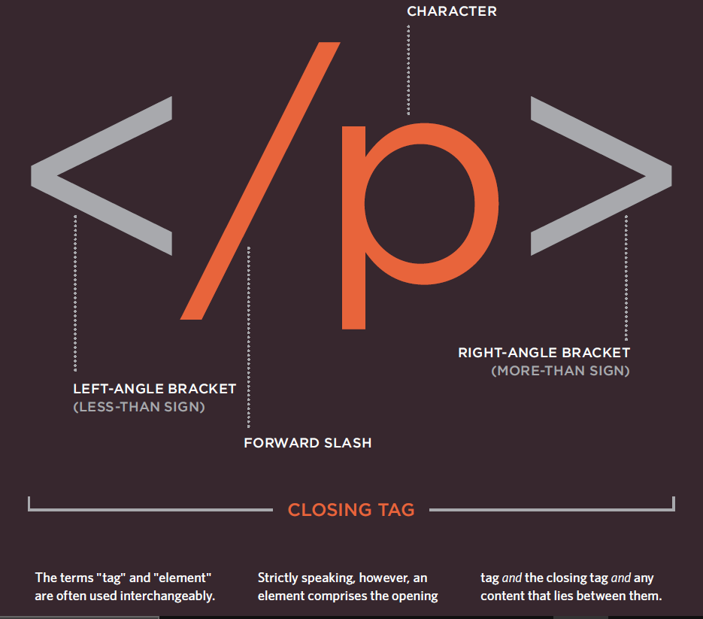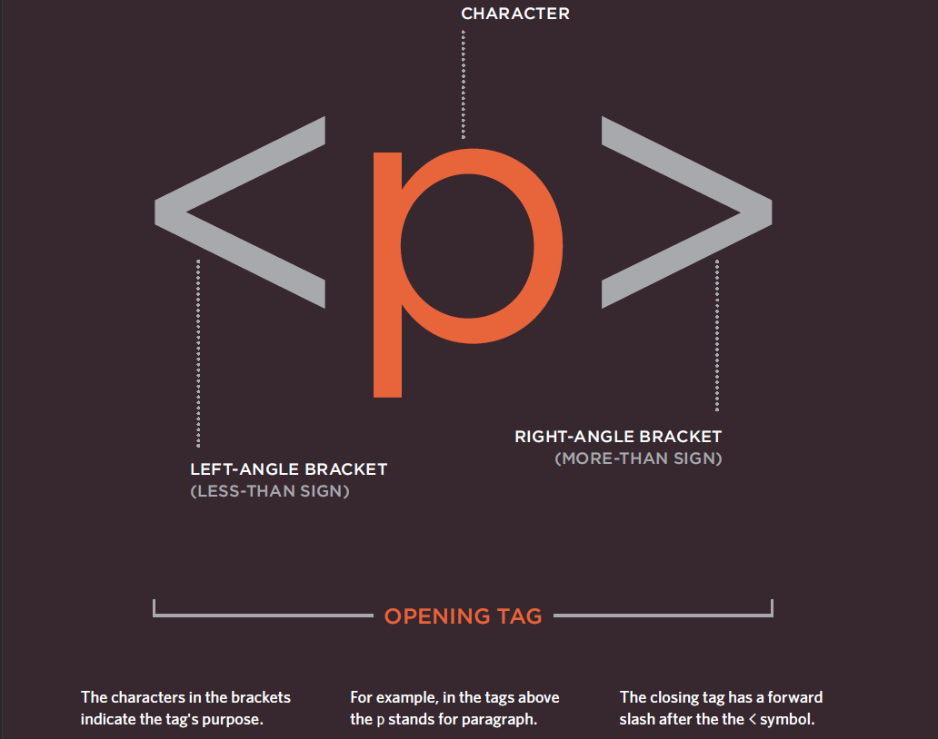Tags act like containers. They tell you something about the information that lies between their opening and closing tags.

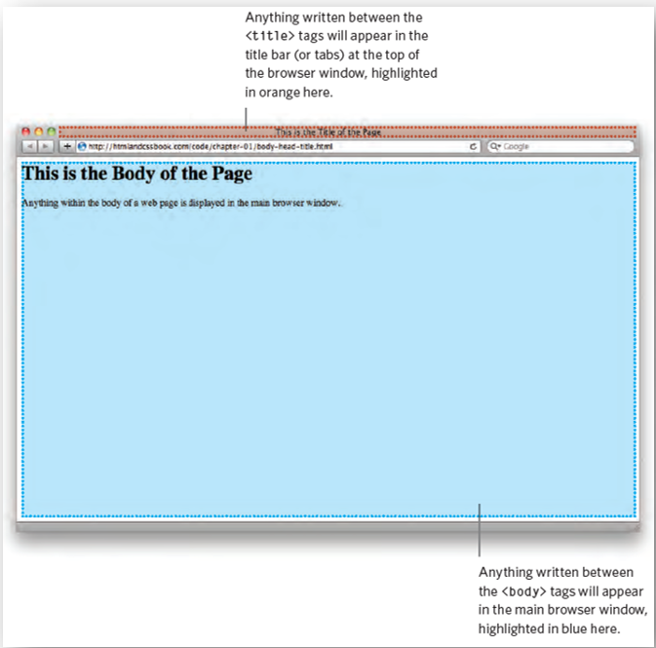

Chapter Summary

* HTML pages are text documents.
* HTML uses tags (characters that sit inside angled brackets) to give the information they surround special meaning.
* Tags are often referred to as elements.
* Tags usually come in pairs. The opening tag denotes the start of a piece of content; the closing tag denotes the end.
* Opening tags can carry attributes, which tell us more about the content of that element.
* To learn HTML, you need to know what tags are available for you to use, what they do, and where they can go.