Rendering Text Elements

When creating a web page, you add tags (known as markup) to the contents of the page. These tags provide extra meaning and allow browsers to show users the appropriate structure for the page.

**HTML Headings (<hx></hx>) :**

HTML has six "levels" of headings H1, H2, H3, H4, H4, H5

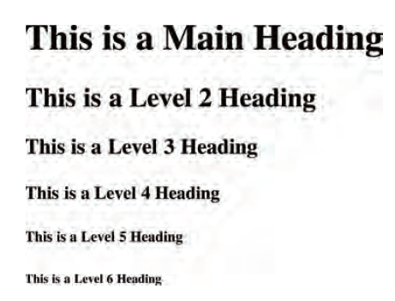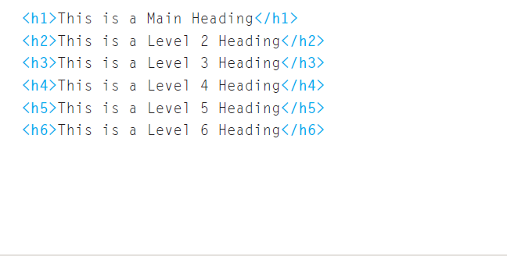

Browsers display the contents of headings at different sizes. The contents of an <h1> element is the largest, and the contents of an <h6> element is the smallest.

The exact size at which each browser shows the headings can vary slightly.

**HTML Paragraphs (<p></p>) :**

To create a paragraph, surround the words that make up the paragraph with an opening <p> tag and closing </p> tag.

By default, a browser will show each paragraph on a new line with some space between it and any subsequent paragraphs.

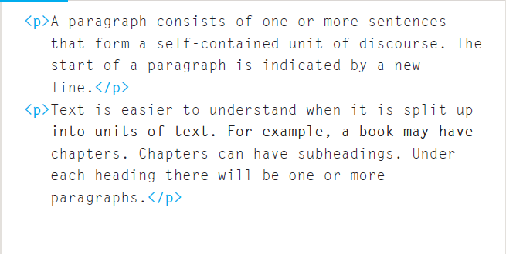

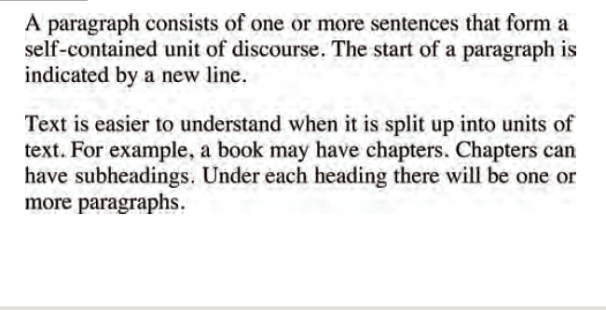

**Making a text Bold (<b></b>) :**

By enclosing words in the tags <b> and </b> we can make characters appear **bold**.

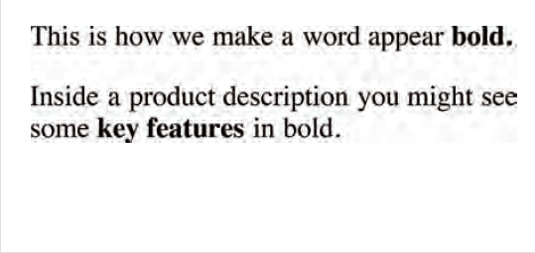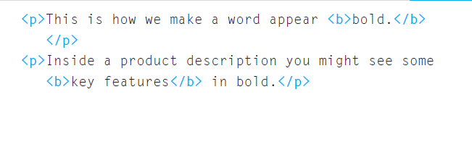

**Making a text Italic (<i></i>) :**

By enclosing words in the tags <i> and </i> we can make characters appear italic.

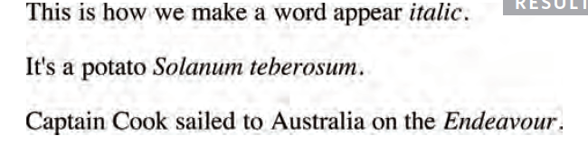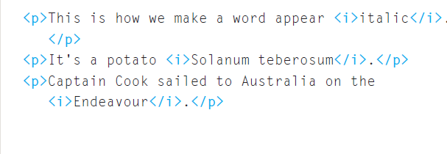

**Subscript (<sub></sub>) and Superscript (<sup></sup>) text :**

The <sup> element is used to contain characters that should be superscript such as the suffixes of dates or mathematical concepts like raising a number to a power such as 22.

The <sub> element is used to contain characters that should be subscript. It is commonly used with foot notes or chemical formulas such as H2O.

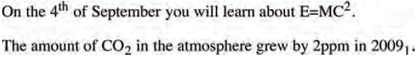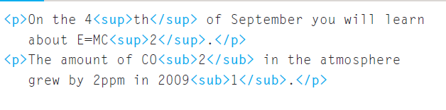

**White Space Collapsing in HTML**

When the browser comes across two or more spaces next to each other, it only displays one space. Similarly, if it comes across a line break, it treats that as a single space too. This is known as

*white space collapsing*.

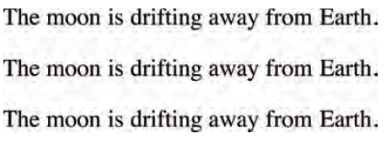

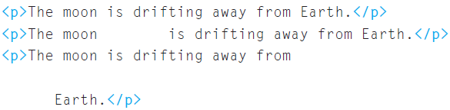

Thus, as a developer, you can take advantage of this phenomenon and provide space as required to provide better readability.

**HTML line break (<br>):**

If you wanted to add a line break inside the middle of a paragraph you can use the line break tag <br/>.

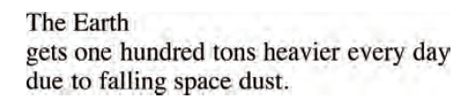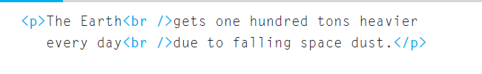

**HTML horizontal rule (<hr>) :**

If you wanted to have a horizontal rule (line) between the contents available we can do it using <hr> tag.

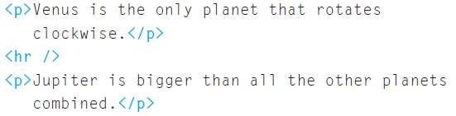

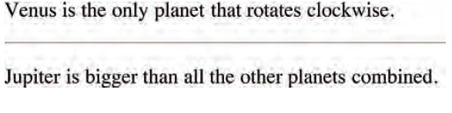

Single Tone tags and Paired Tags

In HTML we normally have tags with starting tag (<p>) and and ending tag (</p>). But we will often encounter a scenario where a tag does not have any closing tag such as line break tag <br>.

The tags with both starting and ending tags are called Paired Tags. Ex : <p></p> , <div></div>

The tags with only one opening tag are called single tone tag. Ex : <hr> , <br> etc.

The forward slash ‘/’ in case of single tone tag is optional. For example <hr> and <hr/> both are correct.