HTML Lists

There are lots of occasions when we need to use lists. HTML provides us with three different types:

1. Ordered lists are lists where each item in the list is numbered. For example, the list might be a set of steps for a recipe that must be performed in order, or a legal contract where each point needs to be identified by a section number.
2. Unordered lists are lists that begin with a bullet point (rather than characters that indicate order).
3. Definition lists are made up of a set of terms along with the definitions for each of those terms.

Ordered Lists (<ol></ol>)

<ol>: The ordered list is created with the <ol> element.

<li>: Each item in the list is placed between an opening <li> tag and a closing </li> tag. (The li stands for list item.)

Browsers indent lists by default.

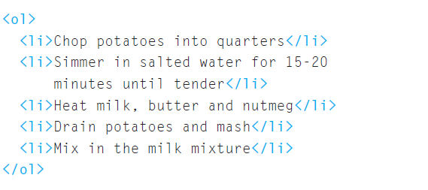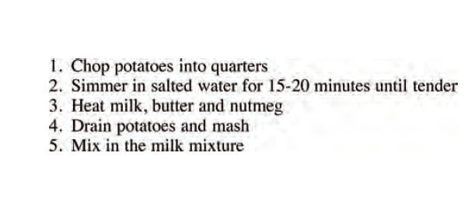

Unordered Lists

<ul>: The unordered list is created with the <ul> element.

<li>: Each item in the list is placed between an opening <li> tag and a closing </li> tag. (The li stands for list item.).

Browsers indent lists by default.

Consider the example below:

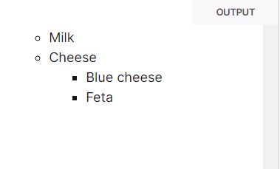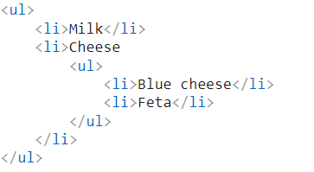

Definition Lists

<dl>: The definition list is created with the <dl> element and usually consists of a series of terms and their definitions.

Inside the <dl> element you will usually see pairs of <dt> and <dd> elements.

<dt>: This is used to contain the term being defined (the definition term).

<dd>: This is used to contain the definition.

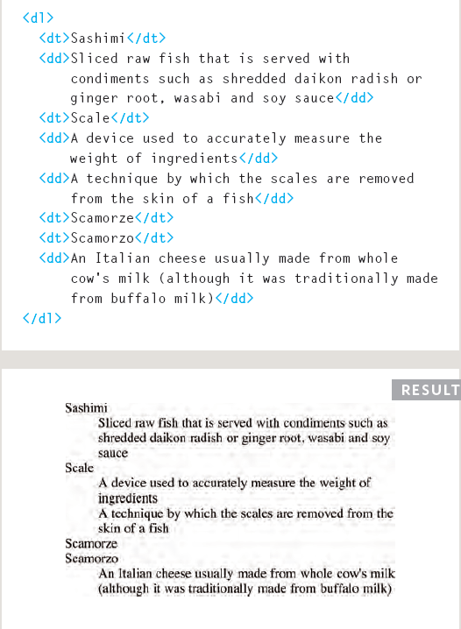

Chapter Summary

1. There are three types of HTML lists: ordered, unordered, and definition.
2. Ordered lists use numbers.
3. Unordered lists use bullets.
4. Definition lists are used to define terminology.
5. Lists can be nested inside one another.