Links in HTML

Links are the defining feature of the web because they allow you to move from one web page to another — enabling the very idea of browsing or surfing.

You will commonly come across the following types of links:

1. Links from one website to another
2. Links from one page to another on the same website
3. Links from one part of a web page to another part of the same page
4. Links that open in a new browser window
5. Links that start up your email program and address a new email to someone

**Creating Links:**

Links are created using the <a> element. Users can click on anything between the opening <a> tag and the closing </a> tag. You specify which page you want to link to using the **href** attribute.

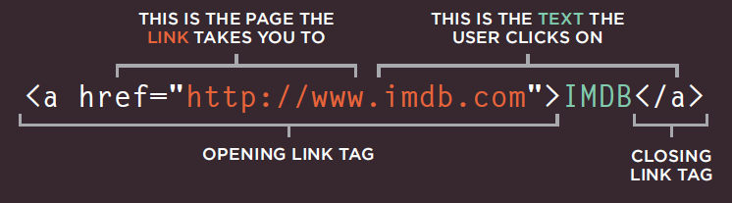

The text between the opening <a> tag and closing </a> tag is known as link text. Where possible, your link text should explain where visitors will be taken if they click on it (rather than just saying "click here").

Below you can see the link to IMDB that was created on the previous page.



Linking to Other Sites

Links are created using the <a> element which has an attribute called href. The value of the href attribute is the page that you want people to go to when they click on the link.

Users can click on anything that appears between the opening <a> tag and the closing </a> tag and will be taken to the page specified in the href attribute.

When you link to a different website, the value of the href attribute will be the full web address for the site, which is known as an absolute URL.

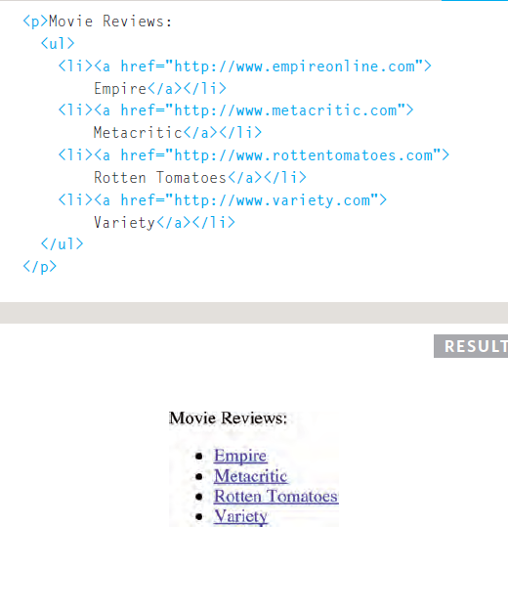

Browsers show links in blue with an underline by default.

Opening Links in a New Window

If you want a link to open in a new window, you can use the target attribute on the opening <a> tag. The value of this attribute should be **_blank**.

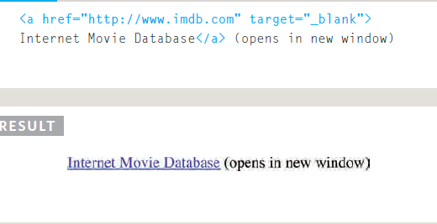One of the most common reasons a web page author might want a link to be opened in a new window is if it points to another website. In such cases, they hope the user will return to the window containing their site after finishing looking at the other one.

Generally, you should avoid opening links in a new window, but if you do, it is considered good practice to inform users that the link will open a new window before they click on it.

Linking to a Specific Part of the Same Page (creating local reference)

At the top of a long page, you might want to add a list of contents that links to the corresponding sections lower down. Or you might want to add a link from part way down the page back to the top of it to save users from having to scroll back to the top. Before you can link to a specific part of a page, you need to identify the points in the page that the link will go to.

You do this using the id attribute (which can be used on every HTML element). You can see that the <h1> and <h2> elements in this example have been given id attributes that identify those sections of the page.

The value of the id attribute should start with a letter or an underscore (not a number or any other character) and, on a single page, no two id attributes should have the same value.

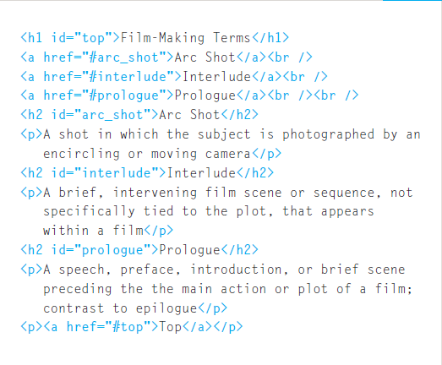

To link to an element that uses an id attribute you use the <a> element again, but the value of the href attribute starts with the # symbol, followed by the value of the id attribute of the element you want to link to.

In this example, <a href="#top"> links to the <h1> element at the top of the page whose id attribute has a value of top.

Embedding Local HTML Files

While you provide a link to get into any website in the web , you can link different html pages using <a></a> tag.

The only difference is instead of providing an external url (ex : <https://www.fb.com)> , you now have to provide the path for your HTML file ( ex : ../../file.html) to the ‘href’ attribute.

<!DOCTYPE html>

<html lang="en">

    <head>

        <title>Creating Links in Html</title>

    </head>

    <body>

        <a href="../home.html"> Home</a>

        <a href="../about-us.html" target="_blank"> About US</a>

        <a href="../services.html" target="_blank"> Services</a>

        <a href="../career.html" target="_blank"> Career</a>

    </body>

</html>

Now when you click different links corresponding html pages will open. Make sure you provide the file path correctly.