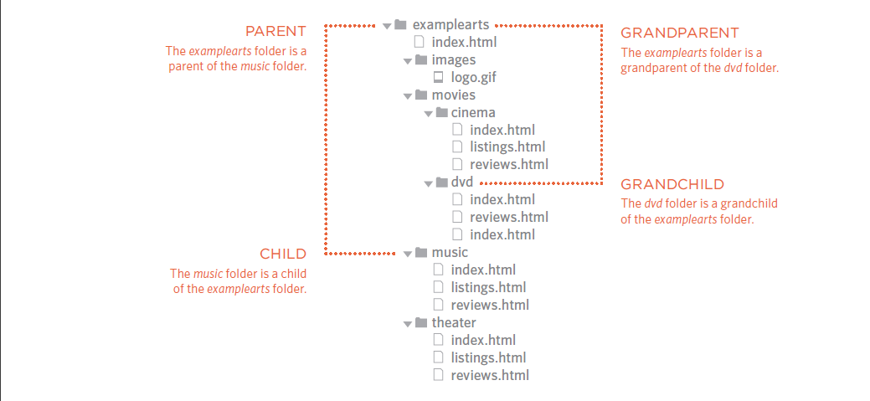Directory Structure

**Relative URLs** can be used when linking to pages within your own website. They provide a shorthand way of telling the browser where to find your files.

When you are linking to a page on your own website, can use relative URLs which are a shorthand way to tell the browser where a page is in relation to the current page. This is especially helpful when

creating a new website or learning about HTML because you can create links between pages when they are only on your personal computer.

If all of the files in your site are in one folder, you simply use the file name for that page. Or you can put a ‘./’ before the file name. Adding a ‘./’ before the file name is optional if it is existing in the same folder, but it is a good practice.

If your project is organized into separate folders (or directories), you need to tell the browser how to get from the page it is currently on to the page that you are linking to.

Consider the diagram below for writing various kind of file paths.

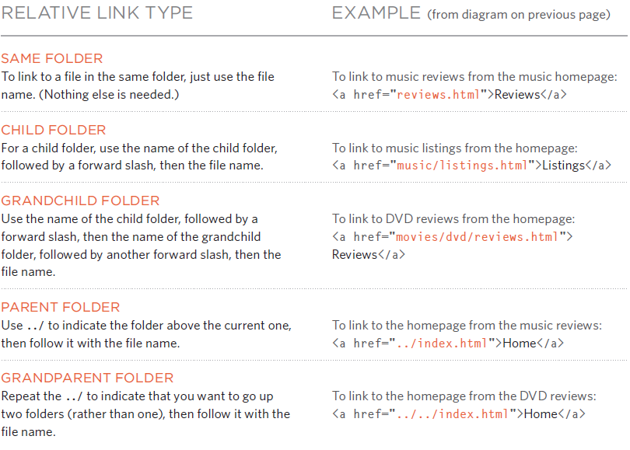

Linking Local HTML Files

While you provide a link to get into any website in the web , you can link different html pages using <a></a> tag.

The only difference is instead of providing an external url (ex : <https://www.fb.com)> , you now have to provide the path for your HTML file ( ex : ../../file.html) to the ‘href’ attribute.

<!DOCTYPE html>

<html lang="en">

    <head>

        <title>Creating Links in Html</title>

    </head>

    <body>

        <a href="../home.html"> Home</a>

        <a href="../about-us.html" target="_blank"> About US</a>

        <a href="../services.html" target="_blank"> Services</a>

        <a href="../career.html" target="_blank"> Career</a>

    </body>

</html>

Now when you click different links corresponding html pages will open. Make sure you provide the file path correctly.

Working with Images in HTML

A picture can say a thousand words, and great images help make the difference between an average-looking site and a really engaging one.

There are many reasons why you might want to add an image to a web page: you might want to include a logo, photograph, illustration, diagram, or chart.

Adding Images

To add an image into the page you need to use an <img> element. This is an single-tone element (which means there is no closing tag).

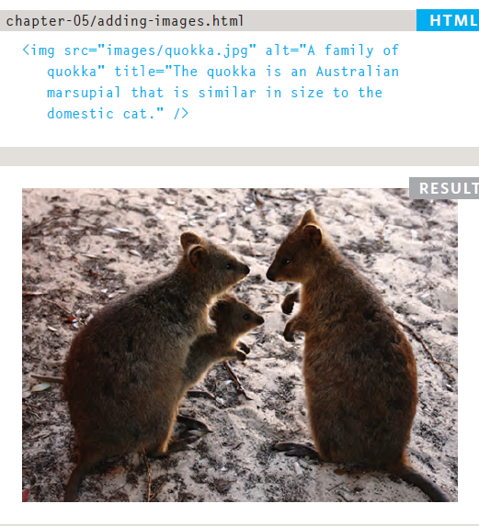

**src :**  This tells the browser where it can find the image file. This will usually be a relative URL pointing to an image on your own site.

**alt :** This provides a text description of the image which describes the image if you cannot see it may be due to incorrect file path or network error.

**title :** You can also use the title attribute with the <img> element to provide additional information about the image. Most browsers will display the content of this attribute in a tootip(infoTip ) when the user hovers over the image.

Height & Width of Images

You will also often see an <img> element use two other attributes that specify its size:

**height :** This specifies the height of the image in pixels.

**width :** This specifies the width of the image in pixels. Images with higher size often take longer to load than the HTML code that makes up the rest of the page , so Don’t panic !!

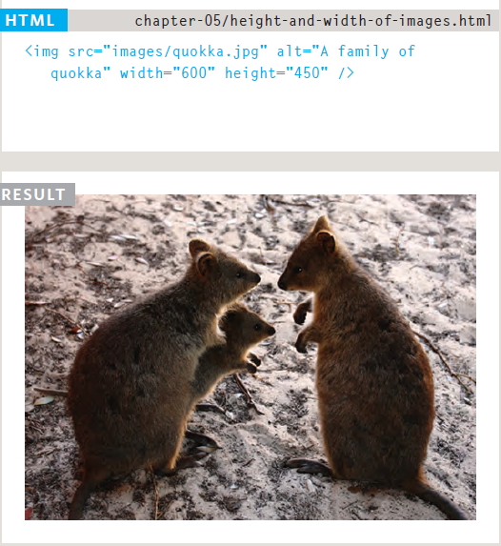

It is, therefore, a good idea to specify the size of the image so that the browser can render the rest of the text on the page while leaving the right amount of space for the image that is still loading.

However, it is advised to adjust an image property with CSS rather using html attributes.

Where Can you Find Images

<https://www.istockphoto.com>

<https://www.gettyimages.com>

<https://www.veer.com>

<https://www.sxc.hu>

<https://www.fotolia.com>

Where Can you edit Images Online

<https://www.photoshop.com>

<https://www.pixlr.com>

<https://www.splashup.com>

<https://www.ipiccy.com>

Chapter Summary

1. The <img> element is used to add images to a web page.
2. You must always specify a src attribute to indicate the source of an image and an alt attribute to describe the content of an image.
3. You should save images at the size you will be using them on the web page and in the appropriate format.
4. Photographs are best saved as JPEGs; illustrations or logos that use flat colors are better saved as GIFs.