Tables in HTML

There are several types of information that need to be displayed in a grid or table. For example: sports results, office shift hours, train timetables.

When representing information in a table, you need to think in terms of a grid made up of rows and columns (a bit like a spreadsheet).

**A table** represents information in a grid format. Examples of tables include financial reports, TV schedules, and sports results. Grids allow us to understand complex data by referencing information on two axes. Each block in the grid is referred to as a **table cell**. In HTML a table is written out **row by row**.

Basic Table Structure

**<table>**: The <table> </table>element is used to create a table. The contents of the table are written out row by row.

**<tr>**: You indicate the start of each row using the opening <tr> tag. (The tr stands for table row.) It is followed by one or more <td> elements (one for each cell in that row). At the end of the row, you use a closing </tr> tag.

**<td>**: Each cell of a table is represented using a <td> element. (The td stands for table data.) At the end of each cell you use a closing </td> tag.

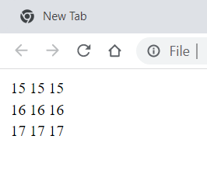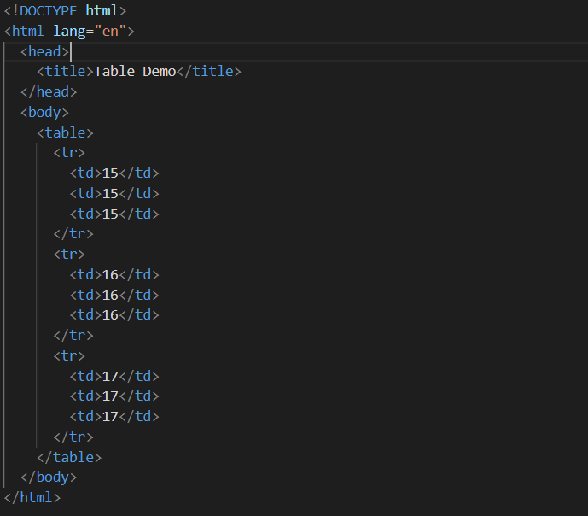

Table Heading <th> </th>

The <th> element is used just like the <td> element but its purpose is to represent the heading for either a column or a row. (The th stands for table heading.)

Even if a cell has no content, you should still use a <td> or <th> element to represent the presence of an empty cell otherwise the table will not render correctly. (The first cell in the first row of this example shows an empty cell.)

Using <th> elements for headings helps people who use screen readers, improves the ability for search engines to index your pages, and also enables you to control the appearance of tables better when you start to use CSS.

You can use the scope attribute on the <th> element to indicate whether it is a heading for a column or a row. It can take the values: row to indicate a heading for a row or col to indicate a heading for a column.

Browsers usually display the content of a <th> element in bold and in the middle of the cell.

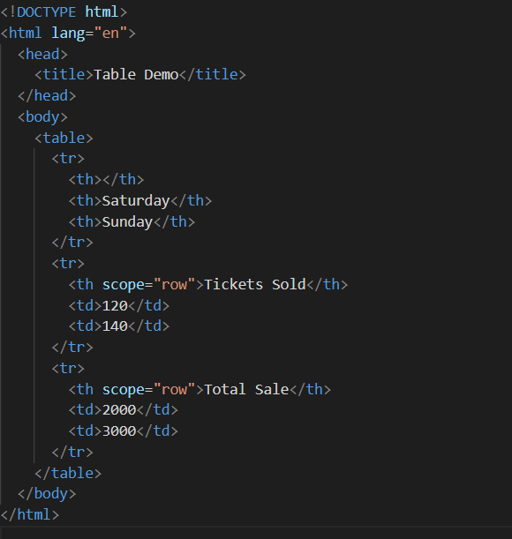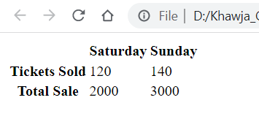

Spanning Columns

Sometimes you may need the entries in a table to stretch across more than one column. The **colspan** attribute can be used on a <th> or <td> element and indicates how many columns that cell should run across.

In the example on the bottom you can see a timetable with five columns; the first column contains the heading for that row (the day), the remaining four represent one hour time slots.

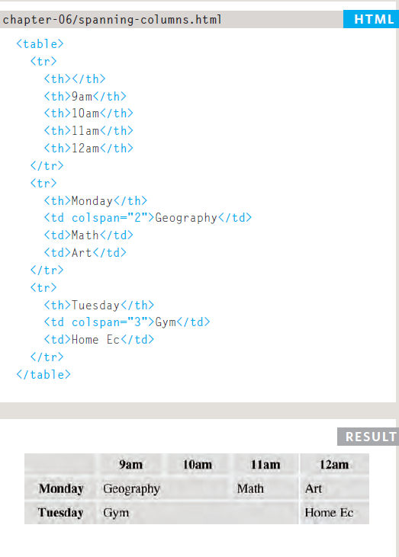

If you look at the table cell that contains the words 'Geography' you will see that the value of the colspan attribute is 2, which indicates that the cell should run across two columns. In the third row, 'Gym' runs across three columns.

You can see that the second and third rows have fewer <td> elements than there are columns. This is because, when a cell extends across more than one column, the <td> or <th> cells that would have been in the place of the wider cells are not included in the code.

Spanning Rows

You may also need entries in a table to stretch down across more than one row. The **rowspan** attribute can be used on a <th> or <td> element to indicate how many rows a cell should span down the table.

In the example on the bottom you can see that ABC is showing a movie from 6pm - 8pm, whereas the BBC and CNN channels are both showing two programs during this time period (each of which lasts one hour).

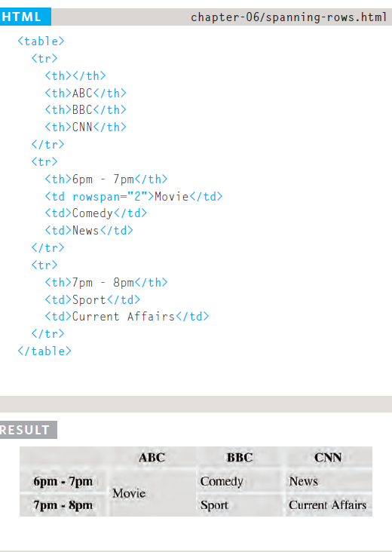

If you look at the last <tr> element, it only contains three elements even though there are four columns in the result below. This is because the movie in the <tr> element above it uses the **rowspan** attribute to stretch down and take over the cell below.

Long Tables

There are three elements that help distinguish between the main content of the table and the first and last rows (which can contain different content).

These elements help people who use screen readers and also allow you to style these sections in a different manner than the rest of the table (as you will see when you learn about CSS).

The headings of the table should sit inside the <thead></thead> element.

The body should sit inside the <tbody></tbody> element.

The footer belongs inside the <tfoot> </tfoot>element.

By default, browsers rarely treat the content of these elements any differently than other elements however designers often use CSS styles to change their appearance.

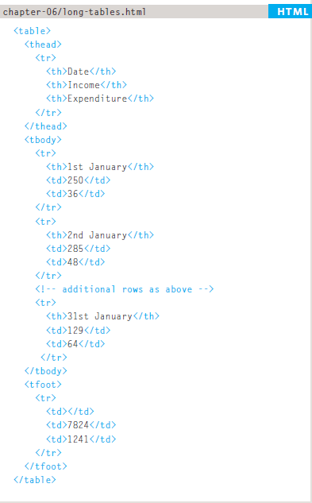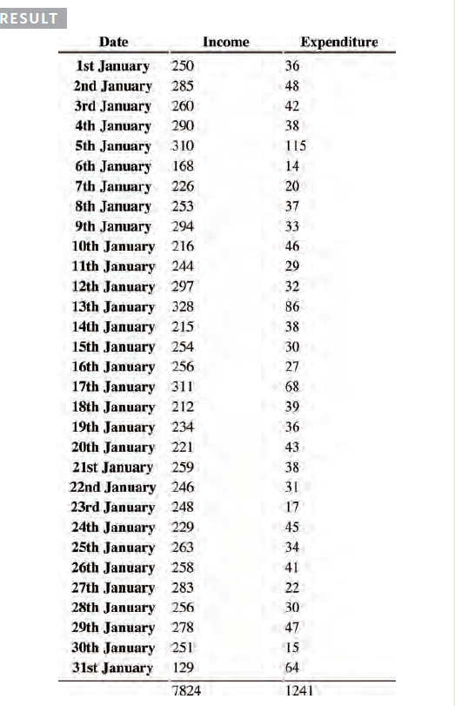

Part of the reason for having separate <thead> and <tfoot> elements is so that, if you have a table that is taller than the screen (or, if printed, longer than one page) then the browser can keep the header and footer visible whilst the contents of the table scroll. This is intended to make it easier for users to see which column the data is in (however this functionality is not implemented by default in any current browser).