DOCTYPEs

Because there have been several versions of HTML, each web page should begin with a DOCTYPE declaration to tell a browser which version of HTML the page is using (although browsers usually display the page even if it is not included).

Below are some different doctype declarations for various versions of html.

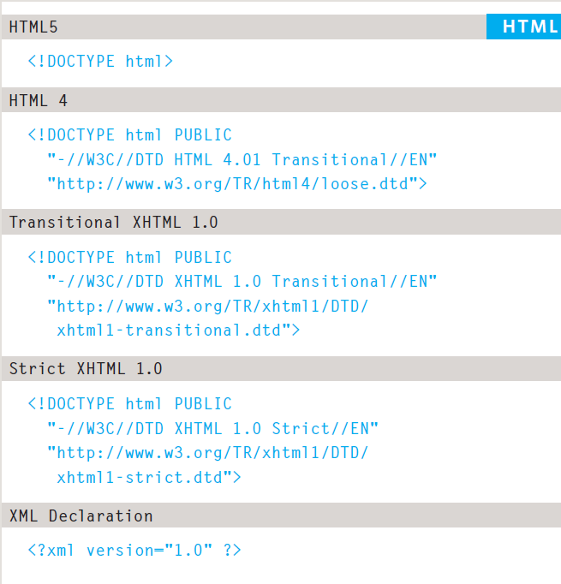

Comments in HTML

If you want to add a comment to your code that will not be visible in the user's browser, you can add the text between these characters:

<!-- comment goes here -->

It is a good idea to add comments to your code because, no matter how familiar you are with the page at the time of writing it, when you come back to it later (or if someone else needs to look at the code), comments will make it much easier to understand.

Although comments are not visible to users in the main browser window, they can be viewed by anyone who looks at the source code behind the page.

On a long page you will often see comments used to indicate where sections of the page start or end, and to pass on notes to help anyone who is looking at the code understand it.

Comments can also be used around blocks of code to stop that code from being displayed in the browser. In the example on the left, the email link has been commented out.

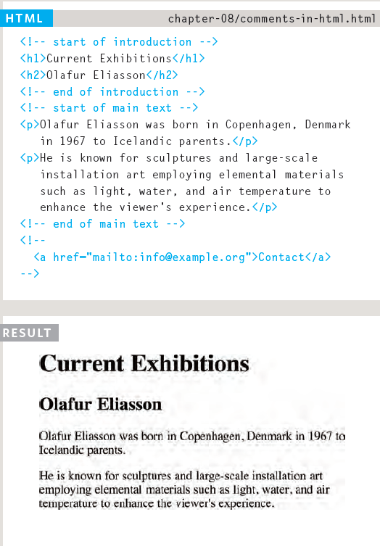

,

ID Attribute

Every HTML element can carry the id attribute. It is used to uniquely identify that element from other elements on the page. Its value should start with a letter or an underscore (not a number or any other character).

It is important that no two elements on the same page have the same value for their id attributes (otherwise the value is no longer unique).

As you will see when you come to look at CSS in the coming section, giving an element a unique identity allows you to style it differently than any other instance of the same element on the page. For example, you might want to assign one paragraph within the page (perhaps a paragraph containing a pull quote) a different style than all of the other paragraphs. In the example on the right, the paragraph with the id attribute whose value is pullquote is made uppercase using CSS.

If you go on to learn about JavaScript (a language that allows you to add interactivity to your pages), id attributes can be used to allow the script to work with that particular element.

The id attribute is known as a global attribute because it can be used on any element.

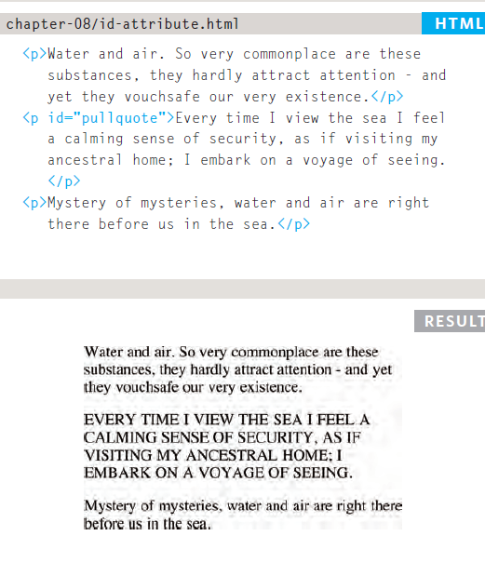

Class Attribute

Every HTML element can also carry a class attribute. Sometimes, rather than uniquely identifying one element within a document, you will want a way to identify several elements as being different from the other elements on the page.

For example, you might have some paragraphs of text that contain information that is more important than others and want to distinguish these elements, or you might want to differentiate between links that point to other pages on your own site and links that point to external sites.

To do this you can use the class attribute. Its value should describe the class it belongs to. In the example on the left, key paragraphs have a class attribute whose value is important.

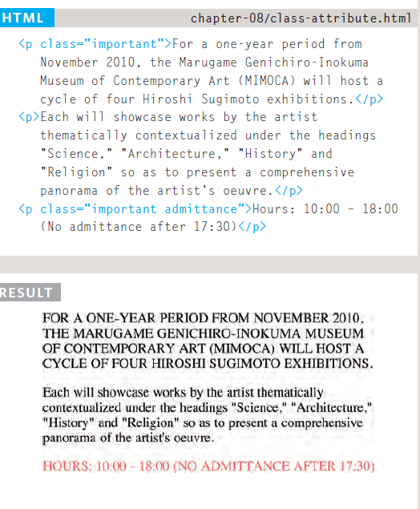

The class attribute on any element can share the same value. So, in this example, the value of important could be used on headings and links, too.

By default, using these attributes does not affect the presentation of an element. It will only change their appearance if there is a CSS rule that indicates it should be displayed differently.

In this example, CSS has been applied to make elements with a class attribute whose value is important uppercase, and elements with a class attribute whose value is admittance red.

If you would like to indicate that an element belongs to several classes, you can separate class names with a space, as you can see in the third paragraph in the example above.

Block Elements

Some elements will always appear to start on a new line in the browser window. These are known as block level elements. Examples of block elements are <h1>, <p>, <ul>, and <li>.

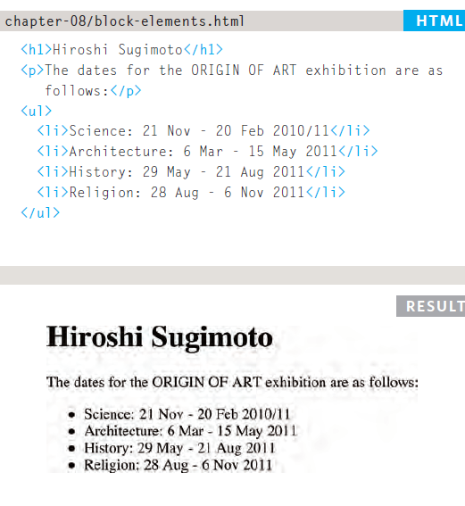

Inline Elements

Some elements will always appear to continue on the same line as their neighbouring elements. These are known as inline elements. Examples of inline elements are <a>, <b>, <em>, and <img>.

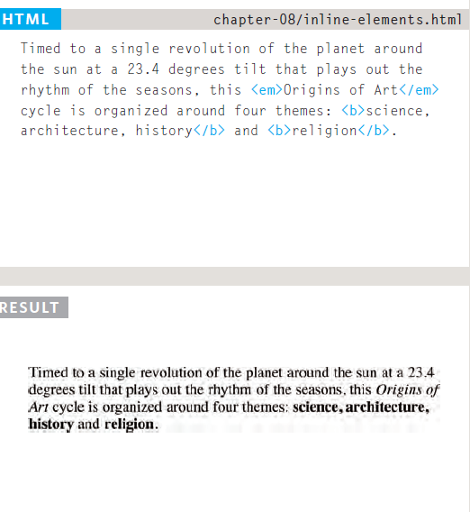

**Grouping Text & Elements In a Block**

The <div> element allows you to group a set of elements together in one block-level box. For example, you might create a <div> element to contain all of the elements for the header of your site (the logo and the navigation), or you might create a <div> element to contain comments from visitors.

In a browser, the contents of the <div> element will start on a new line (as it is a block element), but other than this it will make no difference to the presentation of the page.

Using an id or class attribute on the <div> element, however, means that you can create CSS style rules to indicate how much space the <div> element should occupy on the screen and change the appearance of all the elements contained within it.

It can also make it easier to follow your code if you have used <div> elements to hold each section of the page.

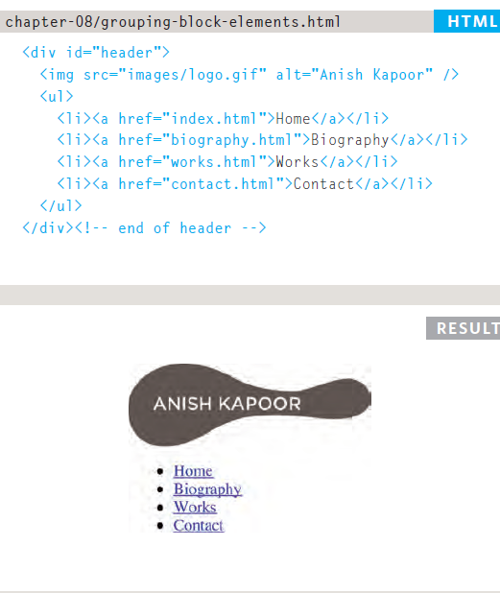

Since there may be several other elements inside a <div> element, it can be helpful to add a comment after the closing </div> tag.

This allows you to clearly see which opening tag it is supposed to correspond to, as shown at the end of the example here.

Grouping Text & Elements Inline

The <span> element acts like an inline equivalent of the <div> element. It is used to either:

1. Contain a section of text where there is no other suitable element to differentiate it from its surrounding text

2. Contain a number of inline Elements

The most common reason why people use <span> elements is so that they can control the appearance of the content of these elements using CSS.

You will usually see that a class or id attribute is used with <span> elements:

●● To explain the purpose of this <span> element

●● So that CSS styles can be applied to elements that have specific values for these attributes

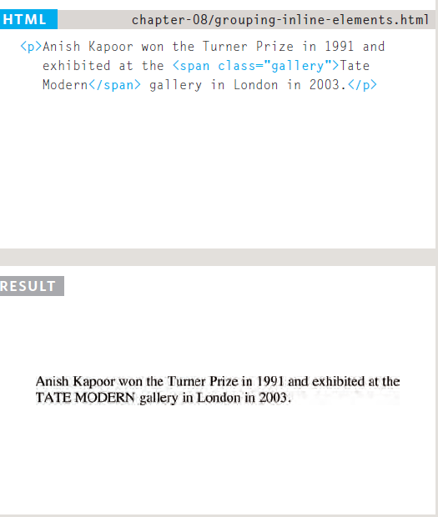

Information About Your Pages

The <meta> element lives inside the <head> element and contains information about that web page.

The <meta> element is an empty element so it does not have a closing tag. It uses attributes to carry the information.

It is not visible to users but fulfills a number of purposes such as telling search engines about your page, who created it, and whether or not it is time sensitive.

The most common attributes are the **name** and **content** attributes, which tend to be used together. These attributes specify properties of the entire page.

The **value** of the **name** attribute is the **property** you are setting, and the **value** of the **content** attribute is the **value** that you want to give to this property.

Commonly used name attributes :

**description** : This contains a description of the page. This description is commonly used by search engines to understand what the page is about and should be a maximum of 155 characters. Sometimes it is also displayed in search engine results.

**keywords** : This contains a list of commaseparated words that a user might search on to find the page. In practice, this no longer has any noticeable effect on how search engines index your site.

**robots** : This indicates whether search engines should add this page to their search results or not. A value of *noindex* can be used if this page should not be added. A value of *nofollow* can be used if search engines should add this page in their results but not any pages that it links to.

The <meta> element also uses the **http-equiv** and **content** attributes in pairs. In our example, you can see three instances of the http-equiv attribute. Each one has a different purpose:

**author** : This defines the author of the web page.

**pragma** : This prevents the browser from caching the page. (That is, storing it locally to save time downloading it on subsequent visits.)

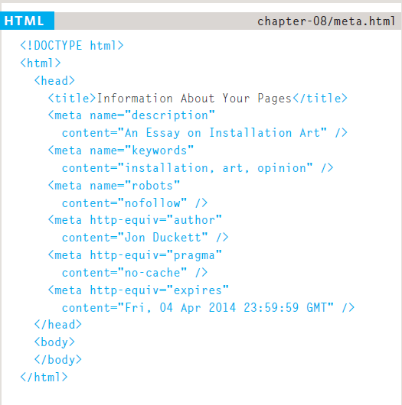

Escape Characters

There are some characters that are used in and reserved by HTML code. (For example, the left and right angled brackets.)

Therefore, if you want these

characters to appear on your page you need to use what are termed "escape" characters (also known as escape codes or entity references).

There are also special codes that can be used to show symbols such as copyright and trademark, currency symbols, mathematical characters, and some punctuation marks.

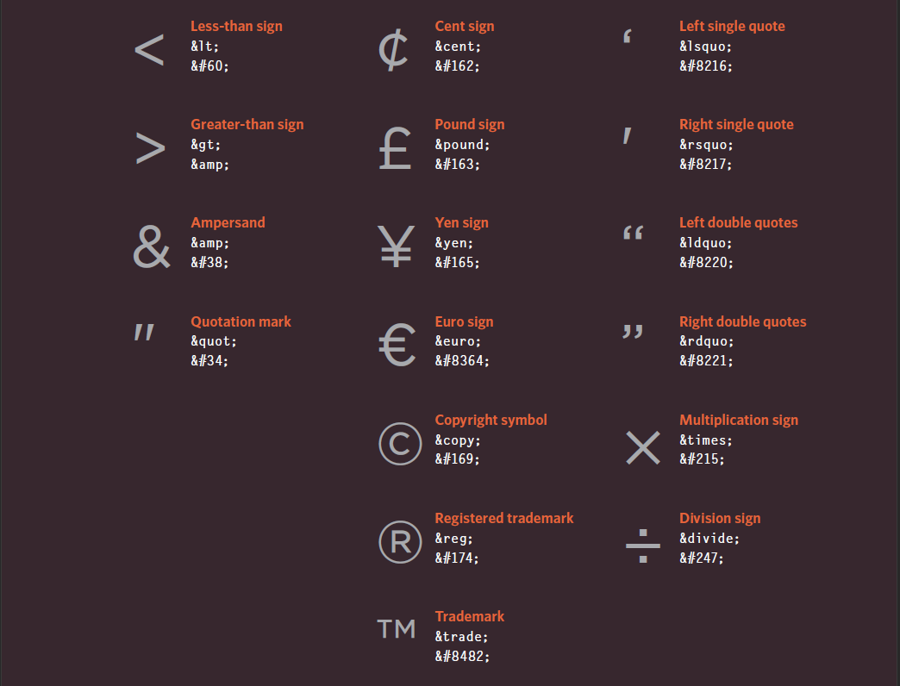

Chapter Summary

DOCTYPES tell browsers which version of HTML you are using.

You can add comments to your code between the <!-- and --> markers.

The id and class attributes allow you to identify particular elements.

The <div> and <span> elements allow you to group block-level and inline elements together.

The <meta> tag allows you to supply all kinds of information about your web page.

Escape characters are used to include special characters in your pages such as <, >, and ©.