**Arrays in Java**

An array in Java is a group of like-typed variables referred to by a common name. Following are some important points about Java arrays.

* In Java, all arrays are dynamically allocated. (discussed below)
* Since arrays are objects in Java, we can find their length using the object property *length*. This is different from C/C++, where we find length using sizeof.
* A Java array variable can also be declared like other variables with [] after the data type.
* The variables in the array are ordered, and each has an index beginning from 0.
* Java array can be also be used as a static field, a local variable, or a method parameter.
* The **size** of an array must be specified by int or short value and not long.
* The direct superclass of an array type is Object.
* Every array type implements the interfaces Cloneable and java.io.Serializable.

An array can contain primitives (int, char, etc.) and object (or non-primitive) references of a class depending on the definition of the array.

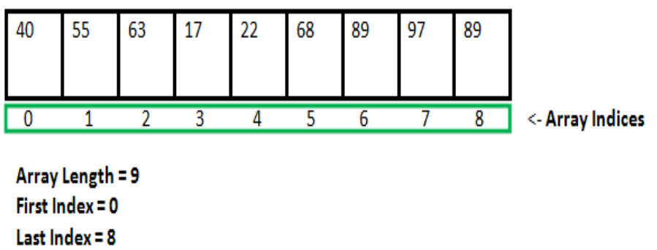

**Creating, Initializing, and Accessing an Array**

**One-Dimensional Arrays:**

The general form of a one-dimensional array declaration is

type var-name[];

OR

type[] var-name;

An array declaration has two components: the type and the name. *type* declares the element type of the array. The element type determines the data type of each element that comprises the array. Like an array of integers, we can also create an array of other primitive data types like char, float, double, etc., or user-defined data types (objects of a class). Thus, the element type for the array determines what type of data the array will hold.

Example:

// both are valid declarations

int intArray[];

or int[] intArray;

Although the first declaration establishes that intArray is an array variable, **no actual array exists**. It merely tells the compiler that this variable (intArray) will hold an array of the integer type. To link intArray with an actual, physical array of integers, you must allocate one using **new** and assign it to intArray.

**Instantiating an Array in Java**

When an array is declared, only a reference of an array is created. To create or give memory to the array, you create an array like this: The general form of *new* as it applies to one-dimensional arrays appears as follows:

var-name = new type [size];

Here, *type* specifies the type of data being allocated, *size* determines the number of elements in the array, and *var-name* is the name of the array variable that is linked to the array. To use *new* to allocate an array, **you must specify the type and number of elements to allocate.**

**Example:**

int intArray[]; //declaring array

intArray = new int[20]; // allocating memory to array

OR

int[] intArray = new int[20]; // combining both statements in one

The elements in the array allocated by new will automatically be initialized to zero (for numeric types), false (for boolean), or null (for reference types, which are described in a later chapter)

Accessing Java Array Elements using for Loop

Each element in the array is accessed via its index. The index begins with 0 and ends at (total array size)-1. All the elements of array can be accessed using Java for Loop.

// accessing the elements of the specified array

for (int i = 0; i < arr.length; i++)

System.out.println("Element at index " + i + " : "+ arr[i]);

Example:

// Java program to illustrate creating an array

// of integers, puts some values in the array,

// and prints each value to standard output.

**class** GFG

{

**public** **static** **void** main (String[] args)

{

// declares an Array of integers.

**int**[] arr;

// allocating memory for 5 integers.

arr = **new** **int**[5];

// initialize the first elements of the array

arr[0] = 10;

// initialize the second elements of the array

arr[1] = 20;

//so on...

arr[2] = 30;

arr[3] = 40;

arr[4] = 50;

// accessing the elements of the specified array

**for** (**int** i = 0; i < arr.length; i++)

System.***out***.println("Element at index " + i +

" : "+ arr[i]);

}

}

**Output**

Element at index 0 : 10

Element at index 1 : 20

Element at index 2 : 30

Element at index 3 : 40

Element at index 4 : 50

What happens if we try to access elements outside the array size?

JVM throws **ArrayIndexOutOfBoundsException** to indicate that the array has been accessed with an illegal index. The index is either negative or greater than or equal to the size of an array.

**Multidimensional Arrays**

Multidimensional arrays are **arrays of arrays** with each element of the array holding the reference of other arrays. These are also known as [Jagged Arrays](https://www.geeksforgeeks.org/jagged-array-in-java/). A multidimensional array is created by appending one set of square brackets ([]) per dimension. Examples:

int[][] intArray = new int[10][20]; //a 2D array or matrix

int[][][] intArray = new int[10][20][10]; //a 3D array

**Class Objects for Arrays**

Every array has an associated Class object, shared with all other arrays with the same component type.

// Java program to demonstrate

// Class Objects for Arrays

**class** Test

{

**public** **static** **void** main(String args[])

{

**int** intArray[] = **new** **int**[3];

**byte** byteArray[] = **new** **byte**[3];

**short** shortsArray[] = **new** **short**[3];

// array of Strings

String[] strArray = **new** String[3];

System.***out***.println(intArray.getClass());

System.***out***.println(intArray.getClass().getSuperclass());

System.***out***.println(byteArray.getClass());

System.***out***.println(shortsArray.getClass());

System.***out***.println(strArray.getClass());

}

}

**Output**

class [I

class java.lang.Object

class [B

class [S

class [Ljava.lang.String;

**Explanation:**

1. The string “[I” is the run-time type signature for the class object “array with component type *int*.”
2. The only direct superclass of an array type is java.lang.Object.
3. The string “[B” is the run-time type signature for the class object “array with component type *byte*.”
4. The string “[S” is the run-time type signature for the class object “array with component type *short*.”
5. The string “[L” is the run-time type signature for the class object “array with component type of a Class.” The Class name is then followed.

**Array Members**

Now, as you know that arrays are objects of a class, and a direct superclass of arrays is a class Object. The members of an array type are all of the following:

* The public final field *length*, which contains the number of components of the array. Length may be positive or zero.
* All the members inherited from class Object; the only method of Object that is not inherited is its clone method.
* The public method *clone()*, which overrides the clone method in class Object and throws no checked exceptions.

Cloning of Arrays:

When you clone a single-dimensional array, such as Object[], a “deep copy” is performed with the new array containing copies of the original array’s elements as opposed to references.

// Java program to demonstrate

// cloning of one-dimensional arrays

**class** Test

{

**public** **static** **void** main(String args[])

{

**int** intArray[] = {1,2,3};

**int** cloneArray[] = intArray.clone();

// will print false as deep copy is created

// for one-dimensional array

System.***out***.println(intArray == cloneArray);

**for** (**int** i = 0; i < cloneArray.length; i++) {

System.***out***.print(cloneArray[i]+" ");

}

}

}

**Output**

false

1 2 3

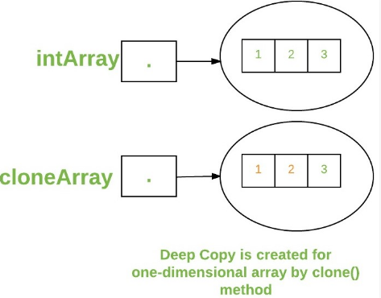

It creates **a shallow copy** of the non-primitive type array elements, even if the enclosed object's class implements the Cloneable interface and overrides the clone() method from the Object class.

A clone of a multi-dimensional array (like Object[][]) is a “shallow copy,” however, which is to say that it creates only a single new array with each element array a reference to an original element array, but subarrays are shared.

// Java program to demonstrate

// cloning of multi-dimensional arrays

**class** Test

{

**public** **static** **void** main(String args[])

{

**int** intArray[][] = {{1,2,3},{4,5}};

**int** cloneArray[][] = intArray.clone();

// will print false

System.***out***.println(intArray == cloneArray);

// will print true as shallow copy is created

// i.e. sub-arrays are shared

System.***out***.println(intArray[0] == cloneArray[0]);

System.***out***.println(intArray[1] == cloneArray[1]);

}

}

**Output**

false

true

true

