**Introduction**

**What is JavaScript?**

JavaScript is a dynamic, weakly typed programming language which is compiled at runtime. It can be executed as part of a webpage in a browser or directly on any machine ("host environment").

JavaScript was created to make webpages more dynamic (e.g. change content on a page directly from inside the browser). Originally, it was called **LiveScript** but due to the popularity of **Java**, it was renamed to **JavaScript**.

**NOTE**: JavaScript is totally independent from java and has nothing in common with Java!

**Why JavaScript was developed?**

Before JS came into existence, we were trying to load both simple and complicated HTML pages through request and response only there was no option of dynamically loading the HTML data. For example in the below image we have simple webpage which has link to load other HTML data through new request and response.

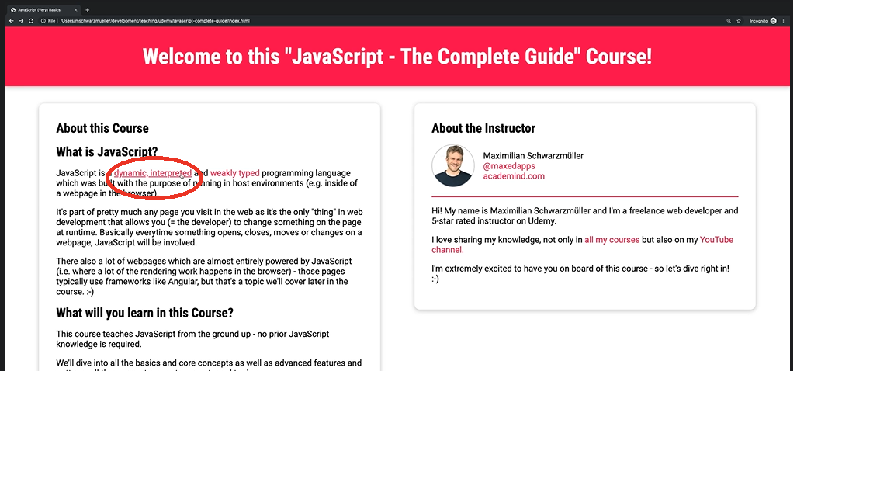

Clicking on ***dynamic or interpreted*** links on the above web page, it makes a new HTTP request and gets a new HTML response as shown below.

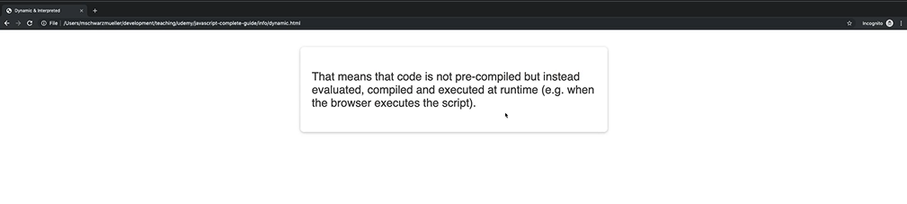

After JS was developed, we can avoid unnecessary HTTP request to load simple HTML. But the modern way and a more friendly way might be to not load a new page but instead show this piece of information overlay to an existing page so we can avoid breaking of user experience as shown in the below image.

