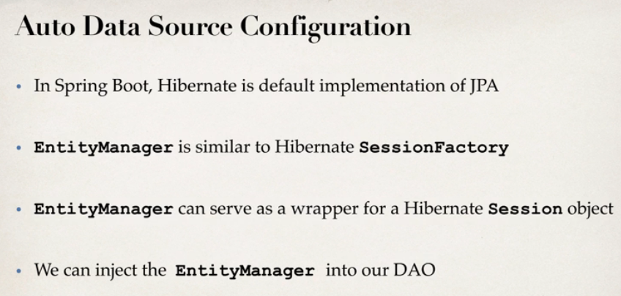

Annotation Used:

1. **@Entity**: Specifies that the class is an entity. This annotation is applied to the entity class.
2. **@Table:** Specifies the primary table for the annotated entity. Additional tables may be specified using SecondaryTable or SecondaryTables annotation.

If no Table annotation is specified for an entity class, the default values apply.

Example:

@Entity

@Table(name="CUST", schema="RECORDS")

public class Customer { ... }

1. **@Id:** Specifies the primary key of an entity. The field or property to which the Id annotation is applied should be one of the following types: any Java primitive type; any primitive wrapper type; String; java.util.Date; java.sql.Date; java.math.BigDecimal; java.math.BigInteger.
2. **@GeneratedValue:** The GeneratedValue annotation may be applied to a primary key property or field of an entity or mapped superclass in conjunction with the [Id](eclipse-javadoc:%E2%98%82=SpringBoot-CURD/C:%5C/Users%5C/Khawja%5C/.m2%5C/repository%5C/jakarta%5C/persistence%5C/jakarta.persistence-api%5C/3.1.0%5C/jakarta.persistence-api-3.1.0.jar=/maven.pomderived=/true=/=/maven.pomderived=/true=/=/maven.groupId=/jakarta.persistence=/=/maven.artifactId=/jakarta.persistence-api=/=/maven.version=/3.1.0=/=/maven.scope=/compile=/%3Cjakarta.persistence(GeneratedValue.class%E2%98%83GeneratedValue%E2%98%82Id) annotation. The use of the GeneratedValue annotation is only required to be supported for simple primary .keys. Use of the **GeneratedValue** annotation is not supported for derived primary keys.