Table of Contents

**Review of Hardware Tools** 2

Hardware Recommendations 3

**Review of Software Tools** 4

Cloud-based Software Options 7

Hybrid-based Software Options 8

Software Recommendations 9

**Server-related recommendations** 11

**Conclusion** 11

**Links** 12

**Appendices** 13

Appendix A 13

Appendix B 13

Appendix C 14

Appendix D 14

**References** 14

Introduction

The purpose of the report is to provide a clear, thorough guidance to a start-up company in the mobile game development. The start-up needs to get comprehension about its IT infrastructure, hardware and software tools in the developing process. Taking into the small scale of the company consideration, IT job categories were recommended as follows:

* Developers – responsible for writing source code and testing applications
* Designers – responsible for design and animation of games
* Managers – responsible for the handling entire projects, planning, execution, and completion of games, and marketing process in the organization

Regarding the scale of the business, the company did not focus on engaging a software tester and designated testing applications as the responsibility of developers. Moreover, the company asked in-depth recommendation concerning “Triple Constraint” (Appendix A) (Time, Cost, Scope) basic principles in a project management to be sufficient fast, to get profits and achieve quality in developing mobile games in game development environment. The report compasses hardware, software solutions with justification along with appropriate recommendations in terms of the company requests.

# Review of Hardware Tools

One of the paramount importance in building mobile games is definitely relies on the types of hardware tools. The several hardware tools were considered for the above-mentioned IT staff members as follows:

|  |  |  |  |  |  |
| --- | --- | --- | --- | --- | --- |
| **Job Position** | **Computer Type** | **Computer Model/Price** | **Central Processing Unit (CPU)** | **Graphics Processing Unit (GPU)** | **Random Access Memory (RAM)** |
| ***Developer*** | Desktop | Dell XPS  Price: $699.99 | 9th Gen Intel Core i5 9400 | NVIDIA GeForce GT 1030 | 8GB (1) |
| ***Designer*** | Desktop | HP EliteDesk 705 G4 Microtower  Price: $565.50 | 9th Gen Intel Core i5 | AMD Radeon R5 | 8 GB (2) |
| ***Manager*** | Laptop | HP 15t-dw200  Price: $659.99 | 10th Gen Intel Core i5 | UHD Graphics | 8 GB (3) |

*Table 1. Hardware solutions for various job categories*

## Hardware Recommendations

The above given hardware technologies for game development meets the requirements of developers. With the help of proposed computer with last generation Intel Core i5 CPU, developers are capable of writing codes and testing the game sufficiently. One of the most features in the choice of the computers is definitely associated with the power of RAM. Hence, an adequate power of RAM with 8GB recommended supports developers in executing tasks on multiple software, such as Visual Studio, Unity and others simultaneously (Appendix B).

According to Animation Arena (2020), game designers are required to obtain a set of artistic and technical skill to create more interactive and outstanding games for players to get delighted (4). Thus, a high-level programming and designing depends on hardware tools and software tools as well. However, a kind of hardware is behind of the software used in developing games. Considering the above given table, the chosen computer for designers is HP EliteDesk 705 G4 Microtower made for the design process. This powerful hardware having CPU and GPU reduces rendering time significantly. More specifically, by using such device designers could avoid wasting of their time from running the games in few days. Indeed, the features of computer –an affordable price and not time-consuming during game development – match the principles of ‘“Triple Constraint” perfectly.

In term of manager role in the company, laptop were offered which is non-special features and characteristics hardware for game development. Have games have been build, it would be easy to handle them using the proposed laptop. In addition, laptop would be comfortable to make presentation in business meetings and events because it is easy to carry.

# Review of Software Tools

In comparison with hardware tools, choosing relevant software tools is vital role in the application development, especially, game industry. Jason (2016) points out that the software developers must pay attention to is the game engine prior to building any game (5). Moreover, a number of software tools have been created so as to get satisfaction of game developers although they are not required a master knowledge or experience (Gamedesigning, 2019) (6). One of primary importance for building any game really relies on what kind of the software utilized in the game development and they should be completely matches the features of computing technologies into the company. Thus, the following table illustrates several software solutions in relation to on-premises, cloud, hybrid oriented environments:

**On-premise based Software Options**

|  |  |  |  |  |  |
| --- | --- | --- | --- | --- | --- |
| **Users** | **Name and price** | **OS/browsers support** | **Short description** | **Benefits** | **Limitations** |
| ***Developer*** | **Unity**  Price: free | Windows/  Mac OS X/Linux | Development platform for creating cross-platform games | **+**supports for creating 2D and 3D games for desktop, mobile  **+**extended support for abundance platforms (Xbox, PS4, Switch and more)  **+**Owns asset store  **+**Documentation | -less features for modeling and designing  -no documentation for update version (5.0)  -lack of control with mouse and difficult to manage with stylus (7) |
| **Visual Studio 2019**  Price: free (Community version) | Windows/  Mac OS X/Linux | Full-featured Integrated Development Environment for building software, games, apps (PC&mobile) websites | **+** working with Unity, Git easily  **+P**roject collaboration  **+**debuggable and refactorable | -limiited features with Git  -additional packages needed  -unreasonable crashes (recommended saving frequently)(8) |
| **Unreal Engine**  Price: free | Windows/  Mac OS X/Linux | Open-source and advanced real-time 3D game engine | **+**integrates pipeline productions: FBX, Alembic, USD  **+** provides excellent metadata and animation  **+**Easily automate data preparation workflows with a visual tool | -having less plugin  -Built-in data influences size of the game heavily  -after deploying game, negotiation on custom license (9) |
| ***Designer*** | **Adobe Creative Suite**  Price:  Starting at $33.99/month, for team | Windows/  Mac OS X/Linux | One of the best design software for creating sketches and short movies | **+**Easily control licenses  **+**more than 20 industry-leading apps  **+**includes tremendous library  **+**provides team working and 1TB of storage for per user | -unstable licenses price  -contains some apps which are old-fashion apps  -Occasional bugs happens during process (10) |
| **Autodesk Maya**  Price: $1620/year for Commercial version | Windows/  Mac OS X/Linux | 3D computer graphics software for game development and animation | **+** powerful modeling, simulation, rendering and animation  **+**extensible with MEL language  **+**Extensive support from vendor globally | -considerably more costly  -challenging to learn  -confusing interface  -unstable and crash unexpectedly (11) |
| **Blender**  Price: free | Windows/  Mac OS X/Linux | Open-source and free 3D creation software | **+**free great features: 3D models, paint, animation, sculpting and more  **+**countless online tutorials  **+**supportive community | -numerous amount of bugs while working  -not functional last up-date  -unavailable hotkeys (12) |
| ***Manager*** | **Microsoft Office 2019**  Price: $249.99 (one-time license) | Windows/  Mac OS X/Linux | A set of packages is office apps that allows to create, edit, manage and share projects | **+**support over 15 various language  **+**speech-text feature  **+**works offline, and dark mode  **+**real-time collaboration | -no real-time coauthoring like in Office 365 which is cloud-based alternative  -expensive unless educational or corporate license is purchased (13) |
| **Odoo**  Price: $37.50/month | Windows/  Mac OS X/Linux  /iPhone/iPad  /Android | All-in-one business management software contains of manufacturing and project management | **+**customizable and integrated open-source suite  **+**high-level security  **+**backups on daily basis  **+**available access from different devices | -lack of functional and technical documentation  -no customer support for updated versions (14) |
| **Microsoft PPM**  Price: $7.00/month  /user | Windows | Desktop app for planning resources, managing team schedules, and calculating scenarios | **+**Provides portfolio management  **+**Milestone tracking  **+** Easy to work with Excel | -Run only on Windows  -no filter capability (15) |

## Cloud-based Software Options

|  |  |  |  |  |  |
| --- | --- | --- | --- | --- | --- |
| **Users** | **Name and price** | **Browsers support** | **Short description** | **Benefits** | **Limitations** |
| ***Developer*** | **AWS Cloud9**  Price: $2.05/month  PaaS1 | Microsoft Edge, Google Chrome, Firefox, Safari, Opera and others | Cloud-based Integrated Development Environment allows to write, debug code | **+** Great IDE including code hint and completion, debugging, etc.  **+** supports plug-ins, libraries, and SDKs  **+** Extended selection of run configurations | -slows down while projects are executed  -no short keys and shortcuts  -code highlighting is not good quality  (16) |
| **Parse Server**  Price: $4.99/month | Microsoft Edge, Google Chrome, Firefox, Safari, Opera and others | Cloud-based software for building, hosting, and managing apps with the open-source backend | **+**Provides a wide range of APIs with documentations  **+**ease of use and open source  **+**supports for extra third-party plugins | -a bit difficult to maintain relationships between classes during coding process  -Confusing GUI (17) |
| **Heroku**  Price: starting at $7/month  PaaS | Microsoft Edge, Google Chrome, Firefox, Safari, Opera and others | Cloud application platform | **+**provides free tier for deploying demo and testing apps  **+**documentation for common programming languages  **+**high scalable | -lack for in-depth error handling  -difficulty with database  -non-exist support  (18) |
| ***Designer*** | **Adobe Creative Cloud**  Price: starting at $33.99/month for team  SaaS2 | Microsoft Edge, Google Chrome, Firefox, Safari, Opera and others | The alternative, cloud version of Adobe Creative Suite | **+** Easily control licenses  **+** more than 20 industry-leading apps  **+** includes tremendous library  **+** provides team working and 1TB of storage for per user | -unstable licenses price  -contains some apps which are old-fashion apps  -Occasional bugs happens during process (19) |
| **Drawtify**  Price: $8.33/month/user;  SaaS | Microsoft Edge, Google Chrome, Firefox, Safari, Opera | Online graphic design software with layout, vector drawing, typography and photo editing | **+**provides professional design features and online resources  **+**easy graphic design  **+**data visualization | -no customer support  -lack of interactivity for collaboration (20) |

PaaS1 – Platform-as-a-Service is computing cloud-service for building, managing and deploying applications

SaaS2 – Software-as-a-Service is computing cloud-service, provides software based on subscription

|  |  |  |  |  |  |
| --- | --- | --- | --- | --- | --- |
|  | **Gravit Designer**  Price: Free  SaaS | Microsoft Edge, Google Chrome, Firefox, Safari, Opera | Cloud-based drawing and sketching software | + cross-platform  +modern UI  +user-friendly keyboard shortcuts  +provides important tools and effects | - Pro subscription required  -sometimes duplicated files and time-consuming to find needed one  - no integration in the system (21) |
| ***Manager*** | **Google Team Drive**  Price: $12/month/team;  SaaS | Microsoft Edge, Google Chrome, Safari, Firefox | Software that provides to create, edit, collaborate and share a variety of documents | **+**provides unlimited storage  **+**available access from different devices  **+**ownership based on team file | -time-consuming for uploading and downloading files (22) |
| **Teamwork Projects**  Price: $9.00/month/user;  Saas | Microsoft Edge, Google Chrome, Safari, Firefox | Teamwork software for in-class collaboration | **+**eligible for any Internet browsers  **+**integrated time tracking for task and project  **+**Customizability | -time-consuming for set-up  -poor interface design  -less proactive (23) |
| **QuickBooks**  Price:$75/month/  Team;  SaaS | Microsoft Edge, Google Chrome, Safari, Firefox | Cloud-based software for accounting, finance in the organization | **+** more than 500 integrations  **+**supports third-party applications  **+**easy to utilize | -limited number of users  -unavailable for quite complex accountings (24) |

## Hybrid-based Software Options

The following table was obtained with combination the above given two software table and demonstrates brief information regarding software. Should you required further information, you can find out from the above-mentioned tables.

|  |  |  |  |
| --- | --- | --- | --- |
| **Users** | **Software Name/Price** | **On-premised based** | **Cloud-based** |
| ***Developer*** | **Unity**  Price: free | **+** | **-** |
| **Visual Studio 2019**  Price: free (Community version) | **+** | **-** |
| **AWS Cloud9**  Price: $2.05/month | **-** | **+** |
| ***Designer*** | **Gravit Designer**  Price: free | **-** | **+** |
| **Autodesk Maya**  Price: $1620/year for Commercial version | **+** | **-** |
| **Blender**  Price: free | **+** | **-** |
| ***Manager*** | **Google Team Drive**  Price: $12/month/team; | **-** | **+** |
| **Teamwork Projects**  Price: $9.00/month/user; | **-** | **+** |
| **Microsoft Office 2019**  Price: $249.99 (one-time license) | **+** | **-** |

## Software Recommendations

Indeed, using what type of computing services plays in a business a critical role. In turn, choosing suitable and appropriate computing services for creating projects is obviously connected with software solutions. In recent years, building cloud computing-based business or organization is considered as a better management practice in running managing or running the business smoothly and successfully. Rekha states that the right choice of programming language, frameworks, tools means 90% of the game performance is done (25). In addition to this, developers save a lot of their time and efforts by using right software tools in the development process. In terms of the task requirements, the lack of powerful software tools is unlikely to lead the start-up to have computing services based upon on-premise structure. Because, in management tasks or team projects, sharing and collaborating with team members might be slow. The proposed approach relies on a hybrid-based infrastructure. Consequently, the following paragraphs explore the software given into the hybrid-based table:

In reference to the hybrid-based table, two on-premise and one cloud-based software were chosen for game developers. They are Visual Studio 2019, Unity, and AWS Cloud9. Serrano notes that mobile game developers were required to gain knowledge in such complex theories as Computational Geometry, Physics, and Linear Algebra to make games customizable for different mobile devices (26). However, with the aid of Unity game engine and C# Xamarin framework, developers are currently capable of building a cross-platform game for various mobile operating systems (E.g.: Android, iOS) without any prerequisite knowledge, and they obtain multitude of benefits in the following:

* To host games in more than 20 different platforms, consisting of contemporary VR technology
* To get the ultimate guide from Unity Community to game developers globally
* To access to Unity Asset Store where developers use a catalog of assets: 2D, 3D, SDKs, templates and more
* To manage and inspect state while running the game in IDE
* To fix bugs or edit at runtime and many more

Rekha mentions that one of the most important stages of the game development is game testing where tester checks game quality thoroughly (27). As developers are also charge in testing of game, they should spend a few hours to install and copy with the game in various mobile phones. To make programmers’ life easy, Unity provides them with a special mobile app – Unity Remote 5 – to test games using USB cables (28). The reason for selection Visual Studio, a compiler of C# programing language, is integrated into Unity and easy to code, debug. The alternative text editor based upon cloud service is AWS Cloud9 is to write, share code in team group in real-time development.

The process of game design might been broken into three parts: sketching, graphics, and editing. For sketching section, a cloud-based Gravit Designer was chosen. Since, the software is completely free and helps to build full-featured vector graphic design games for cross-platform. Concerning graphics editing, the most suitable on-premise based software are Autodesk Maya, and Blender that are a quite costly and completely free of charge software, correspondently. In order to meet the requirements of the company based on “Triple Constraint” principles, Blender was considered as a main graphics software that is open-source and free. The software support the set of 3D pipeline for creating attractive games such as modeling, animation, rigging, rendering, motion tracking, video editing, along with 2D animation pipeline (Blender) (30). In this regard, this software were recommended for designing and editing stages.

In the last section, mainly cloud-based software were recommended for management in handling process and tasks. The primary recommendations are Google Team Drive and Teamwork Projects as a central position in allocating tasks, projects into the team and collaborating with team member each other. Microsoft Office 2019 is on-premise software with one-time purchase enables to manipulate daily documents into the organization.

# Server-related recommendations

Choosing a proper game server is derived from the requirements and specifications of the game that is host for users. If the start-up focus on building quite more light games, for example Counterstrike or Dota, the games server should have more memory, CPU power, and storage. Therefore, the best, affordable choice for the company would be Server Mania dedicated one that is specialized for game hosting. The subscription fee is that starting price at $79 in a month, including 10GB network connection, 100% network uptime SLA, the latest Xeon processor, 512GB of RAM, ultrafast SSD storage, unmetered bandwidth, along with personalized 24/7 support (29).

# Conclusion

In conclusion, organizations must diligently think of relevant hardware, software, and server solutions although cutting-edge technologies provides privileges in game development. For game development, innovative computers with powerful CPU and GPU are required. Such computers - *Dell XPS, and HP EliteDesk 705 G4 Microtower* - were recommended for game developers, designers, respectively. The proposed address to software counts on hybrid infrastructure as professional software Unity, Visual Studio, Autodesk Maya are unavailable in cloud-based service. Eventually, the company should obtain subscription to the dedicated server, *Server Mania* that provides security game environment.

# Links

Git link: XXXXXXXXXXXXXXXXXXXXXXXXXXXXXXXXX

Google Doc link: XXXXXXXXXXXXXXXXXXXXXXXXXXXXX

# Appendices

## Appendix A

Material available from <https://www.projectmanager.com/blog/triple-constraint-project-management-time-scope-cost>

“Triple Constraint” is a project management triangle. Applying for such model makes business run more successfully and smoothly in the market. This model comprises of particular aspects – time, scope, and cost.

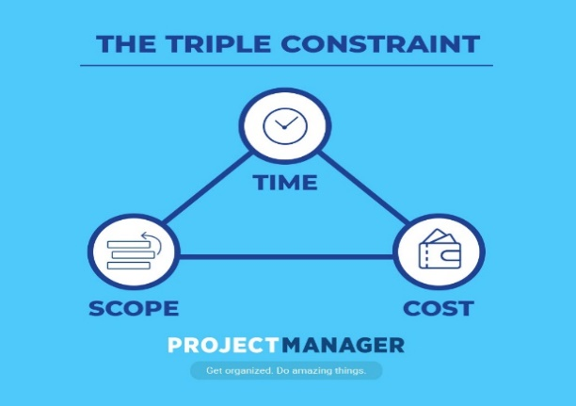

1. Cost – the financial features of a project
2. Scope – a set of tasks required to accomplish the goals of the project
3. Time – the schedule for completing the project on time

## Appendix B

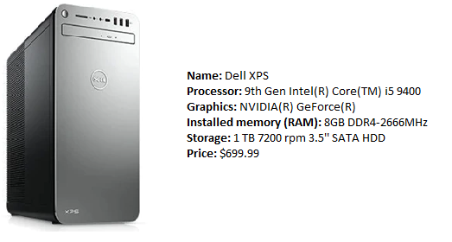

*Source: Dell, 2020*

## Appendix C

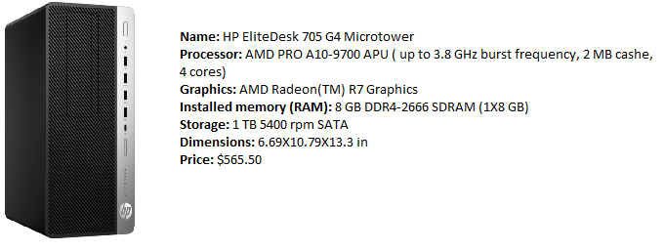

*Source: HP Store, 2020*

## Appendix D

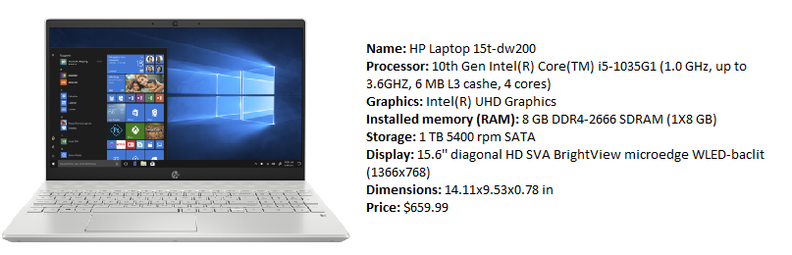

*Source: HP Store, 2020*

# References

1. Dell. XPS Desktops [Internet]. [cited 8th June 2020]. Available from: <https://www.dell.com/en-us/shop/desktop-computers/sf/xps-desktops?appliedRefinements=1358,1359,52>
2. HP. HP EliteDesk 705 G4 Microtower – Customizable [Intenet]. [cited 8th June 2020]. Available from: <https://store.hp.com/us/en/mdp/business-solutions/elitedesk-700-microtower#!&tab=vao>
3. HP. HP Pavilion Laptop – 15t [Internet]*.* [cited 8th June 2020]. Available from: <https://store.hp.com/us/en/pdp/hp-pavilion-laptop-15t-dw200-8wl84av-1>
4. Animation Arena. What is a Mobile Game Designer? [Internet]. [cited 9th June 2020]. Available from: [http://www.animationarena.com/mobile-game-design-articles.html](http://www.animationarena.com/video-game-design-articles.html).
5. Bay, J. Game Industry: What’s the best laptop computer for mobile game design [Internet]. [cited 9th June 2020]. Available from; [https://www.gameindustrycareerguide.com/best-laptop-computer-for-mobile-game-design/](https://www.gameindustrycareerguide.com/best-laptop-computer-for-video-game-design/)
6. Gamedesigning. Gamedesigning: Essential Software for Game Designers [Internet]. [cited 10th June 2020]. Available from: <https://www.gamedesigning.org/career/software/>
7. G2. Unity [Internet]. [cited 11th June 2020]. Available from: <https://www.g2.com/products/unity/reviews#reviews>
8. Capterra . Capterra: Visual Studio [Internet]. [cited 10th June 2020]. Available from: <https://www.capterra.com/p/101288/Visual-Studio>
9. G2. Unreal Engine [Internet]. [cited 11th June 2020]. Available from: <https://www.g2.com/products/unreal-engine/reviews#reviews>
10. Adobe. Designs: Creative Cloud Suit [internet]. [cited 11th June 2020]. Available from: <https://www/adobe.com/creativesuit/business/teams.html>
11. Slant Slant: Autodesk Maya Review [Internet]. [cited 11th June 2020]. Available from: <https://www.slant.co/options/5506/~autodesk-maya-review>
12. Capterra. Capterra: Blender [internet]. [cited 11th June 2020]. Available from: <https://www.capterra.com/p/167519/Blender/#pricing>
13. Slant. Slant: Microsoft Office 2019 Review [Internet]. [cited 11th June 2020]. Available from: <https://www.slant.co/options/22000/~microsoft-office-2019-review>
14. Capterra. Capterra: Odoo [Internet]. [cited 11th June 2020]. Available from: <https://www.capterra.com/p/184896/Odoo/>
15. G2. Microsoft PPM [Internet]. [cited 11th June 2020]. <https://www.g2.com/search?utf8=%E2%9C%93&query=Microsoft+ppm&button>=
16. AWS. AWS: AWS Cloud [Internet]. [cited 11th June 2020]. Available from: <https://aws.amazon.com/cloud9/pricing/>
17. G2. Parse Server [Internet]. [cited 12th June 2020]. Available from: <https://www.g2.com/products/parse-server/reviews>
18. Capterra. Capterra: Heroku [Internet]. [cited 11th June 2020]. Available from: <https://www.capterra.com/p/158191/Heroku/>
19. Adobe. Designs: Creative Cloud For Teams [internet]. [cited 11th June 2020]. Available from: <https://www.adobe.com/creativecloud/business/teams.html>
20. Capterra. Drawtify [Internet]. [cited 11th June 2020]. Available from: <https://www.capterra.com/p/202387/Drawtify/#reviews>
21. Slant. Slant: Gravit Designer Review [Internet]. [cited 11th June 2020]. Available from: <https://www.slant.co/options/22000/~gravit-designer-review>
22. Capterra. Capterra: Google Team Drive [Internet]. [cited 11th June 2020]. Available from: <https://www.capterra.com/p/161425/Drive>
23. TrustRadius. Teamwork Projects Reviews [Internet]. [cited 11th June 2020]. Available from: <https://www.trustradius.com/products/teamwork-projects/reviews?qs=pros-and-cons>
24. Capterra. Capterra: QuickBooks [Internet]. [cited 11th June 2020]. Available from: <https://www.capterra.com/p/46497/QuickBooks>
25. Rekha, K.L. Pattern: 10 Best Game Development Software Tools [Internet]. [cited 14th June 2020]. Available from: <https://pattemdigital.com/insight/game-development-software-tools>
26. Serrano, H. HaroldSerrano: How to become a game engine developer [Internet]. [cited 12th June 2020]. Available from: <https://www.haroldserrano.com/blog/how-to-become-a-game-engine-developer>
27. Rekha, K.L. Pattern: 10 Best Game Development Software Tools [Internet]. [cited 14th June 2020]. Available from: <https://pattemdigital.com/insight/game-development-software-tools>
28. Unity. Unity: Unity Remote [Internet]. [cited 15th June 2020]. Available from: <https://pattemdigital.com/insight/game-development-software-tools>
29. Server Mania. Dedicating Game Server Hosting [Internet]. [cited 12th June 2020]. Available from:
30. [https://www.servermania.com/solutions/game-server-hositng.htm](https://www.servermania.com/solutions/game-server-hositng.htm )
31. Blender. Blender: Blender 2.83 is here [Internet]. [cited 12th June 2020]. Available from: <https://www.blender.org/>