Name: _____Khayyam Saleem____________ Date: ___10/07/16_______

Pledge: _____I pledge my honor that I have abided by the Stevens Honor System.______________

For each of the graphs below, list the order in which the vertices are visited in a **breadth-first search**, starting with vertex 1. If there are multiple vertices adjacent to a given vertex, visit the adjacent vertex with the lowest value first. Then repeat the process for **depth-first search**.

1. 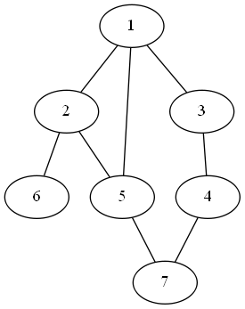

BFS: ____________1, 2, 3, 5, 6, 4, 7___________________________________________

DFS: ____________1, 2, 5, 7, 4, 3, 6___________________________________________

1. 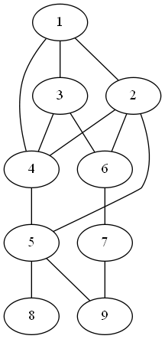

BFS: ______________1, 2, 3, 4, 5, 6, 8, 9, 7_________________________________________

DFS: ______________1, 2, 4, 3, 6, 7, 9, 5, 8_________________________________________

1. 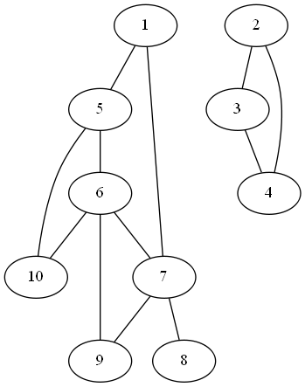

BFS: __________1, 5, 7, 6, 10, 9, 8, 2, 3, 4_____________________________________________

DFS: __________1, 5, 6, 7, 8, 9, 10, 2, 3, 4____________________________________________

For each of the graphs below, list the order in which the vertices are visited in a **topological sort**, starting with vertex 1. If there are multiple vertices adjacent to a given vertex, visit the adjacent vertex with the lowest value first.

1. 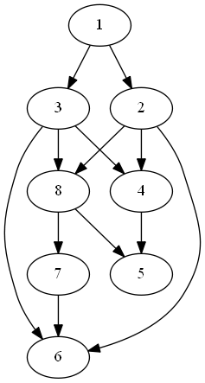

Topological sort: ________1, 2, 3, 4, 8, 5, 7, 6___________________________________________

1. 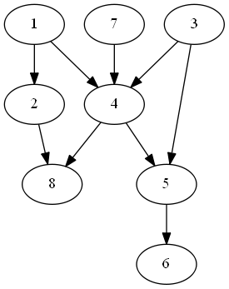

Topological sort: ____________1, 2, 3, 7, 4, 5, 6, 8_________________________________________