Name: __KHAYYAM SALEEM___________ Date: ____12/2/16____

I pledge my honor that I have abided by the Stevens Honor System. – Khayyam Saleem

1. 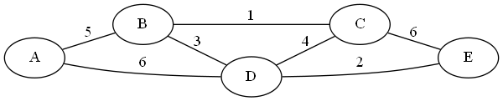Apply Kruskal’s algorithm to find a minimum spanning tree of the graph below.

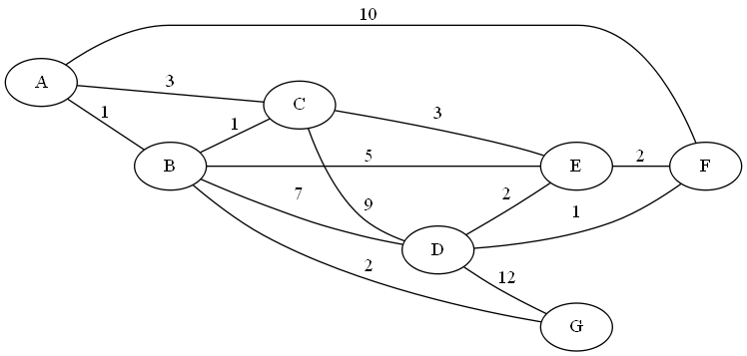2. Use Dijkstra’s algorithm to find the shortest path between nodes **A** and **F**. (Start at A, end at F)

|  |  |
| --- | --- |
| **Tree Vertices** | **Remaining Vertices** |
| A(-, -) | B(A, 1), C(A, 3), D(-, ∞), E(-,∞), F(A, 10), G(-, ∞) |
| B(A, 1) | C(B, 2), D(B, 8), E(B, 6), F(A, 10), G(B, 3) |
| C(B, 2) | D(B, 8), E(C, 5), F(A, 10), G(B, 3) |
| G(B, 3) | D(B, 8), E(C, 5), F(A, 10) |
| E(C, 5) | D(B, 8), F(E, 8) |
| F(E, 8) |  |
|  |  |
|  |  |
|  |  |

Path: _________**A, B, C, E, F**________________________________________________

Distance: __________**7**_________

3.

a. Construct a Huffman tree for the following data:

|  |  |  |  |  |  |
| --- | --- | --- | --- | --- | --- |
| **Symbol** | A | **B** | **C** | **D** | **_** |
| **Frequency** | 0.4 | **0.1** | **0.2** | **0.15** | **0.15** |

1

0

1

A  
0.4

0.60

0

1

1

1

0

0

0.35

0.25

C  
0.2

_  
0.15

D  
0.15

B  
0.1

b. Encode ABACABAD using the tree you generated for (a).

**1 000 1 011 1 000 1 001**

c. Decode 100010111001010 using the tree you generated for (a).

**ABACAD_**

d. What compression gain (percent of improvement) do we get by using Huffman encoding instead of a fixed‐length encoding scheme (assume the fixed‐length scheme would require 3 bits for each character)?

((3 – (0.6*3 + 0.4*1))/3)*100 = **26.66667 %**