**Assignment 1**

Create Angular 2 project using @angular/cli (using npm command). When you run the angular app, the output will be like:



**Ref:** <https://github.com/angular/angular-cli>

**Output:**

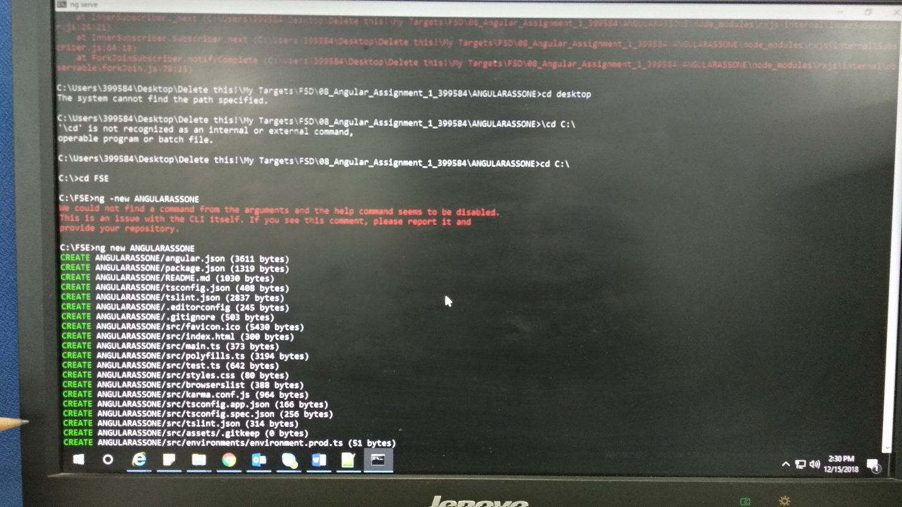

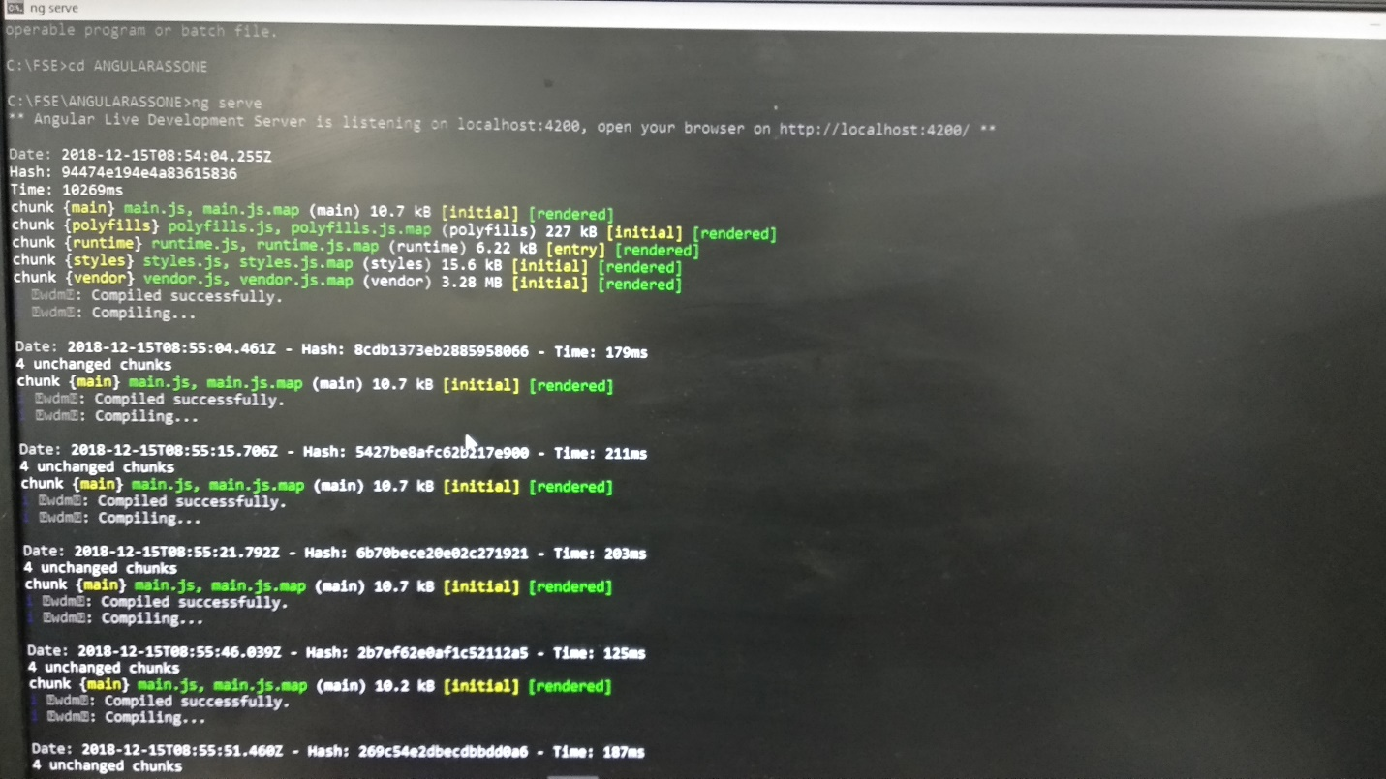

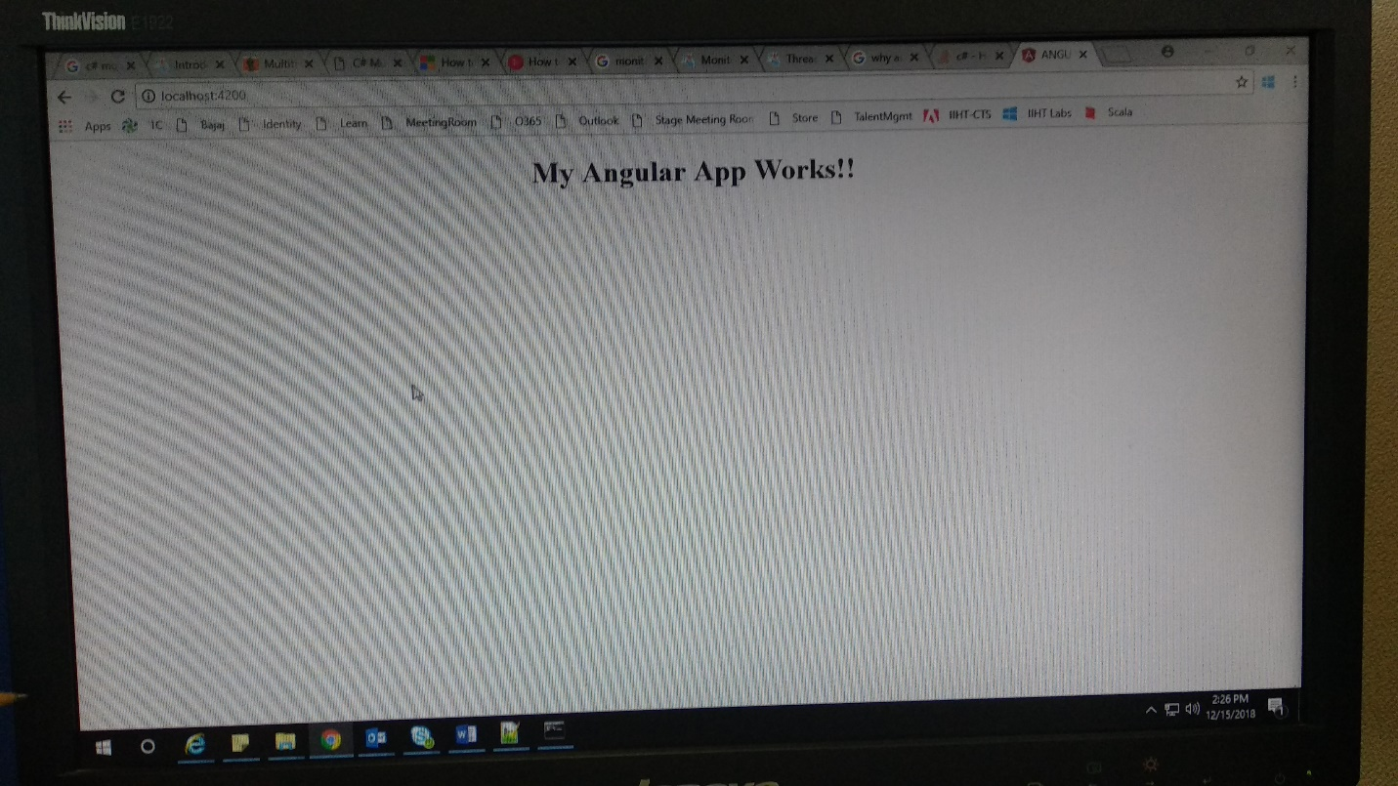

Code changes:

app.component.html:

<!--The content below is only a placeholder and can be replaced.-->

<div style="text-align:center">

<h1>

**{{** title **}}**!

</h1>

</div>

app.component.ts:

import { Component } from '@angular/core';

@Component({

selector: 'app-root',

templateUrl: './app.component.html',

styleUrls: ['./app.component.css']

})

export class AppComponent {

title = 'My Angular App Works!';

}