Use ng command to create new service called Shared Service

Implement a WeatherService Method in shared.service.ts such that it uses http and Yahoo weather service API to inject weather data inside weather component. The service should return JSON data to weather component.

Implement a Movieservice Method in Shared.service.ts such that it uses http and Movie service API to inject Movie data inside Movie component. The service should return JSON data to Movie component.

Implement a Currenyservice Method in Shared.service.ts such that it uses http and Currency service API to inject Currency data inside Currency component. The service should return JSON data to Currency component.

API

Yahoo: 'https://query.yahooapis.com/v1/public/yql?q=select%20\*%20from%20weather.forecast%20where%20woeid%20in%20(select%20woeid%20from%20geo.places(1)%20where%20text%3D%22'+searchCity+'%22)&format=json&env=store%3A%2F%2Fdatatables.org%2Falltableswithkeys'

or

"https://query.yahooapis.com/v1/public/yql?q=" + this.searchtext +"&format=json"

Currency: "http://api.fixer.io/latest?base="+ cur

Movie: "http://www.omdbapi.com/?t=%27"+MovieName+"%27&apikey=8b8b3f2"

Output Screen Shots:

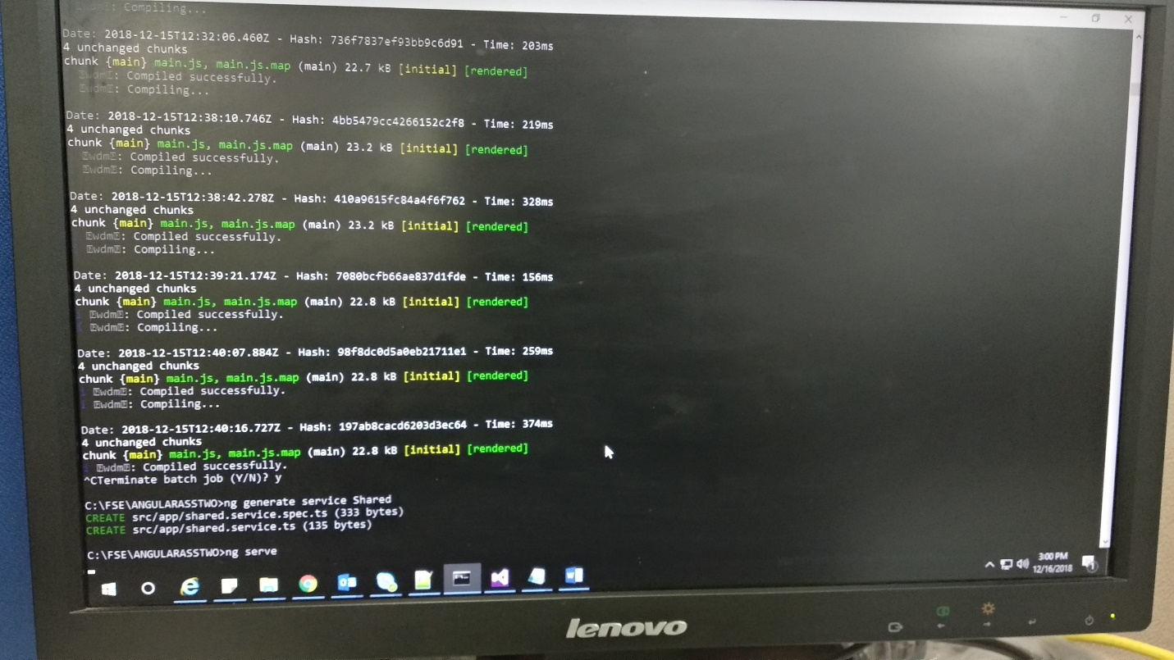

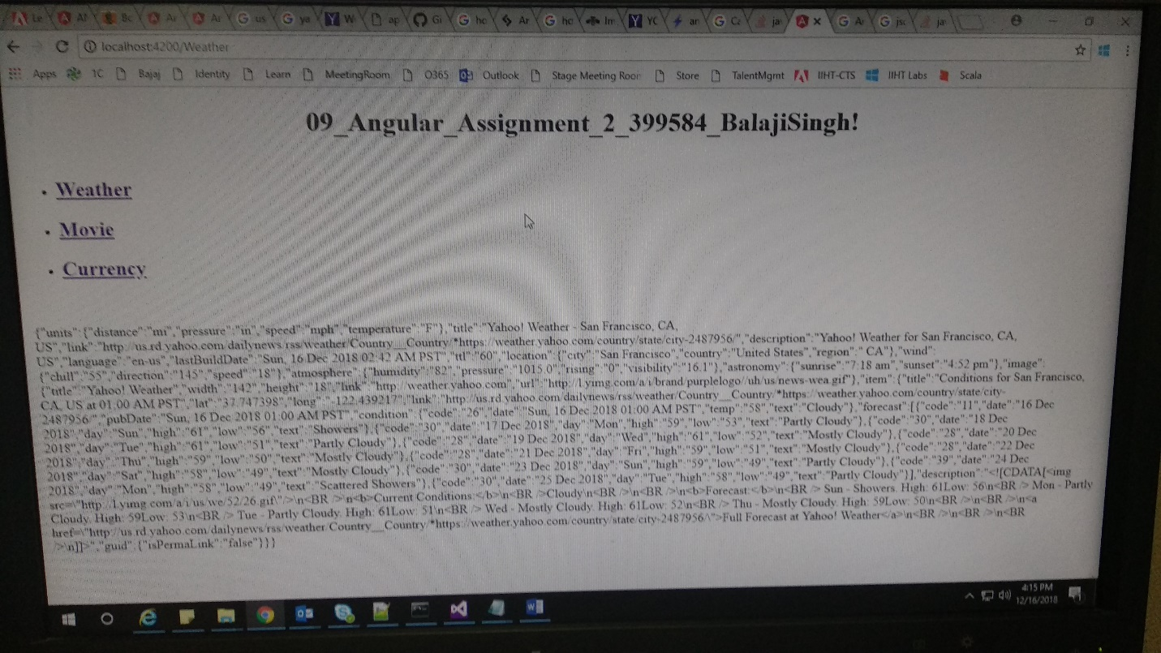

Code: