(continue from previous assignment)

Modify respective component view to display data returned by respective service methods so that output is like:



Note: Implement bootstrap on given Angular 2 project to make it responsive.

Screen shots:

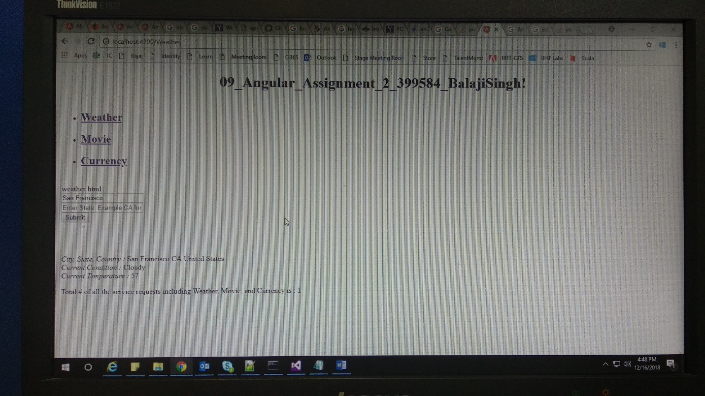

Code: