Consider a banking application in which there is an entity called Account. Its attributes are account number, customer name, customer’s address and balance. It provides the functionality of withdrawal and deposit. There can be two users for a particular bank account (joint account). The two users can perform any type of transaction on the account. Construct a code that performs deposit and withdrawal of money from the same account by two users concurrently. The balance printed after the transactions should be correct.

Hint: Use Monitor class to achieve the same.

**Output Screenshots:**

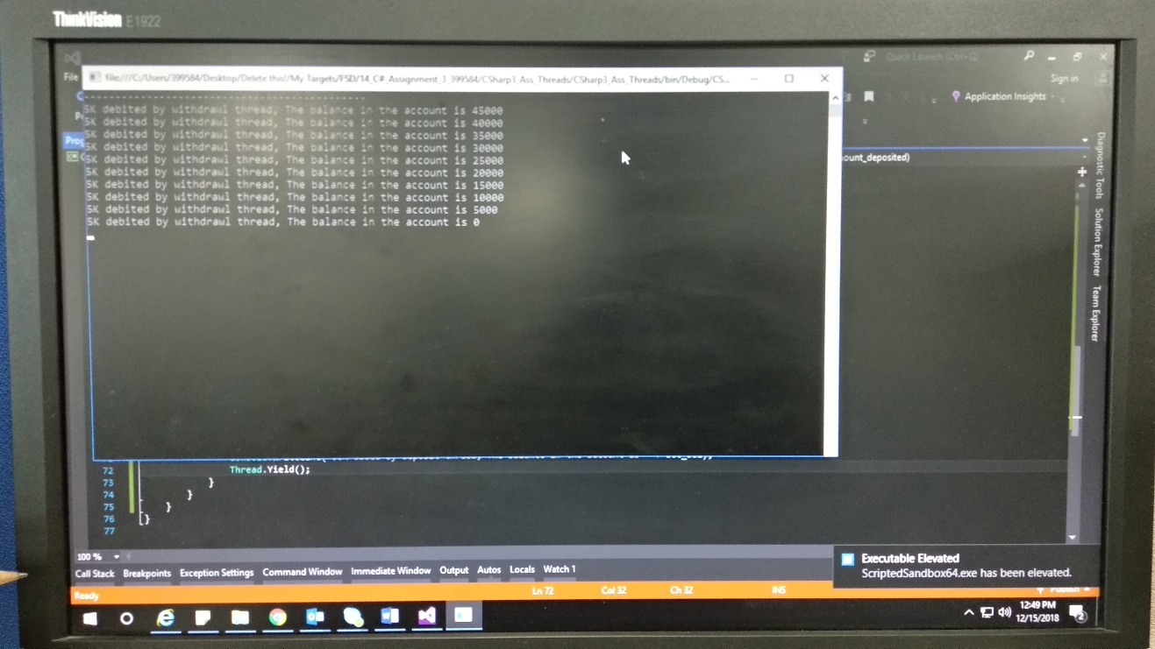

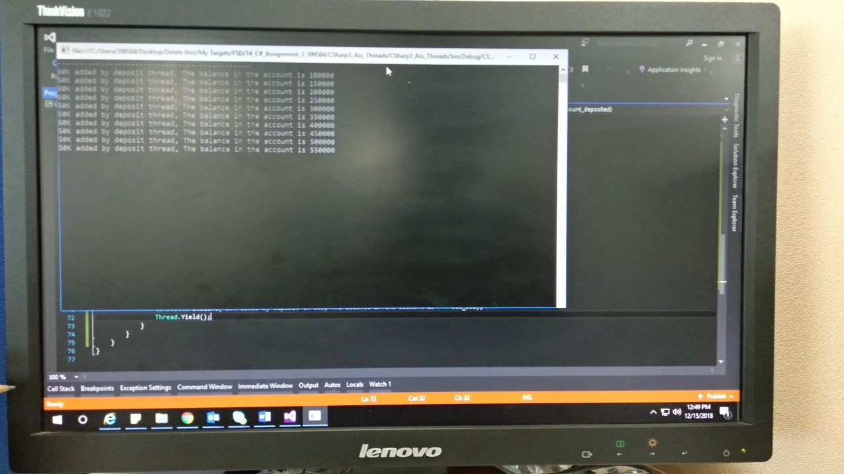

**Code:**

using System;

using System.Threading;

namespace CSharp3_Ass_Threads

{

public class Program

{

public static void Main(string[] args)

{

Account account = new Account(1234, "Balaji Singh", "Kurnool", 50000);

Console.WriteLine("---------------------------------------------");

//account.withdrawl(6678.75);

// Two ways to create threads in C#

//ThreadStart threadstart_withdrawl = new ThreadStart(account.withdrawl(6678.75));

//ThreadStart threadstart_deposit = new ThreadStart(account.deposit(50000));

//Thread thread_withdrawl = new Thread(threadstart_withdrawl);

//Thread thread_deposit = new Thread(threadstart_deposit);

//Thread thread_withdrawl = new Thread(new ThreadStart(account.withdrawl));

//Thread thread_deposit = new Thread(new ThreadStart(account.deposit));

// Both ways are correct

Thread thread_withdrawl = new Thread(() => account.withdrawl(5000));

Thread thread_deposit = new Thread(() => account.deposit(50000));

thread_withdrawl.Start();

thread_deposit.Start();

thread_withdrawl.Join();

thread_deposit.Join();

Console.ReadLine();

}

}

public class Account

{

static object locker = new object();

public int acc_no { get; set; }

public string cust_name { get; set; }

public string cust_address { get; set; }

public double acc_bal { get; set; }

public Account()

{

}

public Account(int ac_number, string customer_nm, string cust_add, double ac_balance)

{

acc_no = ac_number;

cust_name = customer_nm;

cust_address = cust_add;

acc_bal = ac_balance;

}

public void withdrawl(double amount_withdrawn)

{

for (int i = 0; i < 10; i++)

{

Monitor.Enter(locker);

acc_bal = acc_bal - amount_withdrawn;

Console.WriteLine("5K debited by withdrawl thread, The balance in the account is " + acc_bal);

Thread.Yield();

}

}

public void deposit(double amount_deposited)

{

for (int i = 0; i < 10; i++)

{

Monitor.Enter(locker);

acc_bal = acc_bal + amount_deposited;

Console.WriteLine("50K added by deposit thread, The balance in the account is " + acc_bal);

Thread.Yield();

}

}

}

}