Pymaceuticals Data Set

Observable Trends

In this study, 250 mice were treated through a variety of drug regimes over the course of 45 days. The physiological responses were then monitored over the course of that time. The objective is to analyze the data to show how four treatments (Capomulin, Infubinol, Ketapril, and Placebo) compare.

1) Capomulin treatment group has least cancer spreading while Placebo group has the most over time for each treatment.

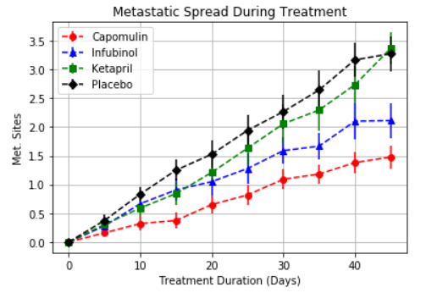

2) Capomulin treatment group’s mice has highest survival rate while Infubinol treatment group has the lowest survival rate. Approximately from 33rd day, the survival rate for Placebo group is higher than Infubionol, so long term usage of Infubionol should be reinvestigated.

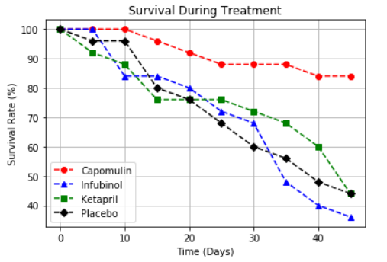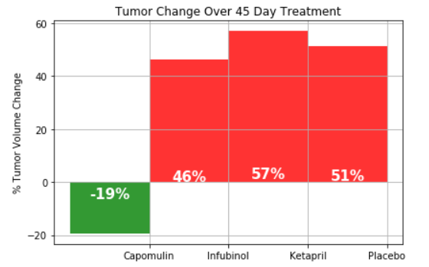

3) After reviewing the Tumor Response to Treatment visualization, it is clear that tumor volume of mice which took Capomulin shows significant decrease when comparing three other drugs

