WeatherPy Data Set

Observable Trends

In this study, 500+ cities across the world were randomly selected and we will determine if there is any trend as we approach the equator.

1) Latitude vs. Temperature: It shows that maximum temperatures tend to be higher as cities are closed to the equator (latitude range of -20 to 20).

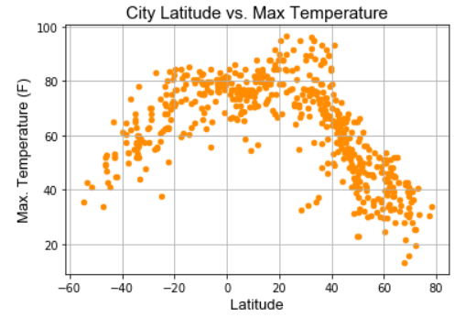

2) Latitude vs. Humidity: It seems that humidity is consistent across all latitude and does not show any significant correlations to latitude. However, the cities on the equator experienced the 40% to 100% range.

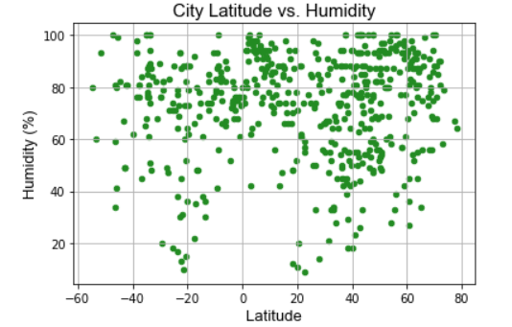

3) Latitude vs. Cloudiness: No significant correlation was found between latitude and cloudiness.

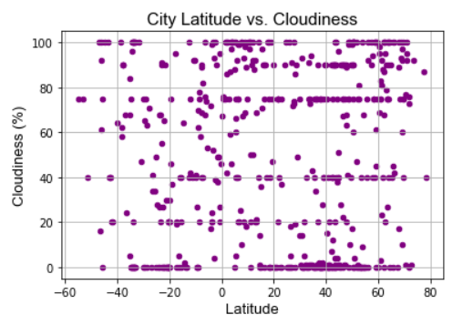

4) Latitude vs. Wind Speed: No significant correlation was found between latitude and wind speed

