University of Technology Sydney

31260 Interface Design

Assignment 2

Interface Development and Implementation

Authors:

Chi Kit Chan (ID 11301506)

Ka Hei Chan (ID 11301239)

Table of contents

Goal 3

Scenario 3

User story 3

Objectives of the design project 3

Inspirations 4

Issues and constraints 4

Design Concepts, Rationale and Prototypes 5

Heuristic evaluations of prototype 1 6

Test methodology 6

Findings 6

1. Lack of searching or filtering function 6

2. Missing news category filter 7

3. The star symbol (☆) for following news is misleading 8

4. Text is too small and condensed 8

5. Related news only display image without title or description 9

Design of the second prototype 9

Evaluation of the prototype 2 10

Findings 10

1. Follow button should be moved to the end of the article 10

2- World map for viewing world news is very intuitive 10

3- Category filter should change to drop down list 10

Design process diagram 11

Stop-motion video 11

Conclusion 12

Appendix 13

Sketch of prototype 13

# Goal

The selected goal of the design is “Catching up on news from around the world”.

# Scenario

It is in the year 2024 on a Monday morning in Sydney, Tex is on his way to his workplace as usual. Tex’ office is situated far away from his home. It takes a long time to travel. Tex would like to use the travelling time to read the latest news. He is particularly interested in world affairs and sport news. Currently it is during NBA season, Tex is a fan of the basketball team Chicago Bulls so he would like to catch up news about their latest matches and events. Besides the tension of Cold War 2 is growing, Tex is very worried about the situation.

# User story

Tex wants to read and follow interesting news highlights from around the world while on his way to work.

# Objectives of the design project

The design project is to design and produce a prototype of the application for Tex to achieve the goal.

From the persona, we understand that Tex is an elder person as he is 52 year old so he may be less comfortable with complex interface, and may have poor vision or suffer from presbyopia. Therefore, the interface has to be simple, intuitive to use. And the text needs to be properly sized for Tex to easily read articles using the application. We also understand that Tex is particularly interested in reading sports news and world affairs, so our design will focus on features in this area.

# Inspirations

Consider that the scenario is in the year 2024, where technology would have advanced a lot. Ultra-thin and light mobile phone, crystal clear monitor, accurate and high sensitive touch screen, and mobile projected interface will be available.

In particular, projected interface will make an important feature of the design where the application will use the built-in projector of the mobile phone to project a screen in front of the phone. So that can user can read news article in a big “screen” when they need it without sacrificing portability by having a fixed big screen.

# Issues and constraints

The biggest issues in designing a newsreader application for a mobile is that, since the screen size of mobile devices are small in general. While a newsreader application would have a section of its screen used to display articles, and some other section for listing other related items, such as related news, and there are usually a lot of those important items. It is hard to fit a lot of necessary content in a small screen while having a minimalistic design.

# Design rationale

# Heuristic evaluations of prototype 1

## Test methodology

Several user evaluations were carried out to help to evaluate the prototype. Two users were invited to participate in the test. Wizard of Oz technique is used, where the user will be shown the paper prototype and invited to simulate button clicks or any interaction with the system, then an evaluator switch screens manually to simulate the real system. User actions and opinions were recorded and then Nielson’s Heuristics is applied.

## Findings

### 1. Duplication close function in notification windows

### 2. “>>” to read more in news preview is misleading

### 3. Missing system feedback in news following

### 4. Catalogue function misplacing

# Design of the second prototype

The second prototype is made to resolve usability issues addressed in the user evaluation. Below is a list of the changes

1. Follow function star icon is changed to a “follow” button right under the news title on top

2. add ability to use phone projector to project a bigger screen to display content to resolve text too condensed problem.

3. News title and short excerpts are now included in related news section in article reader

4. Category filtering function is added.

5. Search button is added to the navigation bar to provide search functionality

# Evaluation of the prototype 2

## Findings

### 1. System feedback of news following is still unclear

A user reflected that it is probably better to have the follow button located at the end of the article rather than always being on top, otherwise users will have to scroll all the way up to hit the follow button after reading the article and decide to follow it. This would be a violation to the efficiency of use heuristics.

### 2. Catalogue should place top right corner of the world map

Users commented that the world map used to display world news is very intuitive and easy to use. It allows the quickly to have a clear picture of where the events happen and easy to explore news in a specific location. This is complying to the Match system to the real world, efficiency of use heuristics.

### 3. Next button is rarely used

A user pointed out that the category filter in world map could have been just a drop-down list rather than having a new screen. This would provide a more cohesive interface and a better experience since the user is able to see the news and apply the category filter and immediately see the change in real time. If it is navigated to another screen like current system, user like him may forget what he was looking. This is a violation to recognition rather than recall.

# Design process diagram

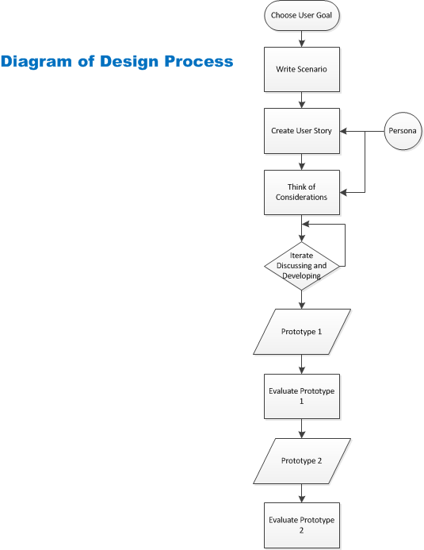

# Conclusion

The outcome of this project is the paper prototype of the design of the newsreader application for Tex to archive the goal of reading news from around the world.

The biggest feature of the design we think is the world map interface to display news headlines form around the world and allow users to interact with it in a very intuitive way. And also the ability to project article using mobile projector to provide a bigger “screen” for users to read news, this should allow Tex to read much more easier.

# Appendix

## Screenshot of first prototype

## Screenshot of second prototype

## Evaluation evidence