

**Carver Electronics Phase: 5**

**ISQA 8040**

Grade: 96/100 pts.



By:

Shilpa Kache

Runhua Lei

Wancheng Sun

William Wetzel

**Table of Contents**

Glossary …… …………………………………………………………………………………… 3

Executive Summary……………………………………………………………………………….4

Updated Project Schedule…………………………………………………………………………6

Computer Architecture design……………………...…………………………………………… .6

Architecture Design…………………………………………………………………………… 10

Specifications of software and hardware ……………………………………………………… 11

Request for Proposal (RFP) ……………………………………………………………………. 12

1.0 Introduction……………………………………………………………………………. 13

2.0 Standards and Instructions………………………………………………………………. 15

3.0 Administrative Rules that Will Govern Selection………………………………………. 16

4.0 Proposal Expenses………………………………………………………………………. 17

5.0 Format for Proposals……………………………………………………………………. 17

6.0 Requirements and Features……………………………………………………………… 19

7.0 Vendor Services................................................................................................................. 24

8.0 Bid Evaluation…………………………………………………………………………... 25

9.0 Vendor Evaluation Criteria……………………………………………………………… 29

10.0 Bid Submission Information………………………………………………………… 31

Input/ Output and Interface Design……………………………………………………………... 32

Summary...................................................................................................................................... . 40

Source............................................................................................................................................ 41

Responsibilities Matrix……………………………………………………………………… …. 42

**Title page and TOC -- 5/5 pts.**

**Glossary**

CE = Carver Electronics

RFID = Radio Frequency Identification

RFP = Request for Proposal

3NF = Third Normal Form

SDLC = System Development Life Cycle

DFD = Data Flow Diagrams

CRM = Customer Relationship Management

SRM = Supplier Relationship Management

SME = Small Medium Enterprise

RFP = Request for Proposal

UI = User Interface

**Executive Summary 5/5 pts.**

In the current phase of the system we are providing CE with a computer architecture design, input/output interface screens, and a Request for Proposal document.  Our project schedule has been updated to reflect new information and requirements we have gathered from CE.  CE has so far received a database design, baseline project plan, DFD diagrams, and an economic feasibility report.  CE should be well positioned to receive bids, and when ready, begin work on the project.

In Phase 5 of our report we have included the following:

* Updated Project Schedule:
  + The Gantt Chart table/project schedule has been updated to reflect new information and requirements gathered from CE.
* Computer Architecture Design
  + This indicates the flow of how computer systems relating to CE’s needs will be integrated and interact with each other.  This is meant to support implementation teams, ensuring performance and functional needs are met.
* Request for Proposal:
  + The RFP has been created from the point of view of CE.  It was written as if our team had been hired as a consultancy agency, and helped CE draft an RFP to secure a vendor.
  + It supplies high level information on the technical requirements of the project, criteria for proposal selection, format for proposals, and bidder evaluation criteria.
* Input/output and Interface Designs:
  + The sample input/output screens provide an example of the functionality CE will need when interacting with their website and database.  Focused on functionality, they demonstrate how CE staff and technical staff will view and enter information.
* Sample Reports:
  + The sample reports provide an example of how informational reports generated from the CE database will be displayed to users.

At this phase in the process, CE is prepared to receive bids and review proposals.  It would be expected work on the project would commence in a few months’ time, and that the entire project would be completed in 6-9 months.

**Updated Project Schedule 15/15 pts.**

In the previous phases we have updated the planning, analysis, design, implementation and maintenance phases for CE’s online order system and trade in system. The project started according to the schedule on the September 22, 2016. With the exception of planning and maintenance, we included Modeling of Data Flow Diagrams, Developing Business Rules and Construct ER Diagrams in analysis phase. Furthermore, we added Logical and Physical Design in design phase. In phase 5, we added Designing Computer Architecture to the task list in the design phase. Since we planned to use a web-based database server to help CE to increase efficiency and profits, designing the computer architecture for the web-based database server is critical. Therefore, we added two days of designing computer architecture in the design phase. The other tasks in design phase are the same as phase 4. In the implementation phase of Phase 5, we moved User Documentation before training because we think it’s important to get the User Documentation ready for training CE staff prior to training. Other tasks are kept as the same as phase 4.

In summary, we will have 5 days for planning phase, 11 days for analysis phase, 31 days for design phase, 15 days for implantation phase, 3 days for maintenance phase. The total time for the whole project is 65 days. The entire project is scheduled to be completed by December 21, 2016.

**Table 1. The updated Gantt chart**

|  |  |  |  |  |
| --- | --- | --- | --- | --- |
| **Task Name** | **Duration** | **Start** | **Finish** | **Predecessors** |
| **Planning** | **5 days** | **Thu 9/22/16** | **Wed 9/28/16** |  |
| Study Current System of CE and Identifying its Problems | 1 day | Thu 9/22/16 | Thu 9/22/16 |  |
| Select the Proper System to be Developed | 1 day | Fri 9/23/16 | Fri 9/23/16 |  |
| Initiate a Draft Plan for the Alternative System | 1 day | Mon 9/26/16 | Mon 9/26/16 |  |
| Analyze the possible Expenses and Profit, Feasibility and Accessibility | 1 day | Tue 9/27/16 | Tue 9/27/16 |  |
| Risk Assessment and Blue Print for the Project | 1 day | Wed 9/28/16 | Wed 9/28/16 |  |
| **Analysis** | **11 days** | **Thu 9/29/16** | **Thu 10/13/16** | 1 |
| **Determining System Requirements** | **7 days** | **Thu 9/29/16** | **Fri 10/7/16** |  |
| Determine Requirements of the Alternative Systems and User Requirements | 1 day | Thu 9/29/16 | Thu 9/29/16 |  |
| Determine Website Requirements and Database Requirements | 1 day | Fri 9/30/16 | Fri 9/30/16 |  |
| Analyze the Software and Hardware Requirements | 1 day | Mon 10/3/16 | Mon 10/3/16 |  |
| Determine the Backup System and possible Servers for this System | 1 day | Tue 10/4/16 | Tue 10/4/16 |  |
| Analyze the Use of RFID | 1 day | Wed 10/5/16 | Wed 10/5/16 |  |
| Determine the Requirements of possible Update System | 1 day | Thu 10/6/16 | Thu 10/6/16 |  |
| Analyze the Methods or Technology to Secure the System | 1 day | Fri 10/7/16 | Fri 10/7/16 |  |
| **Structuring Requirements** | **4 days** | **Mon 10/10/16** | **Thu 10/13/16** | 8 |
| Modeling of Data Flow Diagrams | 1 day | Mon 10/10/16 | Mon 10/10/16 |  |
| Developing Business Rules | 1 day | Tue 10/11/16 | Tue 10/11/16 |  |
| Construct ER Diagrams | 2 days | Wed 10/12/16 | Thu 10/13/16 |  |
| **Design** | **31 days** | **Fri 10/14/16** | **Fri 11/25/16** |  |
| **Database Design** | **5 days** | **Fri 10/14/16** | **Thu 10/20/16** | 16 |
| Logical Design | 1 day | Fri 10/14/16 | Fri 10/14/16 | 16 |
| Screen Design | 1 day | Mon 10/17/16 | Mon 10/17/16 | 22 |
| Physical Design | 2 days | Tue 10/18/16 | Wed 10/19/16 | 23 |
| Forms and Report Design | 1 day | Thu 10/20/16 | Thu 10/20/16 | 24 |
| **Design of RFID System and Payment System** | 2 days | Fri 10/21/16 | Mon 10/24/16 | 21 |
| **Design the Website for CE Including Interface and Dialogue** | 20 days | Tue 10/25/16 | Mon 11/21/16 | 21,26 |
| **Design of Security and Backup Systems** | 2 days | Tue 11/22/16 | Wed 11/23/16 | 27 |
| **Designing Computer Architecture** | 2 days | Thu 11/24/16 | Fri 11/25/16 | 28 |
| **Implementation** | **15 days** | **Mon 11/28/16** | **Fri 12/16/16** |  |
| Programming | 3 days | Mon 11/28/16 | Wed 11/30/16 | 20 |
| Testing (Compatibility, Reliability and Scalability) | 3 days | Thu 12/1/16 | Mon 12/5/16 | 31 |
| Fix the Bugs and Modification from CE | 2 days | Tue 12/6/16 | Wed 12/7/16 | 32 |
| Installation | 2 days | Thu 12/8/16 | Fri 12/9/16 | 33 |
| User Documentation | 3 days | Mon 12/12/16 | Wed 12/14/16 | 34 |
| Training | 2 days | Thu 12/15/16 | Fri 12/16/16 | 35 |
| **Maintenance** | **3 days** | **Mon 12/19/16** | **Wed 12/21/16** | 30 |
| Analyze Request about Modification of New System from CE | 1 day | Mon 12/19/16 | Mon 12/19/16 | 30 |
| Modify the necessary Section of the new system | 1 day | Tue 12/20/16 | Tue 12/20/16 | 38 |
| Develop additional Documentation if needed | 1 day | Wed 12/21/16 | Wed 12/21/16 | 38,39 |

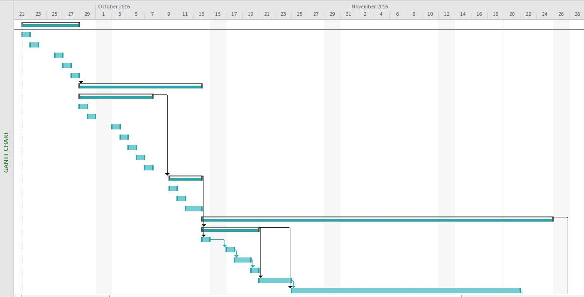

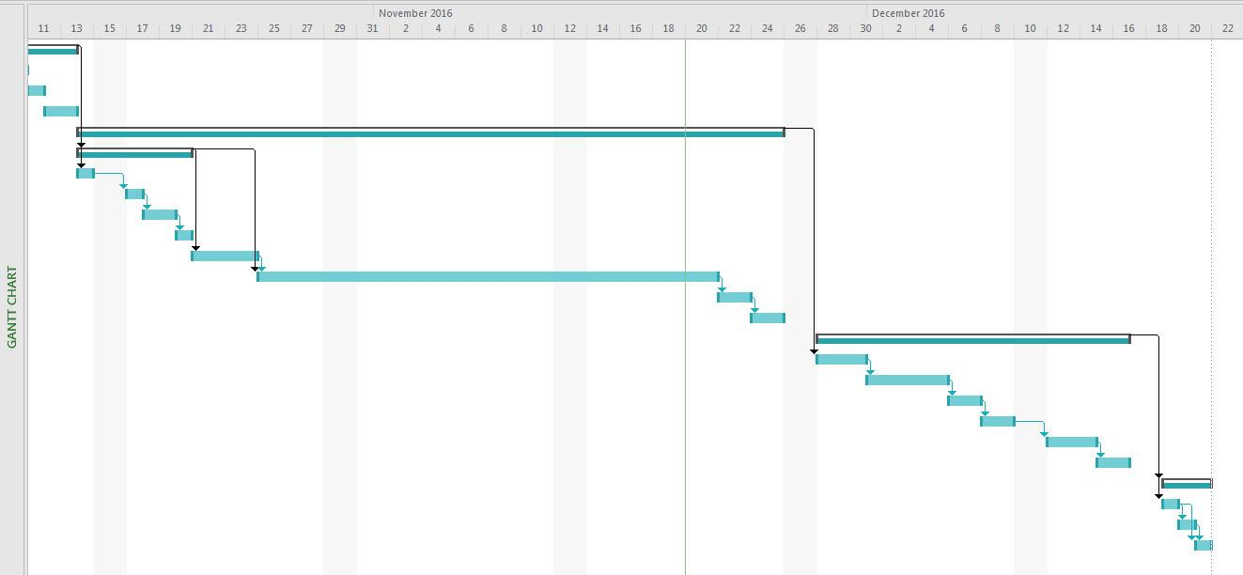

**Computer Architecture Design**

Since the goal of the CE project is to build a web-based database server to increase the efficiency and profit, we used a three-tier architecture design for the CE system development project. The database will be stored on one server, the application stored on a second server, and client logic located on user machines. We designed it in such a way that we kept all servers (web server, application server, database server) in one hardware or cloud computer location in order to reduce cost. The network diagram includes all other relevant features such as routers and Wi-Fi connections. The Internet is utilized so that CE employees can update current prices of products and all other information, such as information from RFID. Furthermore, with Wi-Fi, CE employees can connect to the CE system by phone and laptops.

For security purposes, we set the firewall between CE’s system and client App and web browser. We used a switch to connect all of CE’s workstations. The web browser and App were provided for customers to shop or track products online with multiple platforms to order. The CE employees or administrator can also access CE’s system by remote access for special tasks such as running reports. We have also designed Card readers at the front desk for payment processing as Point of Sale devices. The printer and scanner connected to CE Workstations can be used for billing, invoices and printing as needed.

1) If I understand the configuration correctly, the servers are all off-site (provided by a 3rd party cloud service). If so, then the connections to these servers will need to go through a firewall and the associated router. They are accessed via the Internet. So, a firewall/router will be needed. Maybe this is what you intend to show in the deployment diagram? In any case, there should be a firewall between the cloud service servers and CE. 2) Also, think about specific application software CE will need (e.g., accounting, shipping and inventory, scheduling, etc.). 3) Finally, when you talk about hardware that is needed, what about networking hardware (which you have shown in the network diagram) -- (e.g., router(s), switches, wireless access points)? 4) Back-up storage hardware?? 16/20 pts.

**Architecture Design**

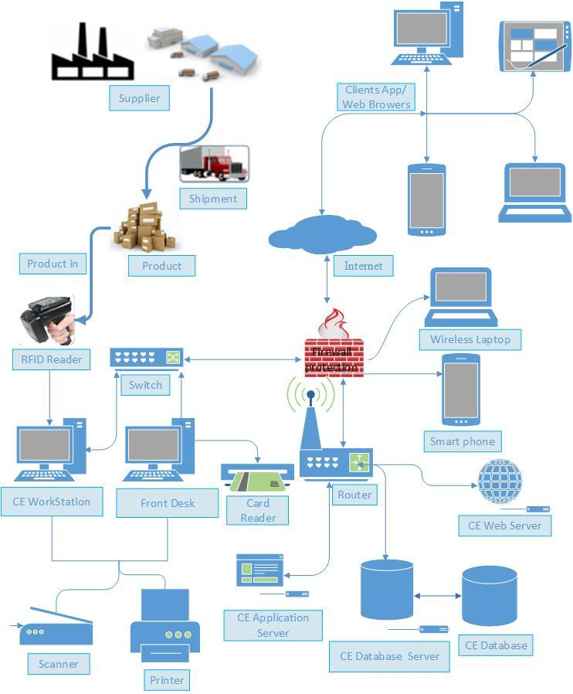

**Specifications of software and hardware:**

|  |  |  |  |  |
| --- | --- | --- | --- | --- |
| **Specifications** | **Workstation** | **Standard Web Server** | **Standard Application Server** | **Standard Database Server** |
| **Operating System** | Windows 10 | Linux | Linux | Linux |
| **Special Software** | Microsoft Office Suite | Apache | PHP | MySQL |
|  | Acrobat Reader |  |  |  |
| **Hardware** | 32 GB Memory | 32 GB Memory | 64 GB Memory | 64 GB Memory |
|  | 1-4TB Hard disk | 1-4TB Hard disk | 1-4TB Hard disk | 2-4TB Hard disk |
|  | Intel Core i7 | Intel Xenon E7 | Intel Xenon E7 | Intel Xenon E7 |
| **Network** | 100Mbps Ethernet  High-Speed Wireless | 100Mbps Ethernet | 100Mbps Ethernet | 100Mbps Ethernet |

**Request for Proposal (RFP) 20/20 pts.**

**Confidentiality Agreement**

It is understood and agreed that the provider of confidential information may provide certain information that is and must be kept confidential. To ensure the protection of such information, and to preserve any confidentiality necessary under patent and/or trade secret laws, it is agreed that:

1. The Confidential Information disclosed can be described as and includes:

Invention description(s), technical and business information relating to proprietary ideas and inventions, ideas, patentable ideas, trade secrets, drawings and/or illustrations, patent searches, existing and/or contemplated products and services, research and development, production, costs, profit and margin information, finances and financial projections, customers, clients, marketing, and current or future business plans and models, regardless of whether such information is designated as “Confidential Information” at the time of its disclosure.

2. The Recipient agrees not to disclose the confidential information obtained from the discloser to anyone even in the event they are required to do so by law.

3. This Agreement states the entire agreement between the parties concerning the disclosure of Confidential Information. Any addition or modification to this Agreement must be made in writing and signed by the parties.

4. If any of the provisions of this Agreement are found to be unenforceable, the remainder shall be enforced as fully as possible and the unenforceable provision(s) shall be deemed modified to the limited extent required to permit enforcement of the Agreement as a whole.

**WHEREFORE**, the parties acknowledge that they have read and understand this Agreement and voluntarily accept the duties and obligations set forth herein.

Further reading of this document constitutes your recipient of confidential information:

(Confidentiality Agreement take from [3])

**1.0 Introduction**

1.1 Background

CE Electronics is a SME located in Des Moines Iowa, serving as a custom audio hardware manufacturer, retailer of professional and consumer audio equipment, and as an audio parts distributor since 1992. Our clients approach us with specialized requests for audio equipment, we then obtain the necessary parts from wholesale entities, and build their requests. If customers wish to purchase individual components, they are ordered from wholesaler suppliers and sold to customers at a markup.

CE also has a range of consumer and professional final audio goods. These are sold as new, and also bought back from customers to be refurbished and resold. CE is a family friendly business with strong Midwestern values. Located in a town of 210,000 people, our relationships with regional customers are what drive our business. While we are seeking to branch to a wider audience with online sales, the primary objective is to improve our current local business processes. Many of our employees have been with us 10+ years, we rely on their dedication and expertise for successful continued operation.

CE has a gross annual revenue of approximately 1.5 million dollars annually, +- %15 the past 10 years.

1.2 Brief Summary of Needs

CE Electronics is asking for a comprehensive digital, centralized, online based solution for the following areas of operations:

* Inventory Management
* Trade-In System
* CRM System
* SRM System
* Online Purchasing

Currently these areas are all manually maintained in numerous spreadsheet based silos. This has led to problems of:

* Employee Overtime
* Unnecessary shipping costs
* Inventory Management
* Customer Dissatisfaction
* Inaccurate records
* Inaccurate billing
* Unnecessary telephone fees

CE is seeking an integrated solution which will automate tasks relating to aforementioned areas of operations, and relieve current problem areas.

The ideal solution will provide the following improvements:

1. Eliminate manual record keeping
2. Improve inventory management and accounting by building a central inventory management database and automating supplier order placements
3. Increase equipment profitability by maintaining accurate retail, buyback, and sales values
4. Increase customer satisfaction with online purchasing and record keeping
5. Support accounting with invoice creation and accounts payable management
6. Provide supplier and customer access portals for order status and account information review

1.3 Explanation of RFP

This RFP has been created by CE serves to solicit bids from potential IT, Software Development, Technology Consulting, and similar vendors. CE is seeking vendors who can provide comprehensive services for all project areas mentioned in this RFP.

This document covers all high level:

* Technical requirements
* Liability requirements
* Proposal standards and formats
* Rules to govern proposal acceptance
* Product requirements and features
* Required vendor supplied information
* Vendor Evaluation Criteria

**2.0 Standards and Instructions**

**2.1 Schedule of Events Leading to Contract**

2.1 Date of Issue of RFP

CE has issued an RFP on Nov. 21st, 2016. It is expected this single RFP will cover all aspects of the proposed project, and will be the only document issued as such. Submission of written questions regarding the RFP are due Jan. 2nd, 2017. CE will respond to all question submissions by Feb. 2nd, 2017. CE may, at its own discretion, issue addendums or a revised RFP relating to vendor questions and clarifications.

2.2 Date Bids Are Due

CE will begin reviewing vendor proposals on March. 1st, 2017. Following review of all submitted bids, CE will contact vendor references and conduct any necessary interviews by April 14th, 2017.

2.3 Bid Selection

CE plans to select a suitable vendor and begin contract negotiations no later than June 1st, 2017. It is possible for a contract to be awarded at an earlier date if CE has completed all due diligence related to the vendor, and negotiations are completed. Negotiations are expected to be completed by June 15th, 2017.

2.4 Commencement of Contractor Work

Following contract negotiations, the vendor will be prepared to begin work no later than August 1st, 2017.

2.5 Date of System Implementation

Based on our technology consultant’s estimates, a project of this scale is expected to take 63-90 business days. Using this estimate, CE is expecting the final project to be implemented between Oct. 26th, 2017 and Dec. 4th, 2017.

**3.0 Administrative Rules That Will Govern Selection Decision**

CE Bids Email Address: acarver@celectronics.com

3.1 Communications with CE Regarding the RFP

Vendors will use CE’s bids email address, identified above, for any communications with CE regarding the RFP and award. Vendors must include the RFP number in the subject line of any written communication.

Prospective vendors will not contact any CE personnel or its consultants for meetings, conferences, or discussions specifically related to this RFP at any time prior to any Notice of Intent to Award a contract. Unauthorized contact with CE staff or its consultants may result in rejection of the vendor’s proposal.

3.2 Questions Regarding the RFP

Bidders interested in responding to the solicitation may submit questions via email to the Bids Email Address, identified above, by Jan. 2nd, 2017. All vendor questions will be answered by Feb. 2nd 2017. Questions received after 5pm CT on the due date will not be answered. All email submissions must contain the RFP number in the subject line.

3.3 Errors in the RFP

If, prior to the date fixed for submission of proposals, a proposer discovers any ambiguity, conflict, discrepancy, omission, or error in this solicitation document, the proposer shall immediately notify CE via email to the CE Bids Email Address, identified above and request modification or clarification of the RFP. If a proposer is requesting a modification, the request must state the recommended modification and the proposer’s reasons for proposing the modification. Without disclosing the source of the request, CE may modify the solicitation document prior to the date fixed for submission of proposals by releasing an addendum to the solicitation. (3.3 Errors in the RFP adapted from [1])

**4.0 Proposal Expenses**

CE is accepting RFP response proposals, not paid evaluations. No bidder will be paid a fee for their recommendations or proposals. Bidders are responsible for any transmission or shipping costs associated with their proposals.

**5.0 Format for Proposals**

5.0 Format for Proposals

At a minimum, any vendor bid should include:

* Company Overview
* Project Plan and Approach
  1. Technical Obstacles
  2. Budgetary Risks
  3. Implementation Plan
* Institutional Resources
* Fee Structure
* Relevant Terms and Conditions
* Financial Health of bidding company - at a minimum should include:
  1. Current Ratio
  2. Quick Ratio
  3. Cash Ratio
  4. Operating Ratio
  5. Net Profit Ratio
* References
  1. To be contacted by CE in the event of bid consideration

5.1 Demonstration Expectations

Proposers are expected to demonstrate their capacity to meet project objectives set by CE. Vendors should be prepared to demonstrate their solution in its eternity, and stipulate any objectives their solution cannot fulfill. CE will not be holding in person presentations or demonstrations. Should your firm be considered as a finalist, CE and the bidder jointly will determine the best method of answering outstanding vendor questions and conducting vendor interviews. Including but not limited to:

* Skype, GoToMeeting Video Meeting
* Asynchronous Video Messaging
* Conference Phone Call

Bidders should make their best judgments about what to include in their proposal demonstration. CE is expecting that each operational area will be individually addressed. If any solution includes the use of 3rd party products, bidders should indicate so in their presentation. Only software and modules to be included in the solution should be included in the demonstration. Bidders should present their solution as a complete integrated solution. Meaning if connectors or data streams affect information in other silos, integration of the whole system should be demonstrated.

5.2 Contractual Expectations

Key contractual areas to be negotiated in writing before project work start are including but not limited to:

1. Project costs and overrun liabilities
2. Warranty and Maintenance Levels
3. Personal liability Requirements
4. Capital restrictions and requirements
5. Selection of 3rd party vendors
6. Service level agreements
7. Progress reporting requirements
8. Escalation process for problems
9. Insurance requirements
10. Objections

5.3 Vendor References

Bidders are expected to provide a minimum of 3 references with sufficient contact information. References will only be contacted should the vendor be considered as a finalist. Bidders are expected to have provided technical services of a similar scope to CE’s RFP to their referencing clients.

5.4 Documentation Expected

Vendors are expected to include full operating and maintenance manuals for any modules, hardware or software provided. Documentation should be sufficient for CE staff to operate and maintain all vendor supplier items. Documents may be provided by 3rd party vendors for 3rd party provided equipment and software. Digital documents are preferred; print may be substituted in the event that digital documents are unavailable.

**6.0 Requirements and Features**

6.1 Hardware

6.11 Database

CE requires a dedicated database capable of processing and storing all customer and supplier transactions. Security will be paramount as sensitive customer and supplier information will be stored in accounts. The server must operate with 0 down time, and have a disaster recovery system with at most 24 hour old backups. The backup system is expected to be automatic and configurable. Backups will take place on a daily basis.

Our consultants estimate we will need no more than 2 TB of storage at go live. The database system should be easily expandable to support future upgrades. Both cloud and physical systems will be considered with equal weight. All peripherals and cabling are to be recommended by vendor.

Information to be stored in database system is included but not limited to:

* All website data
* Part
  + Prices
  + Descriptions
* Custom Product
  + Prices
  + Description
* Retail Products
  + Prices
  + Descriptions
* Customer
  + Account Information
  + Payment Information
  + Orders
* Supplier
  + Account Information
  + Payment Information
  + Orders
  + Parts Supplier
    - (See Parts)

6.12 Computing Hardware

To support this system CE would like to install at a minimum one (1) new high speed desktop computer. Additional desktop stations will be integrated for employee use to manage the website, customer/supplier orders, accounting practices, and data entry. CE has existing computing resources which may be evaluated by the vendor at proposal acceptance. All peripherals and cabling are to be recommended by vendor.

6.13 RFID System

To better track CE inventory, consultants have recommended implementation of an RFID system. This would include but not limited to:

* RFID Tags
* Hand-Held Trackers
* Room Scanners
* Database entry equipment

The RFID system must be able to integrate with the database system, and support employee operations with ease of use. Employees should be able to see unique items price and product information based off of RFID tags.

6.14 General Retail Equipment

CE has acquired a variety of retail electronics over its 24 years in business. A full list of CE commerce related electronics will be turned over to the accepted bidder. Although the above items are considered comprehensive, recommendations on additional equipment needed may be submitted by the vendor upon proposal acceptance.

6.2 Software

CE requires software to run its website and database operations. This software should allow CE staff to easily understand and work with database and website data. Database information should be presented through a User-Interface to CE staff.

Tasks the Software will need to fulfill in-store include but are not limited to:

* Update/View Inventory Stock
* Update/View Inventory Description
* Update/View Inventory Price
* Accept custom orders
* Manage Customer Information
  + Fulfill Customer Orders
  + Update/View order history
* Manage Supplier Information
  + Fulfill supplier orders
  + Update/View order history
* Update/View buyback prices
* Manage accounts payable and accounts receivable
  + Support accounting practices
* Manage employee information

Tasks the Software will need to fulfill on the website include but are not limited to:

* Update/View Product Description
* Update/View Product Price
* Accept Custom Orders
* Allow customers and suppliers to manage their account information
* Process customer orders
  + Accept payment for customer orders

Provided UI software will allow for complete management of the database.

6.3 Custom Website

CE requires a custom website to feature products and services. The site will reflect CE branding and style. All CE retail, part, and custom order products will be displayed on the site. Customers and suppliers will create unique accounts to manage their personal information, place orders, and view order history.

Retail products on the website will display including but not limited to:

* Product Name
* Product Price (From CE)
* Product Description
* Product Photo
* Product Manufacturer

Part Products on the website will display including but not limited to:

* Part Name
* Part Price (From CE)
* Part Description
* Part Photo
* Part Manufacturer

Customer and Suppliers will be able to take the actions including but not limited to:

* Place Custom Orders
* Place Part Orders
* Place Product Orders
  + Pay for Orders
* Create Accounts
  + Manage Account Information

The custom order area of the website will allow customers to:

* View past CE custom product creations
* Understand the ordering and pricing process
* Place a custom order request

**7.0 Vendor Services**

7.1 Warranty

Warranty information on all products will be provided to CE prior to finalization of contractual agreements as part of the negotiation process.

7.2 Repair

CE and the accepted vendor will make contractual service level agreements regarding repair and maintenance rates of all proposed equipment. The vendor will provide the hourly/service cost for repairing and maintaining both software and hardware included in the vendor’s proposal.

This may include:

* Software Engineering
* Software Architecture
* Field Maintenance Technicians
* Database Administrators

Repairs and maintenance existing outside warranties will be covered in additional statements of work.

7.3 Testing

The selected vendor will conduct benchmark tests post implementation to ensure all systems are functional and meet the needs of CE. Vendors will stress test all network connections and software to ensure operational requirements are met.

7.4 Training

CE is requesting the vendor hold sufficient trainings for CE staff after successful implementation of the system. The vendor will make recommendations as to how many hours of training will be needed for CE staff to successfully operate and understand the new system. The vendor will supply CE with a quote of the cost for holding such a training.

**8.0 Bid Evaluation**

8.0 Bid Evaluation

Bids are evaluated in a double blind fashion, with a general weighting of 60% for fulfillment of technical criteria, and 40% for system cost.

8.1 Technical Requirements

CE will blindly review proposals and score them on a technical basis with the following:

Chart from: [2]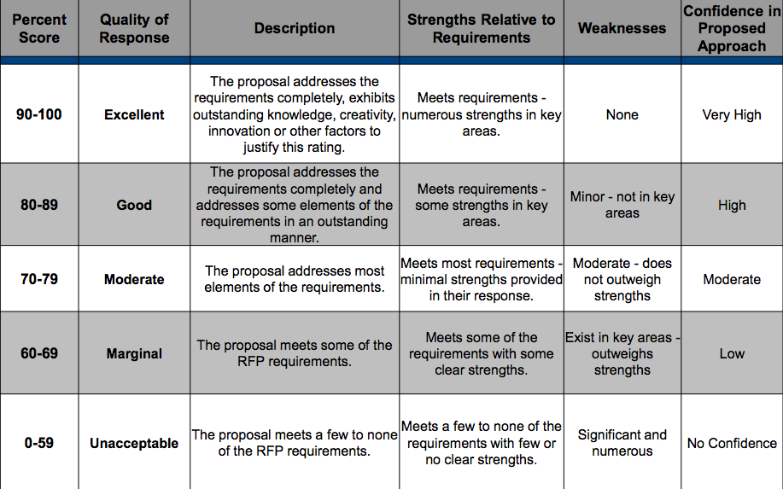

8.2 Financial Requirements

CE will evaluate cost of bids on a best value basis. Vendors are expected to include a total project cost and hourly costs for maintenance and consulting. Pricing information should provide fees, both recurring and nonrecurring as necessary, as well as payment terms and currency. If relevant, it should include escalation clauses and other assumptions related to pricing.

Fixed cost proposals are preferred. Hourly cost structures with a high degree of accuracy and satisfactory explanations are acceptable.

8.3 Capacity and Response Time

The system must be able to scale quickly, adding and maintaining large numbers of users over time. CE currently has 23,000 customers and 5,600 suppliers with account information to be retained. When the CE website deploys, the number of users and orders is expected to increase dramatically within the first 5-10 years. The database and website’s storage and bandwidth must be sufficient to scale with demand.

As of writing CE utilizes 75 Mbps down 15 Mbps up internet connection. Database and website response times are expected to fall within industry and technological norms for projects of a similar scope. No unusual or significant latency should be experienced by CE staff, customer, or suppliers.

8.4 Standardization

Project technical standards are to conform to industry norms and use widely accepted data transmission and interface standards. Website should be of a responsive design, functioning sufficiently well on, mobile, tablet, and desktop systems. As mentioned above, the system should be able to scale and integrate with related technologies on a potentially rapid basis, to grow with CE’s online customer base.

8.5 Customization

Listed here are 3 ‘reference’ websites to be used as a design starting point and to give bidders an idea of the desired layout and aesthetic of the site.

1. <http://www.musiciansfriend.com/>
2. <http://www.guitarcenter.com/>
3. <http://www.sharmusic.com/>

It is not expected CE will assume responsibility for maintenance of any technical, backend, or design areas of the website. The website will be customized to feature all required functional points mentioned in 6.2 Software, and feature CE branding.

CE Branding includes but is not limited to:

* CE themed color scheme
* Inclusion of CE banners and graphics
* Use of CE themed buttons and hyperlinks
* Customized Product Photos
* CE provided text relating to staff and products
* Embedding CE company song

The website must allow CE staff to easily modify:

* Parts
  + Prices
  + Descriptions
* Custom Products
  + Prices
  + Description
* Retail Products
  + Prices
  + Descriptions
* Customers
  + Account Information
  + Payment Information
  + Orders
* Suppliers
  + Account Information
  + Payment Information
  + Orders
  + Supplier Part Provided
    - Supplier Part Prices
    - Supplier Part Descriptions

8.6 Controls

All database and website components will be primarily accessed by CE staff through hardware located at CE’s store location. It will minimally be possible to modify website item descriptions, prices, and photos from both a desktop and mobile device. It is required remote access through a VPN or similar is possible for senior staff to access database and website materials from alternate locations.

Tiered, configurable, secure logins for different staff classes must be included to control permissions in accessing areas of CE’s database and website. At deployment, there will be a single ‘SuperUser’ user account created that will have full control of all aspects of the system. It will be possible for additional ‘SuperUser’ accounts to be created on an as needed basis.

8.7 Documentation

Manuals, instructional materials, and any information needed to effectively operate all supplied hardware, software, and modules will be provided at implementation. All materials should be presented in English and meet industry standard professional writing standards. 3rd party and vendor created documents are acceptable. Digital documentation is preferred, print copies are acceptable only if digital versions are unavailable.

8.8 Ease of Use and Learning

Included software will be used by a majority of CE staff for primary business operations (See 6.2 Software). A typical store employee should be able to effectively operate the software in moderate stress situations of dealing with clients and updating website information. Staff should be able to operate all functional areas of the software for managing database and website information with reasonable training and effort.

Included hardware should be of standard consumer computing technology. The RFID system should be as simple to implement and operate as possible. This is due to CE’s high retail equipment tagging volume and RFIDs future use in supplying customers with item information in real time on the sales floor. Training supplied by the vendor should cover all required areas in sufficient depth to leave staff proficient in use of the system.

**9.0 Vendor Evaluation Criteria**

9.1 Reputation, Stability, Quality of Service

While proposals will be reviewed in a double blind fashion, bidders should include materials speaking to their company history, industry accomplishments, and overall reputation. Vendors must include sufficient financial information for CE to complete due diligence on the health and stability of the vendors.

A minimum vendor should include:

* Current Ratio
* Quick Ratio
* Cash Ratio
* Operating Ratio
* Net Profit Ratio

Vendors should include information about standard customer service practices and associated rates. In the event a vendor is considered as a finalist their provided references will be contacted to further assess reputation, stability, and overall quality of service.

9.2 Licensing Agreement

In the event hardware or software is proposed to be leased from a vendor, all relevant licensing information should be provided.

Including but not limited to:

* Leasing cost model
* Maintenance fees
* Implementation fees
* Subscription costs and models

9.3 Training Program

CE is requesting the vendor hold sufficient trainings for CE staff after successful implementation of the system. The vendor will make recommendations as to how many hours of training will be needed for CE staff to successfully operate and understand the new system. The vendor will supply CE with a quote of the cost for holding such a training.

9.4 Technical Support

Vendors should include information about standard technical support service practices and associated rates.

9.5 Maintenance Agreement

Should a vendor’s proposal be accepted, prior to contracts being signed, CE and the vendor will negotiate any maintenance work covered under warranties, the licensing fee, or that maintenance costs which must be paid for outside of fixed project costs. Vendors should include any annual maintenance costs along with the services provided.

9.6 Warranty

Warranty information on all products will be provided to CE prior to finalization of contractual agreements as part of the negotiation process.

**10.0 Bid Submission Information**

All vendor bids must be received by CE on March 1st, 2017 for consideration. Bids may be emailed or sent by mail, faxes are not accepted.

Send materials by mail to:

Anthony Carver

Carver Electronics

123 Fake Street

Des Moines, IA

52345

Email materials to: acarver@celectronics.com

**Input/ Output and Interface Design 25/25 pts.**

**1. Customer Login**

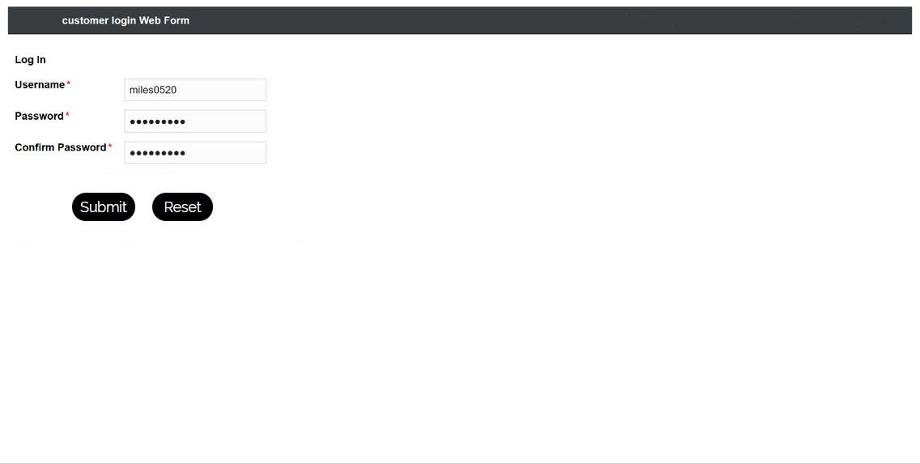

This is an Input screen where old customers can log in to their account. This form asks customers to enter their username and password. When customers enter their login information, they can enter the official website of Carver Electronics Company. And then they can shop for products on the website.

**2. New Customer Login**

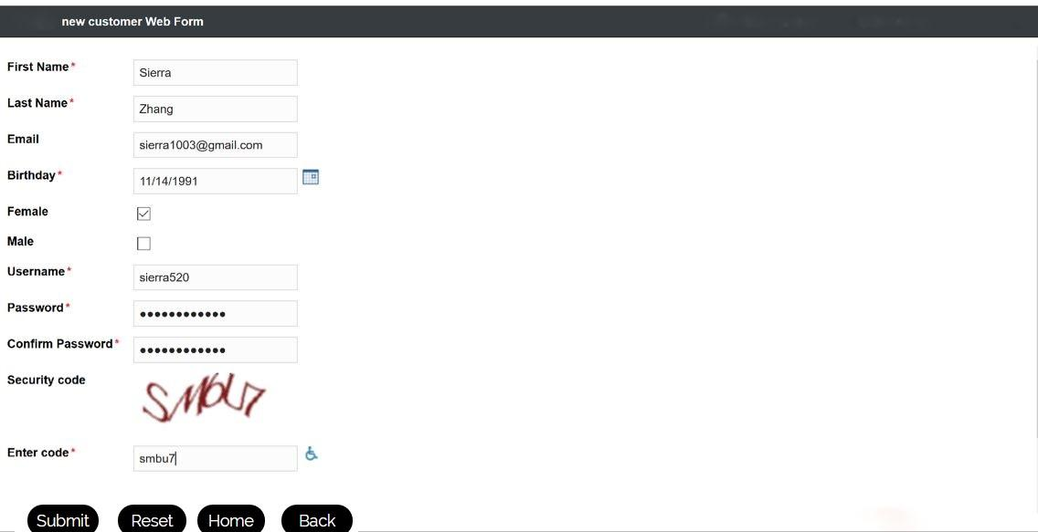

This is an Input screen for new customers where they can enter their information to create an account. This form asks the new customer to enter his/her first name, last name, email address, birthday, and gender to create a username and password. Then when they have account, they can enter the official website of CE company and shop online.

**3.Payment**

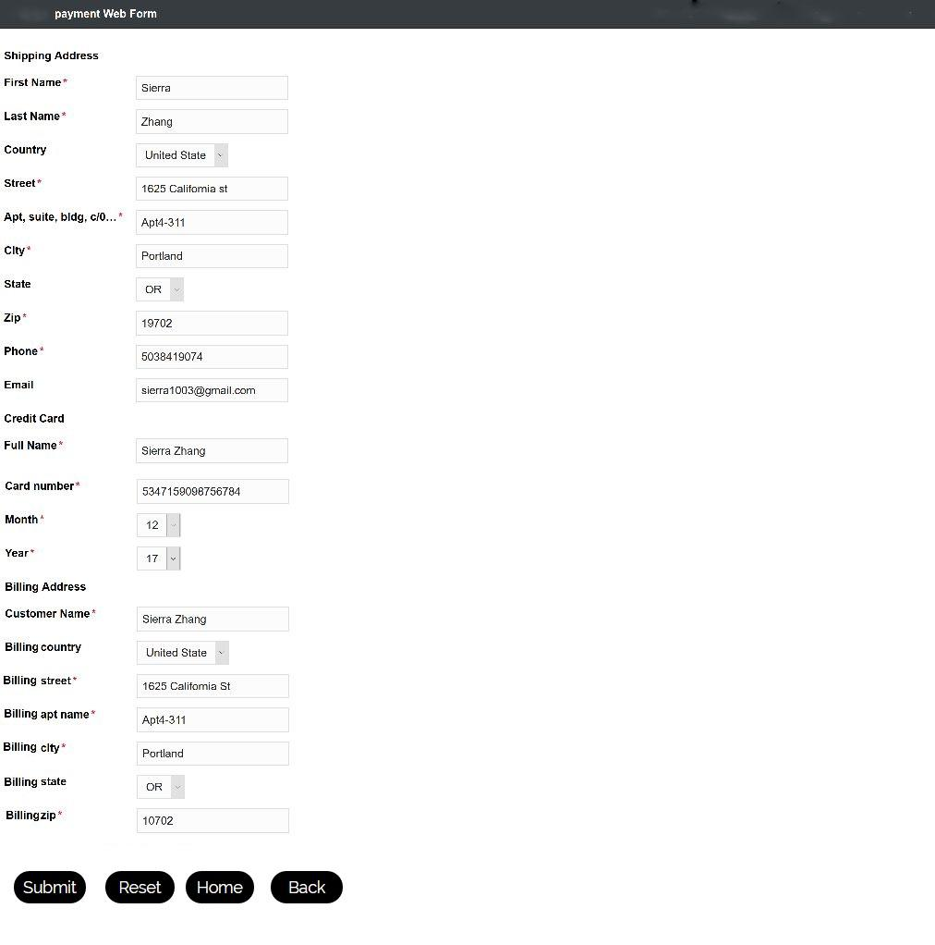

This is an Input screen where customers can enter their payment type and shipping address. This forms asks the customers to enter their shipping address, card numbers and billing address if the customers want to make an order. At the same time, CE can contact the customers when the requested order arrives.

**4.Product Selection**

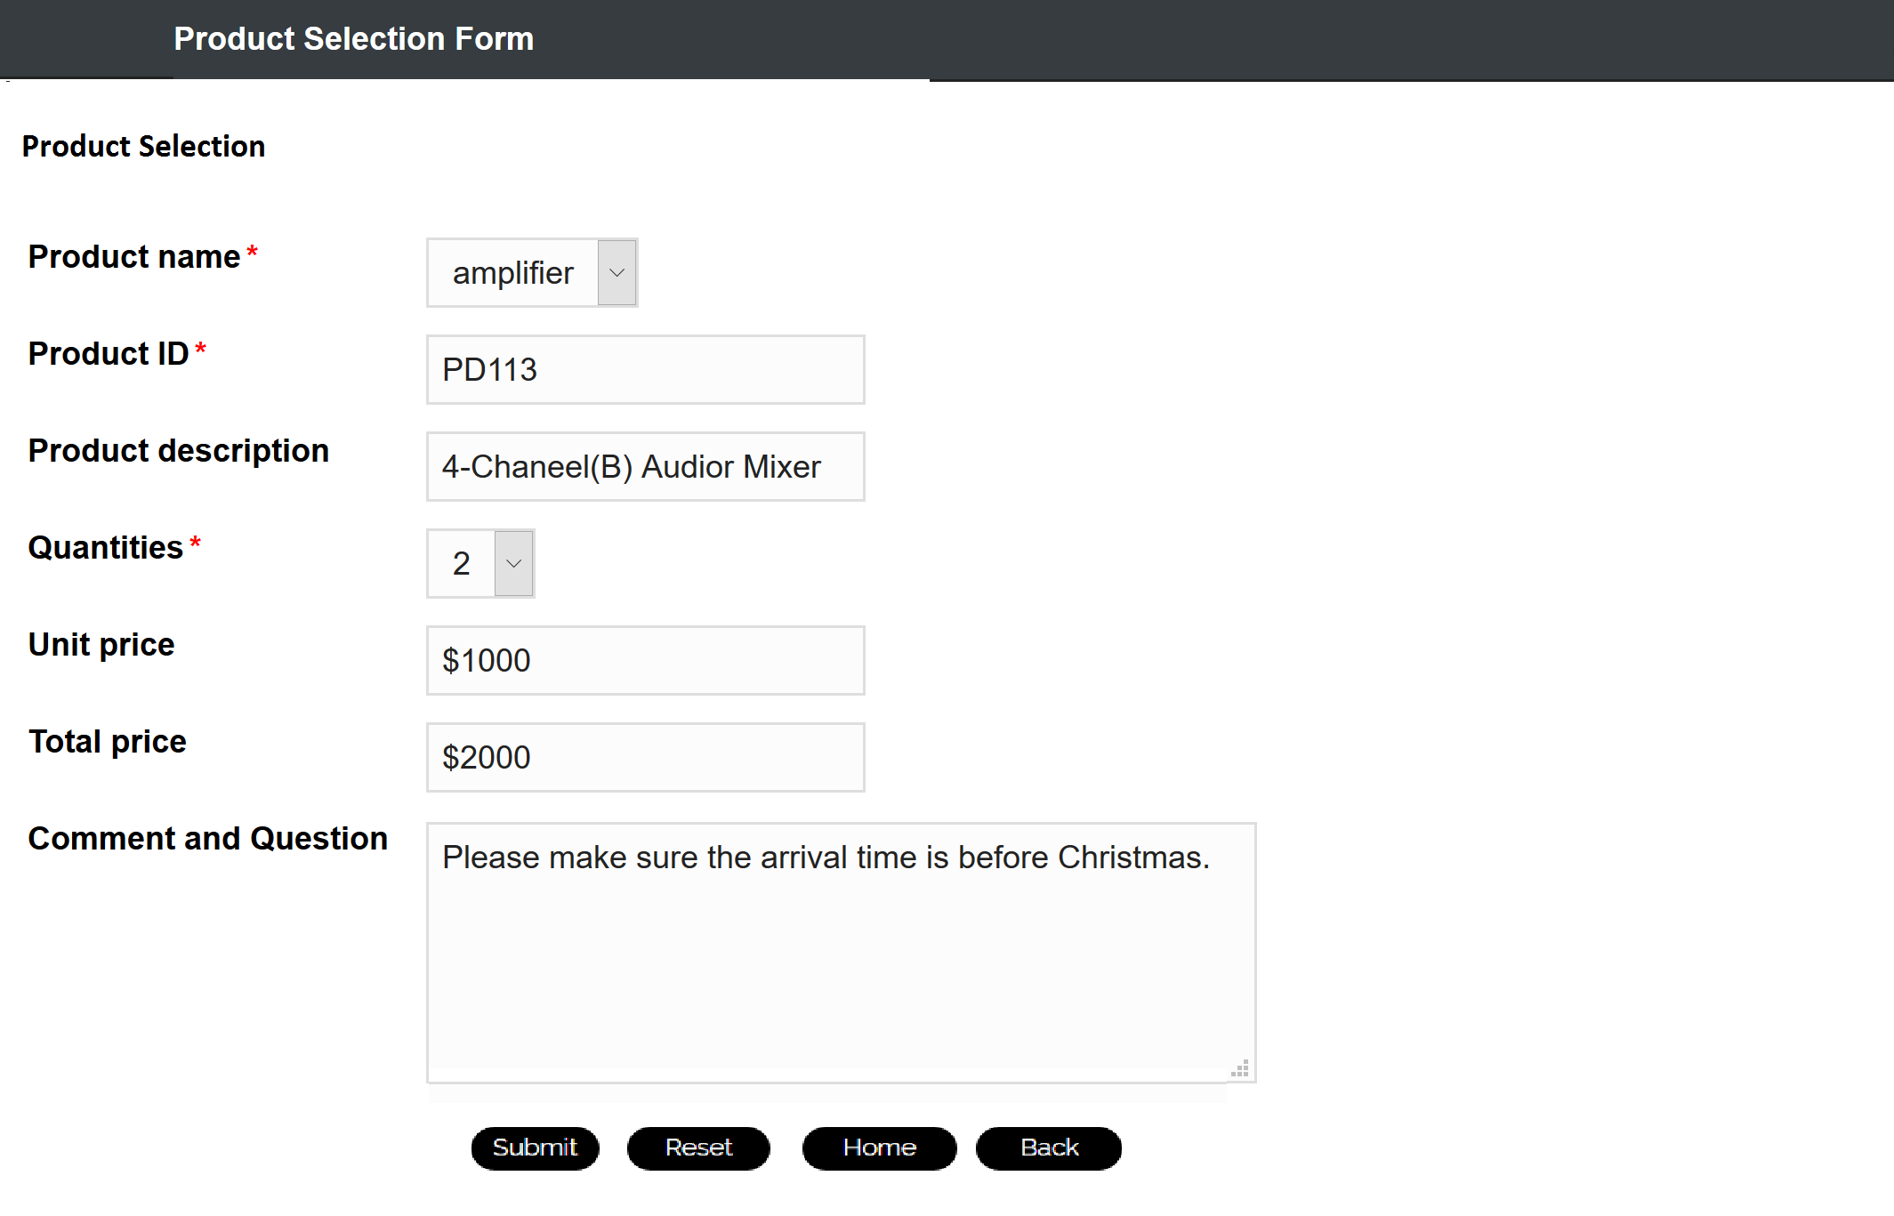

This is an Input screen for product selection. The customers can see the product ID, product description, unit price and total price. Based on this information, customers can choose the product name, quantity, and can put their special comments and questions in the form. CE will send orders based on the customer’s special requests.

**5. Customer Order Summary**

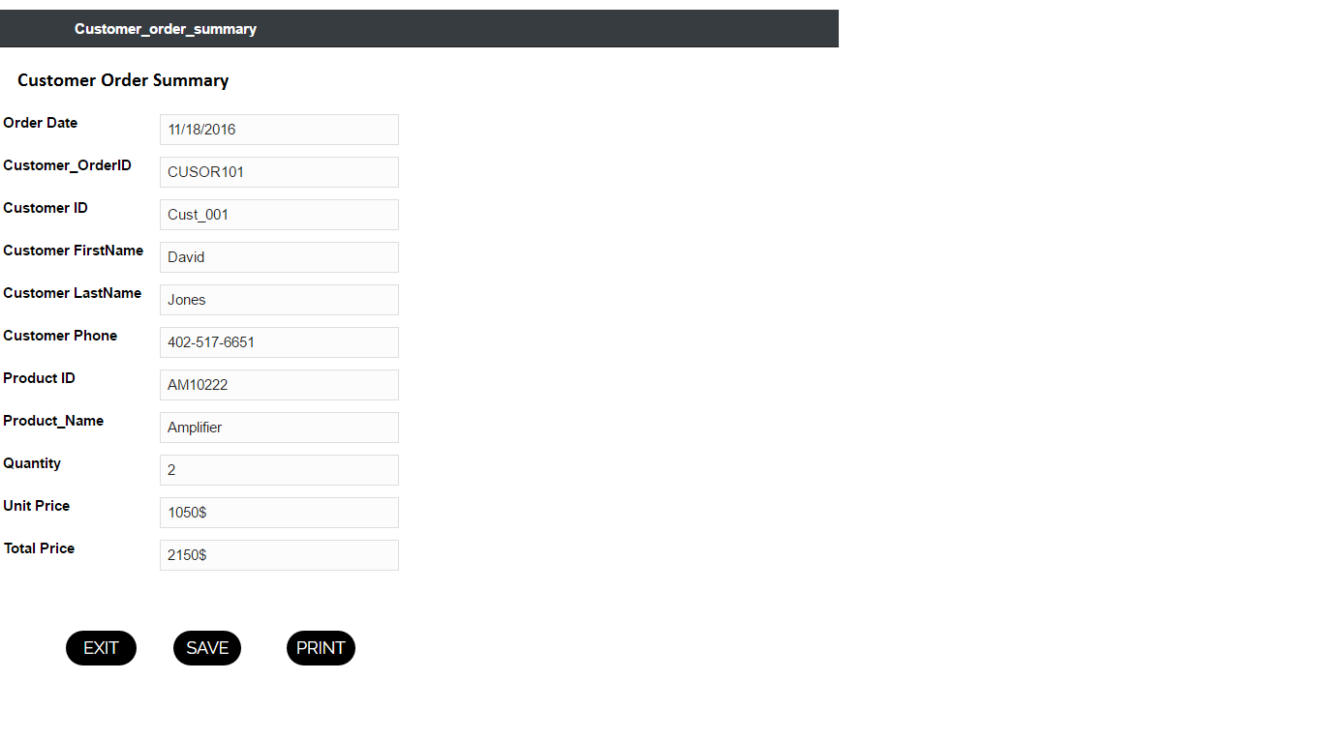

The above screen is an output screen to customers after an order has been placed. This output screen shows a Customer details such as Identification number, name and phone number and Customer order date and Customer order number and product details. For navigation, there are exit, save and print buttons

**6. Account Payable**

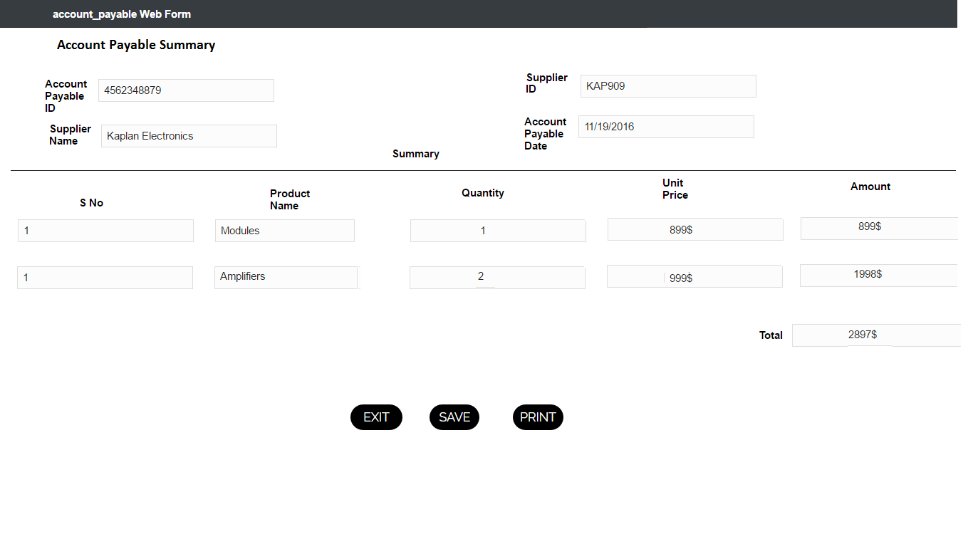

The above screen is the output screen for accounts payable for the product suppliers. This screen appears to CE employees after a purchase order has been sent to the supplier. This screen shows the details of supplier’s name and identification number, Account payable Id and Product details which include the quantity and price of the product.

**Reports**

**1. Monthly Product Sales Report**

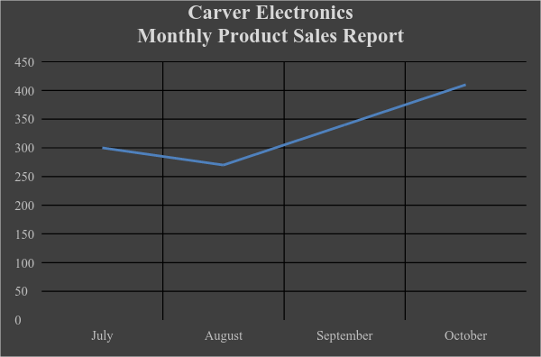

No of Products sold

Months

The above graph represents monthly product sales by Carver Electronics from July 2016 to October 2016. A line graph is used to show the product sales for each month. X-axis represents the months whereas the Y-axis represents the number of products sold. From the graph, we can make out that product sales have increased linearly from August to October. This report will help Carver Electronics manage their inventory and sales effectively.

**2. Products Sold in the Month of October**

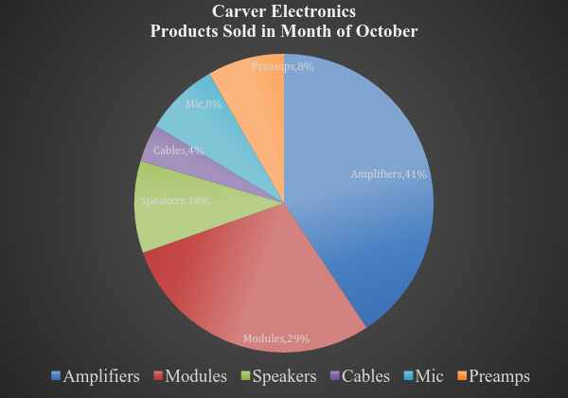

The above Pie Chart reflects the various products sold by Carver Electronics for the month of October. From this report we can observe that amplifiers hold the highest percentage sales (41%) in the month of October. From this report CE can make out products they have in store or in inventory, and products that have to be ordered from a supplier.

**Summary 5/5 pts.**

In Phase 5 of the CE project, based on the SDLC and previous and current phase, we updated the project with the Gantt chart, including Computer Architecture Design and moving User Documentation before Training. We designed the computer architecture based on the needs of CE and the database and web server for the CE online order system and trade in system. The RFP has been created from the point of view of CE.  The input/output design and its samples were presented. The design of reports and examples generated from the database were displayed.

**RFP Sources:**

[1]<http://www.courts.ca.gov/documents/techstaff-augment-rfp-attacha.pdf>

[2]<http://www.dgs.pa.gov/Documents/Procurement%20Forms/Training/Courses/Web-Based/RequestForProposal/EvaluatingRequestfo%20ProposalResponses.pdf>

[3] <http://www.ipwatchdog.com/tradesecret/simple-confidentiality-agreement/>

.

**Responsibility Matrix 5/5 pts. (Who wrote the summary?)**

|  |  |  |  |  |
| --- | --- | --- | --- | --- |
| **ACTIVITY** | **Shilpa Kache** | **Runhua Lei** | **Wancheng Sun** | **William Wetzel** |
| **Title page and Table of Contents** |  | **X** |  |  |
| **Executive Summary** |  |  |  | **X** |
| **Updated Project Schedule** |  | **X** |  |  |
| **Architecture design** |  | **X** |  |  |
| **Request for Proposal (RFP)** |  |  |  | **X** |
| **Input/ Output and Interface Design** | **X** |  | **X** |  |
| **Reports** | **X** |  | **X** |  |
| **Project Submission** |  |  |  |  |
| **Peer Evaluation & reflection** | **X** | **X** | **X** | **X** |

Peer evaluation and reflection -- 5/5 pts.