Impact of Air Pollution on Life Expectancy in India

Kim Duong & Dr. Sachin Pawaskar (M.S, MBA, PhD)

Department of Information Science & Technology

University of Nebraska at Omaha

April 2019

Abstract

Among 15 cities around the world with the worst air pollution, 14 out of 15 cities are in India. Even though many researches were conducted to explain different impacts of air pollution, this paper is focusing on the impact level of air pollution upon life expectancy in India. By pulling data from regarding different emissions among states within India, this provides deeper understanding of which state is most polluted to understand the trend of whether life expectancy is affected anyway.

Keywords: Air pollution, life expectancy

# Introduction

According to the World Health Organization, air pollution is described as ‘the contamination of the indoor or outdoor environment by any chemical, physical or biological agent that modifies the natural characteristics of the atmosphere’ [3]. The impact of air pollution can have major consequences especially on the environment, health, and sanitation. A study done by Lancet Planetary Health has shown air pollution to be a significant health risk especially in India with 29 states. From analyzing the health trend risk, life expectancy can be a factor which shows ‘the overall mortality level of a population’ that summarized the mortality pattern which affects across all age groups [4]. Shown from figure 1, India is right in the middle range of 36.3 to 89 years of life expectancy in 2008. Then, moving onto 2010 through 2014, India’s overall life expectancy at birth is 67.9 with 66.7 in rural and 71.5 in urban parts of India. In Urban, Chhattisgarh and Uttar Pradesh show the lowest expectancy at birth shown in figure 2.

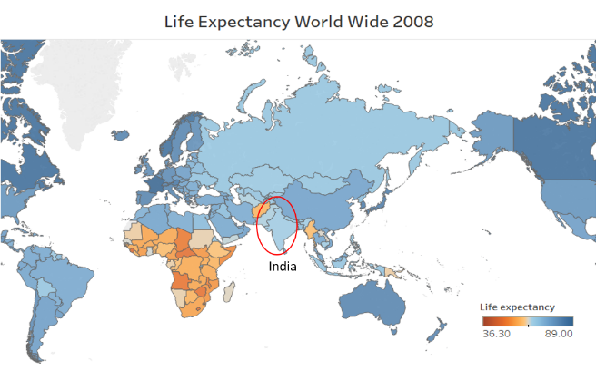

**Figure 1 – Life Expectancy World Wide 2008**

# Methodology

## Literature Review

Power generation, residential energy usage, industrial and transportation have been contributed to the total concentrations of PM 2.5 [1]. Hence PM 2.5 contains mainly level of particulate matter such as sulfur dioxide (So2) and nitrogen oxides (No2) from significant usage of coal from power and industrial sectors [2].

*Experimental Design*

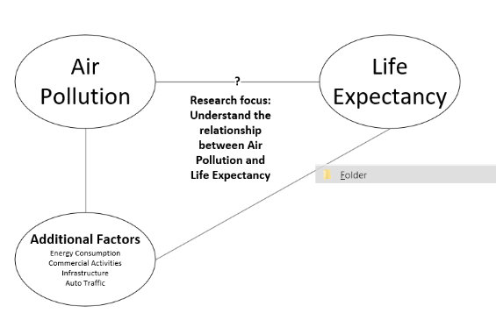

## Data Collection

The main data sources are mainly from World Health Organization, Central Pollution Control Board from India, and World Bank - World Development Indicators.

# Research Question

After data preprocessing, visualizations are created to dive deeper into the topic to find supportive evidences to answer the research question. The research question is formulated after the literature review is ‘How does air pollution impact the life expectancy in India?’.

# Data exploratory visuals

## Suspended Particulate Matter

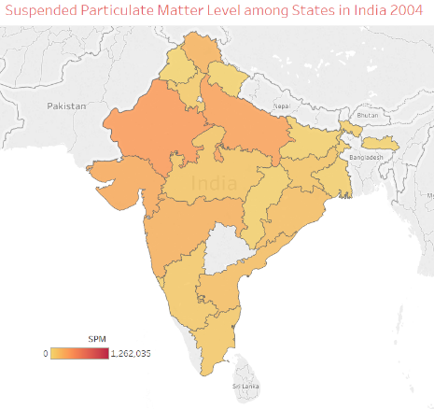

**Figure 2 – Suspended Particulate Mater Level in 2004**

As mentioned, India has 14 out of 15 most polluted cities in the world, figure 2 is showing the level of suspended particulate matter in 2004. While in 2008, the level of suspended particulate matter increases significantly especially in the northern part of India.

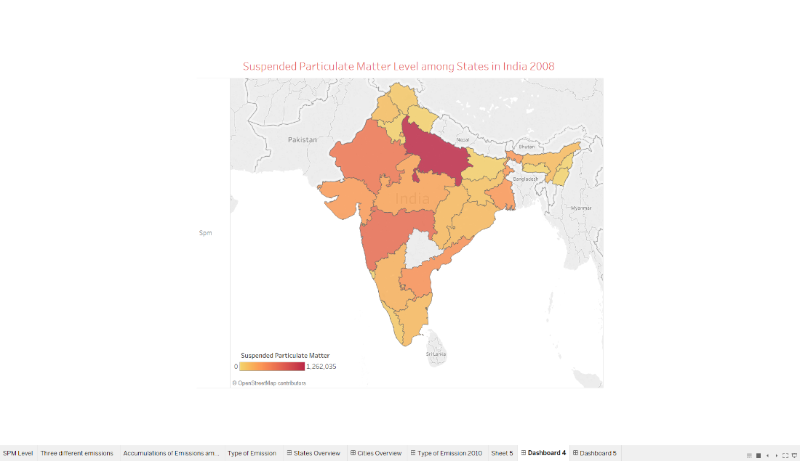

**Figure 3 – Suspended Particulate Matter in India 2008**

## SPM Emission Industrial Activities 2005 vs. 2008

By examining the level of suspended emission from 2005 and 2008, Uttar Pradesh has the most level of pollution increasing from industrial activities compare to other states. Hence, not every parts of the state would have a high level of pollution.

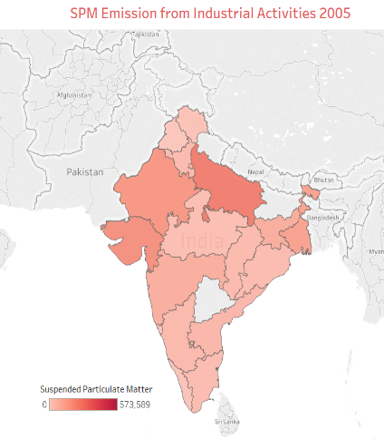

**Figure 4 – SPM Emission from Industrial Activities 2005**

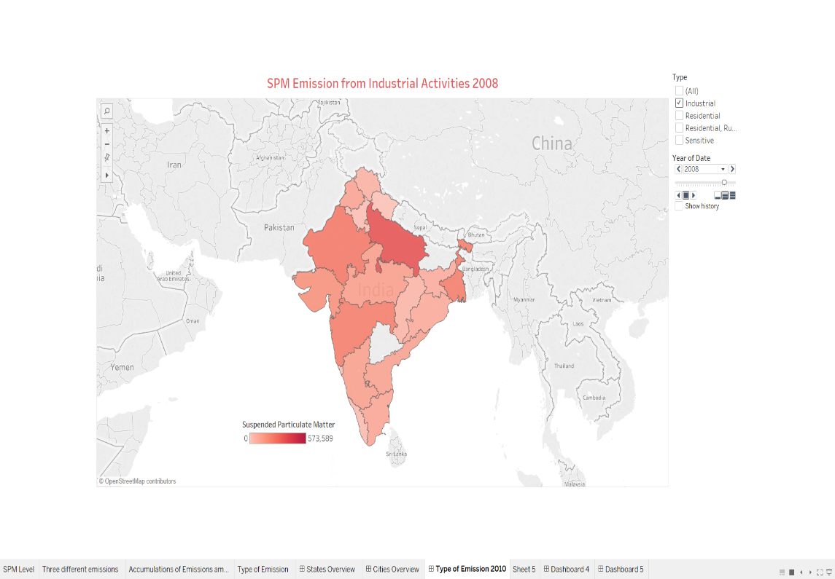

**Figure 5 - SPM level from Industrial Activities 2008**

Among the states, Uttar Pradesh shows the lowest life expectancy from 2010 through 2014 in Figure 4. Even though Uttar Pradesh has the highest level of emission level, its life expectancy is lowest compare to all the states. Therefore, this shows the negative relationship between air pollution and life expectancy.

## Comparisions between Emission Levels among Cities within Uttar Pradesh State

By comparing the results across cities within Uttar Pradesh state, there are three top cities with most polluted level of emissions includes Agra, Kanpur, and Lucknow as shown in Figure 6. From looking at figure 3 – Uttar Pradesh shows the highest amount of pollution emission from industrial activities in 2008.

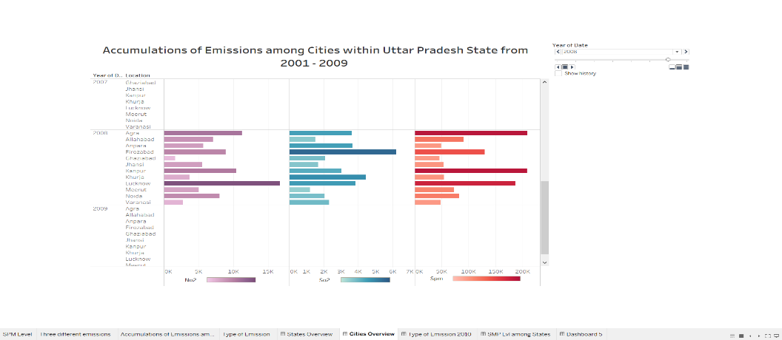

**Figure 6 – Accumulations of Emissions within Cities at Uttar Pradesh**

## Life Expectancy among States in India from 2010 – 2014

## After examining the accumulations of emissions among the cities within Uttar Pradesh state, life expectancy is examined across the states. Shown in Figure 7, Uttar Pradesh has a lower life expectancy among the States in India.

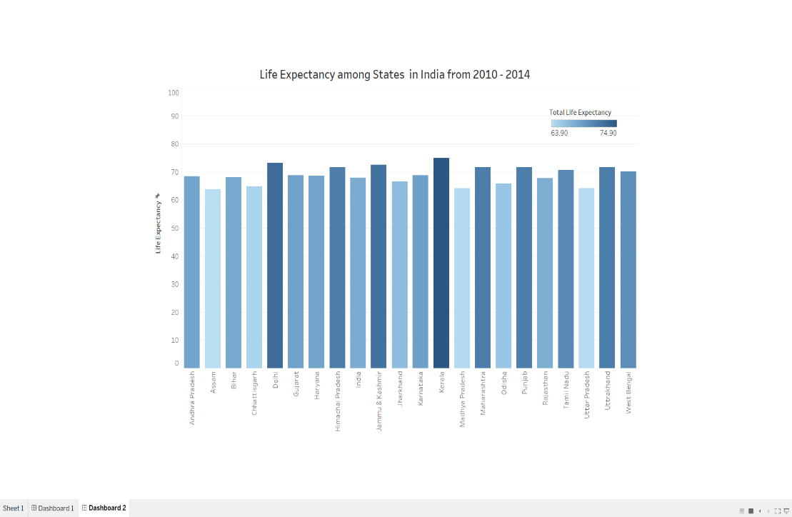

**Figure 7 – Life expectancy among the States in India**

## Results

After examining life expectancy and air pollution trend, a model is created to understand the correlation relationship between life expectancy and air pollution. The relationship is negative correlation of -0.65 which shows a more negative relationship between two variables. Hence, air pollution is negatively correlated to life expectancy. As air pollution increases in terms of PM 2.5 level, the lower the life expectancy for India as shown in Figure 8.

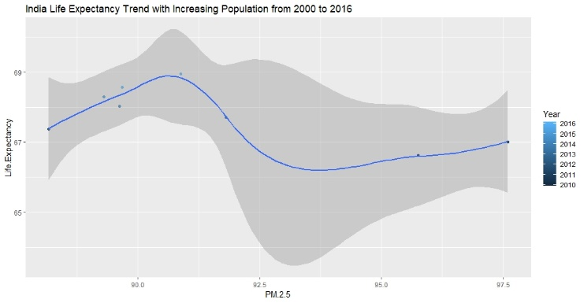

**Figure 8 – Life Expectancy versus PM 2.5 Trend from 2000 - 2016**

# Conclusion

Further research studies with what type of industrial activities in Agra, Kanpur, and Lucknow is encouraged to understand the cause of high air pollution level whether a cap of emission should be implemented to certain industrial level among these cities. Certainly, there are other factors impacting on air pollution to have negative correlation with life expectancy.

##### References

1. Gao, M., Beig, G., Song, S., Zhang, H., Hu, J., Ying, Q., . . . Mcelroy, M. B. (2018). The impact of power generation emissions on ambient PM2.5 pollution and human health in China and India. Environment International, 121, 250-259. doi:10.1016/j.envint.2018.09.015
2. Huang, R. J., Zhang, Y., Bozzetti, C., Ho, K. F., Cao, J. J., Han et al, 2014. High secondary aerosol contribution to particulate pollution during haze events in China.
3. World Health Organization. (2019). Air Pollution. Retrieved from https://www.afro.who.int/health-topics/air-pollution
4. World Health Organization. (2018, May 15). Life expectancy.